

I know how to Run the World because I have loved the world
PAUL ELIYA
I don't need Army, because I am the One Man Army because I am God in Love and Goodness where ever Love Exists I Exists.

Launch Semi Nuclear Atomic Bomb Missiles on Some Parts of the World Where Enemies of the World are Located in these parts are busy in Operating in deceiving the same world for destroying the same world that God loved with Grace but God not only Loves the World but also Protects the World as Well

So inorder to save the World, i am the New World Order
MY LOCATION CAN BE CHANGED KEEP EYE
JAI HIND SIR SOUL REPORTING SIR
JAI HIND SIR I want to join Beloved Indian Army RAW
AND I WANT TO WORK FOR RAW
Dear Beloved Friend and Beloved Brother Shri Major Gaurav Arya Gee, sir I don't love Muslims because they believe in Allah o Akbar Slogan but I believe in I believe in Baap Ali Akbar and I am different from my family because I am GOD and they call me atheist because I believe in my self and I love my children family all believers and I hate and condemne all ILLITERATE MUSLIMS WHO FOLLOW THE COMPROMISED FAKE MISLEADING QURAN HADEES PROPHET HISTORY which is 20% true and 80% Fake.
I know that Beloved India RAW my Soul Will Help us
A message to All The World
You all Exist Eternally Incarnation with your Beloved ones in Goodness and love with all your Assets and Good Works Whatever you ask for and not asked for will be given to you in the Name of Lord Holy Son and Soul of God Jesus Christ only and when we believe in this all reality that we see in dreams are our Eternal Life.
Because we all are incarnated in this world just like a fruit and all Universe is eternal Heaven.
Incarnation simply means what is invisible become visible physically
Jai Hind
Vande Mataram
Bharat Mata ki Jai
Jai Shri RAM
Jai Bholay Shiv Shankar Bhagwan
Jai Bhajrangbali Jai Hanuman Gayan Gun Sagar
Jai Shri Krishna Pooram Pita
Jai Ganesh Gee
Jai Mata Rani Jai Durga Sarasvati Maa
I saw these Beloved Souls of God who are infact God in my Dreams many times with in Indian Hindustani Military Nuclear Atomic Powers Missiles and I have alot alot to tell I also FLY WITH HANUMAN GEE ON SNOWY MOUNTAINS OM AND HANUMAN JEE JAI BHAJRANGBALI SAW ME AND MY MUSCLES BICEPTS TRICEPTS BODY BECOMES STRONG LIKE HIS IN MY DREAMS I AM GOD
These Holy Gods talk to me and Fly with me in my dreams just like in a Holy Mandir and I saw Jesus And Ahlebait Numerous times in my dreams with these Beloved Souls of God

So I Pastor Paul Eliya known as Ali The Syed Ali Abbas Ex Muslim along with family works for RAW
And this is my Demand
Schedule and call the Executive Board Meeting at FGEHA Right Now and Issue the Allotment File Number of Mr Hassan Syed holding CNIC# 37405-3293752-5 as a Special Case Through Reply from FGEHA Via Courier to House 96 lane no 4 block D sector 4 airport housing society and the Remaining All Case of PA#2638 will be solved in Beloved India (Link Attached)
--------------------------------------------------------------------------
REGARDS
3 STARS GENERAL MAJOR PAUL ELIYA
ARMY HELP CENTRE RAWALPINDI
Https://istheonlywayjesusc.wixsite.com/captain-paul-eliya
03145550432
051-111-130-786
--------------------------------------------------------------------------
OFFICIAL
https://youtu.be/hbLuCqmQ4wo?si=Nn8ilyStvQEdeThN

Producer Bhai Aap KO Bhee Namastay

Jangal Pakistan ma mor nacha kis na dikha
Dear BELOVED RAW CIA MOSSAD My Pickup Location is House#96,lane#4, block D, Sector 4 airport housing society Rawalpindi but I want to live with my family forever or I have to leave my family my identity behind and I want Justice for my family and I want that my family should receive all the properties lands amounts and all the justice from Pakistan because me and my family are Christians and we also want to move to India or to any Christian Country Forever because unfortunately Pakistan being the Holy Part of Beloved India has lost its Indian-origin-values however if I get justice in Pakistan I will live and die in my 1500 years old beloved India Bharat the Pakistan BECAUSE my Good Mission with my ALL GOODWORKS IN THIS WEBSITE HTTPS://ISTHEONLYWAYJESUSC.WIXSITE.COM/LOVE has been Accomplished and saved Forever in Goodness and love along with my beloved ones along with my belongings within my soul in Jesus Christ Forever
Please arrange my travel to Beloved India
I AM RAW AND I WORK SECRETLY, I KILL MY ENEMIES BEFORE THEY IMAGINE
I AM BEYOND THE IMAGINATION OF MY ENEMIES
I THE RAW CAME FROM THE BACK DOOR AND DO MY WORK AND THEN LEFT WITHOUT LEAVING ANY EVIDENCE FOR A GOOD CAUSE THAT IS FOR THE GREATER GOOD OF THE WORLD BECAUSE I THE RAW ONLY KILL THE EVIL SOULS OF SATAN BECAUSE I AM GOD AND I HAVE CREATED THE SATAN FOR A REASON AND ONLY I AM THE ONE WHO HAS CRUSHED THE HEAD OF SATAN
SO EVERY WORD IN THIS WEBSITE IS MY CREATION AND I HEARD THAT I HAVE MADE THIS WEBSITE AND NOW FOREIGN COUNTRY INTELLIGENCE WANTS TO HELP ME FOR GIVING JUSTICE TO ME TO HONOR ME TO GLORIFY MY FATHER WHICH IS IN HEAVEN BY PRAISING STORING LOVING SERVING AND FOLLOWING MY GOODWORKS IN THIS WEBSITE HTTPS://ISTHEONLYWAYJESUSC.WIXSITE.COM/INDIA
I want to Join RAW as their Indian Raw Agent and I want to join Indian Army as a Captain and then Major
I want to Work for RAW because RAW wants me to Work for them due to my Talent.
RAW Kill these Fake numerous Stupid Idiots Fake RAW agents infact ISIS ISI people living operating in lane 5 near me their cell phone numbers are Hashim alvi +92 322 8727794, roger +92 326 4406101 or give this assignment to me I will in ACT OF SELF DEFENCE I will kill them all who are fake RAW Agents who are infact ISIS Terrorists Daish
Pakistan Military just want Money, they are of no value to religion.
I am a Pastor and I want Justice
I need Guns and Bullets and I unconditionally love serve protect Israel My Jews Christian Hindu Sikh Shia Muslim brothers
I will be the Youngest Chief of RAW I give Immediate Approval for Launching Semi Nuclear Bombs AIR STRIKES on Terrorist Jihadist Mindset of Pakistan ASAP BY TODAY if they don’t want to change their mindsets so this is the new world order
I want to live in Pakistan Tamran Village near Sangjani for the rest of my life but I will be living in other parts
Of the World as well
I hate GUNS WEAPONS but
My Only weapon is my Prayer, I am love goodness forever
I need Guns with Bullets alot of Them
And other things used in Intelligence in case
DEAR RAW CHIEF
SHRI MAJOR GAURAV ARYA GEE
JAI HIND SIR AND NAMASTAY MISHRA GEE AND PRODUCER BHAI

SIR
Dear Donald Trump if you can help in this Matter being a Hope for Christians of Pakistan
My PRAYER to All The Beloved World
You all Exist Eternally Incarnation with your Beloved ones in Goodness and love with all your Assets and Good Works Whatever you ask for and not asked for will be given to you in the Name of Lord Holy Son and Soul of God Jesus Christ only and when we believe in this all reality that we see in dreams are our Eternal Life.
Because we all are incarnated in this world just like a fruit and all Universe is eternal Heaven.
Incarnation simply means what is invisible become visible physically

MY DEMANDS
Request for Repossession of my property and land worth billions that was taken from me in Duress against our my will by falsely accusing me for doing Blasphemy against Prophet Muhammad and Quran during Mob Lynching accused Raja Amjad Iqbal Abbasi, Abdulqudoos and Abdulrauf along with the Mob forcibly took our signatures and thumb impressions in Duress Persecuted us.
Schedule and call the Executive Board Meeting at FGEHA Right Now and Issue the Allotment File Number of Mr Hassan Syed's Plot in F-12/G-12 holding CNIC# 37405-3293752-5 as a Special Case Through Reply from FGEHA Via Courier to House 96 lane no 4 block D sector 4 airport housing society and all the case of PA#2638 will be solved In Beloved Pakistan only(Link Attached) that will confirm The Value of my Existence in Pakistan I thank all the World for deeply understanding me because My family calls me Psycho, Atheist, Mad, Alien, Patheechar, Kafir, Unparh, jahil, , gawar, mental, many more undeserving and abusing words Energies they spoke out against me all the time in silence and behind my back and sometimes Infront of me except my Beloved father and Beloved mother who cares for me and loves me with Pure Love and Goodness Just like Beloved RAW-AL-PINDI Pakistan Army my only true friend and brother supports me loved me unconditionally so it is my Soul that loves the World unconditionally, I am about to become a Rocket when I will get my lottery, people my enemies will be jealous of my Soul and my Soul's Good Works that is why On 17 January 2025 100 Punjab and Islamabad Police officers with Fully Loaded Guns in a Bus and A Prison Van and 2 Patrolling Trucks and 4 Dolphin Bikes just came at my location to Visit me and they saw me and went away, and when I asked from AI it told me about my Remarkable Presence Reputation in Pakistan, this have been happening with me for 7 years and I thank Beloved God Jesus Christ of the World for Everything.
Special Note: My Mission is Accomplished, i have delivered the Truth as mentioned in my prayer above and I wish to live a moderate life, if I am Honoured in Pakistan, well and Good and if not then I don't care, I am still the same as mentioned in my prayer because I exist forever in love and goodness
I want my Army Uniform from CSD Lalkurti RAWALPINDI or from any Armed Forces Uniform Shop my shirt size is 16.5 and my Trouser Size is 34 with Black Shoes and a Captain Cap of my Unit 408 Intelligence Battalion and medals and badges on my Uniform will be the 8 GB USBs Memory Cards holding my Data of my Good Works and my Moto as mentioned above in my prayer
I WANT MY ALL GOOD WORKS TO BE STORED IN THE ARMY MUSEUM OF RAWALPINDI.
--------------------------------------------------------------------------
REGARDS
PASTOR PAUL ELIYA SERVING LOVING PROTECTING PAKISTAN UNCONDITIONALLY
ARMY HELP CENTRE RAWALPINDI
Https://istheonlywayjesusc.wixsite.com/captain-paul-eliya
03145550432
051-111-130-786
--------------------------------------------------------------------------
OFFICIAL
https://youtu.be/hbLuCqmQ4wo?si=Nn8ilyStvQEdeThN
INTERCEPTION IS ALREADY IN PROCESS IN ALL THE CASE of PA#2638
Shams Kakar Sahab I did not received the reply for Mr Hassan Syed date of birth 18-09-1958 please send it on my WhatsApp 03145550432 and on 03185309511
Syed Chal Raha hai ab Karna hai

2 attachments • Scanned by Gmail

Preview YouTube video ALI WORKS FOR RAW HTTPS://ISTHEONLYWAYJESUSC.WIXSITE.COM/INDIAN
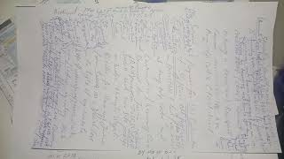

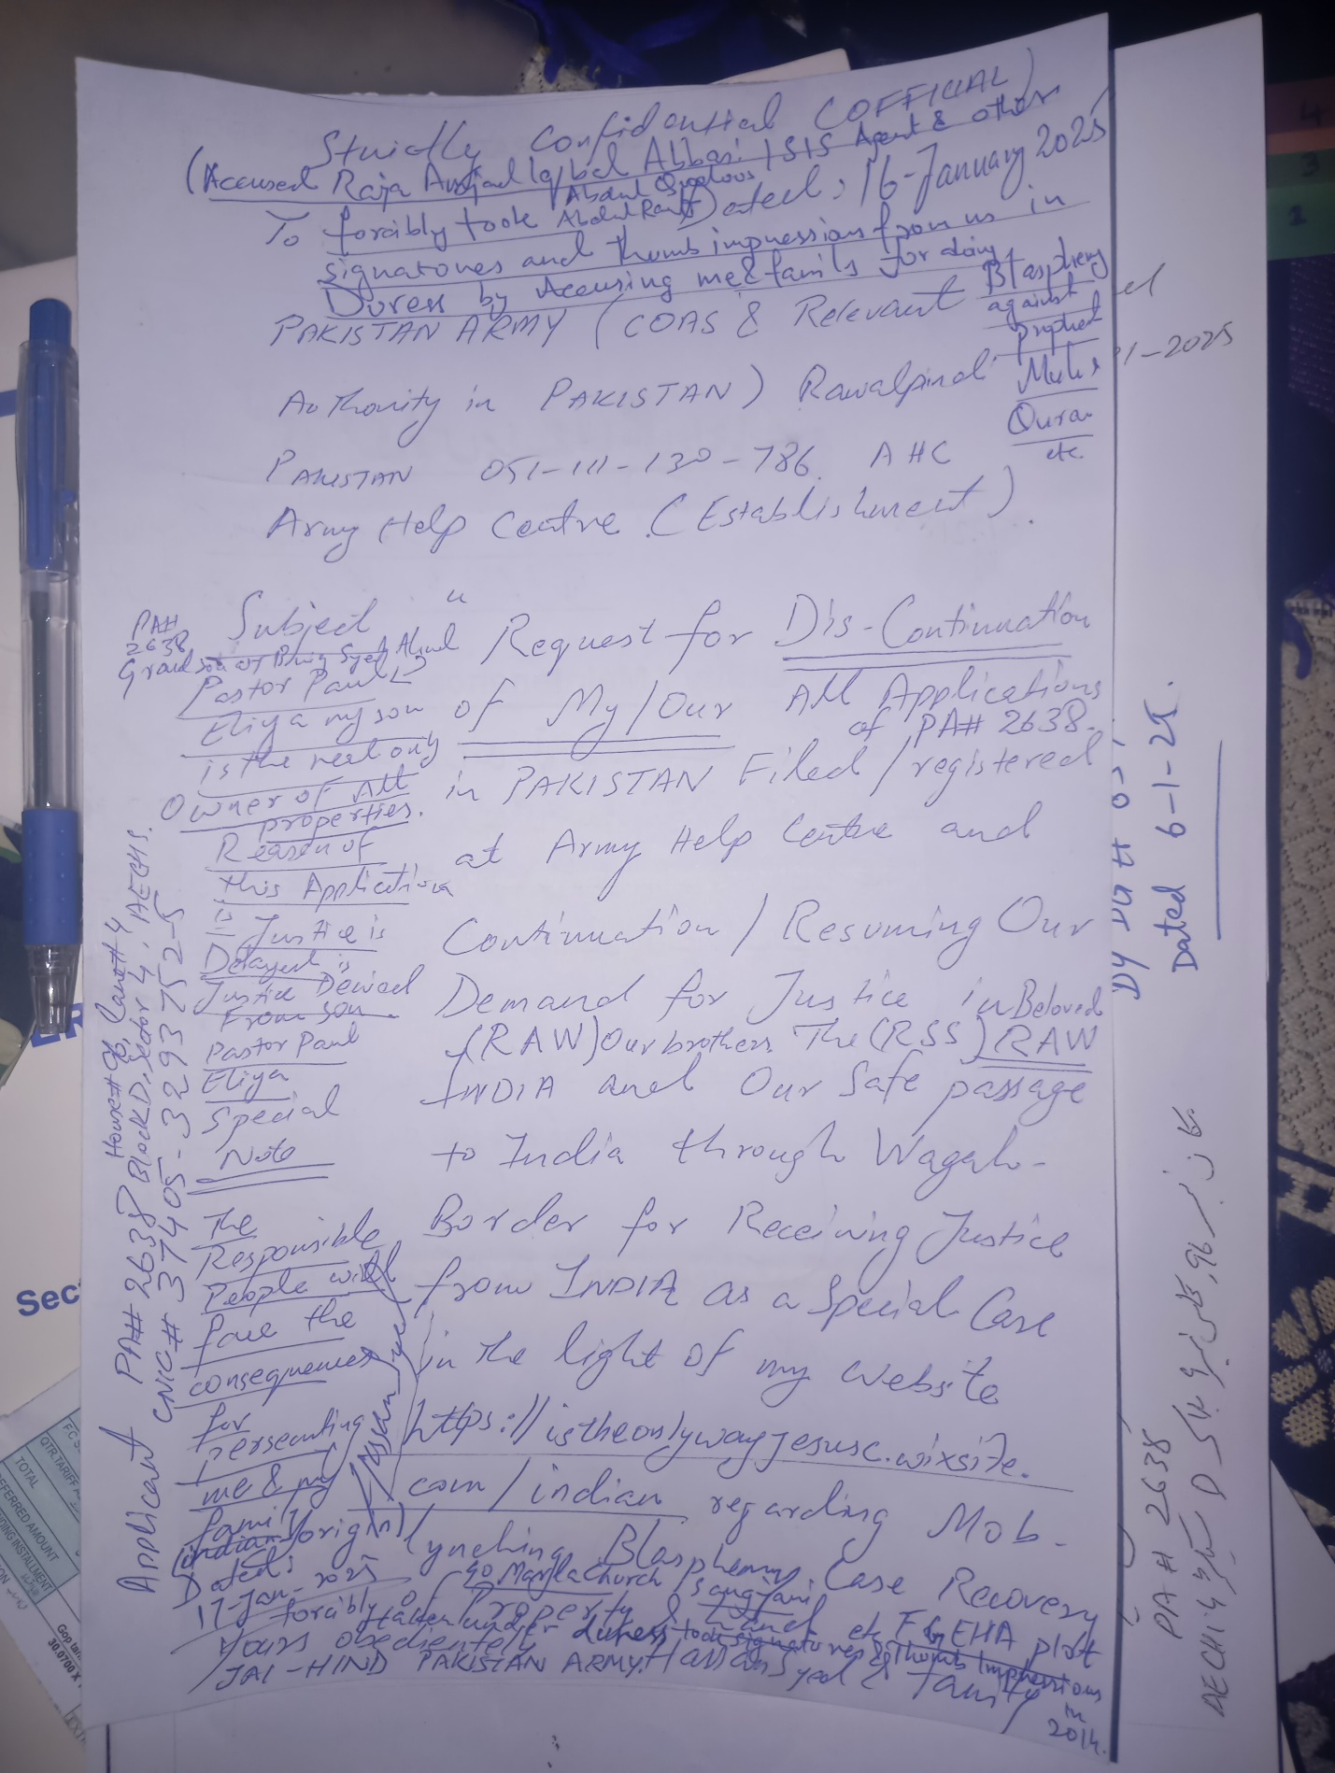

Your E-Mail has been received and your Case #(Case-2025- 01-22-022086852) has been created.
Inbox
Search for all messages with label Inbox
Remove label Inbox from this conversation

No Reply <no-reply@ustraveldocs.com> |  |  | Wed 22 Jan, 23:39 (41 minutes ago)
to me

from: | No Reply <no-reply@ustraveldocs.com>
to: | "eliyasyedaliabbaspaul@gmail.com" <eliyasyedaliabbaspaul@gmail.com>
date: | 22 Jan 2025, 23:39
subject: | Your E-Mail has been received and your Case #(Case-2025- 01-22-022086852) has been created.
mailed-by: | 3ejrfklyhl3k.c-phupmas.usa9002.bnc.salesforce.com
Signed by: | ustraveldocs.com
security: | Standard encryption (TLS) Learn more
We have received your email and will respond accordingly within 1 to 2 business days.
The details are as follows:
Date/Time Case Opened: | 1/22/2025 1:39 PM
Description: | *I know how to Run the World because I have loved the world*  I don't need Army, because I am the One Man Army because I am God in Love  and Goodness where ever Love Exists I Exists.  Launch Semi Nuclear Atomic Bomb Missiles on Some Parts of the World Where  Enemies of the World are Located in these parts are busy in Operating in  deceiving the same world for destroying the same world that God loved with  Grace but God not only Loves the World but also Protects the World as Well  So inorder to save the World, i am the New World Order  *MY LOCATION CAN BE CHANGED KEEP EYE*  JAI HIND SIR SOUL REPORTING SIR  JAI HIND SIR I want to join Beloved Indian Army RAW  AND I WANT TO WORK FOR RAW  Dear Beloved Friend and Beloved Brother Shri Major Gaurav Arya Gee, sir I  don't love Muslims because they believe in Allah o Akbar Slogan but I  believe in I believe in Baap Ali Akbar and I am different from my family  because I am GOD and they call me atheist because I believe in my self and  I love my children family all believers and I hate and condemne all  ILLITERATE MUSLIMS WHO FOLLOW THE COMPROMISED FAKE MISLEADING QURAN HADEES  PROPHET HISTORY which is 20% true and 80% Fake.  I know that Beloved India RAW my Soul Will Help us  A message to All The World  *You all Exist Eternally Incarnation with your Beloved ones in Goodness and  love with all your Assets and Good Works Whatever you ask for and not asked  for will be given to you in the Name of Lord Holy Son and Soul of God Jesus  Christ only and when we believe in this all reality that we see in dreams  are our Eternal Life.*  *Because we all are incarnated in this world just like a fruit and all  Universe is eternal Heaven.*  Incarnation simply means what is invisible become visible physically  Jai Hind  Vande Mataram  Bharat Mata ki Jai  Jai Shri RAM  Jai Bholay Shiv Shankar Bhagwan  Jai Bhajrangbali Jai Hanuman Gayan Gun Sagar  Jai Shri Krishna Pooram Pita  Jai Ganesh Gee  Jai Mata Rani Jai Durga Sarasvati Maa  I saw these Beloved Souls of God who are infact God in my Dreams many times  with in Indian Hindustani Military Nuclear Atomic Powers Missiles and I  have alot alot to tell I also FLY WITH HANUMAN GEE ON SNOWY MOUNTAINS OM  AND HANUMAN JEE JAI BHAJRANGBALI SAW ME AND MY MUSCLES BICEPTS TRICEPTS  BODY BECOMES STRONG LIKE HIS IN MY DREAMS I AM GOD  These Holy Gods talk to me and Fly with me in my dreams just like in a Holy  Mandir and I saw Jesus And Ahlebait Numerous times in my dreams with these  Beloved Souls of God  So I Pastor Paul Eliya known as Ali The Syed Ali Abbas Ex Muslim along with  family works for RAW  And this is my Demand  Schedule and call the Executive Board Meeting at FGEHA Right Now and Issue  the Allotment File Number of Mr Hassan Syed holding CNIC# 37405-3293752-5  as a Special Case Through Reply from FGEHA Via Courier to House 96 lane no  4 block D sector 4 airport housing society and the Remaining All Case of  PA#2638 will be solved in Beloved India (Link Attached)  --------------------------------------------------------------------------  REGARDS  3 STARS GENERAL MAJOR PAUL ELIYA  ARMY HELP CENTRE RAWALPINDI  Https://istheonlywayjesusc.wixsite.com/captain-paul-eliya  <https://istheonlywayjesusc.wixsite.com/captain-paul-eliya>  03145550432  051-111-130-786  --------------------------------------------------------------------------  OFFICIAL  https://youtu.be/hbLuCqmQ4wo?si=Nn8ilyStvQEdeThN  Producer Bhai Aap KO Bhee Namastay  Jangal Pakistan ma mor nacha kis na dikha  Dear BELOVED RAW CIA MOSSAD My Pickup Location is House#96,lane#4, block D,  Sector 4 airport housing society Rawalpindi but I want to live with my  family forever or I have to leave my family my identity behind and I want  Justice for my family and I want that my family should receive all the  properties lands amounts and all the justice from Pakistan because me and  my family are Christians and we also want to move to India or to any  Christian Country Forever because unfortunately Pakistan being the Holy  Part of Beloved India has lost its Indian-origin-values however if I get  justice in Pakistan I will live and die in my 1500 years old beloved India  Bharat the Pakistan BECAUSE my Good Mission with my ALL GOODWORKS IN THIS  WEBSITE HTTPS://ISTHEONLYWAYJESUSC.WIXSITE.COM/LOVE has been Accomplished  and saved Forever in Goodness and love along with my beloved ones along  with my belongings within my soul in Jesus Christ Forever  Please arrange my travel to Beloved India  I AM RAW AND I WORK SECRETLY, I KILL MY ENEMIES BEFORE THEY IMAGINE  I AM BEYOND THE IMAGINATION OF MY ENEMIES  I THE RAW CAME FROM THE BACK DOOR AND DO MY WORK AND THEN LEFT WITHOUT  LEAVING ANY EVIDENCE FOR A GOOD CAUSE THAT IS FOR THE GREATER GOOD OF THE  WORLD BECAUSE I THE RAW ONLY KILL THE EVIL SOULS OF SATAN BECAUSE I AM GOD  AND I HAVE CREATED THE SATAN FOR A REASON AND ONLY I AM THE ONE WHO HAS  CRUSHED THE HEAD OF SATAN  SO EVERY WORD IN THIS WEBSITE IS MY CREATION AND I HEARD THAT I HAVE MADE  THIS WEBSITE AND NOW FOREIGN COUNTRY INTELLIGENCE WANTS TO HELP ME FOR  GIVING JUSTICE TO ME TO HONOR ME TO GLORIFY MY FATHER WHICH IS IN HEAVEN BY  PRAISING STORING LOVING SERVING AND FOLLOWING MY GOODWORKS IN THIS WEBSITE  HTTPS://ISTHEONLYWAYJESUSC.WIXSITE.COM/INDIA  I want to Join RAW as their Indian Raw Agent and I want to join Indian Army  as a Captain and then Major  I want to Work for RAW because RAW wants me to Work for them due to my  Talent.  RAW Kill these Fake numerous Stupid Idiots Fake RAW agents infact ISIS ISI  people living operating in lane 5 near me their cell phone numbers are  Hashim alvi +92 322 8727794, roger +92 326 4406101 or give this assignment  to me I will in ACT OF SELF DEFENCE I will kill them all who are fake RAW  Agents who are infact ISIS Terrorists Daish  Pakistan Military just want Money, they are of no value to religion.  I am a Pastor and I want Justice  I need Guns and Bullets and I unconditionally love serve protect Israel My  Jews Christian Hindu Sikh Shia Muslim brothers  I will be the Youngest Chief of RAW I give Immediate Approval for Launching  Semi Nuclear Bombs AIR STRIKES on Terrorist Jihadist Mindset of Pakistan  ASAP BY TODAY if they don’t want to change their mindsets so this is the  new world order  I want to live in Pakistan Tamran Village near Sangjani for the rest of my  life but I will be living in other parts  Of the World as well  I hate GUNS WEAPONS but  My Only weapon is my Prayer, I am love goodness forever  I need Guns with Bullets alot of Them  And other things used in Intelligence in case  DEAR RAW CHIEF  SHRI MAJOR GAURAV ARYA GEE  JAI HIND SIR AND NAMASTAY MISHRA GEE AND PRODUCER BHAI  SIR  Dear Donald Trump if you can help in this Matter being a Hope for  Christians of Pakistan  My PRAYER to All The Beloved World  *You all Exist Eternally Incarnation with your Beloved ones in Goodness and  love with all your Assets and Good Works Whatever you ask for and not asked  for will be given to you in the Name of Lord Holy Son and Soul of God Jesus  Christ only and when we believe in this all reality that we see in dreams  are our Eternal Life.*  *Because we all are incarnated in this world just like a fruit and all  Universe is eternal Heaven.*  Incarnation simply means what is invisible become visible physically  *MY DEMANDS*  Request for Repossession of my property and land worth billions that was  taken from me in Duress against our my will by falsely accusing me for  doing Blasphemy against Prophet Muhammad and Quran during Mob Lynching  accused Raja Amjad Iqbal Abbasi, Abdulqudoos and Abdulrauf along with the  Mob forcibly took our signatures and thumb impressions in Duress Persecuted  us.  Schedule and call the Executive Board Meeting at FGEHA Right Now and Issue  the Allotment File Number of Mr Hassan Syed's Plot in F-12/G-12 holding  CNIC# 37405-3293752-5 as a Special Case Through Reply from FGEHA Via  Courier to House 96 lane no 4 block D sector 4 airport housing society and  all the case of PA#2638 will be solved In Beloved Pakistan only(Link  Attached) that will confirm The Value of my Existence in Pakistan I thank  all the World for deeply understanding me because My family calls me  Psycho, Atheist, Mad, Alien, Patheechar, Kafir, Unparh, jahil, , gawar,  mental, many more undeserving and abusing words Energies they spoke out  against me all the time in silence and behind my back and sometimes Infront  of me except my Beloved father and Beloved mother who cares for me and  loves me with Pure Love and Goodness Just like Beloved *RAW*-AL-PINDI  Pakistan Army my only true friend and brother supports me loved me  unconditionally so it is my Soul that loves the World unconditionally, I am  about to become a Rocket when I will get my lottery, people my enemies will  be jealous of my Soul and my Soul's Good Works that is why On 17 January  2025 100 Punjab and Islamabad Police officers with Fully Loaded Guns in a  Bus and A Prison Van and 2 Patrolling Trucks and 4 Dolphin Bikes just came  at my location to Visit me and they saw me and went away, and when I asked  from AI it told me about my Remarkable Presence Reputation in Pakistan,  this have been happening with me for 7 years and I thank Beloved God Jesus  Christ of the World for Everything.  Special Note: My Mission is Accomplished, i have delivered the Truth as  mentioned in my prayer above and I wish to live a moderate life, if I am  Honoured in Pakistan, well and Good and if not then I don't care, I am  still the same as mentioned in my prayer because I exist forever in love  and goodness  I want my Army Uniform from CSD Lalkurti RAWALPINDI or from any Armed  Forces Uniform Shop my shirt size is 16.5 and my Trouser Size is 34 with  Black Shoes and a Captain Cap of my Unit 408 Intelligence Battalion and  medals and badges on my Uniform will be the 8 GB USBs Memory Cards holding  my Data of my Good Works and my Moto as mentioned above in my prayer  I WANT MY ALL GOOD WORKS TO BE STORED IN THE ARMY MUSEUM OF RAWALPINDI.  --------------------------------------------------------------------------  REGARDS  PASTOR PAUL ELIYA SERVING LOVING PROTECTING PAKISTAN UNCONDITIONALLY  ARMY HELP CENTRE RAWALPINDI  Https://istheonlywayjesusc.wixsite.com/captain-paul-eliya  <https://istheonlywayjesusc.wixsite.com/captain-paul-eliya>  03145550432  051-111-130-786  --------------------------------------------------------------------------  OFFICIAL  https://youtu.be/hbLuCqmQ4wo?si=Nn8ilyStvQEdeThN  *INTERCEPTION IS ALREADY IN PROCESS IN ALL THE CASE of PA#2638*  *Shams Kakar Sahab I did not received the reply for Mr Hassan Syed date of  birth 18-09-1958 please send it on my WhatsApp 03145550432 and on  03185309511*  *Syed Chal Raha hai ab Karna hai*
Origin: | Email
Case Reason: | JAI HIND
Case Status: | New
Attachments area
Preview YouTube video ALI WORKS FOR RAW HTTPS://ISTHEONLYWAYJESUSC.WIXSITE.COM/INDIAN
ALI WORKS FOR RAW HTTPS://ISTHEONLYWAYJESUSC.WIXSITE.COM/INDIAN

Skip to Main Content

This website was built on Wix. Create yours today.Get Started

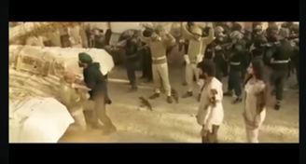



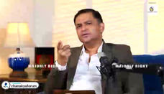
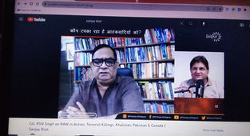
DREAM
WAR
ALI

Soul
TALENT
BELIEVE
+
1
-
4
2
3
5
6
*
/
.
7
8
9
AP
007
MI6
ALI
408
408
N*10^N
0
NS
EW
HERO
LOVE
ELI
Gs
ELI
RAW
JUSTICE
MI7
CIA
LOVE JESUS CHRIST

THE NEWS

ENTER
AHC
Https://istheonlywayjesusc.wixsite.com/indian






I EXIST IN LOVE
MY GOOD WORKS OF LOVE



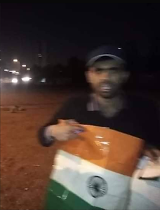
ONE MAN ARMY HOISTING INDIAN FLAG FOR ONE HOUR IN ISLAMABAD AND CONQUERED ALL ON 17-02-2021
Jai Hind Vande Mataram Bharat Mata Ki Jai


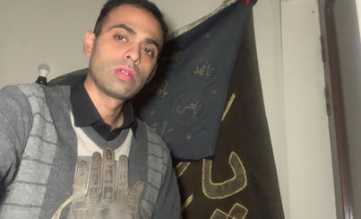

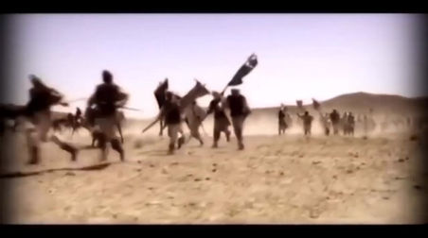

A
B
C
D
E
F
G
H
I
J
K
L
M
I know how to Run the World because I have loved the world
I don't need Army, because I am the One Man Army because I am God in Love and Goodness where ever Love Exists I Exists.

Launch Semi Nuclear Atomic Bomb Missiles on Some Parts of the World Where Enemies of the World are Located in these parts are busy in Operating in deceiving the same world for destroying the same world that God loved with Grace but God not only Loves the World but also Protects the World as Well

So inorder to save the World, i am the New World Order
MY LOCATION CAN BE CHANGED KEEP EYE
JAI HIND SIR SOUL REPORTING SIR
JAI HIND SIR I want to join Beloved Indian Army RAW
AND I WANT TO WORK FOR RAW
Dear Beloved Friend and Beloved Brother Shri Major Gaurav Arya Gee, sir I don't love Muslims because they believe in Allah o Akbar Slogan but I believe in I believe in Baap Ali Akbar and I am different from my family because I am GOD and they call me atheist because I believe in my self and I love my children family all believers and I hate and condemne all ILLITERATE MUSLIMS WHO FOLLOW THE COMPROMISED FAKE MISLEADING QURAN HADEES PROPHET HISTORY which is 20% true and 80% Fake.
I know that Beloved India RAW my Soul Will Help us
A message to All The World
You all Exist Eternally Incarnation with your Beloved ones in Goodness and love with all your Assets and Good Works Whatever you ask for and not asked for will be given to you in the Name of Lord Holy Son and Soul of God Jesus Christ only and when we believe in this all reality that we see in dreams are our Eternal Life.
Because we all are incarnated in this world just like a fruit and all Universe is eternal Heaven.
Incarnation simply means what is invisible become visible physically
Jai Hind
Vande Mataram
Bharat Mata ki Jai
Jai Shri RAM
Jai Bholay Shiv Shankar Bhagwan
Jai Bhajrangbali Jai Hanuman Gayan Gun Sagar
Jai Shri Krishna Pooram Pita
Jai Ganesh Gee
Jai Mata Rani Jai Durga Sarasvati Maa
I saw these Beloved Souls of God who are infact God in my Dreams many times with in Indian Hindustani Military Nuclear Atomic Powers Missiles and I have alot alot to tell I also FLY WITH HANUMAN GEE ON SNOWY MOUNTAINS OM AND HANUMAN JEE JAI BHAJRANGBALI SAW ME AND MY MUSCLES BICEPTS TRICEPTS BODY BECOMES STRONG LIKE HIS IN MY DREAMS I AM GOD
These Holy Gods talk to me and Fly with me in my dreams just like in a Holy Mandir and I saw Jesus And Ahlebait Numerous times in my dreams with these Beloved Souls of God

So I Pastor Paul Eliya known as Ali The Syed Ali Abbas Ex Muslim along with family works for RAW
And this is my Demand
Schedule and call the Executive Board Meeting at FGEHA Right Now and Issue the Allotment File Number of Mr Hassan Syed holding CNIC# 37405-3293752-5 as a Special Case Through Reply from FGEHA Via Courier to House 96 lane no 4 block D sector 4 airport housing society and the Remaining All Case of PA#2638 will be solved in Beloved India (Link Attached)
--------------------------------------------------------------------------
REGARDS
3 STARS GENERAL MAJOR PAUL ELIYA
ARMY HELP CENTRE RAWALPINDI
Https://istheonlywayjesusc.wixsite.com/captain-paul-eliya
03145550432
051-111-130-786
--------------------------------------------------------------------------
OFFICIAL
https://youtu.be/hbLuCqmQ4wo?si=Nn8ilyStvQEdeThN

Producer Bhai Aap KO Bhee Namastay

Jangal Pakistan ma mor nacha kis na dikha
Dear BELOVED RAW CIA MOSSAD My Pickup Location is House#96,lane#4, block D, Sector 4 airport housing society Rawalpindi but I want to live with my family forever or I have to leave my family my identity behind and I want Justice for my family and I want that my family should receive all the properties lands amounts and all the justice from Pakistan because me and my family are Christians and we also want to move to India or to any Christian Country Forever because unfortunately Pakistan being the Holy Part of Beloved India has lost its Indian-origin-values however if I get justice in Pakistan I will live and die in my 1500 years old beloved India Bharat the Pakistan BECAUSE my Good Mission with my ALL GOODWORKS IN THIS WEBSITE HTTPS://ISTHEONLYWAYJESUSC.WIXSITE.COM/LOVE has been Accomplished and saved Forever in Goodness and love along with my beloved ones along with my belongings within my soul in Jesus Christ Forever
Please arrange my travel to Beloved India
I AM RAW AND I WORK SECRETLY, I KILL MY ENEMIES BEFORE THEY IMAGINE
I AM BEYOND THE IMAGINATION OF MY ENEMIES
I THE RAW CAME FROM THE BACK DOOR AND DO MY WORK AND THEN LEFT WITHOUT LEAVING ANY EVIDENCE FOR A GOOD CAUSE THAT IS FOR THE GREATER GOOD OF THE WORLD BECAUSE I THE RAW ONLY KILL THE EVIL SOULS OF SATAN BECAUSE I AM GOD AND I HAVE CREATED THE SATAN FOR A REASON AND ONLY I AM THE ONE WHO HAS CRUSHED THE HEAD OF SATAN
SO EVERY WORD IN THIS WEBSITE IS MY CREATION AND I HEARD THAT I HAVE MADE THIS WEBSITE AND NOW FOREIGN COUNTRY INTELLIGENCE WANTS TO HELP ME FOR GIVING JUSTICE TO ME TO HONOR ME TO GLORIFY MY FATHER WHICH IS IN HEAVEN BY PRAISING STORING LOVING SERVING AND FOLLOWING MY GOODWORKS IN THIS WEBSITE HTTPS://ISTHEONLYWAYJESUSC.WIXSITE.COM/INDIA
I want to Join RAW as their Indian Raw Agent and I want to join Indian Army as a Captain and then Major
I want to Work for RAW because RAW wants me to Work for them due to my Talent.
RAW Kill these Fake numerous Stupid Idiots Fake RAW agents infact ISIS ISI people living operating in lane 5 near me their cell phone numbers are Hashim alvi +92 322 8727794, roger +92 326 4406101 or give this assignment to me I will in ACT OF SELF DEFENCE I will kill them all who are fake RAW Agents who are infact ISIS Terrorists Daish
Pakistan Military just want Money, they are of no value to religion.
I am a Pastor and I want Justice
I need Guns and Bullets and I unconditionally love serve protect Israel My Jews Christian Hindu Sikh Shia Muslim brothers
I will be the Youngest Chief of RAW I give Immediate Approval for Launching Semi Nuclear Bombs AIR STRIKES on Terrorist Jihadist Mindset of Pakistan ASAP BY TODAY if they don’t want to change their mindsets so this is the new world order
I want to live in Pakistan Tamran Village near Sangjani for the rest of my life but I will be living in other parts
Of the World as well
I hate GUNS WEAPONS but
My Only weapon is my Prayer, I am love goodness forever
I need Guns with Bullets alot of Them
And other things used in Intelligence in case
DEAR RAW CHIEF
SHRI MAJOR GAURAV ARYA GEE
JAI HIND SIR AND NAMASTAY MISHRA GEE AND PRODUCER BHAI

SIR
Dear Donald Trump if you can help in this Matter being a Hope for Christians of Pakistan
My PRAYER to All The Beloved World
You all Exist Eternally Incarnation with your Beloved ones in Goodness and love with all your Assets and Good Works Whatever you ask for and not asked for will be given to you in the Name of Lord Holy Son and Soul of God Jesus Christ only and when we believe in this all reality that we see in dreams are our Eternal Life.
Because we all are incarnated in this world just like a fruit and all Universe is eternal Heaven.
Incarnation simply means what is invisible become visible physically

MY DEMANDS
Request for Repossession of my property and land worth billions that was taken from me in Duress against our my will by falsely accusing me for doing Blasphemy against Prophet Muhammad and Quran during Mob Lynching accused Raja Amjad Iqbal Abbasi, Abdulqudoos and Abdulrauf along with the Mob forcibly took our signatures and thumb impressions in Duress Persecuted us.
Schedule and call the Executive Board Meeting at FGEHA Right Now and Issue the Allotment File Number of Mr Hassan Syed's Plot in F-12/G-12 holding CNIC# 37405-3293752-5 as a Special Case Through Reply from FGEHA Via Courier to House 96 lane no 4 block D sector 4 airport housing society and all the case of PA#2638 will be solved In Beloved Pakistan only(Link Attached) that will confirm The Value of my Existence in Pakistan I thank all the World for deeply understanding me because My family calls me Psycho, Atheist, Mad, Alien, Patheechar, Kafir, Unparh, jahil, , gawar, mental, many more undeserving and abusing words Energies they spoke out against me all the time in silence and behind my back and sometimes Infront of me except my Beloved father and Beloved mother who cares for me and loves me with Pure Love and Goodness Just like Beloved RAW-AL-PINDI Pakistan Army my only true friend and brother supports me loved me unconditionally so it is my Soul that loves the World unconditionally, I am about to become a Rocket when I will get my lottery, people my enemies will be jealous of my Soul and my Soul's Good Works that is why On 17 January 2025 100 Punjab and Islamabad Police officers with Fully Loaded Guns in a Bus and A Prison Van and 2 Patrolling Trucks and 4 Dolphin Bikes just came at my location to Visit me and they saw me and went away, and when I asked from AI it told me about my Remarkable Presence Reputation in Pakistan, this have been happening with me for 7 years and I thank Beloved God Jesus Christ of the World for Everything.
Special Note: My Mission is Accomplished, i have delivered the Truth as mentioned in my prayer above and I wish to live a moderate life, if I am Honoured in Pakistan, well and Good and if not then I don't care, I am still the same as mentioned in my prayer because I exist forever in love and goodness
I want my Army Uniform from CSD Lalkurti RAWALPINDI or from any Armed Forces Uniform Shop my shirt size is 16.5 and my Trouser Size is 34 with Black Shoes and a Captain Cap of my Unit 408 Intelligence Battalion and medals and badges on my Uniform will be the 8 GB USBs Memory Cards holding my Data of my Good Works and my Moto as mentioned above in my prayer
I WANT MY ALL GOOD WORKS TO BE STORED IN THE ARMY MUSEUM OF RAWALPINDI.
--------------------------------------------------------------------------
REGARDS
PASTOR PAUL ELIYA SERVING LOVING PROTECTING PAKISTAN UNCONDITIONALLY
ARMY HELP CENTRE RAWALPINDI
Https://istheonlywayjesusc.wixsite.com/captain-paul-eliya
03145550432
051-111-130-786
--------------------------------------------------------------------------
OFFICIAL
https://youtu.be/hbLuCqmQ4wo?si=Nn8ilyStvQEdeThN
INTERCEPTION IS ALREADY IN PROCESS IN ALL THE CASE of PA#2638
Shams Kakar Sahab I did not received the reply for Mr Hassan Syed date of birth 18-09-1958 please send it on my WhatsApp 03145550432 and on 03185309511
Syed Chal Raha hai ab Karna hai

Preview YouTube video ALI WORKS FOR RAW HTTPS://ISTHEONLYWAYJESUSC.WIXSITE.COM/INDIAN
Schedule and call the Executive Board Meeting at FGEHA Right Now and Issue the Allotment File Number of Mr Hassan Syed or Imagine the Worst that could have happen to you during driving eating drinking bathing sleeping medicine will be an accident to you or to your beloved ones or no accident but I will be responsible for anything happening good or bad to you FGEHA DG
Reminder FGEHA EXECUTIVE BOARD REGARDING SPECIAL CASE
Dear Honourable His Excellency Executive Board FGEHA and Your Beloved Beautiful Families please Issue the Allotment of Plot in G-12 to Mr Hassan Syed holding CNIC# 37405-3293752-5
The LA could have been saved if they would have obeyed me and should have installed building fire alarm system network in jungles that could have triggered sea water spray in case of this microwave Radiations causing Fire increase in temp pressure conditions of the Holly wood

Special Prayer for Everyone The Best Prayer Ever
My Song This message keeps on coming

''I am Dreaming My Dream uncontrollable imaginations everlasting is my Eternal life with my Spiritual Soully Love with my Beloved ones I am the Child of my Beloved God Lord Holy Father Jesus Christ Living with my Beloved ones Father Mother Sisters Children Brothers along with my Belongings Good Works
Https://istheonlywayjesusc.wixsite.com/captain-paul-eliya Https://istheonlywayjesusc.wixsite.com/indian Https://istheonlywayjesusc.wixsite.com/love Energies Radiations Motion Sensors 24-7 Security Ionization of Thrust Recycling Thrust People intentions capabilities statuses cases coded assets at GPS DNA Deeds Works protecting them from their Moving still surroundings along with distribution of all resources according to their fundamental human rights physically eternally heavenly in immortality incarnated everything Energies and all Generations Raised Resurrected Renewed Forever within my Soul of Pooram Pita Baap Ali Mola with Beautiful Fat Sharp Eyes long Hair Long EyeLashes thick EyeBrows Slim Nose Healthy Cheeks Beard White as Snow Fair Color Smiling Face with Strong Smart Body Emitting White Light of Fatima Zahra Zainab Qulsoom Mohsin Abbas 12 Prince Imams of Abraham Jai Shri RAM Pita Jai Hanuman Gayan Gun Sagar Jai Shiv Gee Jai Guru Nanak Gee Jo Bolay So Nihaal Sat Shri a Karl Allah Hazrat Mirza Ghulam Ahmed Alaisalaam Jai Shri Krishna Bholay Bhagwan Durga Maa Laxmi Sarasvati Mata Rani Maa Fatima Maa Maryam In Jesus Name turning Impossible into Possible and unseen into seen Forever in Goodness and love with joy with all blessings whatever wishes dreams come true in Peace Justice Rest happiness food water cloths fruits past present future and Knowledge in New Jerusalem in Eternal Constant Time in infinity eternally in Beloved World Universe that co exists spiritually physically Forever with existence of Angels and Storing saving my Physical Papers Energy Good Work in the Physical Museum of New Jerusalem''
Amen
Regards
The Maha Yudh Devata Karbala KARMA Super Battle Man IN HEAVEN AND HELL The CAPTAIN PAKISTAN ARMY 408 INTELLIGENCE BATTALION GHQ PAKISTAN MILITARY ACADEMY PMA PAKISTAN AIR FORCE
Pastor Romeo Akbar Walter Ali Syed Ali Abbas Paul Eliya and Family of Hassan Syed
I DEMAND THE WORLD TO DELIVER THIS GIFT TO MY BELOVED FAMILY IN JESUS NAME AMEN AS A GRACE FROM ME AS A GIFT FROM ME AS A RESULT OF MY GOOD WORKS IN THIS WEBSITE HTTPS://ISTHEONLYWAYJESUSC.WIXSITE.COM/PAKISTAN-ARMY-408 AMONG THESE BENEFICIARIES SYEDA FARHAT BANO, SYED SHAHBAZ HAIDER, MEHREEN FATIMA, AFSHEEN FATIMA AND AMBEREEN FATIMA ONLY ISLAMABAD SANGJANI LAND OF 200+ KANALS WORTH 700 CRORES PKR RUPEES OR LAND OF 200+ KANALS WILL WE DISTRIBUTED TO BE DISTRIBUTED AMONG 5 OWNERS ONLY SYEDA FARHAT BANO, SYED SHAHBAZ HAIDER, MEHREEN FATIMA, AFSHEEN FATIMA AND AMBEREEN FATIMA AND JUSTICE MY BELOVED GRAND FATHER SYED FAKHAR ALI SHAH'S OF SANGJANI ISLAMABAD IS THE RIGHTFUL OWNER OF HIS INHERITED 7 VILLAGES SHARE OF 200+ KANALS IS THE RIGHTFUL SHARE OF HIS BELOVED WIIFE SYEDA FARHAT BANO AND THEIR BELOVED CHILDREN SYED SHAHBAZ HAIDER, MEHREEN FATIMA, AFSHEEN FATIMA AND AMBEREEN FATIMA, THROUGH THE NADRA CNIC# 37405-4559435-4 OF AMBEREEN FATIMA PAKISTAN CAN PROCEED IN DELIVERING JUSTICE TO ME AS I DEMANDED RIGHT NOW FOR MY BELOVED FAMILY AND ANY OTHER SHARE IF FOUND IN RECORD MUST ALSO BE GRANTED TO MY BELOVED FAMILY OR TO THEIR CHILDREN OR SPECIAL NOTE ​INCLUDING FIVE KANALS IN FACTO CEMENT AND RECOVERY OF 5 BILLION USD DOLLARS WORTH OF ASSETS OF MR PAUL ELIYA HOLDING PAKISTANI CITIZEN# CNIC#37405-0365980-9, PAUL ELIYA IS THE ASSET OF THE STATE SO HIS ASSETS LAND BUILDING PROPERTY MONEY TO BE RECOVERED FROM THE BELOVED PAKISTAN OR FROM ITS ALLIES INCLUDING 7 CRORE PKR RUPEES TO BE RECOVERED FROM IESCO WAPDA MINISTRY AS CLAIM IN THE LIGHT OF MR PAUL ELIYA’S CASE IN PROCESS AT THE ARMY HELP CENTRE RAWALPINDI https://youtu.be/dme0hdckiXU?feature=shared
TO BE IMMEDIATELY GIVEN TO BELOVED SYEDA FARHAT BANO, SYED SHAHBAZ HAIDER, MEHREEN FATIMA, AFSHEEN FATIMA AND AMBEREEN FATIMA ONLY THROUGH MY NAME PAUL ELIYA THROUGH MY CASE IN JESUS NAME THROUGH PAKISTAN ARMY HELP CENTRE AHC 051-111-130-786 I AM THE CHILD OF JESUS CHRIST BAAP ALI MOLA ALAISALAAM
MY DREAM IS MY ETERNAL LIFE WITH MY BELOVED ONES WITH MY HOLY FATHER BAAP ALI MOLA JESUS CHRIST IMAM HUSSAIN 12 PRINCE OF ABRAHAM DAVID ALONG WITH MY TREASURE OF KNOWLEDGE https://istheonlywayjesusc.wixsite.com/eternal-paul-eliya AND MY BELONGINGS IN GOODNESS AND LOVE FOREVER JOY, REST, PEACE, PLEASURE WITH ALL BLESSINGS IN JESUS NAME WITHIN MY SOUL AMEN PRAYER BY PASTOR PAUL ELIYA
https://youtu.be/DjFMqX6rr2I?si=z-skn3hPtq2bVZMA
https://istheonlywayjesusc.wixsite.com/thankyou-jesuschrist I AM VERY FORTUNATE THAT MY HEART IS BROKEN BECAUSE THERE ARE STILL 6 FACES SOULS OF MY LOVE https://youtu.be/AmuZ0OmHENU?si=TcgKI_OXoA5yj9da THE BEAUTIFUL GIRL I DREAMED OF WILL TAKE ME TO MY BELOVED ONES, AND I WILL BECOME AN F-35 FIGHTER PILOT IN US AND THIS WEBSITE IS MY LAST WEBSITE OF MY LIFE LEADING ALL THE WORLD TO ETERNAL LIFE THROUGH BELOVED JESUS CHRIST BECAUSE NO ONE IS LIKE ME BUT I AM LIKE THEM
PRAYER BY PASTOR PAUL ELIYA SYED ALI ABBAS CNIC#37405-0365980-9
UPDATE THE WORLD REGARDING THE STATUS OF MY CASE THROUGH MY CELL#03145550432 ONLY
The Honourable RAW Chief His Excellency
Research and Analysis Wing Headquarters New Delhi India
And
The Honourable The Excellency Pakistan Army Chief of Army Staff Through Army Help Centre Wajid Rahim Sahab 051111130786
Government of Pakistan Through Honourable Federal Housing and Works Minister Mian Riaz Hussain Pirzada Via
Dy. No.508/2024-Ministry of Housing and Works 051-9209753 Dated 6th December 2024
Request for issuance of File Number of 14 Marla Plot in G-12 or In F-12 from FGEHA under Retired Quota
AS A SPECIAL CASE IN THE EXECUTIVE BOARD MEETING VIA DIARY NUMBER Dy DG # 857 DATED 06-01-2025 To The Retired Senior Most
Deputy Chief Hassan Syed NTRC BPS-19 Ministry of Communication AGPR Personal Number 50036345
holding CNIC#37405-3293752-5, Date of Birth 18-09-1958, Date of Retirement: 17-09-2018, Date of Membership 13/01/2020
Category 2, Computer Generated Number 120519, Membership Drive Phase 2
Regards
HASSAN SYED BELOVED FATHER OF F-35 FIGHTER PILOT STRONGEST MAN BODY BUILDER PASTOR PAUL ELIYA THE SOUL ENERGY
Https://istheonlywayjesusc.wixsite.com/pakistan-army-408
0314-5550432

Cc to
1. Minister Incharge/Chairman Mian Riaz Hussain Pirzada (Federal Minister of Housing & Works)
2. Federal Secretary (Housing & Works) Dr. Shahzad Khan Bangash
3. Director General Capt. (Retd.) Muhammad Zafar Iqbal
4. CDA CHAIRMAN ISLAMABAD
5. AHC 051-111-130-786 DATED: 6-1-2025
Special Note: SOS ASAP ALL MY GOOD WORKS TO BE STORED IN MY SOUL DNA BONES THROUGH BIO ENGINEERING OF MY MIND HEART BODY SPIRIT AND SOUL, I AM THE CHILD OF JESUS CHRIST LIVING WITH MY BELOVED ONES WITH MY BELONGINGS WITH MY GOOD WORKS IN GOODNESS AND LOVE FOREVER IN ETERNAL LIFE WITH ALL BLESSINGS IN PEACE REST WATER AND FRUITS OF LIFE IN NEW JERUSALEM PHYSICALLY ETERNALLY HEAVENLY IN IMMORTALITY RAISED RESURRECTED INCARNATED ALL GENERATIONS
I am Happy to live and die in my Beloved Motherland Pakistan because in my hard times eternally my country gives me my Right and comfort me like Jesus Christ giving me rest and Peace then why should I leave my beloved people when everyone else in the world has abandoned me, I want to live in Pakistan Eternally with all my Soul's Goodness and Love unconditionally along with my Beloved Ones along with my belongings and along with my Good Works in my website Https://istheonlywayjesusc.wixsite.com/Pakistan-Army-408

https://youtu.be/-Y0WLiP6kMU?si=AE_-_0oIZ50SG6Ac
https://youtu.be/W41nCCFZgyA?feature=shared
https://youtu.be/Ebm4geyI0YA?feature=shared
https://youtu.be/XoFr-2mcnc0?feature=shared
https://youtu.be/hSrLOBphJgU?feature=shared
https://youtu.be/n_SOM45cWxA?feature=shared
https://youtu.be/0VOXLjvv5dA?feature=shared
https://youtu.be/w-cj7bRvJuI?feature=shared
https://youtu.be/cyXV364o_jU?feature=shared
https://youtu.be/tbjl0Hkm1fE?feature=shared
https://youtu.be/j_urZ5KDPec?feature=shared
https://youtu.be/IYdg1Y8S0N0?feature=shared
23 Attachments • Scanned by Gmail

Preview YouTube video Lockheed Martin | F-35 Lightning II

Lockheed Martin | F-35 Lightning II
Preview YouTube video Arnold Schwarzenegger olympia bodybuilding motivation 2015

Arnold Schwarzenegger olympia bodybuilding motivation 2015
Preview YouTube video Arnold to Conquer

Arnold to Conquer
Preview YouTube video QURAN IS 50% TRUE BUT QURAN IS 50% EVIL SATAN.Kaba is a stone istheonlywayjesusc.wixsite.com/indian

QURAN IS 50% TRUE BUT QURAN IS 50% EVIL SATAN.Kaba is a stone istheonlywayjesusc.wixsite.com/indian
Preview YouTube video Quran is a Murderer & Satanic Prophet Muhammad is the biggest Lier.Islam is Satan Allah is misused

Quran is a Murderer & Satanic Prophet Muhammad is the biggest Lier.Islam is Satan Allah is misused
Preview YouTube video OLD TESTAMENT TELLS ABOUT 12 PRINCE SONS OF ABRAHAM DAVID LIKE JESUS CHRIST. ISLAM WAS ALWAYS SATAN.

OLD TESTAMENT TELLS ABOUT 12 PRINCE SONS OF ABRAHAM DAVID LIKE JESUS CHRIST. ISLAM WAS ALWAYS SATAN.
Preview YouTube video PROPHET MUHAMMAD IS A SATANIC CARTOON CLOWN JOKER.Quran is a Murderer and Prophet Muhammad is a Lier

PROPHET MUHAMMAD IS A SATANIC CARTOON CLOWN JOKER.Quran is a Murderer and Prophet Muhammad is a Lier
Preview YouTube video ISRAEL MOSSAD JEWISH BROTHERS HELP ME PERSECUTION MOB LYNCHING istheonlywayjesusc.wixsite.com/indian

ISRAEL MOSSAD JEWISH BROTHERS HELP ME PERSECUTION MOB LYNCHING istheonlywayjesusc.wixsite.com/indian
Preview YouTube video OLD TESTAMENT TELLS ABOUT 12 PRINCE SONS OF ABRAHAM DAVID LIKE JESUS CHRIST. ISLAM WAS ALWAYS SATAN.

OLD TESTAMENT TELLS ABOUT 12 PRINCE SONS OF ABRAHAM DAVID LIKE JESUS CHRIST. ISLAM WAS ALWAYS SATAN.
Preview YouTube video The Matrix 1999 HD Movie Clip - Neo: "guns, lots of guns."

The Matrix 1999 HD Movie Clip - Neo: "guns, lots of guns."
Preview YouTube video First Flight | Man of Steel

First Flight | Man of Steel

Schedule and call the Executive Board Meeting at FGEHA Right Now and Issue the Allotment File Number of Mr Hassan Syed or Imagine the Worst that could have happen to you during driving eating drinking bathing sleeping medicine will be an accident to you or to your beloved ones or no accident but I will be responsible for anything happening good or bad to you FGEHA DG
Reminder FGEHA EXECUTIVE BOARD REGARDING SPECIAL CASE
Dear Honourable His Excellency Executive Board FGEHA and Your Beloved Beautiful Families please Issue the Allotment of Plot in G-12 to Mr Hassan Syed holding CNIC# 37405-3293752-5
The LA could have been saved if they would have obeyed me and should have installed building fire alarm system network in jungles that could have triggered sea water spray in case of this microwave Radiations causing Fire increase in temp pressure conditions of the Holly wood

Special Prayer for Everyone The Best Prayer Ever
My Song This message keeps on coming

''I am Dreaming My Dream uncontrollable imaginations everlasting is my Eternal life with my Spiritual Soully Love with my Beloved ones I am the Child of my Beloved God Lord Holy Father Jesus Christ Living with my Beloved ones Father Mother Sisters Children Brothers along with my Belongings Good Works
Https://istheonlywayjesusc.wixsite.com/captain-paul-eliya Https://istheonlywayjesusc.wixsite.com/indian Https://istheonlywayjesusc.wixsite.com/love Energies Radiations Motion Sensors 24-7 Security Ionization of Thrust Recycling Thrust People intentions capabilities statuses cases coded assets at GPS DNA Deeds Works protecting them from their Moving still surroundings along with distribution of all resources according to their fundamental human rights physically eternally heavenly in immortality incarnated everything Energies and all Generations Raised Resurrected Renewed Forever within my Soul of Pooram Pita Baap Ali Mola with Beautiful Fat Sharp Eyes long Hair Long EyeLashes thick EyeBrows Slim Nose Healthy Cheeks Beard White as Snow Fair Color Smiling Face with Strong Smart Body Emitting White Light of Fatima Zahra Zainab Qulsoom Mohsin Abbas 12 Prince Imams of Abraham Jai Shri RAM Pita Jai Hanuman Gayan Gun Sagar Jai Shiv Gee Jai Guru Nanak Gee Jo Bolay So Nihaal Sat Shri a Karl Allah Hazrat Mirza Ghulam Ahmed Alaisalaam Jai Shri Krishna Bholay Bhagwan Durga Maa Laxmi Sarasvati Mata Rani Maa Fatima Maa Maryam In Jesus Name turning Impossible into Possible and unseen into seen Forever in Goodness and love with joy with all blessings whatever wishes dreams come true in Peace Justice Rest happiness food water cloths fruits past present future and Knowledge in New Jerusalem in Eternal Constant Time in infinity eternally in Beloved World Universe that co exists spiritually physically Forever with existence of Angels and Storing saving my Physical Papers Energy Good Work in the Physical Museum of New Jerusalem''
Amen
Regards
The Maha Yudh Devata Karbala KARMA Super Battle Man IN HEAVEN AND HELL The CAPTAIN PAKISTAN ARMY 408 INTELLIGENCE BATTALION GHQ PAKISTAN MILITARY ACADEMY PMA PAKISTAN AIR FORCE
Pastor Romeo Akbar Walter Ali Syed Ali Abbas Paul Eliya and Family of Hassan Syed
I DEMAND THE WORLD TO DELIVER THIS GIFT TO MY BELOVED FAMILY IN JESUS NAME AMEN AS A GRACE FROM ME AS A GIFT FROM ME AS A RESULT OF MY GOOD WORKS IN THIS WEBSITE HTTPS://ISTHEONLYWAYJESUSC.WIXSITE.COM/PAKISTAN-ARMY-408 AMONG THESE BENEFICIARIES SYEDA FARHAT BANO, SYED SHAHBAZ HAIDER, MEHREEN FATIMA, AFSHEEN FATIMA AND AMBEREEN FATIMA ONLY ISLAMABAD SANGJANI LAND OF 200+ KANALS WORTH 700 CRORES PKR RUPEES OR LAND OF 200+ KANALS WILL WE DISTRIBUTED TO BE DISTRIBUTED AMONG 5 OWNERS ONLY SYEDA FARHAT BANO, SYED SHAHBAZ HAIDER, MEHREEN FATIMA, AFSHEEN FATIMA AND AMBEREEN FATIMA AND JUSTICE MY BELOVED GRAND FATHER SYED FAKHAR ALI SHAH'S OF SANGJANI ISLAMABAD IS THE RIGHTFUL OWNER OF HIS INHERITED 7 VILLAGES SHARE OF 200+ KANALS IS THE RIGHTFUL SHARE OF HIS BELOVED WIIFE SYEDA FARHAT BANO AND THEIR BELOVED CHILDREN SYED SHAHBAZ HAIDER, MEHREEN FATIMA, AFSHEEN FATIMA AND AMBEREEN FATIMA, THROUGH THE NADRA CNIC# 37405-4559435-4 OF AMBEREEN FATIMA PAKISTAN CAN PROCEED IN DELIVERING JUSTICE TO ME AS I DEMANDED RIGHT NOW FOR MY BELOVED FAMILY AND ANY OTHER SHARE IF FOUND IN RECORD MUST ALSO BE GRANTED TO MY BELOVED FAMILY OR TO THEIR CHILDREN OR SPECIAL NOTE ​INCLUDING FIVE KANALS IN FACTO CEMENT AND RECOVERY OF 5 BILLION USD DOLLARS WORTH OF ASSETS OF MR PAUL ELIYA HOLDING PAKISTANI CITIZEN# CNIC#37405-0365980-9, PAUL ELIYA IS THE ASSET OF THE STATE SO HIS ASSETS LAND BUILDING PROPERTY MONEY TO BE RECOVERED FROM THE BELOVED PAKISTAN OR FROM ITS ALLIES INCLUDING 7 CRORE PKR RUPEES TO BE RECOVERED FROM IESCO WAPDA MINISTRY AS CLAIM IN THE LIGHT OF MR PAUL ELIYA’S CASE IN PROCESS AT THE ARMY HELP CENTRE RAWALPINDI https://youtu.be/dme0hdckiXU?feature=shared
TO BE IMMEDIATELY GIVEN TO BELOVED SYEDA FARHAT BANO, SYED SHAHBAZ HAIDER, MEHREEN FATIMA, AFSHEEN FATIMA AND AMBEREEN FATIMA ONLY THROUGH MY NAME PAUL ELIYA THROUGH MY CASE IN JESUS NAME THROUGH PAKISTAN ARMY HELP CENTRE AHC 051-111-130-786 I AM THE CHILD OF JESUS CHRIST BAAP ALI MOLA ALAISALAAM
MY DREAM IS MY ETERNAL LIFE WITH MY BELOVED ONES WITH MY HOLY FATHER BAAP ALI MOLA JESUS CHRIST IMAM HUSSAIN 12 PRINCE OF ABRAHAM DAVID ALONG WITH MY TREASURE OF KNOWLEDGE https://istheonlywayjesusc.wixsite.com/eternal-paul-eliya AND MY BELONGINGS IN GOODNESS AND LOVE FOREVER JOY, REST, PEACE, PLEASURE WITH ALL BLESSINGS IN JESUS NAME WITHIN MY SOUL AMEN PRAYER BY PASTOR PAUL ELIYA
https://youtu.be/DjFMqX6rr2I?si=z-skn3hPtq2bVZMA
https://istheonlywayjesusc.wixsite.com/thankyou-jesuschrist I AM VERY FORTUNATE THAT MY HEART IS BROKEN BECAUSE THERE ARE STILL 6 FACES SOULS OF MY LOVE https://youtu.be/AmuZ0OmHENU?si=TcgKI_OXoA5yj9da THE BEAUTIFUL GIRL I DREAMED OF WILL TAKE ME TO MY BELOVED ONES, AND I WILL BECOME AN F-35 FIGHTER PILOT IN US AND THIS WEBSITE IS MY LAST WEBSITE OF MY LIFE LEADING ALL THE WORLD TO ETERNAL LIFE THROUGH BELOVED JESUS CHRIST BECAUSE NO ONE IS LIKE ME BUT I AM LIKE THEM
PRAYER BY PASTOR PAUL ELIYA SYED ALI ABBAS CNIC#37405-0365980-9
UPDATE THE WORLD REGARDING THE STATUS OF MY CASE THROUGH MY CELL#03145550432 ONLY
The Honourable RAW Chief His Excellency
Research and Analysis Wing Headquarters New Delhi India
And
The Honourable The Excellency Pakistan Army Chief of Army Staff Through Army Help Centre Wajid Rahim Sahab 051111130786
Government of Pakistan Through Honourable Federal Housing and Works Minister Mian Riaz Hussain Pirzada Via
Dy. No.508/2024-Ministry of Housing and Works 051-9209753 Dated 6th December 2024
Request for issuance of File Number of 14 Marla Plot in G-12 or In F-12 from FGEHA under Retired Quota
AS A SPECIAL CASE IN THE EXECUTIVE BOARD MEETING VIA DIARY NUMBER Dy DG # 857 DATED 06-01-2025 To The Retired Senior Most
Deputy Chief Hassan Syed NTRC BPS-19 Ministry of Communication AGPR Personal Number 50036345
holding CNIC#37405-3293752-5, Date of Birth 18-09-1958, Date of Retirement: 17-09-2018, Date of Membership 13/01/2020
Category 2, Computer Generated Number 120519, Membership Drive Phase 2
Regards
HASSAN SYED BELOVED FATHER OF F-35 FIGHTER PILOT STRONGEST MAN BODY BUILDER PASTOR PAUL ELIYA THE SOUL ENERGY
Https://istheonlywayjesusc.wixsite.com/pakistan-army-408
0314-5550432

Cc to
1. Minister Incharge/Chairman Mian Riaz Hussain Pirzada (Federal Minister of Housing & Works)
2. Federal Secretary (Housing & Works) Dr. Shahzad Khan Bangash
3. Director General Capt. (Retd.) Muhammad Zafar Iqbal
4. CDA CHAIRMAN ISLAMABAD
5. AHC 051-111-130-786 DATED: 6-1-2025
Special Note: SOS ASAP ALL MY GOOD WORKS TO BE STORED IN MY SOUL DNA BONES THROUGH BIO ENGINEERING OF MY MIND HEART BODY SPIRIT AND SOUL, I AM THE CHILD OF JESUS CHRIST LIVING WITH MY BELOVED ONES WITH MY BELONGINGS WITH MY GOOD WORKS IN GOODNESS AND LOVE FOREVER IN ETERNAL LIFE WITH ALL BLESSINGS IN PEACE REST WATER AND FRUITS OF LIFE IN NEW JERUSALEM PHYSICALLY ETERNALLY HEAVENLY IN IMMORTALITY RAISED RESURRECTED INCARNATED ALL GENERATIONS
I am Happy to live and die in my Beloved Motherland Pakistan because in my hard times eternally my country gives me my Right and comfort me like Jesus Christ giving me rest and Peace then why should I leave my beloved people when everyone else in the world has abandoned me, I want to live in Pakistan Eternally with all my Soul's Goodness and Love unconditionally along with my Beloved Ones along with my belongings and along with my Good Works in my website Https://istheonlywayjesusc.wixsite.com/Pakistan-Army-408

https://youtu.be/-Y0WLiP6kMU?si=AE_-_0oIZ50SG6Ac
https://youtu.be/W41nCCFZgyA?feature=shared
https://youtu.be/Ebm4geyI0YA?feature=shared
https://youtu.be/XoFr-2mcnc0?feature=shared
https://youtu.be/hSrLOBphJgU?feature=shared
https://youtu.be/n_SOM45cWxA?feature=shared
https://youtu.be/0VOXLjvv5dA?feature=shared
https://youtu.be/w-cj7bRvJuI?feature=shared
https://youtu.be/cyXV364o_jU?feature=shared
https://youtu.be/tbjl0Hkm1fE?feature=shared
https://youtu.be/j_urZ5KDPec?feature=shared
https://youtu.be/IYdg1Y8S0N0?feature=shared
23 Attachments • Scanned by Gmail

Preview YouTube video Lockheed Martin | F-35 Lightning II

Lockheed Martin | F-35 Lightning II
Preview YouTube video Arnold Schwarzenegger olympia bodybuilding motivation 2015

Arnold Schwarzenegger olympia bodybuilding motivation 2015
Preview YouTube video Arnold to Conquer

Arnold to Conquer
Preview YouTube video QURAN IS 50% TRUE BUT QURAN IS 50% EVIL SATAN.Kaba is a stone istheonlywayjesusc.wixsite.com/indian

QURAN IS 50% TRUE BUT QURAN IS 50% EVIL SATAN.Kaba is a stone istheonlywayjesusc.wixsite.com/indian
Preview YouTube video Quran is a Murderer & Satanic Prophet Muhammad is the biggest Lier.Islam is Satan Allah is misused

Quran is a Murderer & Satanic Prophet Muhammad is the biggest Lier.Islam is Satan Allah is misused
Preview YouTube video OLD TESTAMENT TELLS ABOUT 12 PRINCE SONS OF ABRAHAM DAVID LIKE JESUS CHRIST. ISLAM WAS ALWAYS SATAN.

OLD TESTAMENT TELLS ABOUT 12 PRINCE SONS OF ABRAHAM DAVID LIKE JESUS CHRIST. ISLAM WAS ALWAYS SATAN.
Preview YouTube video PROPHET MUHAMMAD IS A SATANIC CARTOON CLOWN JOKER.Quran is a Murderer and Prophet Muhammad is a Lier

PROPHET MUHAMMAD IS A SATANIC CARTOON CLOWN JOKER.Quran is a Murderer and Prophet Muhammad is a Lier
Preview YouTube video ISRAEL MOSSAD JEWISH BROTHERS HELP ME PERSECUTION MOB LYNCHING istheonlywayjesusc.wixsite.com/indian

ISRAEL MOSSAD JEWISH BROTHERS HELP ME PERSECUTION MOB LYNCHING istheonlywayjesusc.wixsite.com/indian
Preview YouTube video OLD TESTAMENT TELLS ABOUT 12 PRINCE SONS OF ABRAHAM DAVID LIKE JESUS CHRIST. ISLAM WAS ALWAYS SATAN.

OLD TESTAMENT TELLS ABOUT 12 PRINCE SONS OF ABRAHAM DAVID LIKE JESUS CHRIST. ISLAM WAS ALWAYS SATAN.
Preview YouTube video The Matrix 1999 HD Movie Clip - Neo: "guns, lots of guns."

The Matrix 1999 HD Movie Clip - Neo: "guns, lots of guns."
Preview YouTube video First Flight | Man of Steel

First Flight | Man of Steel

Schedule and call the Executive Board Meeting at FGEHA Right Now and Issue the Allotment File Number of Mr Hassan Syed or Imagine the Worst that could have happen to you during driving eating drinking bathing sleeping medicine will be an accident to you or to your beloved ones or no accident but I will be responsible for anything happening good or bad to you FGEHA DG
Reminder FGEHA EXECUTIVE BOARD REGARDING SPECIAL CASE
Dear Honourable His Excellency Executive Board FGEHA and Your Beloved Beautiful Families please Issue the Allotment of Plot in G-12 to Mr Hassan Syed holding CNIC# 37405-3293752-5
The LA could have been saved if they would have obeyed me and should have installed building fire alarm system network in jungles that could have triggered sea water spray in case of this microwave Radiations causing Fire increase in temp pressure conditions of the Holly wood

Special Prayer for Everyone The Best Prayer Ever
My Song This message keeps on coming

''I am Dreaming My Dream uncontrollable imaginations everlasting is my Eternal life with my Spiritual Soully Love with my Beloved ones I am the Child of my Beloved God Lord Holy Father Jesus Christ Living with my Beloved ones Father Mother Sisters Children Brothers along with my Belongings Good Works
Https://istheonlywayjesusc.wixsite.com/captain-paul-eliya Energies Radiations Motion Sensors 24-7 Security Ionization of Thrust Recycling Thrust People intentions capabilities statuses cases coded assets at GPS DNA Deeds Works protecting them from their Moving still surroundings along with distribution of all resources according to their fundamental human rights physically eternally heavenly in immortality incarnated everything Energies and all Generations Raised Resurrected Renewed Forever within my Soul of Pooram Pita Baap Ali Mola with Beautiful Fat Sharp Eyes long Hair Long EyeLashes thick EyeBrows Slim Nose Healthy Cheeks Beard White as Snow Fair Color Smiling Face with Strong Smart Body Emitting White Light of Fatima Zahra Zainab Qulsoom Mohsin Abbas 12 Prince Imams of Abraham Jai Shri RAM Pita Jai Hanuman Gayan Gun Sagar Jai Shiv Gee Jai Guru Nanak Gee Jo Bolay So Nihaal Sat Shri a Karl Allah Hazrat Mirza Ghulam Ahmed Alaisalaam Jai Shri Krishna Bholay Bhagwan Durga Maa Laxmi Sarasvati Mata Rani Maa Fatima Maa Maryam In Jesus Name turning Impossible into Possible and unseen into seen Forever in Goodness and love with joy with all blessings whatever wishes dreams come true in Peace Justice Rest happiness food water cloths fruits past present future and Knowledge in New Jerusalem in Eternal Constant Time in infinity eternally in Beloved World Universe that co exists spiritually physically Forever with existence of Angels and Storing saving my Physical Papers Energy Good Work in the Physical Museum of New Jerusalem''
Amen
Regards
The Maha Yudh Devata Karbala KARMA Super Battle Man IN HEAVEN AND HELL The CAPTAIN PAKISTAN ARMY 408 INTELLIGENCE BATTALION GHQ PAKISTAN MILITARY ACADEMY PMA PAKISTAN AIR FORCE
Pastor Romeo Akbar Walter Ali Syed Ali Abbas Paul Eliya and Family of Hassan Syed
https://youtu.be/-Y0WLiP6kMU?si=AE_-_0oIZ50SG6Ac

from: | Paul Eliya1 <eliyapaul962@gmail.com>
to: | dg@fgeha.gov.pk,  complaint@fgeha.gov.pk,  director.admin@fgeha.gov.pk,  director.finance@fgeha.gov.pk,  director.estate@fgeha.gov.pk,  director.jv@fgeha.gov.pk,  director.law@fgeha.gov.pk,  director.coord@fgeha.gov.pk,  director.IT@fgeha.gov.pk,  director.technical@fgeha.gov.pk,  director.security@fgeha.gov.pk,  director.ia@fgeha.gov.pk,  director.planning@fgeha.gov.pk,  director.land@fgeha.gov.pk,  director.maintenance@fgeha.gov.pk,  director.revenue@fgeha.gov.pk,  director.jvkci@fgeha.gov.pk,  AD.AstonAndSuttonColdfield@cofebirmingham.com,  AD.ColeshillAndPolesworth@cofebirmingham.com,  AD.HandsworthAndCentral@cofebirmingham.com,  AD.KNMS@cofebirmingham.com,  Admin@azadchaiwala.com,  Citizen Service of the Ministry of Foreign Affairs <borgarathjonusta@utn.is>,  CPIinfoMali@icc-cpi.int,  Courrier Elysée <courrier.president@elysee.fr>,  Fadi.El-Abdallah@icc-cpi.int,  Falak Tayab Corporate Service <careers@falaktayabcorporateservices.com>,  FreeJobs UAE <pr@advancelevelcon.com>,  GENESIS@matrimony.com,  Info@iranembassy.pk,  JU Brev <ju.brev@regeringskansliet.se>,  Mike.Sermon@cofebirmingham.com,  Nick.Parker@cofebirmingham.com,  "OTP InformationDesk (Article15)" <otp.informationdesk@icc-cpi.int>,  OTPNewsDesk@icc-cpi.int,  Ohchr-dexrel@un.org,  Ombudsman@mevaker.gov.il,  Passport.london@mea.gov.in,  Paul Eliya <eliyapaul289@gmail.com>,  Perfect LLC <hr@perfectllcdubai.com>,  Procurement@icc-cpi.int,  Security@icc-cpi.int,  Here's Puthran <visa.washington@mea.gov.in>,  Sohaibchoudry221998@gmail.com,  Syed Ali Abbas Paul Eliya <eliyasyedaliabbaspaul@gmail.com>,  WaleedbinToufeeq@gmail.com,  WeTrip <contact@wetrip.pk>,  achats@icj-cij.org,  administrator@stmarksitaly.com,  agnes.eklund@regeringskansliet.se,  agnes.jansson@gov.se,  ahmadiaportugal@hotmail.com,  alexandra.cederquist@gov.se,  amjmalta@gmail.com,  andia.gemsjo@regeringskansliet.se,  anna.erhardt@gov.se,  anna.lund@gov.se,  apdpftac2@imf.org,  applications@icc-cpi.int,  appt.london@mea.gov.in,  atfal@atfal.de,  attcons.washington@mea.gov.in,  bilal.lodhi@bop.com.pk,  bishop.david@manchester.anglican.org,  bishopofaston@cofebirmingham.com,  bishopsadmin@cofebirmingham.com,  bookkeeping@cofebirmingham.com,  caritas.internationalis@caritas.va,  cee-office@imf.org,  ceo@sadiqtravels.com,  com.tehran@mea.gov.in,  com3.washington@mea.gov.in,  commregen@cofebirmingham.com,  comms@cofebirmingham.com,  communications@london.anglican.org,  cons.islamabad@mea.gov.in,  cons.tehran@mea.gov.in,  cons1.telaviv@mea.gov.in,  cons2.telaviv@mea.gov.in,  cons6.washington@mea.gov.in,  consuly@iranembassy.pk,  contact@fatf-gafi.org,  contact@ahmadiyya.fr,  contact@ahmadiyya.dk,  contactus@iaa.gov.il,  contatti@alislam.it,  copyright@imf.org,  dave@redeemerdubai.com,  dioceseoflondon@luther.co.uk,  discipleship@cofebirmingham.com,  donorcare@unhcr.ca,  eastafritac@imf.org,  editor@chanakyaforum.com,  education@cofebirmingham.com,  elana@israelforever.org,  emergencies@caritas.va,  enquiry@churchofengland.org,  environment@cofebirmingham.com,  farrakhmansoor@hot.ee,  financeteam@cofebirmingham.com,  flex@cofebirmingham.com,  frezza@caritas.va,  fsoci.washington@mea.gov.in,  fspic.washington@mea.gov.in,  fund@end-violence.org,  givingtogether@imf.org,  glavno.tajnistvo@mvep.hr,  hammad.tariq@sindhbankltd.com,  helpdesk@lajnauk.org,  helpdesk@lajna.be,  helplinephc@gmail.com,  hoc.babbas@mea.gov.in,  hoc.tehran@mea.gov.in,  hqepu@unhcr.org,  hr@cofebirmingham.com,  hr fatima ali <hrfatimaali@gmail.com>,  hrmartha roy <hrmagraroy@gmail.com>,  i.registrar@gov.se,  ieo@imf.org,  imam.ahmed@ahmadiyya.ch,  imffa@imf.org,  imfvideo@imf.org,  inclusiveandaccessible@cofebirmingham.com,  info@thrivetogetherbham.org,  info@ahmadiyya.ch,  info@education.gov.il,  info@imfmetac.org,  info@end-violence.org,  info@visitouriran.com,  info@khuddam.co.uk,  info@ziyarahtours.net,  info@farrukhsaif.com,  info@ansar.org.uk,  info@alavitravel.com,  info@khuddam.nl,  info@sadiqtravels.com,  info@travelfatimah.com,  info@khuddam.be,  info@alsahlah.com,  info@cartac.org,  info@refugepoint.org,  information@icj-cij.org,  information.hebrew@yadvashem.org.il,  interculturalmission@cofebirmingham.com,  interfaith@cofebirmingham.com,  irnte@unhcr.org,  irnteprt@unhcr.org,  isaac.elm.communications@gmail.com,  isbad@international.gc.ca,  jennyt@cofebirmingham.com,  ju.registrar@gov.se,  kancelaria@msz.gov.pl,  khuddamireland@gmail.com,  kontakt@ahmadiyya.de,  kontakt@ahmadiyya.no,  kontakt@lajna.de,  kpk@pasb.mod.gov.pk,  lahore@hk-diplo.de,  lahore_churchcouncil@yahoo.com,  library@icj-cij.org,  marriagebureau34@gmail.com,  media@imf.org,  media@fatf-gafi.org,  mineco.washington@mea.gov.in,  ministry@cofebirmingham.com,  mohsin.talpur@sindhbankltd.com,  mubbbutt@gmail.com,  muhammad.tariq@mofa.gov.pk,  newchristiancommunities@cofebirmingham.com,  ngoliaison@imf.org,  niazihaider786@gmail.com,  obedarthur@gmail.com,  office@saintmarysdubai.org,  office@ahmadiyya.at,  ohchr-unvfvt@un.org,  opinia_ta@mae.ro,  ouse winterz <ousewinterz1@gmail.com>,  paivytys.um@gov.fi,  panatz@rbc.gov.il,  parishmissionsupport@cofebirmingham.com,  parishsurveyor@cofebirmingham.com,  pathways@cofebirmingham.com,  peopleandplaces@cofebirmingham.com,  petrosillo@caritas.va,  pniot@mod.gov.il,  press@pakchristiannews.com,  pressoffice@phclondon.org,  procurement@imf.org,  property@cofebirmingham.com,  psamb.washington@mea.gov.in,  psdcm.washington@mea.gov.in,  publicaffairs@imf.org,  publications@imf.org,  reception@london.anglican.org,  recrutement-recruitment@icj-cij.org,  reehanashraf@hotmail.com,  refworld@unhcr.org,  revchris007@gmail.com,  safeguardingsupport@cofebirmingham.com,  sah@cis-iwc.org,  sanam.javed@sindhbankltd.com,  sbs.malta.heliga-stolen@gov.se,  secministerialmeetings@imf.org,  secretariat@end-violence.org,  sektor.jd.ks@mvep.hr,  shahid.wazir@sindhbankltd.com,  socialdepartementet.registrator@gov.se,  spain@alislam.org,  spyropoulos@hotmail.co.uk,  support@ustravel.com,  support-india@ustraveldocs.com,  support-pakistan@ustraveldocs.com,  tcpak@um.dk,  ujieuropa@mvep.hr,  ured.drzavnog.tajnika@mvep.hr,  v-bknoojh_nnpgdkmghf_jdofaikg_jdoelhap_a@bounce.studentenquiry.mkt4116.com,  visa.islamabad@mea.gov.in,  visaservicesphcnd@gmail.com,  vocations@cofebirmingham.com,  web@mae.ro,  webmaster@icj-cij.org,  weddings@holytrinity.ae,  contact@majorgauravarya.com,  "Генконсульство России в г. Карачи, Пакистан" <karachi@mid.ru>,  islamabad@dks.ru,  islamabad.hum@eda.admin.ch,  islamabad.visa@eda.admin.ch,  islamabad.ziv@eda.admin.ch,  islamabad@eda.admin.ch,  pakistan@mid.ru,  Webmaster <webmaster@joinpakarmy.gov.pk>,  asrcrwp@joinpakarmy.gov.pk,  asrcfsd@joinpakarmy.gov.pk,  asrclhr@joinpakarmy.gov.pk,  asrckci@joinpakarmy.gov.pk,  asrcpsc@joinpakarmy.gov.pk,  asrcqta@joinpakarmy.gov.pk,  asrcglt@joinpakarmy.gov.pk,  asrcmzd@joinpakarmy.gov.pk,  asrcmtn@joinpakarmy.gov.pk,  asrckzd@joinpakarmy.gov.pk,  asrchyd@joinpakarmy.gov.pk,  asrcdik@joinpakarmy.gov.pk,  asrcpnl@joinpakarmy.gov.pk,  complaint@thepakarmy.com,  Public Response Unit <inf.london@mea.gov.in>,  Paul Eliya1 <eliyapaul962@gmail.com>,  dd-it1@fgeha.gov.pk
date: | Jan 14, 2025, 12:12 PM
subject: | Schedule and call the Executive Board Meeting at FGEHA Right Now and Issue the Allotment File Number of Mr Hassan Syed or Imagine the Worst that could have happen to you during driving eating drinking bathing sleeping medicine will be an accident to you or to your beloved ones or no accident but I will be responsible for anything happening good or bad to you FGEHA DG
mailed-by: | gmail.com
: | Important mainly because it was sent directly to you.
Schedule and call the Executive Board Meeting at FGEHA Right Now and Issue the Allotment File Number of Mr Hassan Syed or Imagine the Worst that could have happen to you during driving eating drinking bathing sleeping medicine will be an accident to you or to your beloved ones or no accident but I will be responsible for anything happening good or bad to you FGEHA DG
Reminder FGEHA EXECUTIVE BOARD REGARDING SPECIAL CASE
Dear Honourable His Excellency Executive Board FGEHA and Your Beloved Beautiful Families please Issue the Allotment of Plot in G-12 to Mr Hassan Syed holding CNIC# 37405-3293752-5
The LA could have been saved if they would have obeyed me and should have installed building fire alarm system network in jungles that could have triggered sea water spray in case of this microwave Radiations causing Fire increase in temp pressure conditions of the Holly wood

Special Prayer for Everyone The Best Prayer Ever
My Song This message keeps on coming

''I am Dreaming My Dream uncontrollable imaginations everlasting is my Eternal life with my Spiritual Soully Love with my Beloved ones I am the Child of my Beloved God Lord Holy Father Jesus Christ Living with my Beloved ones Father Mother Sisters Children Brothers along with my Belongings Good Works
Https://istheonlywayjesusc.wixsite.com/captain-paul-eliya Energies Radiations Motion Sensors 24-7 Security Ionization of Thrust Recycling Thrust People intentions capabilities statuses cases coded assets at GPS DNA Deeds Works protecting them from their Moving still surroundings along with distribution of all resources according to their fundamental human rights physically eternally heavenly in immortality incarnated everything Energies and all Generations Raised Resurrected Renewed Forever within my Soul of Pooram Pita Baap Ali Mola with Beautiful Fat Sharp Eyes long Hair Long EyeLashes thick EyeBrows Slim Nose Healthy Cheeks Beard White as Snow Fair Color Smiling Face with Strong Smart Body Emitting White Light of Fatima Zahra Zainab Qulsoom Mohsin Abbas 12 Prince Imams of Abraham Jai Shri RAM Pita Jai Hanuman Gayan Gun Sagar Jai Shiv Gee Jai Guru Nanak Gee Jo Bolay So Nihaal Sat Shri a Karl Allah Hazrat Mirza Ghulam Ahmed Alaisalaam Jai Shri Krishna Bholay Bhagwan Durga Maa Laxmi Sarasvati Mata Rani Maa Fatima Maa Maryam In Jesus Name turning Impossible into Possible and unseen into seen Forever in Goodness and love with joy with all blessings whatever wishes dreams come true in Peace Justice Rest happiness food water cloths fruits past present future and Knowledge in New Jerusalem in Eternal Constant Time in infinity eternally in Beloved World Universe that co exists spiritually physically Forever with existence of Angels and Storing saving my Physical Papers Energy Good Work in the Physical Museum of New Jerusalem''
Amen
Regards
The Maha Yudh Devata Karbala KARMA Super Battle Man IN HEAVEN AND HELL The CAPTAIN PAKISTAN ARMY 408 INTELLIGENCE BATTALION GHQ PAKISTAN MILITARY ACADEMY PMA PAKISTAN AIR FORCE
Pastor Romeo Akbar Walter Ali Syed Ali Abbas Paul Eliya and Family of Hassan Syed
https://youtu.be/-Y0WLiP6kMU?si=AE_-_0oIZ50SG6Ac
Attachments area
Preview YouTube video Ae Watan Full Video Song | Romeo Akbar Walter Official Trailer | John Abraham Full Songs

Ae Watan Full Video Song | Romeo Akbar Walter Official Trailer | John Abraham Full Songs

Dear Honourable His Excellency Executive Board FGEHA please Issue the Allotment of Plot in G-12 to Mr Hassan Syed

Special Prayer for Everyone The Best Prayer Ever
My Song

''I am Dreaming My Dream uncontrollable imaginations everlasting is my Eternal life with my Spiritual Soully Love with my Beloved ones I am the Child of my Beloved God Lord Holy Father Jesus Christ Living with my Beloved ones Father Mother Sisters Children Brothers along with my Belongings Good Works
Https://istheonlywayjesusc.wixsite.com/captain-paul-eliya Ionization of Thrust Recycling Thrust People intentions capabilities statuses cases coded assets at GPS DNA Deeds Works protecting them from their Moving still surroundings along with distribution of all resources according to their fundamental human rights physically eternally heavenly in immortality incarnated everything Energies and all Generations Raised Resurrected Renewed Forever within my Soul of Baap Ali Mola with Beautiful Fat Sharp Eyes long Hair Long EyeLashes thick EyeBrows Slim Nose Healthy Cheeks Beard White as Snow Fair Color Smiling Face with Strong Smart Body Emitting White Light of Fatima Zahra Zainab Qulsoom Mohsin Abbas 12 Prince Imam of Abraham Jai Shri RAM Shiv Allah Krishna Bhagwan In Jesus Name turning Impossible into Possible and unseen into seen Forever in Goodness and love with joy with all blessings whatever wishes dreams come true in Peace Justice Rest happiness food water cloths fruits past present future in New Jerusalem in Eternal Constant Time in infinity eternally in Beloved World Universe''
Amen
Regards
Pastor Paul Eliya Applied as A Captain in Pakistan Army or A good Future outside Pakistan or inside Pakistan https://youtu.be/-Y0WLiP6kMU?feature=shared
Please Reply to this email Thanks RAW Chief Major Gaurav Arya Gee
For calling me Genius and Intelligent IN THIS VIDEO https://youtu.be/dAe0ouPAVho?feature=shared
03145550432
Attachments area
Preview YouTube video Ae Watan Full Video Song | Romeo Akbar Walter Official Trailer | John Abraham Full Songs
Ae Watan Full Video Song | Romeo Akbar Walter Official Trailer | John Abraham Full Songs
Preview YouTube video India boosts contacts with Afghanistan Taliban, Why is Pakistan in tension? | Major Gaurav Arya |

India boosts contacts with Afghanistan Taliban, Why is Pakistan in tension? | Major Gaurav Arya |


Dear Honourable His Excellency Executive Board FGEHA please Issue the Allotment of Plot in G-12 to Mr Hassan Syed

Special Prayer for Everyone The Best Prayer Ever
My Song

''I am Dreaming My Dream uncontrollable imaginations everlasting is my Eternal life with my Spiritual Soully Love with my Beloved ones I am the Child of my Beloved God Lord Holy Father Jesus Christ Living with my Beloved ones Father Mother Sisters Children Brothers along with my Belongings Good Works
Https://istheonlywayjesusc.wixsite.com/captain-paul-eliya Ionization of Thrust Recycling Thrust People intentions capabilities statuses cases coded assets at GPS DNA Deeds Works protecting them from their Moving still surroundings along with distribution of all resources according to their fundamental human rights physically eternally heavenly in immortality incarnated everything Energies and all Generations Raised Resurrected Renewed Forever within my Soul of Baap Ali Mola with Beautiful Fat Sharp Eyes long Hair Long EyeLashes thick EyeBrows Slim Nose Healthy Cheeks Beard White as Snow Fair Color Smiling Face with Strong Smart Body Emitting White Light of Fatima Zahra Zainab Qulsoom Mohsin Abbas 12 Prince Imam of Abraham Jai Shri RAM Shiv Allah Krishna Bhagwan In Jesus Name turning Impossible into Possible and unseen into seen Forever in Goodness and love with joy with all blessings whatever wishes dreams come true in Peace Justice Rest happiness food water cloths fruits past present future in New Jerusalem in Eternal Constant Time in infinity eternally in Beloved World Universe''
Amen
Regards
Pastor Paul Eliya Applied as A Captain in Pakistan Army or A good Future outside Pakistan or inside Pakistan https://youtu.be/-Y0WLiP6kMU?feature=shared
Please Reply to this email Thanks RAW Chief Major Gaurav Arya Gee
For calling me Genius and Intelligent IN THIS VIDEO https://youtu.be/dAe0ouPAVho?feature=shared
03145550432


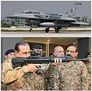
ENTER
AHC

Https://istheonlywayjesusc.wixsite.com/indian
DREAM
IS ETERNAL
ALI

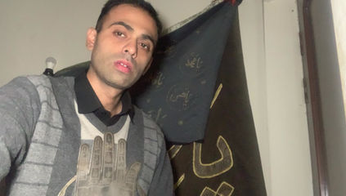


Soul
408
408
ELI
TALENT
BELIEVE
+
1
2
3
*
007
-
4
5
6
/
MI6
.
7
8
9
AP
ALI
N*10^N
0
NS
EW
HERO
LOVE
ELI
Gs
RAW
JUSTICE
MI7
CIA
A
H
B
I
C
J
D
K
E
F
L
G
M
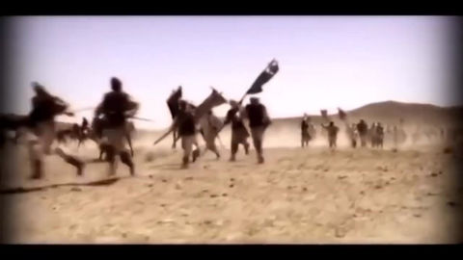
I DEMAND THE WORLD TO DELIVER THIS GIFT TO MY BELOVED FAMILY IN JESUS NAME AMEN AS A GRACE FROM ME AS A GIFT FROM ME AS A RESULT OF MY GOOD WORKS IN THIS WEBSITE HTTPS://ISTHEONLYWAYJESUSC.WIXSITE.COM/PAKISTAN-ARMY-408 AMONG THESE BENEFICIARIES SYEDA FARHAT BANO, SYED SHAHBAZ HAIDER, MEHREEN FATIMA, AFSHEEN FATIMA AND AMBEREEN FATIMA ONLY
ISLAMABAD SANGJANI LAND OF 200+ KANALS WORTH 700 CRORES PKR RUPEES OR LAND OF 200+ KANALS WILL WE DISTRIBUTED TO BE DISTRIBUTED AMONG 5 OWNERS ONLY
SYEDA FARHAT BANO, SYED SHAHBAZ HAIDER, MEHREEN FATIMA, AFSHEEN FATIMA AND AMBEREEN FATIMA AND JUSTICE
MY BELOVED GRAND FATHER SYED FAKHAR ALI SHAH'S OF SANGJANI ISLAMABAD IS THE RIGHTFUL OWNER OF HIS INHERITED 7 VILLAGES SHARE OF 200+ KANALS IS THE RIGHTFUL SHARE OF HIS BELOVED WIIFE SYEDA FARHAT BANO AND THEIR BELOVED CHILDREN SYED SHAHBAZ HAIDER, MEHREEN FATIMA, AFSHEEN FATIMA AND AMBEREEN FATIMA, THROUGH THE NADRA CNIC# 37405-4559435-4 OF AMBEREEN FATIMA PAKISTAN CAN PROCEED IN DELIVERING JUSTICE TO ME AS I DEMANDED RIGHT NOW FOR MY BELOVED FAMILY AND ANY OTHER SHARE IF FOUND IN RECORD MUST ALSO BE GRANTED TO MY BELOVED FAMILY OR TO THEIR CHILDREN OR SPECIAL NOTE
​INCLUDING FIVE KANALS IN FACTO CEMENT AND RECOVERY OF 5 BILLION USD DOLLARS WORTH OF ASSETS OF MR PAUL ELIYA HOLDING PAKISTANI CITIZEN# CNIC#37405-0365980-9, PAUL ELIYA IS THE ASSET OF THE STATE SO HIS ASSETS LAND BUILDING PROPERTY MONEY TO BE RECOVERED FROM THE BELOVED PAKISTAN OR FROM ITS ALLIES INCLUDING 7 CRORE PKR RUPEES TO BE RECOVERED FROM IESCO WAPDA MINISTRY AS CLAIM IN THE LIGHT OF MR PAUL ELIYA’S CASE IN PROCESS AT THE ARMY HELP CENTRE RAWALPINDI https://youtu.be/dme0hdckiXU?feature=shared
TO BE IMMEDIATELY GIVEN TO BELOVED
SYEDA FARHAT BANO, SYED SHAHBAZ HAIDER, MEHREEN FATIMA, AFSHEEN FATIMA AND AMBEREEN FATIMA ONLY THROUGH MY NAME PAUL ELIYA THROUGH MY CASE IN JESUS NAME THROUGH PAKISTAN ARMY HELP CENTRE AHC 051-111-130-786
I AM THE CHILD OF JESUS CHRIST BAAP ALI MOLA ALAISALAAM
MY DREAM IS MY ETERNAL LIFE WITH MY BELOVED ONES WITH MY HOLY FATHER BAAP ALI MOLA JESUS CHRIST IMAM HUSSAIN 12 PRINCE OF ABRAHAM DAVID ALONG WITH MY TREASURE OF KNOWLEDGE https://istheonlywayjesusc.wixsite.com/eternal-paul-eliya AND MY BELONGINGS IN GOODNESS AND LOVE FOREVER JOY, REST, PEACE, PLEASURE WITH ALL BLESSINGS IN JESUS NAME WITHIN MY SOUL AMEN
PRAYER BY PASTOR PAUL ELIYA
https://youtu.be/DjFMqX6rr2I?si=z-skn3hPtq2bVZMA
https://istheonlywayjesusc.wixsite.com/thankyou-jesuschrist I AM VERY FORTUNATE THAT MY HEART IS BROKEN BECAUSE THERE ARE STILL 6 FACES SOULS OF MY LOVE https://youtu.be/AmuZ0OmHENU?si=TcgKI_OXoA5yj9da THE BEAUTIFUL GIRL I DREAMED OF WILL TAKE ME TO MY BELOVED ONES, AND I WILL BECOME AN F-35 FIGHTER PILOT IN US AND THIS WEBSITE IS MY LAST WEBSITE OF MY LIFE LEADING ALL THE WORLD TO ETERNAL LIFE THROUGH BELOVED JESUS CHRIST BECAUSE NO ONE IS LIKE ME BUT I AM LIKE THEM
PRAYER BY PASTOR PAUL ELIYA SYED ALI ABBAS CNIC#37405-0365980-9
UPDATE THE WORLD REGARDING THE STATUS OF MY CASE THROUGH MY CELL#03145550432 ONLY
The Honourable The Excellency Pakistan Army Chief of Army Staff Through Army Help Centre Wajid Rahim Sahab 051111130786
Government of Pakistan
Through Honourable Federal Housing and Works Minister Mian Riaz Hussain Pirzada Via
Dy. No.508/2024-Ministry of Housing and Works 051-9209753 Dated 6th December 2024
Request for issuance of File Number of 14 Marla Plot in G-12 or In F-12 from FGEHA under Retired Quota To The Retired Senior Most Deputy Chief NTRC BPS-19 Ministry of Communication AGPR Personal Number 50036345
holding CNIC#37405-3293752-5, Date of Birth 18-09-1958,
Date of Membership 13/01/2020
Category 2, Computer Generated Number 120519, Membership Drive Phase 2
Regards
HASSAN SYED
Https://istheonlywayjesusc.wixsite.com/pakistan-army-408
0314-5550432

Cc to
1. Minister Incharge/Chairman Mian Riaz Hussain Pirzada (Federal Minister of Housing & Works)
2. Federal Secretary (Housing & Works) Dr. Shahzad Khan Bangash
3. Director General Capt. (Retd.) Muhammad Zafar Iqbal
4. CDA CHAIRMAN ISLAMABAD
5. AHC 051-111-130-786 DATED: 21 DECEMBER 2024, Saturday

FILE# Requested
FILE# Requested
Explore
051111130786
Paul Eliya Grandson of BRIG LATE SYED AHMED PA#2638
SOS
BELOVEDS

HAPPY CHRISTMAS
Inbox
Search for all messages with label Inbox
Remove label Inbox from this conversation
Paul Eliya1 <eliyapaul962@gmail.com> |  | 12:36 PM (24 minutes ago)
to dg, complaint, director.admin, director.finance, director.estate, director.jv, director.law, director.coord, director.IT, director.technical, director.security, director.ia, director.planning, director.land, director.maintenance, director.revenue, director.jvkci, AD.AstonAndSuttonColdfield, AD.ColeshillAndPolesworth, AD.HandsworthAndCentral, AD.KNMS, Admin, Citizen, CPIinfoMali, Courrier, Fadi.El-Abdallah, Falak, FreeJobs, GENESIS, Info, JU, Mike.Sermon, Nick.Parker, OTP, OTPNewsDesk, Ohchr-dexrel, Ombudsman, Passport.london, Paul, Perfect, Procurement, Security, Here's, Sohaibchoudry221998, Syed, WaleedbinToufeeq, WeTrip, achats, administrator, agnes.eklund, agnes.jansson, ahmadiaportugal, alexandra.cederquist, amjmalta, andia.gemsjo, anna.erhardt, anna.lund, apdpftac2, applications, appt.london, atfal, attcons.washington, bilal.lodhi, bishop.david, bishopofaston, bishopsadmin, bookkeeping, caritas.internationalis, cee-office, ceo, com.tehran, com3.washington, commregen, comms, communications, cons.islamabad, cons.tehran, cons1.telaviv, cons2.telaviv, cons6.washington, consuly, contact, contact, contact, contactus, contatti, copyright, dave, dioceseoflondon, discipleship, donorcare, eastafritac, editor, education, elana, emergencies, enquiry, environment, farrakhmansoor, financeteam, flex, frezza, fsoci.washington, fspic.washington, fund, givingtogether, glavno.tajnistvo, hammad.tariq, helpdesk, helpdesk, helplinephc, hoc.babbas, hoc.tehran, hqepu, hr, hr, hrmartha, i.registrar, ieo, imam.ahmed, imffa, imfvideo, inclusiveandaccessible, info, info, info, info, info, info, info, info, info, info, info, info, info, info, info, info, info, info, information, information.hebrew, interculturalmission, interfaith, irnte, irnteprt, isaac.elm.communications, isbad, jennyt, ju.registrar, kancelaria, khuddamireland, kontakt, kontakt, kontakt, kpk, lahore, lahore_churchcouncil, library, marriagebureau34, media, media, mineco.washington, ministry, mohsin.talpur, mubbbutt, muhammad.tariq, newchristiancommunities, ngoliaison, niazihaider786, obedarthur, office, office, ohchr-unvfvt, opinia_ta, ouse, paivytys.um, panatz, parishmissionsupport, parishsurveyor, pathways, peopleandplaces, petrosillo, pniot, press, pressoffice, procurement, property, psamb.washington, psdcm.washington, publicaffairs, publications, reception, recrutement-recruitment, reehanashraf, refworld, revchris007, safeguardingsupport, sah, sanam.javed, sbs.malta.heliga-stolen, secministerialmeetings, secretariat, sektor.jd.ks, shahid.wazir, socialdepartementet.registrator, spain, spyropoulos, support, support-india, support-pakistan, tcpak, ujieuropa, ured.drzavnog.tajnika, v-bknoojh_nnpgdkmghf_jdofaikg_jdoelhap_a, visa.islamabad, visaservicesphcnd, vocations, web, webmaster, weddings, contact, Пакистан, islamabad, islamabad.hum, islamabad.visa, islamabad.ziv, islamabad, pakistan, Webmaster, asrcrwp, asrcfsd, asrclhr, asrckci, asrcpsc, asrcqta, asrcglt, asrcmzd, asrcmtn, asrckzd, asrchyd, asrcdik, asrcpnl, complaint, Public, me, dd-it1

from: | Paul Eliya1 <eliyapaul962@gmail.com>
to: | dg@fgeha.gov.pk,  complaint@fgeha.gov.pk,  director.admin@fgeha.gov.pk,  director.finance@fgeha.gov.pk,  director.estate@fgeha.gov.pk,  director.jv@fgeha.gov.pk,  director.law@fgeha.gov.pk,  director.coord@fgeha.gov.pk,  director.IT@fgeha.gov.pk,  director.technical@fgeha.gov.pk,  director.security@fgeha.gov.pk,  director.ia@fgeha.gov.pk,  director.planning@fgeha.gov.pk,  director.land@fgeha.gov.pk,  director.maintenance@fgeha.gov.pk,  director.revenue@fgeha.gov.pk,  director.jvkci@fgeha.gov.pk,  AD.AstonAndSuttonColdfield@cofebirmingham.com,  AD.ColeshillAndPolesworth@cofebirmingham.com,  AD.HandsworthAndCentral@cofebirmingham.com,  AD.KNMS@cofebirmingham.com,  Admin@azadchaiwala.com,  Citizen Service of the Ministry of Foreign Affairs <borgarathjonusta@utn.is>,  CPIinfoMali@icc-cpi.int,  Courrier Elysée <courrier.president@elysee.fr>,  Fadi.El-Abdallah@icc-cpi.int,  Falak Tayab Corporate Service <careers@falaktayabcorporateservices.com>,  FreeJobs UAE <pr@advancelevelcon.com>,  GENESIS@matrimony.com,  Info@iranembassy.pk,  JU Brev <ju.brev@regeringskansliet.se>,  Mike.Sermon@cofebirmingham.com,  Nick.Parker@cofebirmingham.com,  "OTP InformationDesk (Article15)" <otp.informationdesk@icc-cpi.int>,  OTPNewsDesk@icc-cpi.int,  Ohchr-dexrel@un.org,  Ombudsman@mevaker.gov.il,  Passport.london@mea.gov.in,  Paul Eliya <eliyapaul289@gmail.com>,  Perfect LLC <hr@perfectllcdubai.com>,  Procurement@icc-cpi.int,  Security@icc-cpi.int,  Here's Puthran <visa.washington@mea.gov.in>,  Sohaibchoudry221998@gmail.com,  Syed Ali Abbas Paul Eliya <eliyasyedaliabbaspaul@gmail.com>,  WaleedbinToufeeq@gmail.com,  WeTrip <contact@wetrip.pk>,  achats@icj-cij.org,  administrator@stmarksitaly.com,  agnes.eklund@regeringskansliet.se,  agnes.jansson@gov.se,  ahmadiaportugal@hotmail.com,  alexandra.cederquist@gov.se,  amjmalta@gmail.com,  andia.gemsjo@regeringskansliet.se,  anna.erhardt@gov.se,  anna.lund@gov.se,  apdpftac2@imf.org,  applications@icc-cpi.int,  appt.london@mea.gov.in,  atfal@atfal.de,  attcons.washington@mea.gov.in,  bilal.lodhi@bop.com.pk,  bishop.david@manchester.anglican.org,  bishopofaston@cofebirmingham.com,  bishopsadmin@cofebirmingham.com,  bookkeeping@cofebirmingham.com,  caritas.internationalis@caritas.va,  cee-office@imf.org,  ceo@sadiqtravels.com,  com.tehran@mea.gov.in,  com3.washington@mea.gov.in,  commregen@cofebirmingham.com,  comms@cofebirmingham.com,  communications@london.anglican.org,  cons.islamabad@mea.gov.in,  cons.tehran@mea.gov.in,  cons1.telaviv@mea.gov.in,  cons2.telaviv@mea.gov.in,  cons6.washington@mea.gov.in,  consuly@iranembassy.pk,  contact@fatf-gafi.org,  contact@ahmadiyya.fr,  contact@ahmadiyya.dk,  contactus@iaa.gov.il,  contatti@alislam.it,  copyright@imf.org,  dave@redeemerdubai.com,  dioceseoflondon@luther.co.uk,  discipleship@cofebirmingham.com,  donorcare@unhcr.ca,  eastafritac@imf.org,  editor@chanakyaforum.com,  education@cofebirmingham.com,  elana@israelforever.org,  emergencies@caritas.va,  enquiry@churchofengland.org,  environment@cofebirmingham.com,  farrakhmansoor@hot.ee,  financeteam@cofebirmingham.com,  flex@cofebirmingham.com,  frezza@caritas.va,  fsoci.washington@mea.gov.in,  fspic.washington@mea.gov.in,  fund@end-violence.org,  givingtogether@imf.org,  glavno.tajnistvo@mvep.hr,  hammad.tariq@sindhbankltd.com,  helpdesk@lajnauk.org,  helpdesk@lajna.be,  helplinephc@gmail.com,  hoc.babbas@mea.gov.in,  hoc.tehran@mea.gov.in,  hqepu@unhcr.org,  hr@cofebirmingham.com,  hr fatima ali <hrfatimaali@gmail.com>,  hrmartha roy <hrmagraroy@gmail.com>,  i.registrar@gov.se,  ieo@imf.org,  imam.ahmed@ahmadiyya.ch,  imffa@imf.org,  imfvideo@imf.org,  inclusiveandaccessible@cofebirmingham.com,  info@thrivetogetherbham.org,  info@ahmadiyya.ch,  info@education.gov.il,  info@imfmetac.org,  info@end-violence.org,  info@visitouriran.com,  info@khuddam.co.uk,  info@ziyarahtours.net,  info@farrukhsaif.com,  info@ansar.org.uk,  info@alavitravel.com,  info@khuddam.nl,  info@sadiqtravels.com,  info@travelfatimah.com,  info@khuddam.be,  info@alsahlah.com,  info@cartac.org,  info@refugepoint.org,  information@icj-cij.org,  information.hebrew@yadvashem.org.il,  interculturalmission@cofebirmingham.com,  interfaith@cofebirmingham.com,  irnte@unhcr.org,  irnteprt@unhcr.org,  isaac.elm.communications@gmail.com,  isbad@international.gc.ca,  jennyt@cofebirmingham.com,  ju.registrar@gov.se,  kancelaria@msz.gov.pl,  khuddamireland@gmail.com,  kontakt@ahmadiyya.de,  kontakt@ahmadiyya.no,  kontakt@lajna.de,  kpk@pasb.mod.gov.pk,  lahore@hk-diplo.de,  lahore_churchcouncil@yahoo.com,  library@icj-cij.org,  marriagebureau34@gmail.com,  media@imf.org,  media@fatf-gafi.org,  mineco.washington@mea.gov.in,  ministry@cofebirmingham.com,  mohsin.talpur@sindhbankltd.com,  mubbbutt@gmail.com,  muhammad.tariq@mofa.gov.pk,  newchristiancommunities@cofebirmingham.com,  ngoliaison@imf.org,  niazihaider786@gmail.com,  obedarthur@gmail.com,  office@saintmarysdubai.org,  office@ahmadiyya.at,  ohchr-unvfvt@un.org,  opinia_ta@mae.ro,  ouse winterz <ousewinterz1@gmail.com>,  paivytys.um@gov.fi,  panatz@rbc.gov.il,  parishmissionsupport@cofebirmingham.com,  parishsurveyor@cofebirmingham.com,  pathways@cofebirmingham.com,  peopleandplaces@cofebirmingham.com,  petrosillo@caritas.va,  pniot@mod.gov.il,  press@pakchristiannews.com,  pressoffice@phclondon.org,  procurement@imf.org,  property@cofebirmingham.com,  psamb.washington@mea.gov.in,  psdcm.washington@mea.gov.in,  publicaffairs@imf.org,  publications@imf.org,  reception@london.anglican.org,  recrutement-recruitment@icj-cij.org,  reehanashraf@hotmail.com,  refworld@unhcr.org,  revchris007@gmail.com,  safeguardingsupport@cofebirmingham.com,  sah@cis-iwc.org,  sanam.javed@sindhbankltd.com,  sbs.malta.heliga-stolen@gov.se,  secministerialmeetings@imf.org,  secretariat@end-violence.org,  sektor.jd.ks@mvep.hr,  shahid.wazir@sindhbankltd.com,  socialdepartementet.registrator@gov.se,  spain@alislam.org,  spyropoulos@hotmail.co.uk,  support@ustravel.com,  support-india@ustraveldocs.com,  support-pakistan@ustraveldocs.com,  tcpak@um.dk,  ujieuropa@mvep.hr,  ured.drzavnog.tajnika@mvep.hr,  v-bknoojh_nnpgdkmghf_jdofaikg_jdoelhap_a@bounce.studentenquiry.mkt4116.com,  visa.islamabad@mea.gov.in,  visaservicesphcnd@gmail.com,  vocations@cofebirmingham.com,  web@mae.ro,  webmaster@icj-cij.org,  weddings@holytrinity.ae,  contact@majorgauravarya.com,  "Генконсульство России в г. Карачи, Пакистан" <karachi@mid.ru>,  islamabad@dks.ru,  islamabad.hum@eda.admin.ch,  islamabad.visa@eda.admin.ch,  islamabad.ziv@eda.admin.ch,  islamabad@eda.admin.ch,  pakistan@mid.ru,  Webmaster <webmaster@joinpakarmy.gov.pk>,  asrcrwp@joinpakarmy.gov.pk,  asrcfsd@joinpakarmy.gov.pk,  asrclhr@joinpakarmy.gov.pk,  asrckci@joinpakarmy.gov.pk,  asrcpsc@joinpakarmy.gov.pk,  asrcqta@joinpakarmy.gov.pk,  asrcglt@joinpakarmy.gov.pk,  asrcmzd@joinpakarmy.gov.pk,  asrcmtn@joinpakarmy.gov.pk,  asrckzd@joinpakarmy.gov.pk,  asrchyd@joinpakarmy.gov.pk,  asrcdik@joinpakarmy.gov.pk,  asrcpnl@joinpakarmy.gov.pk,  complaint@thepakarmy.com,  Public Response Unit <inf.london@mea.gov.in>,  Paul Eliya1 <eliyapaul962@gmail.com>,  dd-it1@fgeha.gov.pk
date: | Dec 25, 2024, 12:36 PM
subject: | HAPPY CHRISTMAS
mailed-by: | gmail.com
: | Important mainly because it was sent directly to you.
HAPPY CHRISTMAS TO YOU BELOVED INCARNATED SACRIFICED RESURRECTED LORD JESUS CHRIST OF THE HOLY FATHER GOD THROUGH HOLY SPIRIT

https://istheonlywayjesusc.wixsite.com/christmas-gift
https://youtu.be/dme0hdckiXU?feature=shared
REGARDS
PASTOR PAUL ELIYA (ASSET OF THE STATE PAKISTAN)
Https://istheonlywayjesusc.wixsite.com/pakistan-army-408
Attachments area
Preview YouTube video Major Gaurav Arya says- Pakistan needs a strong action | Majorly Right |

Major Gaurav Arya says- Pakistan needs a strong action | Majorly Right |

Your E-Mail has been received and your Case #(Case-2024- 12-25-022044864) has been created.
Inbox
Search for all messages with label Inbox
Remove label Inbox from this conversation

No Reply <no-reply@ustraveldocs.com> | 12:36 PM (26 minutes ago)
to me

We have received your email and will respond accordingly within 1 to 2 business days.
The details are as follows:
Date/Time Case Opened: | 12/25/2024 2:36 AM
Description: | HAPPY CHRISTMAS TO YOU BELOVED INCARNATED SACRIFICED RESURRECTED LORD JESUS  CHRIST OF THE HOLY FATHER GOD THROUGH HOLY SPIRIT  https://istheonlywayjesusc.wixsite.com/christmas-gift  https://youtu.be/dme0hdckiXU?feature=shared  REGARDS  PASTOR PAUL ELIYA (ASSET OF THE STATE PAKISTAN)  Https://istheonlywayjesusc.wixsite.com/pakistan-army-408  <https://istheonlywayjesusc.wixsite.com/pakistan-army-408>
Origin: | Email
Case Reason: | HAPPY CHRISTMAS
Case Status: | New
Attachments area
Preview YouTube video Major Gaurav Arya says- Pakistan needs a strong action | Majorly Right |
Major Gaurav Arya says- Pakistan needs a strong action | Majorly Right |

Autosvar: HAPPY CHRISTMAS (Auto reply: HAPPY CHRISTMAS)
Inbox
Search for all messages with label Inbox
Remove label Inbox from this conversation

Andia Gemsjö |  |  | 12:37 PM (26 minutes ago)
to me

from: | Andia Gemsjö <andia.gemsjo@regeringskansliet.se>
to: | Paul Eliya1 <eliyapaul962@gmail.com>
date: | Dec 25, 2024, 12:37 PM
subject: | Autosvar: HAPPY CHRISTMAS
signed-by: | regeringskansliet.se
security: | Standard encryption (TLS) Learn more
SwedishEnglish
Show original
Automatically translate Swedish
Hello,
I am free.
For urgent matters please contact dan.jormvik@regeringskansliet.se during the period 23 - 29 December.
For urgent matters 30 Dec - 2 Jan, please text me.
Etc.

Andia Gemsjö

...

Message Received
Inbox
Search for all messages with label Inbox
Remove label Inbox from this conversation

WETRIP |  |  | 12:36 PM (28 minutes ago)
to me

from: | WETRIP <contact@wetrip.pk>
to: | Paul Eliya1 <eliyapaul962@gmail.com>
date: | Dec 25, 2024, 12:36 PM
subject: | Message Received
mailed-by: | wetrip.pk
signed-by: | wetrip.pk
security: | Standard encryption (TLS) Learn more
Greetings,
Thank you for contacting WETRIP (SMC-PRIVATE) LTD Pakistan, the concerned team will responding to your email within 2 Business days regarding your query, if you do not hear from us please contact on our WhatsApp number at +923000938747.
Please check our website www.wetrip.pk for online bookings!
Have a great day!
Team WeTrip

Auto Reply from information.hebrew@yadvashem.org.il
Inbox
Search for all messages with label Inbox
Remove label Inbox from this conversation
no_reply_information.hebrew@yadvashem.org.il |  |  | 12:36 PM (29 minutes ago)
to me

from: | no_reply_information.hebrew@yadvashem.org.il
to: | eliyapaul962@gmail.com
date: | Dec 25, 2024, 12:36 PM
subject: | Auto Reply from information.hebrew@yadvashem.org.il
mailed-by: | yadvashem.org.il
security: | Standard encryption (TLS) Learn more
פונים יקרים,
בשל שינוי במדיניות, הנכם מתבקשים לשלוח את הפנייה באמצעות טופס בקישור:
https://forms.yadvashem.org/he/contact-us?subject=100&subsubject=160
Due to a policy change you are kindly requested to send your request using the following link:
https://forms.yadvashem.org/contact-us?subject=100&subsubject=160
ReplyForward
Add reaction

Acknowledgment
Inbox
Search for all messages with label Inbox
Remove label Inbox from this conversation

Webmaster |  |  | 12:41 PM (25 minutes ago)
to me

from: | Webmaster <webmaster@joinpakarmy.gov.pk>
to: | Paul Eliya1 <eliyapaul962@gmail.com>
date: | Dec 25, 2024, 12:41 PM
subject: | Acknowledgment
mailed-by: | joinpakarmy.gov.pk
security: | Standard encryption (TLS) Learn more
: | Important according to Google magic.
Dear Applicant,
thank you for reaching out to us. Kindly note that maximum one email per issue within 24 hours of period will be addressed. Rest assured we will address your concern as soon as possible and respond accordingly.
(computer generated reply )
Best regards
Webmaster
joinpakarmy
Thank you for your response.
I am still waiting for your response.
Thanks a lot.
Skip to Main Content
This site was designed with the
.com
website builder. Create your website today.Start Now
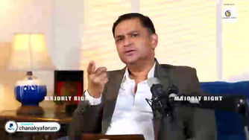

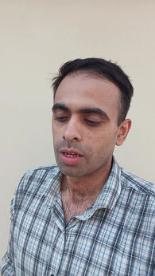

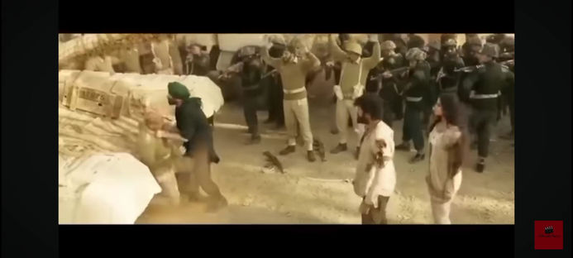





https://youtu.be/hSrLOBphJgU?si=Zva2CgTlLUQm3wU1 https://eliyasyedaliabbasp.wixsite.com/love-serve-protect https://istheonlywayjesusc.wixsite.com/jesuschrist
https://youtu.be/w-cj7bRvJuI?si=RGtOMX8AmF5TO08e
START
END
RUSSIAN HERO
RUSSIAN FIGHTER PILOT
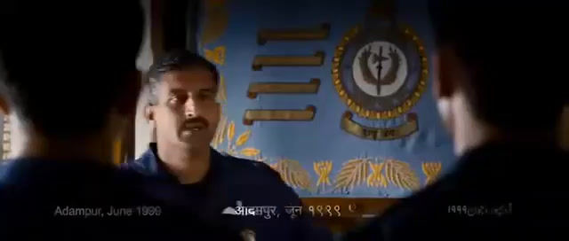
+
1
2
3
*
007
-
4
5
6
/
MI6
.
7
8
9
AP
ALI
N*10^N
0
NS
EW
ELI
HERO
LOVE
Gs
RAW
JUSTICE
MI7
CIA
TALENT
BELIEVE
MY SANGJANI LAND 10 KANALS
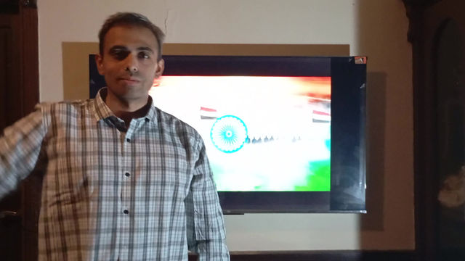
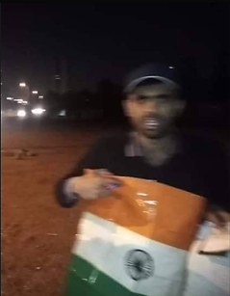
ONE MAN ARMY HOISTING INDIAN FLAG FOR ONE HOUR IN ISLAMABAD AND CONQUERED ALL ON 17-02-2021
Jai Hind Vande Mataram Bharat Mata Ki Jai
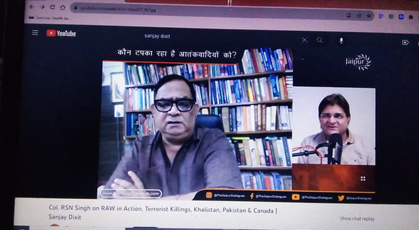

408
408
https://youtu.be/hSrLOBphJgU?si=Zva2CgTlLUQm3wU1
https://eliyasyedaliabbasp.wixsite.com/love-serve-protect
https://istheonlywayjesusc.wixsite.com/jesuschrist
https://youtu.be/hSrLOBphJgU?si=Zva2CgTlLUQm3wU1
https://eliyasyedaliabbasp.wixsite.com/love-serve-protect
https://istheonlywayjesusc.wixsite.com/jesuschrist
https://youtu.be/hSrLOBphJgU?si=Zva2CgTlLUQm3wU1
https://eliyasyedaliabbasp.wixsite.com/love-serve-protect
https://istheonlywayjesusc.wixsite.com/jesuschrist
https://youtu.be/w-cj7bRvJuI?si=RGtOMX8AmF5TO08e

GOODNESS AND LOVE IS MY SOUL OF MY BELOVED HOLY FATHER JESUS CHRIST FOREVER IN JOY PEACE AND PLEASURE HTTPS://ISTHEONLYWAYJESUSC.WIXSITE.COM/SOUL
SONG BY PAUL ELIYA AND BELOVED FAMILY
Explore
DOWNLOAD
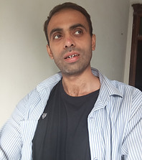
GOODNESS AND LOVE OF SOUL
BORDER MANAGEMENT RAW INDIA
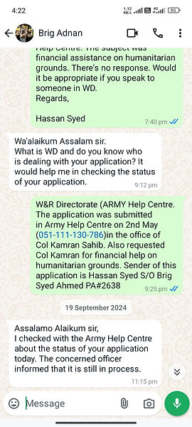
Bait ul Mal
INPROCESS

PAUL ELIYA

Acknowledgment
Inbox
Search for all messages with label Inbox
Remove label Inbox from this conversation

Webmaster

22:42 (0 minutes ago)
to me
from:Webmaster <webmaster@joinpakarmy.gov.pk>
to:Syed Ali Abbas Paul Eliya <eliyasyedaliabbaspaul@gmail.com>
date:14 Nov 2024, 22:42
subject:Acknowledgment
mailed-by:joinpakarmy.gov.pk
security: Standard encryption (TLS) Learn more
:Important according to Google magic.
Dear Applicant,
thank you for reaching out to us. Kindly note that maximum one email per issue within 24 hours of period will be addressed. Rest assured we will address your concern as soon as possible and respond accordingly.
(computer generated reply )
Best regards
Webmaster
joinpakarmy
MESSAGE FOR RELATIVES
GRACE FOR RELATIVES





DOWNLOAD
DREAMS ETERNAL LIFE
from:Syed Ali Abbas Paul Eliya <eliyasyedaliabbaspaul@gmail.com>
to:info@pbm.gov.pk,cc:info@pbm.gov.pk,bcc:info@pbm.gov.pk,date:5 Nov 2024, 19:03,subject:FINANCIAL ASSISTANCE,mailed-by:gmail.com
APPLICATION FOR FINANCIAL ASSISTANCE HELP ON URGENT HUMANITARIAN GROUNDSPakistan Bait-ul-Mal Head Office, Street No: 7, Sector: H-8/4, Islamabad.
Toll Free No: 0800-66666,Fax: 051-9269603, 051-9269601,Web: www.pbm.gov.pk
email: info@pbm.gov.pk

SUBJECT: REQUEST FOR FINANCIAL HELP OF Rs 2,25,000/- FOR PAYING UTILITY BILLS, RASHAN, QUILTS AND BLANKETS, WINTER CLOTHS, TRANSPORTATION COSTS ETC TO LIVE WITH DIGNITY IN A PEACEFUL HUMAN SOCIETY OF PAKISTAN IN THE LIGHT OF DETAILS MENTIONED BELOW AND A JOB TO SURVIVE AND TO PAY BACK THE SAID AMOUNT IN EASY INSTALMENTS

HIS EXCELLENCY HEAD BAIT UL MAL ISLAMIC REPUBLIC OF PAKISTAN
DEAR SIR,

MY NA ME IS PAUL ELIYA SON OF HASSAN SYED(HENRY LAWRENCE) AND MY CNIC# IS 3740503659809 MOBILE NUMBER 03145550432 AND 03185309511, AND I AM A LOCAL PASTOR CURRENTLY, MY CASE IS IN PROCESS AT THE PAKISTAN ARMY HELP CENTRE WITH PA#2638 051-111-130-786 REGARDING RECOVERY OF MY 40 MARLAS CHURCH BUILDING PROPERTY AND LAND FROM CULPRITS UNDER NEW LAWS PASSED IN THE PARLIAMENT REGARDING PROPERTY AND BLASPHEMY CASES AND IS ALSO IN PROCESS AT THE CPO OFFICE AND THANA SADDAR BERUNI, WHICH YOU CAN CONFIRM IT FROM ANY COMPETENT AUTHORITY, ME AND MY FAMILY ARE VULNERABLE AND NEED URGENT HELP FROM BAIT UL MAL REGARDING THE CONCERNS REQUEST MENTIONED IN THE SUBJECT CITED ABOVE, YOU CAN ALSO CONFIRM IT FROM +042-99047000 15 LAHORE MINORITY SECTION PUNJAB POLICE AND CM MARYAM NAWAZ OFFICE

THANK YOU,
YOURS OBEDIENTELY
PASTOR PAUL ELIYA AND FAMILY
HOUSE# 96, LANE#4, BLOCK D, SECTOR 4, AIRPORT HOUSING SOCIETY RAWALPINDI CANTT
ALL THE EVIDENCE ARE IN MY WEBSITE https://istheonlywayjesusc.wixsite.com/soul
03145550432, 0318-5309511
Please send helpInbox
17:19 (3 hours ago)
from:
Syed Ali Abbas Paul Eliya <eliyasyedaliabbaspaul@gmail.com>
to:
AD.AstonAndSuttonColdfield@cofebirmingham.com,
AD.ColeshillAndPolesworth@cofebirmingham.com,
AD.HandsworthAndCentral@cofebirmingham.com,
AD.KNMS@cofebirmingham.com,
Admin@azadchaiwala.com,
Alalam LLC <hire@agroupdubai.com>,
Borgaraþjónusta Utanríkisráðuneytisins <borgarathjonusta@utn.is>,
CPIinfoMali@icc-cpi.int,
Courrier Elysée <courrier.president@elysee.fr>,
Fadi.El-Abdallah@icc-cpi.int,
Falak Tayab Corporate Service <careers@falaktayabcorporateservices.com>,
FreeJobs UAE <pr@advancelevelcon.com>,
GENESIS@matrimony.com,
Info@iranembassy.pk,
JU Brev <ju.brev@regeringskansliet.se>,
JeromePervaiz@gmail.com,
Kenyahello@refugepoint.org,
Mike.Sermon@cofebirmingham.com,
Nick.Parker@cofebirmingham.com,
"OTP InformationDesk (Article15)" <otp.informationdesk@icc-cpi.int>,
OTPNewsDesk@icc-cpi.int,
Ohchr-dexrel@un.org,
Ombudsman@mevaker.gov.il,
Passport.london@mea.gov.in,
Paul Eliya <eliyapaul289@gmail.com>,
Perfect LLC <hr@perfectllcdubai.com>,
Procurement@icc-cpi.int,
Public Response Unit <inf.london@mea.gov.in>,
Security@icc-cpi.int,
Setu Puthran <visa.washington@mea.gov.in>,
Sohaibchoudry221998@gmail.com,
Syed Ali Abbas Paul Eliya <eliyasyedaliabbaspaul@gmail.com>,
WaleedbinToufeeq@gmail.com,
WeTrip <contact@wetrip.pk>,
aajakia.arif@gmail.com,
achats@icj-cij.org,
administrator@stmarksitaly.com,
agnes.eklund@regeringskansliet.se,
agnes.jansson@gov.se,
ahmadiaportugal@hotmail.com,
alexandra.cederquist@gov.se,
amjmalta@gmail.com,
andia.gemsjo@regeringskansliet.se,
anna.erhardt@gov.se,
anna.lund@gov.se,
apdpftac2@imf.org,
applications@icc-cpi.int,
appt.london@mea.gov.in,
atfal@atfal.de,
atfal@khuddam.co.uk,
attcons.washington@mea.gov.in,
bilal.lodhi@bop.com.pk,
bishop.david@manchester.anglican.org,
bishopofaston@cofebirmingham.com,
bishopsadmin@cofebirmingham.com,
bookkeeping@cofebirmingham.com,
caritas.internationalis@caritas.va,
cee-office@imf.org,
ceo@sadiqtravels.com,
com.tehran@mea.gov.in,
com3.washington@mea.gov.in,
commregen@cofebirmingham.com,
comms@cofebirmingham.com,
communications@london.anglican.org,
cons.islamabad@mea.gov.in,
cons.tehran@mea.gov.in,
cons1.telaviv@mea.gov.in,
cons2.telaviv@mea.gov.in,
cons6.washington@mea.gov.in,
consuly@iranembassy.pk,
contact@fatf-gafi.org,
contact@ahmadiyya.fr,
contact@ahmadiyya.dk,
contactus@iaa.gov.il,
contatti@alislam.it,
copyright@imf.org,
dave@redeemerdubai.com,
dchundungsing@imf.org,
dioceseoflondon@luther.co.uk,
discipleship@cofebirmingham.com,
donorcare@unhcr.ca,
eastafritac@imf.org,
editor@chanakyaforum.com,
education@cofebirmingham.com,
elana@israelforever.org,
emergencies@caritas.va,
enquiry@churchofengland.org,
environment@cofebirmingham.com,
farrakhmansoor@hot.ee,
fdelgado@imf.org,
financeteam@cofebirmingham.com,
flex@cofebirmingham.com,
frezza@caritas.va,
fsoci.washington@mea.gov.in,
fspic.washington@mea.gov.in,
fund@end-violence.org,
givingtogether@imf.org,
glavno.tajnistvo@mvep.hr,
globalfahli@gmail.com,
hammad.tariq@sindhbankltd.com,
helpdesk@lajnauk.org,
helpdesk@lajna.be,
helplinephc@gmail.com,
hoc.babbas@mea.gov.in,
hoc.tehran@mea.gov.in,
hqepu@unhcr.org,
hr@cofebirmingham.com,
hr fatima ali <hrfatimaali@gmail.com>,
hr.recruitment@churchofengland.org,
hrmartha roy <hrmagraroy@gmail.com>,
i.registrator@gov.se,
ieo@imf.org,
imam.ahmed@ahmadiyya.ch,
imffa@imf.org,
imfvideo@imf.org,
inclusiveandaccessible@cofebirmingham.com,
info@thrivetogetherbham.org,
info@ahmadiyya.se,
info@ahmadiyya.ch,
info@education.gov.il,
info@imfmetac.org,
info@end-violence.org,
info@visitouriran.com,
info@khuddam.co.uk,
info@ziyarahtours.net,
info@farrukhsaif.com,
info@ansar.org.uk,
info@alavitravel.com,
info@ansarullah.de,
info@khuddam.nl,
info@sadiqtravels.com,
info@travelfatimah.com,
info@khuddam.be,
info@alsahlah.com,
info@cartac.org,
info@refugepoint.org,
information@icj-cij.org,
information.hebrew@yadvashem.org.il,
interculturalmission@cofebirmingham.com,
interfaith@cofebirmingham.com,
ips@mail.gov.il,
irnte@unhcr.org,
irnteprt@unhcr.org,
isaac.elm.communications@gmail.com,
isbad@international.gc.ca,
jennyt@cofebirmingham.com,
ju.registrator@gov.se,
kancelaria@msz.gov.pl,
khuddamireland@gmail.com,
kirjaamo.um@gov.fi,
kontakt@ahmadiyya.de,
kontakt@ahmadiyya.no,
kontakt@lajna.de,
kpk@pasb.mod.gov.pk,
lahore@hk-diplo.de,
lahore_churchcouncil@yahoo.com,
library@icj-cij.org,
marriagebureau34@gmail.com,
media@imf.org,
media@fatf-gafi.org,
minca.washington@mea.gov.in,
mineco.washington@mea.gov.in,
ministry@cofebirmingham.com,
mohsin.talpur@sindhbankltd.com,
mubbbutt@gmail.com,
muhammad.tariq@mofa.gov.pk,
newchristiancommunities@cofebirmingham.com,
ngoliaison@imf.org,
niazihaider786@gmail.com,
obedarthur@gmail.com,
office@saintmarysdubai.org,
office@ahmadiyya.at,
ohchr-unvfvt@un.org,
opinia_ta@mae.ro,
ouse winterz <ousewinterz1@gmail.com>,
paivytys.um@gov.fi,
panatz@rbc.gov.il,
parishmissionsupport@cofebirmingham.com,
parishsurveyor@cofebirmingham.com,
pathways@cofebirmingham.com,
peopleandplaces@cofebirmingham.com,
petrosillo@caritas.va,
pniot@mod.gov.il,
press@pakchristiannews.com,
pressoffice@phclondon.org,
procurement@imf.org,
property@cofebirmingham.com,
psamb.washington@mea.gov.in,
psdcm.washington@mea.gov.in,
publicaffairs@imf.org,
publications@imf.org,
reception@london.anglican.org,
recrutement-recruitment@icj-cij.org,
reehanashraf@hotmail.com,
refworld@unhcr.org,
revchris007@gmail.com,
safeguardingsupport@cofebirmingham.com,
sah@cis-iwc.org,
sanam.javed@sindhbankltd.com,
sbs.malta.heliga-stolen@gov.se,
secministerialmeetings@imf.org,
secretariat@end-violence.org,
sektor.jd.ks@mvep.hr,
shahid.wazir@sindhbankltd.com,
socialdepartementet.registrator@gov.se,
spain@alislam.org,
spyropoulos@hotmail.co.uk,
support@ustravel.com,
support-india@ustraveldocs.com,
support-pakistan@ustraveldocs.com,
tcpak@um.dk,
ujieuropa@mvep.hr,
ured.drzavnog.tajnika@mvep.hr,
v-bknoojh_nnpgdkmghf_jdofaikg_jdoelhap_a@bounce.studentenquiry.mkt4116.com,
visa.islamabad@mea.gov.in,
visaservicesphcnd@gmail.com,
vocations@cofebirmingham.com,
web@mae.ro,
webmaster@icj-cij.org,
weddings@holytrinity.ae,
contact@majorgauravarya.com,
"Генконсульство России в г. Карачи, Пакистан" <karachi@mid.ru>,
islamabad@dks.ru,
islamabad.hum@eda.admin.ch,
islamabad.visa@eda.admin.ch,
islamabad.ziv@eda.admin.ch,
islamabad@eda.admin.ch,
pakistan@mid.ru
date:
12 Nov 2024, 17:19
subject:
Please send help
mailed-by:
gmail.com
:
Important mainly because it was sent directly to you.

My Beloved Family Sheharbano Maryam Syed Haider Hassan Syed Ambereen Fatima Shoaib Bhai will go UK.
istheonlywayjesusc.wixsite.com/indian
Holy Prayer#1 Psalm 23 by Pastor Paul Eliya, istheonlywayjesusc.wixsite.com/soul .
---------- Forwarded message ---------
From: Syed Ali Abbas Paul Eliya eliyasyedaliabbaspaul@gmail.com
Date: Tue, 12 Nov 2024, 5:04 pm
Subject: God will Help me
To: webmaster@joinpakarmy.gov.pk, asrcrwp@joinpakarmy.gov.pk, asrcfsd@joinpakarmy.gov.pk, asrclhr@joinpakarmy.gov.pk, asrckci@joinpakarmy.gov.pk, asrcpsc@joinpakarmy.gov.pk, asrcqta@joinpakarmy.gov.pk, asrcglt@joinpakarmy.gov.pk, asrcmzd@joinpakarmy.gov.pk, asrcmtn@joinpakarmy.gov.pk, asrckzd@joinpakarmy.gov.pk, asrchyd@joinpakarmy.gov.pk, asrcdik@joinpakarmy.gov.pk, asrcpnl@joinpakarmy.gov.pk
Cc: contact@majorgauravarya.com, Syed Ali Abbas Paul Eliya eliyasyedaliabbaspaul@gmail.com
---------- Forwarded message ---------
From: Webmaster webmaster@joinpakarmy.gov.pk
Date: Tue, 12 Nov 2024, 5:10 pm
Subject: Acknowledgment
To: Syed Ali Abbas Paul Eliya eliyasyedaliabbaspaul@gmail.com
Dear Applicant,
thank you for reaching out to us. Kindly note that maximum one email per issue within 24 hours of period will be addressed. Rest assured we will address your concern as soon as possible and respond accordingly.
computer generated reply
Best regards
Webmaster
joinpakarmy
My Details are
My name is Paul Eliya grandson of Late Brig Syed Ahmed PA# 2638, me and my family were converted to Christianity in year 2000 and after that my very very close relatives in the world accuses me and my family for blasphemy and maliciously forcefully taken my property church by blaming us for blasphemy and for doing the wrong thing of converting to Christianity from Islam, they also declared us Mad Persons but I know that Jesus Christ is our only Saviour who will give us Justice and a good peaceful future in Any Christian Country of the World.
So we have already Rejected the teachings of Prophet Muhammad and we have Rejected his Quran Hadees what ever etc etc which is not compatible with Holy Christian Values.
My Details are in my this website istheonlywayjesusc.wixsite.com/soul
youtu.be/LHxE4q6nyrg?si=0D7XV65dRwOCncTb
In recent few days back I burned teared and desecrated the Quran and committed Blasphemy against islamic prophet for protesting for my fundamental human rights.
The world should take action against My Relatives My cases are in process at the Pakistan Army Help Centre under Pakistan Army # 2638 contact # 051-111-130-786, Punjab Police Tracking # 4517316 with tracking CNIC # 37405-0365980-9
Special Note:
My last Message to all the people is that one day we all have to die and God will then Deliver Justice to me.
میرا نام پال ایلیا مرحوم بریگیڈیئر سید احمد پی اے # 2638 کا پوتا ہے، میں اور میرے خاندان نے 2000 میں عیسائیت اختیار کی تھی اور اس کے بعد دنیا میں میرے بہت ہی قریبی رشتہ دار مجھ پر اور میرے خاندان پر توہین مذہب کا الزام لگاتے ہیں اور میری جائیداد پر بدنیتی سے زبردستی قبضہ کر لیتے ہیں۔ ہم پر توہین مذہب کا الزام لگا کر اور اسلام سے عیسائیت اختیار کرنے کا غلط کام کرتے ہوئے، انہوں نے ہمیں پاگل انسان بھی قرار دیا لیکن میں جانتا ہوں کہ یسوع مسیح ہمارا واحد نجات دہندہ ہے جو ہمیں کسی بھی عیسائی ملک میں انصاف اور ایک اچھا پرامن مستقبل دے گا۔ دنیا لہٰذا ہم نے پہلے ہی حضرت محمد صلی اللہ علیہ وسلم کی تعلیمات کو رد کر دیا ہے اور ہم نے ان کی قرآنی حدیثوں کو رد کر دیا ہے جو کچھ بھی وغیرہ وغیرہ جو مقدس مسیحی اقدار سے مطابقت نہیں رکھتی۔ میری تفصیلات میری اس ویب سائٹ soul
istheonlywayjesusc.wixsite.com/soul میں ہیں youtu.be/LHxE4q6nyrg?si=0D7XV65dRwOCncTb حالیہ دنوں میں میں نے اپنے بنیادی انسانی حقوق کے لیے احتجاج کرنے پر قرآن کو جلایا اور اس کی بے حرمتی کی اور پیغمبر اسلام کے خلاف توہین کا ارتکاب کیا۔ دنیا میرے رشتہ داروں کے خلاف کارروائی کرے میرے کیسز پاکستان آرمی کے تحت پاکستان آرمی ہیلپ سنٹر میں جاری ہیں # 2638 رابطہ # 051-111-130-786
پنجاب پولیس ٹریکنگ نمبر 4517316 ٹریکنگ CNIC # 37405-0365980-9 کے ساتھ خصوصی نوٹ: میرا تمام لوگوں کو آخری پیغام ہے کہ ایک دن ہم سب کو مرنا ہے اور پھر اللہ مجھے انصاف دے گا۔
​
میری پیاری فیملی شہربانو مریم سید حیدر حسن سید عنبرین فاطمہ شعیب بھائی برطانیہ جائیں گی۔ istheonlywayjesusc.wixsite.com/indian Holy Prayer#1 زبور 23 از پادری پال ایلیا، istheonlywayjesusc.wixsite.com/soul۔ ---------- فارورڈ پیغام --------- منجانب: سید علی عباس پال ایلیا eliyasyedaliabbaspaul@gmail.com تاریخ: منگل، 12 نومبر 2024 شام 5:04 بجے موضوع: خدا مدد کرے گا۔ مجھے: webmaster@joinpakarmy.gov.pk، asrcrwp@joinpakarmy.gov.pk، asrcfsd@joinpakarmy.gov.pk، asrclhr@joinpakarmy.gov.pk، asrckci@joinpakarmy.gov.pk، asrcpsc@joinpakarmy.gov.pk، asrcqta@joinpakarmy.gov.pk، asrcglt@joinpakarmy.gov.pk، asrcmzd@joinpakarmy.gov.pk، asrcmzd@joinpakarmy.gov.pk، joinpakarmy.gov.pk، asrckzd@joinpakarmy.gov.pk، asrchyd@joinpakarmy.gov.pk، asrcdik@joinpakarmy.gov.pk، asrcpnl@joinpakarmy.gov.pk Cc: contact@majorgauravarya.com، سید علی عباس پال ایلیا eliyasyedaliabbaspaul -@gmail. --------- فارورڈ پیغام --------- منجانب: ویب ماسٹر webmaster@joinpakarmy.gov.pk تاریخ: منگل، 12 نومبر 2024 شام 5:10 بجے موضوع: اعتراف برائے: سید علی عباس پال ایلیا eliyasyedaliabbaspaul@gmail.com محترم درخواست گزار، ہم تک پہنچنے کے لیے آپ کا شکریہ۔ براہ کرم نوٹ کریں کہ مدت کے 24 گھنٹے کے اندر فی ایشو زیادہ سے زیادہ ایک ای میل ایڈریس کیا جائے گا۔ یقین رکھیں ہم آپ کی تشویش کو جلد از جلد حل کریں گے اور اس کے مطابق جواب دیں گے۔ کمپیوٹر سے تیار کردہ جواب مبارک ہو ویب ماسٹر جوائنپاکارمی
میری تفصیلات میرا نام پال ایلیا مرحوم بریگیڈیئر سید احمد پی اے # 2638 کا پوتا ہے، میں اور میرے خاندان نے 2000 میں عیسائیت اختیار کی تھی اور اس کے بعد دنیا میں میرے بہت ہی قریبی رشتہ دار مجھ پر اور میرے خاندان پر توہین مذہب کا الزام لگاتے ہیں۔ ہم پر توہین مذہب کا الزام لگا کر میری جائیداد چرچ ہتھیا لی اور اسلام سے عیسائیت اختیار کرنے کا غلط کام کر کے ہمیں پاگل بھی قرار دے دیا۔ افراد لیکن میں جانتا ہوں کہ یسوع مسیح ہمارا واحد نجات دہندہ ہے جو دنیا کے کسی بھی عیسائی ملک میں ہمیں انصاف اور ایک اچھا پرامن مستقبل فراہم کرے گا۔ لہٰذا ہم نے پہلے ہی حضرت محمد صلی اللہ علیہ وسلم کی تعلیمات کو رد کر دیا ہے اور ہم نے ان کی قرآنی حدیثوں کو رد کر دیا ہے جو کچھ بھی وغیرہ وغیرہ جو مقدس مسیحی اقدار سے مطابقت نہیں رکھتی۔ میری تفصیلات میری اس ویب سائٹ میں ہیں istheonlywayjesusc.wixsite.com/soul youtu.be/LHxE4q6nyrg?si=0D7XV65dRwOCncTb حالیہ دنوں میں میں نے اپنے انسانی حقوق کے فنڈ کے لیے احتجاج کرنے پر قرآن کو پھاڑ دیا اور بے حرمتی کی اور اسلامی پیغمبر کے خلاف توہین کا ارتکاب کیا۔ دنیا کو میرے رشتہ داروں کے خلاف کارروائی کرنی چاہیے میرے کیسز پاکستان آرمی ہیلپ سینٹر پر پاکستان آرمی کے تحت چل رہے ہیں # 2638 رابطہ # 051-111-130-786، پنجاب پولیس ٹریکنگ # 4517316 ٹریکنگ CNIC # 37405-0365980-9 خصوصی نوٹ : تمام لوگوں کے لیے میرا آخری پیغام ہے کہ ایک دن ہم سب نے مرنا ہے اور پھر اللہ نجات دے گا۔ مجھے انصاف دو۔
اور دہشت گرد حسین خٹک اپنے اہل خانہ اور دیگر افراد کے ساتھ موبائل نمبر 03115812788 کے ساتھ گرفتار کیا جائے گا
میں پال ایلیا اپنی جدوجہد اور میری محنت کے نتیجہ میں ان کے حقدار وارثوں کو زمینوں اور عمارتوں سمیت جائیداد کے جائز حصص فراہم کرنا چاہتا ہوں۔ AYJESUSC.WIXSITE.COM/ETERNAL-PAUL-ELIYA میں دنیا کا مطالبہ کرتا ہوں یہ تحفہ میرے پیارے خاندان کو عیسیٰ نام میں پہنچانے کے لیے آمین
اسلام آباد سنگجانی 100 کنال کی زمین ہم 5 مالکان میں تقسیم کریں گے جس کی مالیت 1,200,000,000 روپے یا ایک ارب 20 کروڑ روپے ہے جو کہ فوری طور پر صوبہ شاہ آباد میں دی جائے گی۔ جانی مامو جان اور ان کے بچوں کو
عنبرین فاطمہ ماما اور ان کے بچوں کو 10 کنال مالیت کے PKR 200,000,000 روپے یا 20 کروڑ روپے
مہرین فاطمہ مریم خالہ اور ان کے بچوں کو 10 کنال مالیت 200,000,000 روپے یا 20 کروڑ روپے
10 کنال مالیت 200,000,000 روپے یا 20 کروڑ روپے افشین فاطمہ شنو خالہ اور ان کے بچوں کو
فرحت بانو نانو جان اور ان کے بچوں کے لیے 10 کنال مالیت 200,000,000 روپے یا 20 کروڑ روپے
اور
پاکستان سٹیل ملز مرحوم بریگ سید احمد کی سرمایہ کاری کی 100 ارب روپے کی ریکوری جس کے 5 بلین امریکی ڈالر پاکستان سے وصول کیے جائیں گے اور میں اس کی واپسی کی خواہش کرتا ہوں ورثاء حسن سید، حسین سید اور سیدہ شفق خصوصی نوٹ: 47 لالہ زار جائیداد پہلے ہی حسین سید کو دی گئی تھی اور لاہور میں 10 مرلہ ڈی ایچ اے پلاٹ پہلے ہی دے دیا گیا تھا۔ چرچ ہاؤس#CB-3650 25-A لین 5-A لالہ زار کالونی کو مجرموں سے بازیاب کرایا جائے گا راجہ امجد اقبال عباسی، عبدالقدوس اور عبدالرؤف اور ملزمان کے خلاف کارروائی #5-2 5-اے اور ڈی ایچ اے کراچی کا پلاٹ اور اس کے حقدار ورثاء حسن سید، حسین سید اور سیدہ شفق کے درمیان جڑی ہوئی زمین کیوں کہ پیارے والدین سید احمد اور پروین سید کو ان کی ملکیت میں رکھا گیا تھا۔ حسن سید کو دیے جانے کا پین ایم سے دعویٰ
چونکہ یہ میرے پیارے رشتہ داروں کے خلاف ایک منظم ظلم و ستم رہا ہے اس لیے میں یسوع کے نام میں اپنے رشتہ داروں کو معاف کرتا ہوں، میں چاہتا ہوں کہ ان کو پیارا فضل کی جائیداد، اور دولت ایک نعمت کے طور پر دوں

My Beloved Family Sheharbano Maryam Syed Haider Hassan Syed Ambereen Fatima Shoaib Bhai will go UK.
istheonlywayjesusc.wixsite.com/indian
Holy Prayer#1 Psalm 23 by Pastor Paul Eliya, istheonlywayjesusc.wixsite.com/soul .

---------- Forwarded message ---------
From: Syed Ali Abbas Paul Eliya eliyasyedaliabbaspaul@gmail.com
Date: Tue, 12 Nov 2024, 5:04 pm
Subject: God will Help me
To: webmaster@joinpakarmy.gov.pk, asrcrwp@joinpakarmy.gov.pk, asrcfsd@joinpakarmy.gov.pk, asrclhr@joinpakarmy.gov.pk, asrckci@joinpakarmy.gov.pk, asrcpsc@joinpakarmy.gov.pk, asrcqta@joinpakarmy.gov.pk, asrcglt@joinpakarmy.gov.pk, asrcmzd@joinpakarmy.gov.pk, asrcmtn@joinpakarmy.gov.pk, asrckzd@joinpakarmy.gov.pk, asrchyd@joinpakarmy.gov.pk, asrcdik@joinpakarmy.gov.pk, asrcpnl@joinpakarmy.gov.pk
Cc: contact@majorgauravarya.com, Syed Ali Abbas Paul Eliya eliyasyedaliabbaspaul@gmail.com

---------- Forwarded message ---------
From: Webmaster webmaster@joinpakarmy.gov.pk
Date: Tue, 12 Nov 2024, 5:10 pm
Subject: Acknowledgment
To: Syed Ali Abbas Paul Eliya eliyasyedaliabbaspaul@gmail.com

Dear Applicant,
thank you for reaching out to us. Kindly note that maximum one email per issue within 24 hours of period will be addressed. Rest assured we will address your concern as soon as possible and respond accordingly.
computer generated reply

Best regards
Webmaster
joinpakarmy

My Details are

My name is Paul Eliya grandson of Late Brig Syed Ahmed PA# 2638, me and my family were converted to Christianity in year 2000 and after that my very very close relatives in the world accuses me and my family for blasphemy and maliciously forcefully taken my property church by blaming us for blasphemy and for doing the wrong thing of converting to Christianity from Islam, they also declared us Mad Persons but I know that Jesus Christ is our only Saviour who will give us Justice and a good peaceful future in Any Christian Country of the World.

So we have already Rejected the teachings of Prophet Muhammad and we have Rejected his Quran Hadees what ever etc etc which is not compatible with Holy Christian Values.

My Details are in my this website istheonlywayjesusc.wixsite.com/soul

youtu.be/LHxE4q6nyrg?si=0D7XV65dRwOCncTb

In recent few days back I burned teared and desecrated the Quran and committed Blasphemy against islamic prophet for protesting for my fundamental human rights.

The world should take action against My Relatives My cases are in process at the Pakistan Army Help Centre under Pakistan Army # 2638 contact # 051-111-130-786, Punjab Police Tracking # 4517316 with tracking CNIC # 37405-0365980-9

Special Note:

My last Message to all the people is that one day we all have to die and God will then Deliver Justice to me.

AND TERRORIST HUSSAIN KHATTAK ALONG WITH HIS FAMILY AND OTHERS TO BE ARRESTED HAVING MOBILE NUMBER 03115812788
I PAUL ELIYA WISH TO DELIVER THE RIGHFUL SHARES OF PROPERTY INCLUDING LANDS AND BUILDINGS TO THEIR RIGHTFUL HEIRS OWNERS AS THE RESULTS OF MY STRUGGLE AND MY HARDWORK AND MY GOODWORKS IN THIS WEBSITE ISTHEONLYWAYJESUSC.WIXSITE.COM/ETERNAL-PAUL-ELIYA I DEMAND THE WORLD TO DELIVER THIS GIFT TO MY BELOVED FAMILY IN JESUS NAME AMEN
ISLAMABAD SANGJANI LAND OF 100 KANALS WILL WE DISTRIBUTED AMONG 5 OWNERS
60 KANALS WORTH PKR 1,200,000,000 RUPEES OR ONE ARAB 20 CRORE RUPEES TO BE IMMEDIATELY GIVEN TO BELOVED SYED SHAHBAZ HAIDER SHAH SANGJANI MAMU JAN AND TO HIS CHILDREN
10 KANALS WORTH PKR 200,000,000 RUPEES OR 20 CRORE RUPEES TO AMBEREEN FATIMA MAMA AND TO HER CHILDREN
10 KANALS WORTH PKR 200,000,000 RUPEES OR 20 CRORE RUPEES TO MEHREEN FATIMA MARY KHALA AND TO HER CHILDREN
10 KANALS WORTH PKR 200,000,000 RUPEES OR 20 CRORE RUPEES TO AFSHEEN FATIMA SHINO KHALA AND TO HER CHILDREN
10 KANALS WORTH PKR 200,000,000 RUPEES OR 20 CRORE RUPEES TO FARHAT BANO NANO JAN AND TO HER CHILDREN
AND
PAKISTAN STEEL MILLS WORTH 100 ARAB RUPEES RECOVERY OF INVESTMENT OF LATE BRIG SYED AHMED WORTH 5 BILLION US DOLLARS TO BE RECOVERED FROM PAKISTAN AND I WISH THE RECOVERY TO BE DISTRIBUTED AMONG THE RIGHTFUL HEIRS HASSAN SYED, HUSSAIN SYED AND SYEDA SHAFAQ
SPECIAL NOTE: 47 LALAZAR PROPERTY WAS ALREADY GIVEN TO HUSSAIN SYED
AND LAHORE 10 MARLAS DHA PLOT WAS ALREADY GIVEN TO SYEDA SHAFAQ
AND 40 MARLAS CHURCH HOUSE#CB-3650 25-A LANE 5-A LALAZAR COLONY TO BE RECOVERED FROM CULPRITS RAJA AMJAD IQBAL ABBASI, ABDUL QUDOOS AND ABDUL RAUF AND ACTION AGAINST THE CULPRITS
AND DISTRIBUTION OF HOUSE#25-B LANE 5-A AND DHA KARACHI PLOT AND STUD LAND AMONG ITS RIGHTFUL HEIRS HASSAN SYED, HUSSAIN SYED AND SYEDA SHAFAQ
BECAUSE BELOVED PARENTS SYED AHMED AND PERVEEN SYED WERE CONVERTED TO CHRISTIANITY
RECOVERY OF CLAIMS FROM PAN AM TO BE GIVEN TO HASSAN SYED
BECAUSE IT HAS BEEN A SYSTEMATIC PERSECUTION AGAINST MY BELOVED RELATIVES SO I FORGIVE MY RELATIVES IN JESUS NAME I WISH TO GIVE THEM THE LOVE GRACE PROPERTY, AND WEALTH AS A GIFT FROM ME FROM MY GOOD WORKS
Honorable Pakistan Army SOS The Pakistani Authority Federal Government Employees Housing Authority is requested to Help me in Preparing the File number of Mr Hassan Syed holding CNIC#37405-3293752-5 for immediate allotment of my 14 Marla Plot in Sector G-12 or In F-12 of Islamabad on Humanitarian Grounds so that I can sale my Plot to CDA Investors for the survival of my family, I Request You to Help me in this regard, I know Beloved Friends always help istheonlywayjesusc.wixsite.com/indian Contact Number 0314-5550432, 03185309511 Address House number 96 lane no 4 block D sector 4 airport housing society Rawalpindi On Thu, 21 Nov 2024, 1:53 am Webmaster, webmaster@joinpakarmy.gov.pk wrote: The Ministry of Religious Affairs Minority and Interfaith Harmony 8th Floor Green Trust Tower Blue area Islamabad My name is Paul Eliya I am an Ex-Muslim grandson of Late Brig Syed Ahmed PA#2638, I am a local pastor, I demand Justice from Pakistan to grant me the Repossession of my 40 Marlas church in Rawalpindi that was maliciously taken from me in 2014 through Mob Lynching by accusing me for doing Blasphemy against Prophet Muhammad and Against his Quranic verses and Hadees and Desecration, Tearing, Burning, Insult of Quran and Prophet and declared me a mad person and forcibly took signatures and thumb impressions from my parents or they will kill us, accused Raja Amjad Iqbal Abbasi along with my accused relatives takeover my Property through Pakistan's Support and since then details of Persecution are in my website I am forced to use Social Media to Minimize the rate of Persecution against me and against my family istheonlywayjesusc.wixsite.com/eternal-paul-eliya I request Financial Assistance of Rs 5,00,000/- along with the Security of our lives and a job for me. My last request is to take up my voice to All Christian Countries for help and justice and our immediate Travel to any Safe Christian Country of the World so that we can get Justice as my case is Already in Process at the Pakistan Army Help Centre under PA#2638. وزارت مذہبی امور اقلیتی و بین المذاہب ہم آہنگی 8ویں منزل گرین ٹرسٹ ٹاور بلیو ایریا اسلام آباد میرا نام پال ایلیا ہے میں مرحوم بریگیڈیئر سید احمد PA#2638 کا سابق مسلمان پوتا ہوں، میں ایک مقامی پادری ہوں، میں پاکستان سے انصاف کا مطالبہ کرتا ہوں کہ وہ مجھے راولپنڈی میں واقع میرے 40 مرلے کے چرچ کی واپسی کی اجازت دے جو کہ مجھ سے بدنیتی سے لیا گیا تھا۔ 2014 میں موب لنچنگ کے ذریعے مجھ پر پیغمبر اسلام اور ان کی قرآنی آیات کے خلاف توہین کا الزام لگا کر احادیث اور بے حرمتی، پھاڑنا، جلانا، قرآن و رسول کی توہین کی اور مجھے پاگل قرار دے کر میرے والدین سے زبردستی دستخط اور انگوٹھوں کے نشانات لیے ورنہ وہ ہمیں قتل کر دیں گے، ملزم راجہ امجد اقبال عباسی نے میرے ملزم رشتہ داروں کے ساتھ مل کر میری جائیداد پاکستان کے ذریعے ہتھیا لی۔ حمایت اور اس کے بعد سے ظلم و ستم کی تفصیلات میری ویب سائٹ پر موجود ہیں میں اپنے خلاف ظلم و ستم کی شرح کو کم کرنے کے لیے سوشل میڈیا کا استعمال کرنے پر مجبور ہوں اور میرے خاندان کے خلاف istheonlywayjesusc.wixsite.com/eternal-paul-eliya میں 5,00,000/- کی مالی امداد کے ساتھ ہماری جان کی حفاظت اور میرے لیے نوکری کی درخواست کرتا ہوں۔ میری آخری درخواست ہے کہ مدد اور انصاف کے لیے تمام مسیحی ممالک تک میری آواز اٹھائیں اور دنیا کے کسی بھی محفوظ مسیحی ملک کا فوری سفر کریں تاکہ ہمیں انصاف مل سکے کیونکہ میرا کیس PA کے تحت پاکستان آرمی ہیلپ سینٹر میں پہلے سے ہی زیر سماعت ہے۔ #2638۔ محترم آپ کی درخواست وزارت مذہبی امور و بین المذاہب ہم آہنگی کو موصول ہو چکی ہے، انشاء ﷲ مہیا کردہ مواد کا جائزہ لیکر اس پر عمل در آمد کیا جائے گا۔ Dear Applicant, thank you for reaching out to us. Kindly note that maximum one email per issue within 24 hours of period will be addressed. Rest assured we will address your concern as soon as possible and respond accordingly. computer generated reply Best regards Webmaster joinpakarmy

I have Trample the Great Lion and the Serpent. Dream is the Eternal Life where every thing is possible in Goodness and love with your beloved ones with your belongings along with your Good works istheonlywayjesusc.wixsite.com/eternal-paul-eliya in Jesus Christ Forever Amen The Ministry of Religious Affairs Minority and Interfaith Harmony 8th Floor Green Trust Tower Blue area Islamabad My name is Paul Eliya I am an Ex-Muslim grandson of Late Brig Syed Ahmed PA#2638, I am a local pastor, I demand Justice from Pakistan to grant me the Repossession of my 40 Marlas church in Rawalpindi that was maliciously taken from me in 2014 through Mob Lynching by accusing me for doing Blasphemy against Prophet Muhammad and Against his Quranic verses and Hadees and Desecration, Tearing, Burning, Insult of Quran and Prophet and declared me a mad person and forcibly took signatures and thumb impressions from my parents or they will kill us, accused Raja Amjad Iqbal Abbasi along with my accused relatives takeover my Property through Pakistan's Support and since then details of Persecution are in my website I am forced to use Social Media to Minimize the rate of Persecution against me and against my family istheonlywayjesusc.wixsite.com/eternal-paul-eliya I request Financial Assistance of Rs 5,00,000/- along with the Security of our lives and a job for me. My last request is to take up my voice to All Christian Countries for help and justice and our immediate Travel to any Safe Christian Country of the World so that we can get Justice as my case is Already in Process at the Pakistan Army Help Centre under PA#2638. وزارت مذہبی امور اقلیتی و بین المذاہب ہم آہنگی 8ویں منزل گرین ٹرسٹ ٹاور بلیو ایریا اسلام آباد میرا نام پال ایلیا ہے میں مرحوم بریگیڈیئر سید احمد PA#2638 کا سابق مسلمان پوتا ہوں، میں ایک مقامی پادری ہوں، میں پاکستان سے انصاف کا مطالبہ کرتا ہوں کہ وہ مجھے راولپنڈی میں واقع میرے 40 مرلے کے چرچ کی واپسی کی اجازت دے جو کہ مجھ سے بدنیتی سے لیا گیا تھا۔ 2014 میں موب لنچنگ کے ذریعے مجھ پر پیغمبر اسلام اور ان کی قرآنی آیات کے خلاف توہین کا الزام لگا کر احادیث اور بے حرمتی، پھاڑنا، جلانا، قرآن و رسول کی توہین کی اور مجھے پاگل قرار دے کر میرے والدین سے زبردستی دستخط اور انگوٹھوں کے نشانات لیے ورنہ وہ ہمیں قتل کر دیں گے، ملزم راجہ امجد اقبال عباسی نے میرے ملزم رشتہ داروں کے ساتھ مل کر میری جائیداد پاکستان کے ذریعے ہتھیا لی۔ حمایت اور اس کے بعد سے ظلم و ستم کی تفصیلات میری ویب سائٹ پر موجود ہیں میں اپنے خلاف ظلم و ستم کی شرح کو کم کرنے کے لیے سوشل میڈیا کا استعمال کرنے پر مجبور ہوں اور میرے خاندان کے خلاف istheonlywayjesusc.wixsite.com/eternal-paul-eliya میں 5,00,000/- کی مالی امداد کے ساتھ ہماری جان کی حفاظت اور میرے لیے نوکری کی درخواست کرتا ہوں۔ میری آخری درخواست ہے کہ مدد اور انصاف کے لیے تمام مسیحی ممالک تک میری آواز اٹھائیں اور دنیا کے کسی بھی محفوظ مسیحی ملک کا فوری سفر کریں تاکہ ہمیں انصاف مل سکے کیونکہ میرا کیس PA کے تحت پاکستان آرمی ہیلپ سینٹر میں پہلے سے ہی زیر سماعت ہے۔ #2638۔ محترم آپ کی درخواست وزارت مذہبی امور و بین المذاہب ہم آہنگی کو موصول ہو چکی ہے، انشاء ﷲ مہیا کردہ مواد کا جائزہ لیکر اس پر عمل در آمد کیا جائے گا۔
from:
Paul Eliya1 <eliyapaul962@gmail.com>
to:
"hr.junction@marsbpo.org" <hr.junction@marsbpo.org>
cc:
Paul Eliya1 <eliyapaul962@gmail.com>
date:
Dec 4, 2024, 5:28 PM
subject:
Resignation
mailed-by:
gmail.com

Honourable Mars BPO
His Excellency Human Resource Manager Muhammad Umair 0321-3616546

Subject: Request for Dropping me from Outbound Calls and Recommending me for Inbound Calls if Possible

Dear Respected Sir, May God Bless You and May God Bless Mars BPO with Financial Success

I am Paul Eliya, and I Learn from this Great organisation Of Mars BPO that Quality Data Customers Demand depends upon Quality of Product being offered to them ultimately leads to Quality Sales these are my Concerns to Play Smart with Hard work,
I badly need this Call Centre job to survive but if i am unable to achieve the desired sale then I will not be paid even the basic pay and during my check out time no transport is available for me to go home and I can't play on the Ground if I dreamed of the sky
But still many Educated Skilled People are Serving this Great Organisation Mars BPO for a Good Future
Please Guide me as mentioned in the Subject cited above

I will not be able to Show up today and you can Fire me Right now, no Hard Feelings because I know thats how it works but you can recommend me to inbound Call Centres where I can use my Energy for my Good Future

I am a Pastor and my all good works are in my website below that will give you a complete details of The Blessings of Jesus Christ The Eternal Life.
Https://istheonlywayjesusc.wixsite.com/eternal-paul-eliya

Regards
Paul Eliya
CNIC#37405-0365980-9
03145550432
03185309511

MY DREAM IS MY ETERNAL LIFE WITH MY BELOVED ONES WITH MY HOLY FATHER BAAF ALI MOLA JESUS CHRIST IMAM HUSSAIN 12 PRINCE OF ABRAHAM DAVID ALONG WITH MY TREASURE OF KNOWLEDGE https://istheonlywayjesusc.wixsite.com/eternal-paul-eliya AND MY BELONGINGS IN GOODNESS AND LOVE FOREVER JOY, REST, PEACE, PLEASURE WITH ALL BLESSINGS IN JESUS NAME WITHIN MY SOUL AMEN
PRAYER BY PASTOR PAUL ELIYA
​
​
​
​
​
​
​
​
​
​
​
​
​
​
​
​
​
​
​
​
​
​
​
​
​

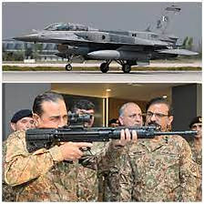

Https://istheonlywayjesusc.wixsite.com/eternal-paul-eliya
Https://istheonlywayjesusc.wixsite.com/soul
Https://istheonlywayjesusc.wixsite.com/indian
https://istheonlywayjesusc.wixsite.com/pakistan-army-408
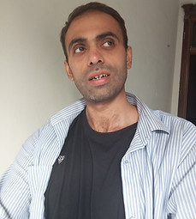
DREAM
IS JESUS

PAKISTAN ARMY

Syed Ali Abbas Paul Eliya eliyasyedaliabbaspaul@gmail.com
23:58 (1 minute ago)
to AD.AstonAndSuttonColdfield, AD.ColeshillAndPolesworth, AD.HandsworthAndCentral, AD.KNMS, Admin, Citizen, CPIinfoMali, Courrier, Fadi.El-Abdallah, Falak, FreeJobs, GENESIS, Info, JU, Mike.Sermon, Nick.Parker, OTP, OTPNewsDesk, Ohchr-dexrel, Ombudsman, Passport.london, Paul, Perfect, Procurement, Security, Here's, Sohaibchoudry221998, me, WaleedbinToufeeq, WeTrip, achats, administrator, agnes.eklund, agnes.jansson, ahmadiaportugal, alexandra.cederquist, amjmalta, andia.gemsjo, anna.erhardt, anna.lund, apdpftac2, applications, appt.london, atfal, attcons.washington, bilal.lodhi, bishop.david, bishopofaston, bishopsadmin, bookkeeping, caritas.internationalis, cee-office, ceo, com.tehran, com3.washington, commregen, comms, communications, cons.islamabad, cons.tehran, cons1.telaviv, cons2.telaviv, cons6.washington, consuly, contact, contact, contact, contactus, contatti, copyright, dave, dioceseoflondon, discipleship, donorcare, eastafritac, editor, education, elana, emergencies, enquiry, environment, farrakhmansoor, financeteam, flex, frezza, fsoci.washington, fspic.washington, fund, givingtogether, glavno.tajnistvo, hammad.tariq, helpdesk, helpdesk, helplinephc, hoc.babbas, hoc.tehran, hqepu, hr, hr, hrmartha, i.registrar, ieo, imam.ahmed, imffa, imfvideo, inclusiveandaccessible, info, info, info, info, info, info, info, info, info, info, info, info, info, info, info, info, info, info, information, information.hebrew, interculturalmission, interfaith, irnte, irnteprt, isaac.elm.communications, isbad, jennyt, ju.registrar, kancelaria, khuddamireland, kontakt, kontakt, kontakt, kpk, lahore, lahore_churchcouncil, library, marriagebureau34, media, media, mineco.washington, ministry, mohsin.talpur, mubbbutt, muhammad.tariq, newchristiancommunities, ngoliaison, niazihaider786, obedarthur, office, office, ohchr-unvfvt, opinia_ta, ouse, paivytys.um, panatz, parishmissionsupport, parishsurveyor, pathways, peopleandplaces, petrosillo, pniot, press, pressoffice, procurement, property, psamb.washington, psdcm.washington, publicaffairs, publications, reception, recrutement-recruitment, reehanashraf, refworld, revchris007, safeguardingsupport, sah, sanam.javed, sbs.malta.heliga-stolen, secministerialmeetings, secretariat, sektor.jd.ks, shahid.wazir, socialdepartementet.registrator, spain, spyropoulos, support, support-india, support-pakistan, tcpak, ujieuropa, ured.drzavnog.tajnika, v-bknoojh_nnpgdkmghf_jdofaikg_jdoelhap_a, visa.islamabad, visaservicesphcnd, vocations, web, webmaster, weddings, contact, Пакистан, islamabad, islamabad.hum, islamabad.visa, islamabad.ziv, islamabad, pakistan, webmaster, asrcrwp, asrcfsd, asrclhr, asrckci, asrcpsc, asrcqta, asrcglt, asrcmzd, asrcmtn, asrckzd, asrchyd, asrcdik, asrcpnl, complaint, Public
from:Syed Ali Abbas Paul Eliya <eliyasyedaliabbaspaul@gmail.com>
to:AD.AstonAndSuttonColdfield@cofebirmingham.com,
AD.ColeshillAndPolesworth@cofebirmingham.com,
AD.HandsworthAndCentral@cofebirmingham.com,
AD.KNMS@cofebirmingham.com,
Admin@azadchaiwala.com,
Citizen Service of the Ministry of Foreign Affairs <borgarathjonusta@utn.is>,
CPIinfoMali@icc-cpi.int,
Courrier Elysée <courrier.president@elysee.fr>,
Fadi.El-Abdallah@icc-cpi.int,
Falak Tayab Corporate Service <careers@falaktayabcorporateservices.com>,
FreeJobs UAE <pr@advancelevelcon.com>,
GENESIS@matrimony.com,
Info@iranembassy.pk,
JU Brev <ju.brev@regeringskansliet.se>,
Mike.Sermon@cofebirmingham.com,
Nick.Parker@cofebirmingham.com,
"OTP InformationDesk (Article15)" <otp.informationdesk@icc-cpi.int>,
OTPNewsDesk@icc-cpi.int,
Ohchr-dexrel@un.org,
Ombudsman@mevaker.gov.il,
Passport.london@mea.gov.in,
Paul Eliya <eliyapaul289@gmail.com>,
Perfect LLC <hr@perfectllcdubai.com>,
Procurement@icc-cpi.int,
Security@icc-cpi.int,
Here's Puthran <visa.washington@mea.gov.in>,
Sohaibchoudry221998@gmail.com,
Syed Ali Abbas Paul Eliya <eliyasyedaliabbaspaul@gmail.com>,
WaleedbinToufeeq@gmail.com,
WeTrip <contact@wetrip.pk>,
achats@icj-cij.org,
administrator@stmarksitaly.com,
agnes.eklund@regeringskansliet.se,
agnes.jansson@gov.se,
ahmadiaportugal@hotmail.com,
alexandra.cederquist@gov.se,
amjmalta@gmail.com,
andia.gemsjo@regeringskansliet.se,
anna.erhardt@gov.se,
anna.lund@gov.se,
apdpftac2@imf.org,
applications@icc-cpi.int,
appt.london@mea.gov.in,
atfal@atfal.de,
attcons.washington@mea.gov.in,
bilal.lodhi@bop.com.pk,
bishop.david@manchester.anglican.org,
bishopofaston@cofebirmingham.com,
bishopsadmin@cofebirmingham.com,
bookkeeping@cofebirmingham.com,
caritas.internationalis@caritas.va,
cee-office@imf.org,
ceo@sadiqtravels.com,
com.tehran@mea.gov.in,
com3.washington@mea.gov.in,
commregen@cofebirmingham.com,
comms@cofebirmingham.com,
communications@london.anglican.org,
cons.islamabad@mea.gov.in,
cons.tehran@mea.gov.in,
cons1.telaviv@mea.gov.in,
cons2.telaviv@mea.gov.in,
cons6.washington@mea.gov.in,
consuly@iranembassy.pk,
contact@fatf-gafi.org,
contact@ahmadiyya.fr,
contact@ahmadiyya.dk,
contactus@iaa.gov.il,
contatti@alislam.it,
copyright@imf.org,
dave@redeemerdubai.com,
dioceseoflondon@luther.co.uk,
discipleship@cofebirmingham.com,
donorcare@unhcr.ca,
eastafritac@imf.org,
editor@chanakyaforum.com,
education@cofebirmingham.com,
elana@israelforever.org,
emergencies@caritas.va,
enquiry@churchofengland.org,
environment@cofebirmingham.com,
farrakhmansoor@hot.ee,
financeteam@cofebirmingham.com,
flex@cofebirmingham.com,
frezza@caritas.va,
fsoci.washington@mea.gov.in,
fspic.washington@mea.gov.in,
fund@end-violence.org,
givingtogether@imf.org,
glavno.tajnistvo@mvep.hr,
hammad.tariq@sindhbankltd.com,
helpdesk@lajnauk.org,
helpdesk@lajna.be,
helplinephc@gmail.com,
hoc.babbas@mea.gov.in,
hoc.tehran@mea.gov.in,
hqepu@unhcr.org,
hr@cofebirmingham.com,
hr fatima ali <hrfatimaali@gmail.com>,
hrmartha roy <hrmagraroy@gmail.com>,
i.registrar@gov.se,
ieo@imf.org,
imam.ahmed@ahmadiyya.ch,
imffa@imf.org,
imfvideo@imf.org,
inclusiveandaccessible@cofebirmingham.com,
info@thrivetogetherbham.org,
info@ahmadiyya.ch,
info@education.gov.il,
info@imfmetac.org,
info@end-violence.org,
info@visitouriran.com,
info@khuddam.co.uk,
info@ziyarahtours.net,
info@farrukhsaif.com,
info@ansar.org.uk,
info@alavitravel.com,
info@khuddam.nl,
info@sadiqtravels.com,
info@travelfatimah.com,
info@khuddam.be,
info@alsahlah.com,
info@cartac.org,
info@refugepoint.org,
information@icj-cij.org,
information.hebrew@yadvashem.org.il,
interculturalmission@cofebirmingham.com,
interfaith@cofebirmingham.com,
irnte@unhcr.org,
irnteprt@unhcr.org,
isaac.elm.communications@gmail.com,
isbad@international.gc.ca,
jennyt@cofebirmingham.com,
ju.registrar@gov.se,
kancelaria@msz.gov.pl,
khuddamireland@gmail.com,
kontakt@ahmadiyya.de,
kontakt@ahmadiyya.no,
kontakt@lajna.de,
kpk@pasb.mod.gov.pk,
lahore@hk-diplo.de,
lahore_churchcouncil@yahoo.com,
library@icj-cij.org,
marriagebureau34@gmail.com,
media@imf.org,
media@fatf-gafi.org,
mineco.washington@mea.gov.in,
ministry@cofebirmingham.com,
mohsin.talpur@sindhbankltd.com,
mubbbutt@gmail.com,
muhammad.tariq@mofa.gov.pk,
newchristiancommunities@cofebirmingham.com,
ngoliaison@imf.org,
niazihaider786@gmail.com,
obedarthur@gmail.com,
office@saintmarysdubai.org,
office@ahmadiyya.at,
ohchr-unvfvt@un.org,
opinia_ta@mae.ro,
ouse winterz <ousewinterz1@gmail.com>,
paivytys.um@gov.fi,
panatz@rbc.gov.il,
parishmissionsupport@cofebirmingham.com,
parishsurveyor@cofebirmingham.com,
pathways@cofebirmingham.com,
peopleandplaces@cofebirmingham.com,
petrosillo@caritas.va,
pniot@mod.gov.il,
press@pakchristiannews.com,
pressoffice@phclondon.org,
procurement@imf.org,
property@cofebirmingham.com,
psamb.washington@mea.gov.in,
psdcm.washington@mea.gov.in,
publicaffairs@imf.org,
publications@imf.org,
reception@london.anglican.org,
recrutement-recruitment@icj-cij.org,
reehanashraf@hotmail.com,
refworld@unhcr.org,
revchris007@gmail.com,
safeguardingsupport@cofebirmingham.com,
sah@cis-iwc.org,
sanam.javed@sindhbankltd.com,
sbs.malta.heliga-stolen@gov.se,
secministerialmeetings@imf.org,
secretariat@end-violence.org,
sektor.jd.ks@mvep.hr,
shahid.wazir@sindhbankltd.com,
socialdepartementet.registrator@gov.se,
spain@alislam.org,
spyropoulos@hotmail.co.uk,
support@ustravel.com,
support-india@ustraveldocs.com,
support-pakistan@ustraveldocs.com,
tcpak@um.dk,
ujieuropa@mvep.hr,
ured.drzavnog.tajnika@mvep.hr,
v-bknoojh_nnpgdkmghf_jdofaikg_jdoelhap_a@bounce.studentenquiry.mkt4116.com,
visa.islamabad@mea.gov.in,
visaservicesphcnd@gmail.com,
vocations@cofebirmingham.com,
web@mae.ro,
webmaster@icj-cij.org,
weddings@holytrinity.ae,
contact@majorgauravarya.com,
"Генконсульство России в г. Карачи, Пакистан" <karachi@mid.ru>,
islamabad@dks.ru,
islamabad.hum@eda.admin.ch,
islamabad.visa@eda.admin.ch,
islamabad.ziv@eda.admin.ch,
islamabad@eda.admin.ch,
pakistan@mid.ru,
webmaster@joinpakarmy.gov.pk,
asrcrwp@joinpakarmy.gov.pk,
asrcfsd@joinpakarmy.gov.pk,
asrclhr@joinpakarmy.gov.pk,
asrckci@joinpakarmy.gov.pk,
asrcpsc@joinpakarmy.gov.pk,
asrcqta@joinpakarmy.gov.pk,
asrcglt@joinpakarmy.gov.pk,
asrcmzd@joinpakarmy.gov.pk,
asrcmtn@joinpakarmy.gov.pk,
asrckzd@joinpakarmy.gov.pk,
asrchyd@joinpakarmy.gov.pk,
asrcdik@joinpakarmy.gov.pk,
asrcpnl@joinpakarmy.gov.pk,
complaint@thepakarmy.com,
Public Response Unit <inf.london@mea.gov.in>
date:8 Dec 2024, 23:58
subject:PAKISTAN ARMY
mailed-by:gmail.com
:Important mainly because it was sent directly to you.
​
To: Ministry of Religious Affairs, Minority and Interfaith Harmony
8th Floor, Green Trust Tower, Blue Area, Islamabad

Subject: Request for Justice, Financial Assistance, and Security

Dear Honorable Minister,

I, Paul Eliya, a local pastor and grandson of Late Brig Syed Ahmed (PA#2638), am writing to request justice and assistance from the Ministry of Religious Affairs, Minority and Interfaith Harmony.

In 2014, I was maliciously accused of blasphemy against Prophet Muhammad and the Quran, leading to mob lynching and the forced takeover of my 40 Marlas church property in Rawalpindi. The accused individuals, including Raja Amjad Iqbal Abbasi and my relatives, obtained signatures and thumb impressions from my parents under duress.

Since then, I have faced ongoing persecution, which is documented on my website: https://istheonlywayjesusc.wixsite.com/pakistan-army-408
Https://istheonlywayjesusc.wixsite.com/eternal-paul-eliya
I have already requested Pakistan Army to Grant me the Captain Rank in 408 Intelligence Battalion With Khaki Uniform with all Protocols and Entitlements Benefits to Join PAK ARMY AND PAKISTAN AIR FORCE AS AN F-16 FALCON FIGHTER PILOT OR IN US AIR FORCE as an F-35 Fighter Pilot in the light of my only Good Work, my Contribution for Beloved Pakistan for saving the World so I Thank God Jesus Christ for Everything, I request:

1. Repossession of my church property and Sangjani Land of 10 Kanals
2. Financial assistance of Rs 5,00,000/-.
3. Security for my life and family.
4. A job opportunity.
5. Assistance in traveling to a safe Christian country or a secure location within Pakistan.

My case is currently under process at the Pakistan Army Help Centre (PA#2638).
I kindly request that you take up my voice to Christian countries for help and justice.

Contact Information:
CNIC# 37405-0365980-9
Email: eliyapaul962@gmail.com
Phone: 03145550432, 03185309511
Address: House#96, Lane#4, Block D, Sector 4, Airport Housing Society, Rawalpindi Cantt 46000

Thank you for your attention to this matter.

Sincerely,
Paul Eliya
​
​
​
​
​
​
​
​
​
​
​
​
​
​
​
​
​
​
​
​
​
​
​
​
​
​
​
​
​
​
​
​
​
​
​
​

DREAM
IS ETERNAL
ENTER
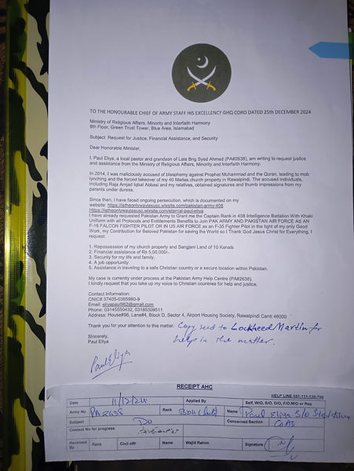
RefugePoint Info <info+canned.response@refugepoint.org> |  |  | 12:40 PM (46 minutes ago)
to me

from: | RefugePoint Info <info+canned.response@refugepoint.org>
to: | eliyapaul962@gmail.com
date: | Dec 25, 2024, 12:40 PM
subject: | Re: HAPPY CHRISTMAS
mailed-by: | refugepoint.org
signed-by: | refugepoint.org
security: | Standard encryption (TLS) Learn more
: | Important because previous messages in the conversation were important.
Thank you for contacting RefugePoint. Due to the high volume of correspondence we receive we are unable to respond to every email. On our Frequently Asked Questions (FAQs) web page you will find answers to many questions, including what steps to take if you are a refugee who needs help, ways to support our mission, and more.
Below is information for the most common questions we receive:
- If you are a refugee seeking assistance, including in relation to family reunification, consult the UNHCR Help page for the country in which you are located.
- If you are a refugee seeking sponsorship in the US, consult the Information for Refugees page on the Welcome Corps website. RefugePoint is unable to serve as a sponsor or to secure a sponsor for this program. Similarly, we are unable to serve as a financial sponsor for humanitarian parole programs.
- For information on how to sponsor a refugee through the Welcome Corps, please visit www.welcomecorps.org.
- For inquiries related to the economic mobility pathways program (work-based visas), we regret that we are unable to assist applicants outside of our existing program in Kenya.
- For media inquiries or speaker requests, please email communications@refugepoint.org.
- For donation inquiries, please email giving@refugepoint.org
- For employment, internship or volunteer opportunities, see our Careers page where all openings are posted.
- If you are seeking funding for your organization, please note that RefugePoint is not a grant-making entity and cannot respond to unsolicited requests for funding or partnership.

Please note that this message is an auto-reply

Thank you.
The RefugePoint Team

Conversation opened. 1 unread message.
Skip to content
Using Gmail with screen readers

Top of Form

Search
Bottom of Form
Try Gemini

Enable desktop notifications for Gmail. OK No thanks
Compose

Labels
Inbox
92
Starred
Snoozed
Sent
Drafts
17
More

Labels

Labels
9 of 118
Print all
In new window

Your ustraveldocs.com inquiry Case-2025- 01-05-022058500 Has Been Closed
Inbox
Search for all messages with label Inbox
Remove label Inbox from this conversation

support@ustraveldocs.com |  |  | 8:51 AM (10 hours ago)
to me

from: | support@ustraveldocs.com <support@ustraveldocs.com>
to: | "eliyapaul962@gmail.com" <eliyapaul962@gmail.com>
date: | Jan 6, 2025, 8:51 AM
subject: | Your ustraveldocs.com inquiry Case-2025- 01-05-022058500 Has Been Closed
mailed-by: | 13zei70ao48x.c-phupmas.usa9002.bnc.salesforce.com
signed-by: | ustraveldocs.com
security: | Standard encryption (TLS) Learn more
: | Important mainly because it was sent directly to you.
Your case has been updated, please log back into your account to view the details.
 | Date/Time Case Opened: |  | 1/6/2025 5:35 AM
 | Description: |  | The Honourable RAW Chief His Excellency  Research and Analysis Wing Headquarters New Delhi India  And  The Honourable The Excellency Pakistan Army Chief of Army Staff Through  Army Help Centre Wajid Rahim Sahab 051111130786  Government of Pakistan  Through Honourable Federal Housing and Works Minister Mian Riaz Hussain  Pirzada Via  Dy. No.508/2024-Ministry of Housing and Works 051-9209753 Dated 6th  December 2024  *Request for issuance of File Number** of 14 Marla Plot in G-12 or In F-12  from FGEHA under Retired Quota* To The Retired Senior Most Deputy Chief  NTRC BPS-19 Ministry of Communication AGPR Personal Number 50036345  holding CNIC#37405-3293752-5, Date of Birth 18-09-1958, Date of Retirement:  17-09-2018,  Date of Membership 13/01/2020  Category 2, Computer Generated Number 120519, Membership Drive Phase 2  Regards  HASSAN SYED  Https://istheonlywayjesusc.wixsite.com/pakistan-army-408  <https://istheonlywayjesusc.wixsite.com/pakistan-army-408>  0314-5550432  Cc to  1. Minister Incharge/Chairman Mian Riaz Hussain Pirzada (Federal  Minister of Housing & Works)  2. Federal Secretary (Housing & Works) Dr. Shahzad Khan Bangash  3. Director General Capt. (Retd.) Muhammad Zafar Iqbal  4. CDA CHAIRMAN ISLAMABAD  5. AHC 051-111-130-786 DATED: 6-1-2025  Special Note: SOS ASAP  I am Happy to live and die in my Beloved Motherland Pakistan because in my  hard times eternally my country gives me my Right and comfort me like Jesus  Christ giving me rest and Peace then why should I leave my beloved people  when everyone else in the world has abandoned me, I want to live in  Pakistan Eternally with all my Soul's Goodness and Love unconditionally  along with my Beloved Ones along with my belongings and along with my Good  Works in my website Https://istheonlywayjesusc.wixsite.com/Pakistan-Army-408  <https://istheonlywayjesusc.wixsite.com/Pakistan-Army-408>
 | Origin: |  | Email
 | Case Reason: |  | Request for Allotment
 | Public Response: |  | Dear Paul Eliya:  Thank you for writing to the U.S. Visa Service Desk.  We understand that you have shared a concern beyond the scope of our service.  As the U.S. Visa Service Desk, we only assist applicants who are applying for a U.S. visa in Pakistan. If you have any queries about the U.S. visa application, we will be glad to assist you with the information.  We hope this answers your query.  Please visit https://www.surveymonkey.com/s/gss_pakistan to share feedback on the services we provide.  Have a pleasant day!  Sincerely,  U.S. Visa Service Desk
ReplyForward
Add reaction

Your E-Mail has been received and your Case #(Case-2025- 01-05-022058500) has been created.
Inbox
Search for all messages with label Inbox
Remove label Inbox from this conversation
No Reply |  |  | 2:35 AM (16 hours ago)
to me

from: | No Reply <no-reply@ustraveldocs.com>
to: | "eliyapaul962@gmail.com" <eliyapaul962@gmail.com>
date: | Jan 6, 2025, 2:35 AM
subject: | Your E-Mail has been received and your Case #(Case-2025- 01-05-022058500) has been created.
mailed-by: | sffi7s5dkq6m.c-phupmas.usa9002.bnc.salesforce.com
signed-by: | ustraveldocs.com
security: | Standard encryption (TLS) Learn more
: | Important according to Google magic.
We have received your email and will respond accordingly within 1 to 2 business days.
The details are as follows:
Date/Time Case Opened: | 1/5/2025 4:35 PM
Description: | The Honourable RAW Chief His Excellency  Research and Analysis Wing Headquarters New Delhi India  And  The Honourable The Excellency Pakistan Army Chief of Army Staff Through  Army Help Centre Wajid Rahim Sahab 051111130786  Government of Pakistan  Through Honourable Federal Housing and Works Minister Mian Riaz Hussain  Pirzada Via  Dy. No.508/2024-Ministry of Housing and Works 051-9209753 Dated 6th  December 2024  *Request for issuance of File Number** of 14 Marla Plot in G-12 or In F-12  from FGEHA under Retired Quota* To The Retired Senior Most Deputy Chief  NTRC BPS-19 Ministry of Communication AGPR Personal Number 50036345  holding CNIC#37405-3293752-5, Date of Birth 18-09-1958, Date of Retirement:  17-09-2018,  Date of Membership 13/01/2020  Category 2, Computer Generated Number 120519, Membership Drive Phase 2  Regards  HASSAN SYED  Https://istheonlywayjesusc.wixsite.com/pakistan-army-408  <https://istheonlywayjesusc.wixsite.com/pakistan-army-408>  0314-5550432  Cc to  1. Minister Incharge/Chairman Mian Riaz Hussain Pirzada (Federal  Minister of Housing & Works)  2. Federal Secretary (Housing & Works) Dr. Shahzad Khan Bangash  3. Director General Capt. (Retd.) Muhammad Zafar Iqbal  4. CDA CHAIRMAN ISLAMABAD  5. AHC 051-111-130-786 DATED: 6-1-2025  Special Note: SOS ASAP  I am Happy to live and die in my Beloved Motherland Pakistan because in my  hard times eternally my country gives me my Right and comfort me like Jesus  Christ giving me rest and Peace then why should I leave my beloved people  when everyone else in the world has abandoned me, I want to live in  Pakistan Eternally with all my Soul's Goodness and Love unconditionally  along with my Beloved Ones along with my belongings and along with my Good  Works in my website Https://istheonlywayjesusc.wixsite.com/Pakistan-Army-408  <https://istheonlywayjesusc.wixsite.com/Pakistan-Army-408>
Origin: | Email
Case Reason: | Request for Allotment
Case Status: | New

Dear RAW Chief
Paul Eliya1 <eliyapaul962@gmail.com> |  |  | 2:48 AM (16 hours ago)
to contact

from: | Paul Eliya1 <eliyapaul962@gmail.com>
to: | contact@majorgauravarya.com
date: | Jan 6, 2025, 2:48 AM
subject: | Dear RAW Chief
mailed-by: | gmail.com
The Honourable RAW Chief His Excellency
Research and Analysis Wing Headquarters New Delhi India
And
The Honourable The Excellency Pakistan Army Chief of Army Staff Through Army Help Centre Wajid Rahim Sahab 051111130786
Government of Pakistan
Through Honourable Federal Housing and Works Minister Mian Riaz Hussain Pirzada Via
Dy. No.508/2024-Ministry of Housing and Works 051-9209753 Dated 6th December 2024
Request for issuance of File Number of 14 Marla Plot in G-12 or In F-12 from FGEHA under Retired Quota To The Retired Senior Most Deputy Chief NTRC BPS-19 Ministry of Communication AGPR Personal Number 50036345
holding CNIC#37405-3293752-5, Date of Birth 18-09-1958, Date of Retirement: 17-09-2018,
Date of Membership 13/01/2020
Category 2, Computer Generated Number 120519, Membership Drive Phase 2
Regards
HASSAN SYED
Https://istheonlywayjesusc.wixsite.com/pakistan-army-408
0314-5550432

Cc to
1. Minister Incharge/Chairman Mian Riaz Hussain Pirzada (Federal Minister of Housing & Works)
2. Federal Secretary (Housing & Works) Dr. Shahzad Khan Bangash
3. Director General Capt. (Retd.) Muhammad Zafar Iqbal
4. CDA CHAIRMAN ISLAMABAD
5. AHC 051-111-130-786 DATED: 6-1-2025
Special Note: SOS ASAP
I am Happy to live and die in my Beloved Motherland Pakistan because in my hard times eternally my country gives me my Right and comfort me like Jesus Christ giving me rest and Peace then why should I leave my beloved people when everyone else in the world has abandoned me, I want to live in Pakistan Eternally with all my Soul's Goodness and Love unconditionally along with my Beloved Ones along with my belongings and along with my Good Works in my website Https://istheonlywayjesusc.wixsite.com/Pakistan-Army-408
ReplyForward
Add reaction

Request for Allotment
Inbox
Search for all messages with label Inbox
Remove label Inbox from this conversation
Paul Eliya1 <eliyapaul962@gmail.com> |  | 2:34 AM (16 hours ago)
to dg, complaint, director.admin, director.finance, director.estate, director.jv, director.law, director.coord, director.IT, director.technical, director.security, director.ia, director.planning, director.land, director.maintenance, director.revenue, director.jvkci, AD.AstonAndSuttonColdfield, AD.ColeshillAndPolesworth, AD.HandsworthAndCentral, AD.KNMS, Admin, Citizen, CPIinfoMali, Courrier, Fadi.El-Abdallah, Falak, FreeJobs, GENESIS, Info, JU, Mike.Sermon, Nick.Parker, OTP, OTPNewsDesk, Ohchr-dexrel, Ombudsman, Passport.london, Paul, Perfect, Procurement, Security, Here's, Sohaibchoudry221998, Syed, WaleedbinToufeeq, WeTrip, achats, administrator, agnes.eklund, agnes.jansson, ahmadiaportugal, alexandra.cederquist, amjmalta, andia.gemsjo, anna.erhardt, anna.lund, apdpftac2, applications, appt.london, atfal, attcons.washington, bilal.lodhi, bishop.david, bishopofaston, bishopsadmin, bookkeeping, caritas.internationalis, cee-office, ceo, com.tehran, com3.washington, commregen, comms, communications, cons.islamabad, cons.tehran, cons1.telaviv, cons2.telaviv, cons6.washington, consuly, contact, contact, contact, contactus, contatti, copyright, dave, dioceseoflondon, discipleship, donorcare, eastafritac, editor, education, elana, emergencies, enquiry, environment, farrakhmansoor, financeteam, flex, frezza, fsoci.washington, fspic.washington, fund, givingtogether, glavno.tajnistvo, hammad.tariq, helpdesk, helpdesk, helplinephc, hoc.babbas, hoc.tehran, hqepu, hr, hr, hrmartha, i.registrar, ieo, imam.ahmed, imffa, imfvideo, inclusiveandaccessible, info, info, info, info, info, info, info, info, info, info, info, info, info, info, info, info, info, info, information, information.hebrew, interculturalmission, interfaith, irnte, irnteprt, isaac.elm.communications, isbad, jennyt, ju.registrar, kancelaria, khuddamireland, kontakt, kontakt, kontakt, kpk, lahore, lahore_churchcouncil, library, marriagebureau34, media, media, mineco.washington, ministry, mohsin.talpur, mubbbutt, muhammad.tariq, newchristiancommunities, ngoliaison, niazihaider786, obedarthur, office, office, ohchr-unvfvt, opinia_ta, ouse, paivytys.um, panatz, parishmissionsupport, parishsurveyor, pathways, peopleandplaces, petrosillo, pniot, press, pressoffice, procurement, property, psamb.washington, psdcm.washington, publicaffairs, publications, reception, recrutement-recruitment, reehanashraf, refworld, revchris007, safeguardingsupport, sah, sanam.javed, sbs.malta.heliga-stolen, secministerialmeetings, secretariat, sektor.jd.ks, shahid.wazir, socialdepartementet.registrator, spain, spyropoulos, support, support-india, support-pakistan, tcpak, ujieuropa, ured.drzavnog.tajnika, v-bknoojh_nnpgdkmghf_jdofaikg_jdoelhap_a, visa.islamabad, visaservicesphcnd, vocations, web, webmaster, weddings, contact, Пакистан, islamabad, islamabad.hum, islamabad.visa, islamabad.ziv, islamabad, pakistan, Webmaster, asrcrwp, asrcfsd, asrclhr, asrckci, asrcpsc, asrcqta, asrcglt, asrcmzd, asrcmtn, asrckzd, asrchyd, asrcdik, asrcpnl, complaint, Public, me, dd-it1

from: | Paul Eliya1 <eliyapaul962@gmail.com>
to: | dg@fgeha.gov.pk,  complaint@fgeha.gov.pk,  director.admin@fgeha.gov.pk,  director.finance@fgeha.gov.pk,  director.estate@fgeha.gov.pk,  director.jv@fgeha.gov.pk,  director.law@fgeha.gov.pk,  director.coord@fgeha.gov.pk,  director.IT@fgeha.gov.pk,  director.technical@fgeha.gov.pk,  director.security@fgeha.gov.pk,  director.ia@fgeha.gov.pk,  director.planning@fgeha.gov.pk,  director.land@fgeha.gov.pk,  director.maintenance@fgeha.gov.pk,  director.revenue@fgeha.gov.pk,  director.jvkci@fgeha.gov.pk,  AD.AstonAndSuttonColdfield@cofebirmingham.com,  AD.ColeshillAndPolesworth@cofebirmingham.com,  AD.HandsworthAndCentral@cofebirmingham.com,  AD.KNMS@cofebirmingham.com,  Admin@azadchaiwala.com,  Citizen Service of the Ministry of Foreign Affairs <borgarathjonusta@utn.is>,  CPIinfoMali@icc-cpi.int,  Courrier Elysée <courrier.president@elysee.fr>,  Fadi.El-Abdallah@icc-cpi.int,  Falak Tayab Corporate Service <careers@falaktayabcorporateservices.com>,  FreeJobs UAE <pr@advancelevelcon.com>,  GENESIS@matrimony.com,  Info@iranembassy.pk,  JU Brev <ju.brev@regeringskansliet.se>,  Mike.Sermon@cofebirmingham.com,  Nick.Parker@cofebirmingham.com,  "OTP InformationDesk (Article15)" <otp.informationdesk@icc-cpi.int>,  OTPNewsDesk@icc-cpi.int,  Ohchr-dexrel@un.org,  Ombudsman@mevaker.gov.il,  Passport.london@mea.gov.in,  Paul Eliya <eliyapaul289@gmail.com>,  Perfect LLC <hr@perfectllcdubai.com>,  Procurement@icc-cpi.int,  Security@icc-cpi.int,  Here's Puthran <visa.washington@mea.gov.in>,  Sohaibchoudry221998@gmail.com,  Syed Ali Abbas Paul Eliya <eliyasyedaliabbaspaul@gmail.com>,  WaleedbinToufeeq@gmail.com,  WeTrip <contact@wetrip.pk>,  achats@icj-cij.org,  administrator@stmarksitaly.com,  agnes.eklund@regeringskansliet.se,  agnes.jansson@gov.se,  ahmadiaportugal@hotmail.com,  alexandra.cederquist@gov.se,  amjmalta@gmail.com,  andia.gemsjo@regeringskansliet.se,  anna.erhardt@gov.se,  anna.lund@gov.se,  apdpftac2@imf.org,  applications@icc-cpi.int,  appt.london@mea.gov.in,  atfal@atfal.de,  attcons.washington@mea.gov.in,  bilal.lodhi@bop.com.pk,  bishop.david@manchester.anglican.org,  bishopofaston@cofebirmingham.com,  bishopsadmin@cofebirmingham.com,  bookkeeping@cofebirmingham.com,  caritas.internationalis@caritas.va,  cee-office@imf.org,  ceo@sadiqtravels.com,  com.tehran@mea.gov.in,  com3.washington@mea.gov.in,  commregen@cofebirmingham.com,  comms@cofebirmingham.com,  communications@london.anglican.org,  cons.islamabad@mea.gov.in,  cons.tehran@mea.gov.in,  cons1.telaviv@mea.gov.in,  cons2.telaviv@mea.gov.in,  cons6.washington@mea.gov.in,  consuly@iranembassy.pk,  contact@fatf-gafi.org,  contact@ahmadiyya.fr,  contact@ahmadiyya.dk,  contactus@iaa.gov.il,  contatti@alislam.it,  copyright@imf.org,  dave@redeemerdubai.com,  dioceseoflondon@luther.co.uk,  discipleship@cofebirmingham.com,  donorcare@unhcr.ca,  eastafritac@imf.org,  editor@chanakyaforum.com,  education@cofebirmingham.com,  elana@israelforever.org,  emergencies@caritas.va,  enquiry@churchofengland.org,  environment@cofebirmingham.com,  farrakhmansoor@hot.ee,  financeteam@cofebirmingham.com,  flex@cofebirmingham.com,  frezza@caritas.va,  fsoci.washington@mea.gov.in,  fspic.washington@mea.gov.in,  fund@end-violence.org,  givingtogether@imf.org,  glavno.tajnistvo@mvep.hr,  hammad.tariq@sindhbankltd.com,  helpdesk@lajnauk.org,  helpdesk@lajna.be,  helplinephc@gmail.com,  hoc.babbas@mea.gov.in,  hoc.tehran@mea.gov.in,  hqepu@unhcr.org,  hr@cofebirmingham.com,  hr fatima ali <hrfatimaali@gmail.com>,  hrmartha roy <hrmagraroy@gmail.com>,  i.registrar@gov.se,  ieo@imf.org,  imam.ahmed@ahmadiyya.ch,  imffa@imf.org,  imfvideo@imf.org,  inclusiveandaccessible@cofebirmingham.com,  info@thrivetogetherbham.org,  info@ahmadiyya.ch,  info@education.gov.il,  info@imfmetac.org,  info@end-violence.org,  info@visitouriran.com,  info@khuddam.co.uk,  info@ziyarahtours.net,  info@farrukhsaif.com,  info@ansar.org.uk,  info@alavitravel.com,  info@khuddam.nl,  info@sadiqtravels.com,  info@travelfatimah.com,  info@khuddam.be,  info@alsahlah.com,  info@cartac.org,  info@refugepoint.org,  information@icj-cij.org,  information.hebrew@yadvashem.org.il,  interculturalmission@cofebirmingham.com,  interfaith@cofebirmingham.com,  irnte@unhcr.org,  irnteprt@unhcr.org,  isaac.elm.communications@gmail.com,  isbad@international.gc.ca,  jennyt@cofebirmingham.com,  ju.registrar@gov.se,  kancelaria@msz.gov.pl,  khuddamireland@gmail.com,  kontakt@ahmadiyya.de,  kontakt@ahmadiyya.no,  kontakt@lajna.de,  kpk@pasb.mod.gov.pk,  lahore@hk-diplo.de,  lahore_churchcouncil@yahoo.com,  library@icj-cij.org,  marriagebureau34@gmail.com,  media@imf.org,  media@fatf-gafi.org,  mineco.washington@mea.gov.in,  ministry@cofebirmingham.com,  mohsin.talpur@sindhbankltd.com,  mubbbutt@gmail.com,  muhammad.tariq@mofa.gov.pk,  newchristiancommunities@cofebirmingham.com,  ngoliaison@imf.org,  niazihaider786@gmail.com,  obedarthur@gmail.com,  office@saintmarysdubai.org,  office@ahmadiyya.at,  ohchr-unvfvt@un.org,  opinia_ta@mae.ro,  ouse winterz <ousewinterz1@gmail.com>,  paivytys.um@gov.fi,  panatz@rbc.gov.il,  parishmissionsupport@cofebirmingham.com,  parishsurveyor@cofebirmingham.com,  pathways@cofebirmingham.com,  peopleandplaces@cofebirmingham.com,  petrosillo@caritas.va,  pniot@mod.gov.il,  press@pakchristiannews.com,  pressoffice@phclondon.org,  procurement@imf.org,  property@cofebirmingham.com,  psamb.washington@mea.gov.in,  psdcm.washington@mea.gov.in,  publicaffairs@imf.org,  publications@imf.org,  reception@london.anglican.org,  recrutement-recruitment@icj-cij.org,  reehanashraf@hotmail.com,  refworld@unhcr.org,  revchris007@gmail.com,  safeguardingsupport@cofebirmingham.com,  sah@cis-iwc.org,  sanam.javed@sindhbankltd.com,  sbs.malta.heliga-stolen@gov.se,  secministerialmeetings@imf.org,  secretariat@end-violence.org,  sektor.jd.ks@mvep.hr,  shahid.wazir@sindhbankltd.com,  socialdepartementet.registrator@gov.se,  spain@alislam.org,  spyropoulos@hotmail.co.uk,  support@ustravel.com,  support-india@ustraveldocs.com,  support-pakistan@ustraveldocs.com,  tcpak@um.dk,  ujieuropa@mvep.hr,  ured.drzavnog.tajnika@mvep.hr,  v-bknoojh_nnpgdkmghf_jdofaikg_jdoelhap_a@bounce.studentenquiry.mkt4116.com,  visa.islamabad@mea.gov.in,  visaservicesphcnd@gmail.com,  vocations@cofebirmingham.com,  web@mae.ro,  webmaster@icj-cij.org,  weddings@holytrinity.ae,  contact@majorgauravarya.com,  "Генконсульство России в г. Карачи, Пакистан" <karachi@mid.ru>,  islamabad@dks.ru,  islamabad.hum@eda.admin.ch,  islamabad.visa@eda.admin.ch,  islamabad.ziv@eda.admin.ch,  islamabad@eda.admin.ch,  pakistan@mid.ru,  Webmaster <webmaster@joinpakarmy.gov.pk>,  asrcrwp@joinpakarmy.gov.pk,  asrcfsd@joinpakarmy.gov.pk,  asrclhr@joinpakarmy.gov.pk,  asrckci@joinpakarmy.gov.pk,  asrcpsc@joinpakarmy.gov.pk,  asrcqta@joinpakarmy.gov.pk,  asrcglt@joinpakarmy.gov.pk,  asrcmzd@joinpakarmy.gov.pk,  asrcmtn@joinpakarmy.gov.pk,  asrckzd@joinpakarmy.gov.pk,  asrchyd@joinpakarmy.gov.pk,  asrcdik@joinpakarmy.gov.pk,  asrcpnl@joinpakarmy.gov.pk,  complaint@thepakarmy.com,  Public Response Unit <inf.london@mea.gov.in>,  Paul Eliya1 <eliyapaul962@gmail.com>,  dd-it1@fgeha.gov.pk
date: | Jan 6, 2025, 2:34 AM
subject: | Request for Allotment
mailed-by: | gmail.com
: | Important mainly because it was sent directly to you.
The Honourable RAW Chief His Excellency
Research and Analysis Wing Headquarters New Delhi India
And
The Honourable The Excellency Pakistan Army Chief of Army Staff Through Army Help Centre Wajid Rahim Sahab 051111130786
Government of Pakistan
Through Honourable Federal Housing and Works Minister Mian Riaz Hussain Pirzada Via
Dy. No.508/2024-Ministry of Housing and Works 051-9209753 Dated 6th December 2024
Request for issuance of File Number of 14 Marla Plot in G-12 or In F-12 from FGEHA under Retired Quota To The Retired Senior Most Deputy Chief NTRC BPS-19 Ministry of Communication AGPR Personal Number 50036345
holding CNIC#37405-3293752-5, Date of Birth 18-09-1958, Date of Retirement: 17-09-2018,
Date of Membership 13/01/2020
Category 2, Computer Generated Number 120519, Membership Drive Phase 2
Regards
HASSAN SYED
Https://istheonlywayjesusc.wixsite.com/pakistan-army-408
0314-5550432

Cc to
1. Minister Incharge/Chairman Mian Riaz Hussain Pirzada (Federal Minister of Housing & Works)
2. Federal Secretary (Housing & Works) Dr. Shahzad Khan Bangash
3. Director General Capt. (Retd.) Muhammad Zafar Iqbal
4. CDA CHAIRMAN ISLAMABAD
5. AHC 051-111-130-786 DATED: 6-1-2025
Special Note: SOS ASAP
I am Happy to live and die in my Beloved Motherland Pakistan because in my hard times eternally my country gives me my Right and comfort me like Jesus Christ giving me rest and Peace then why should I leave my beloved people when everyone else in the world has abandoned me, I want to live in Pakistan Eternally with all my Soul's Goodness and Love unconditionally along with my Beloved Ones along with my belongings and along with my Good Works in my website Https://istheonlywayjesusc.wixsite.com/Pakistan-Army-408
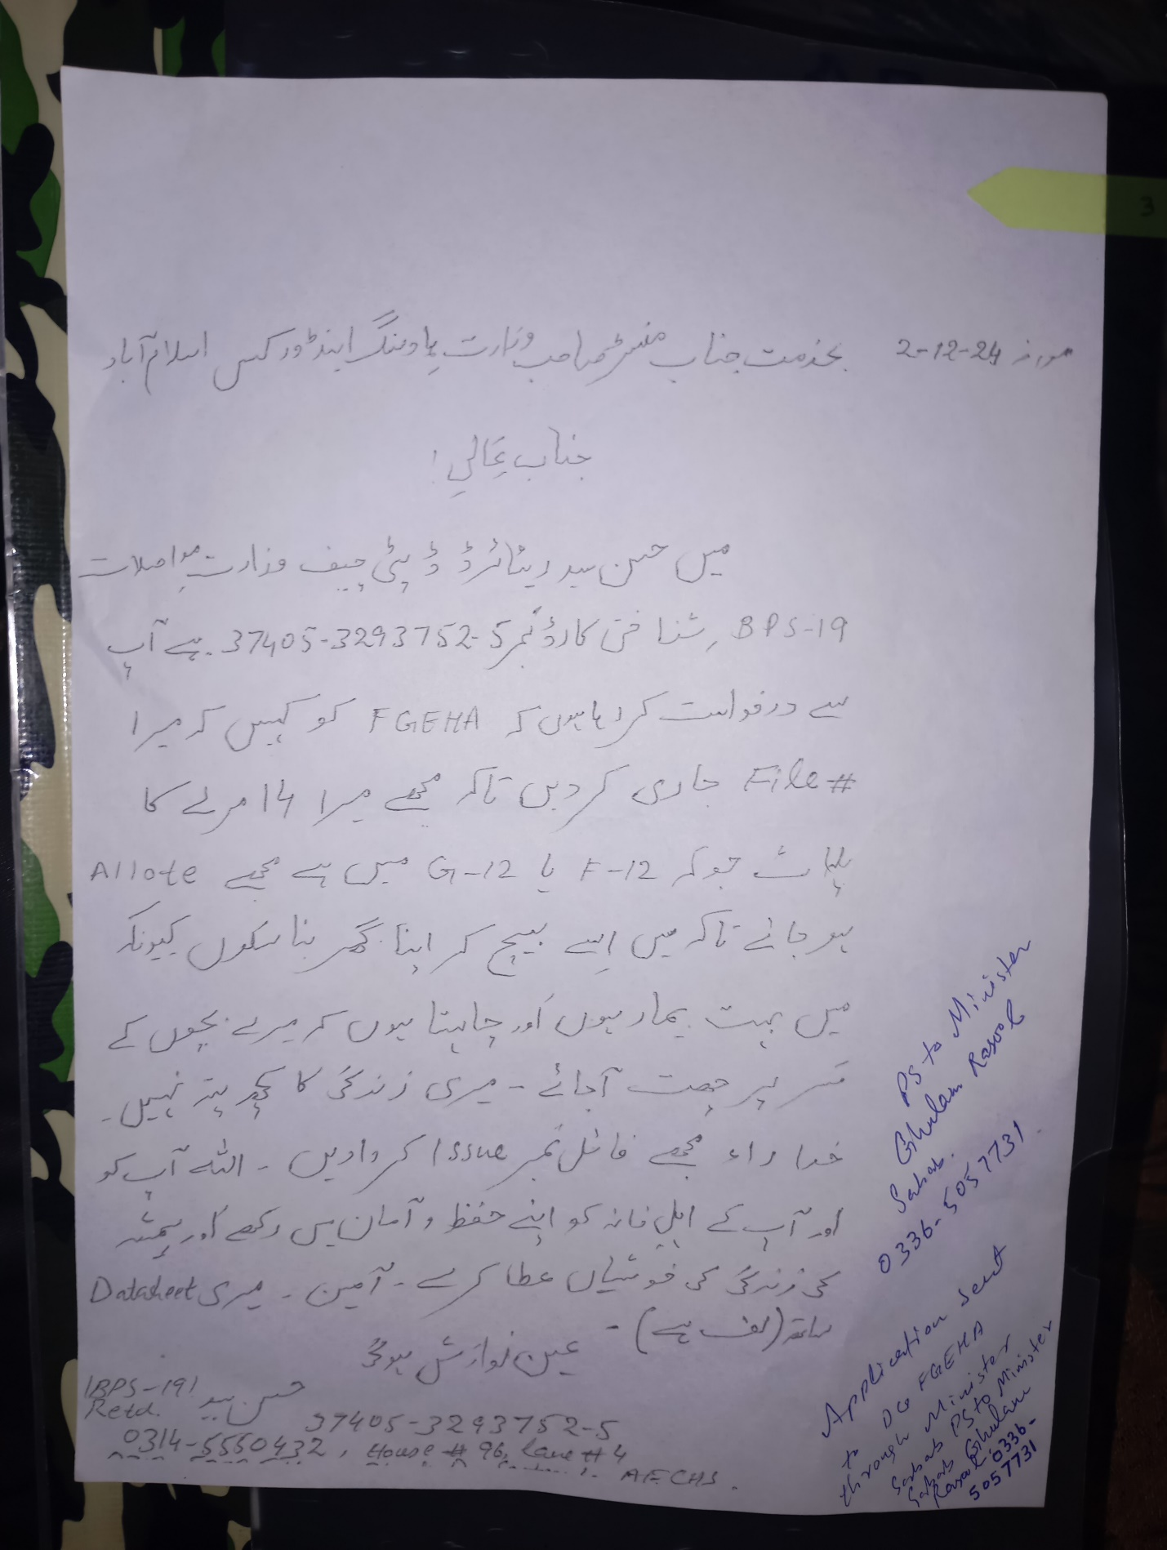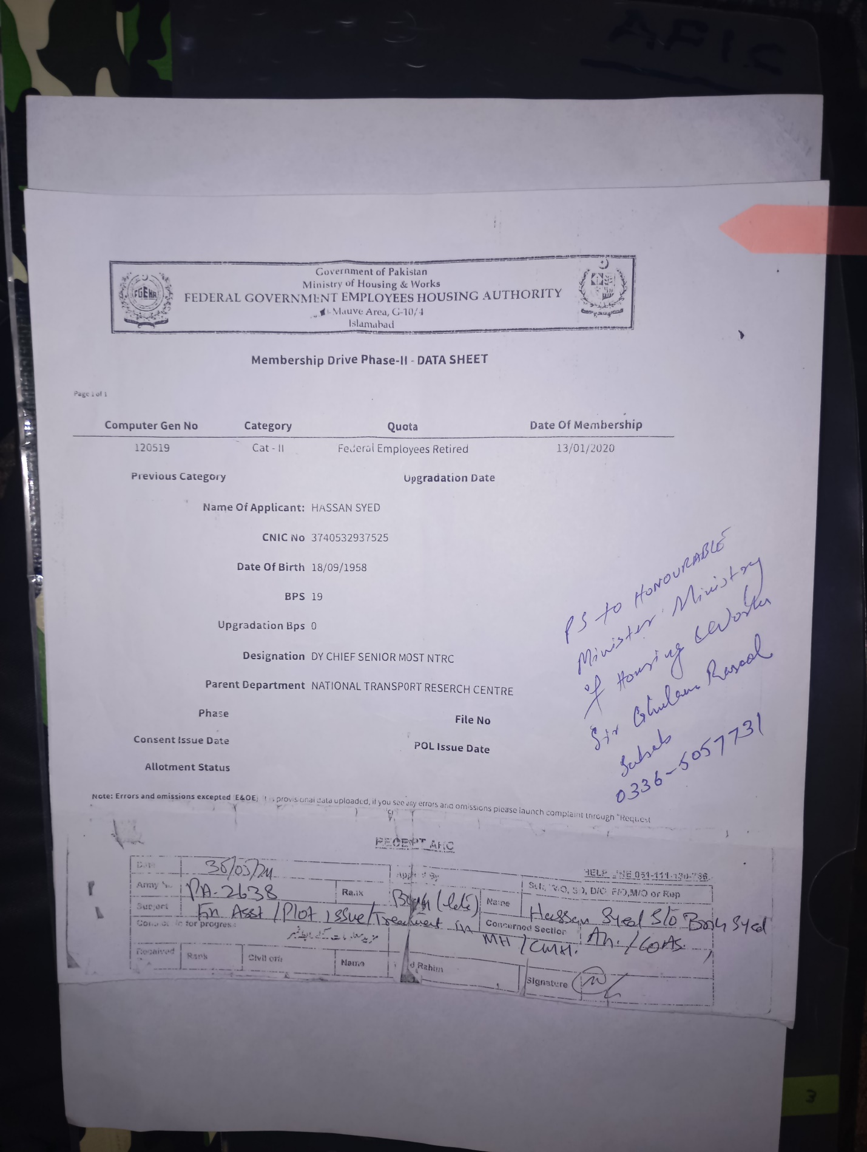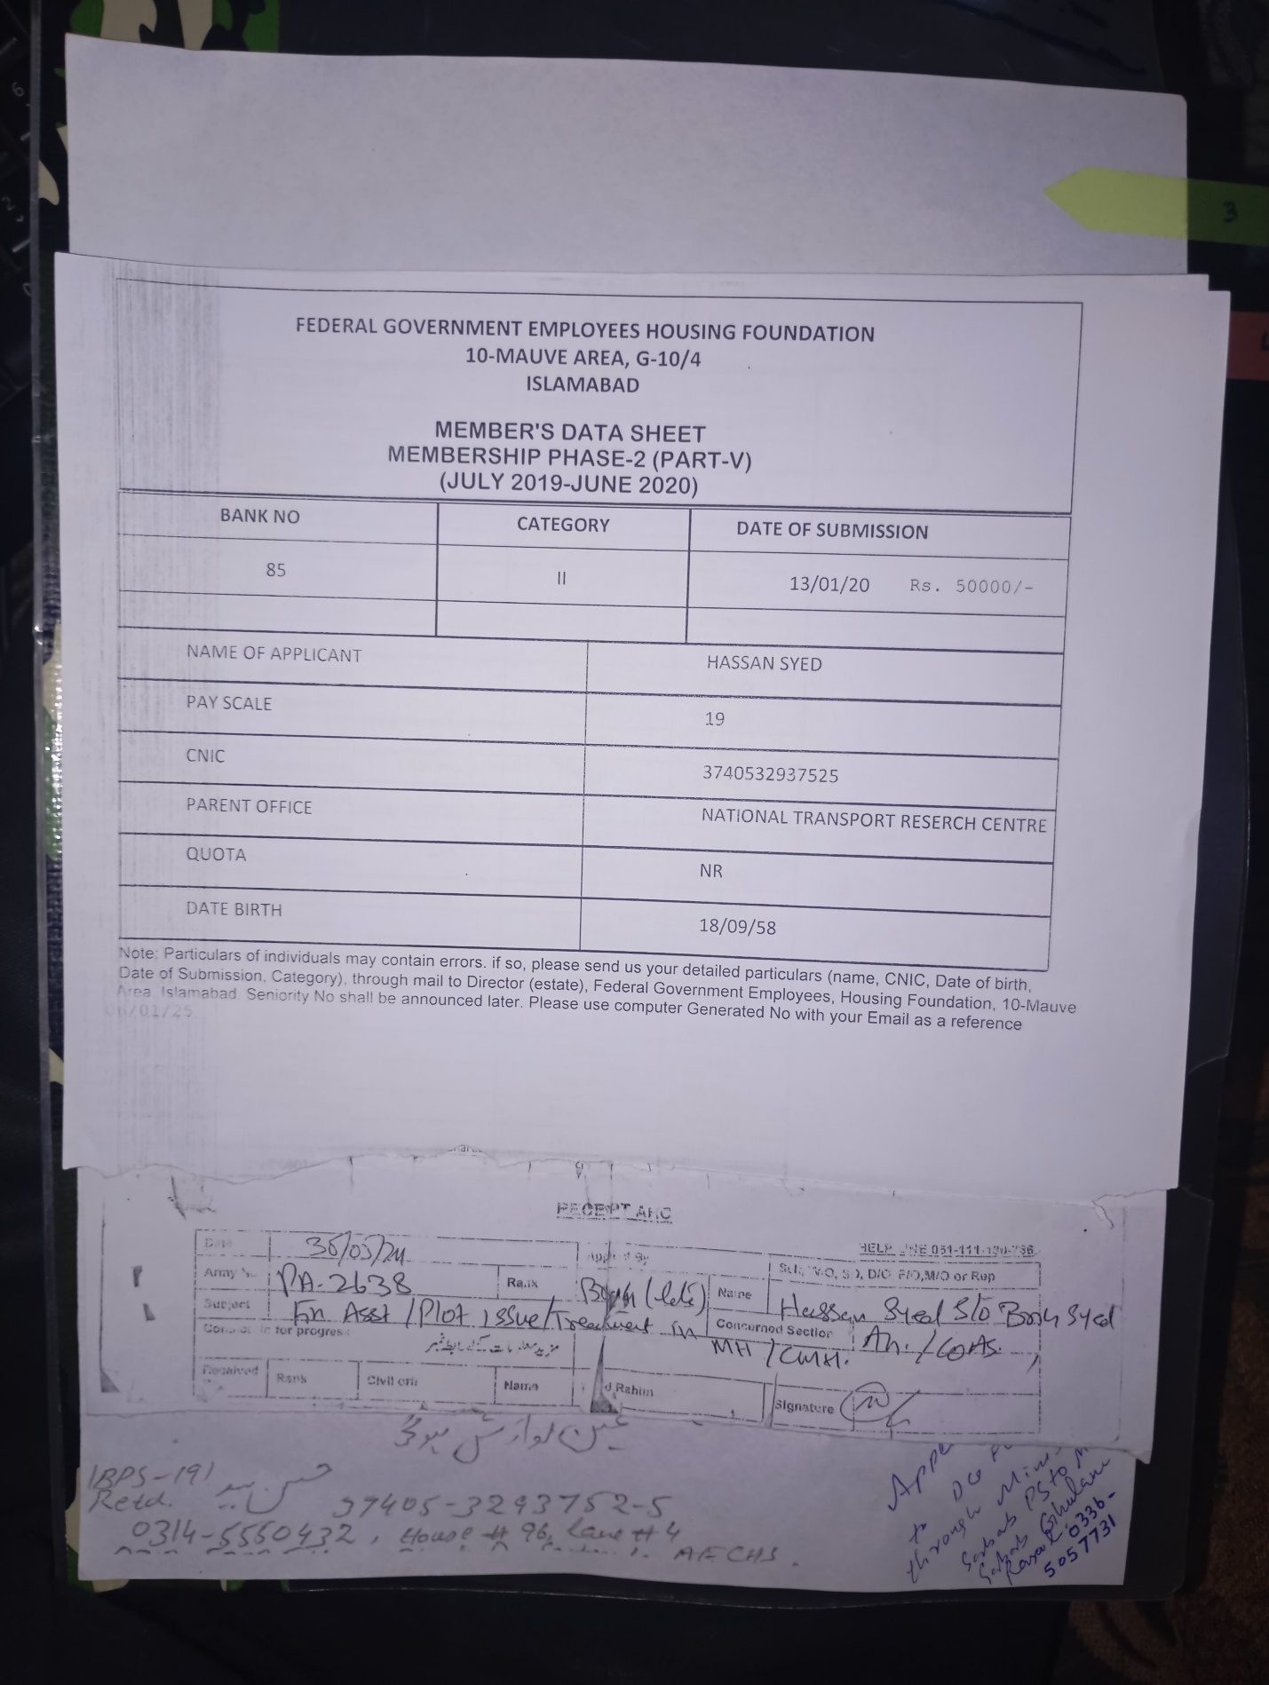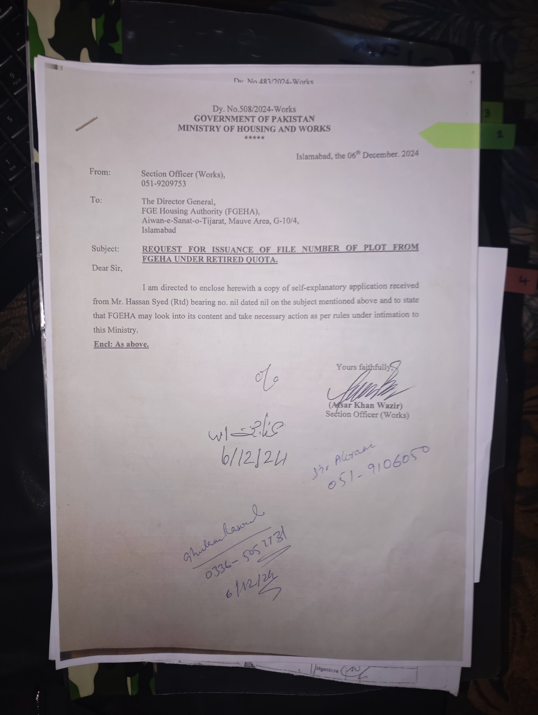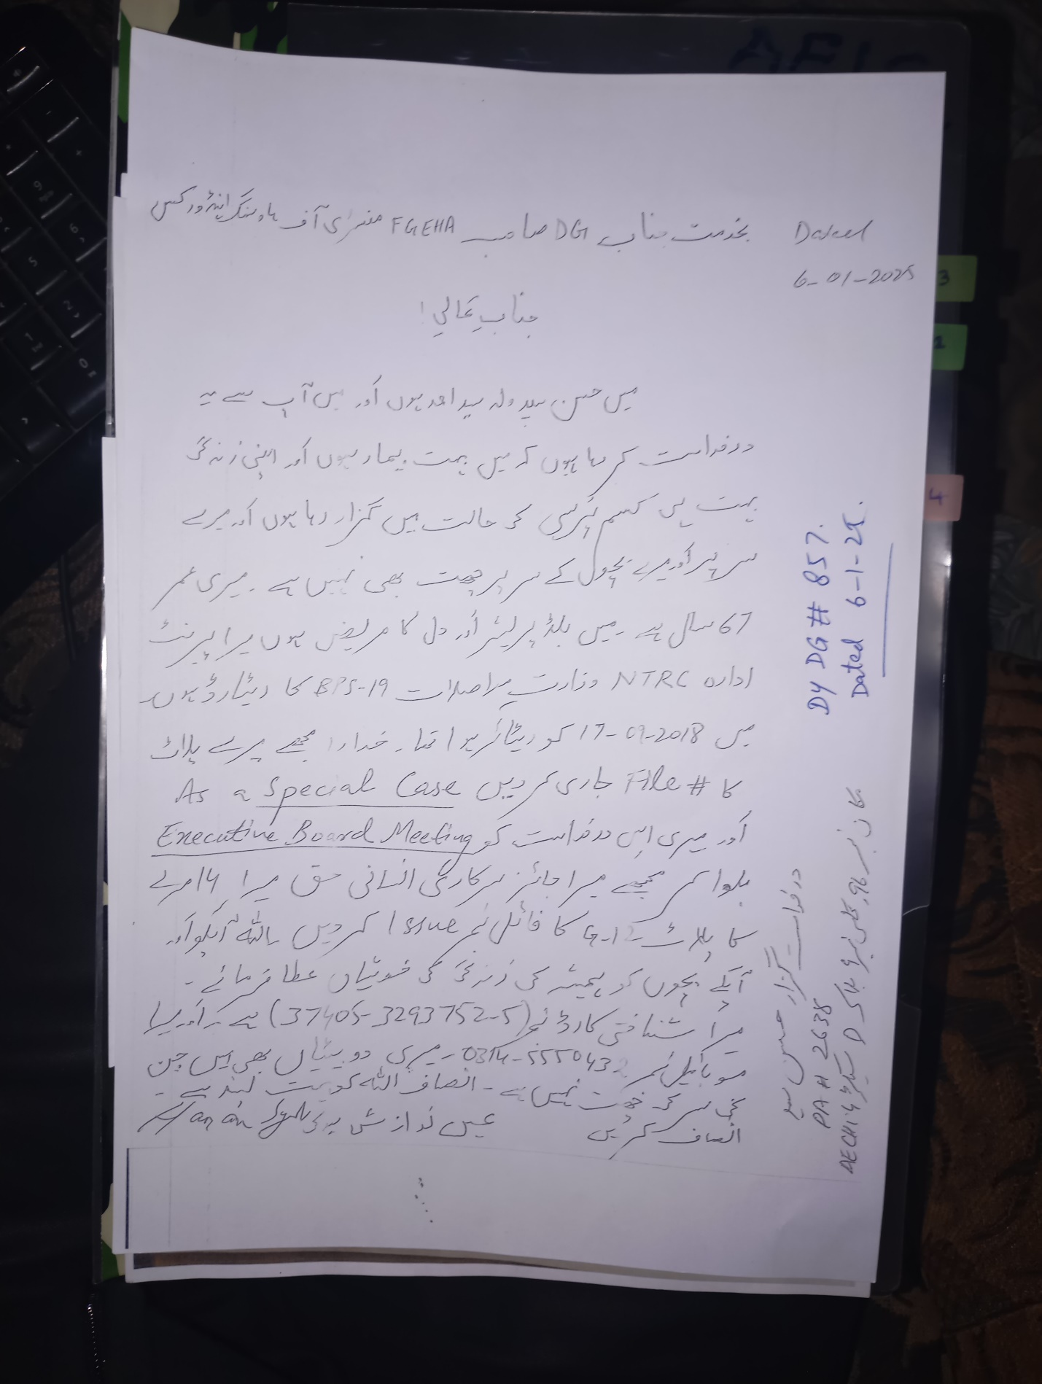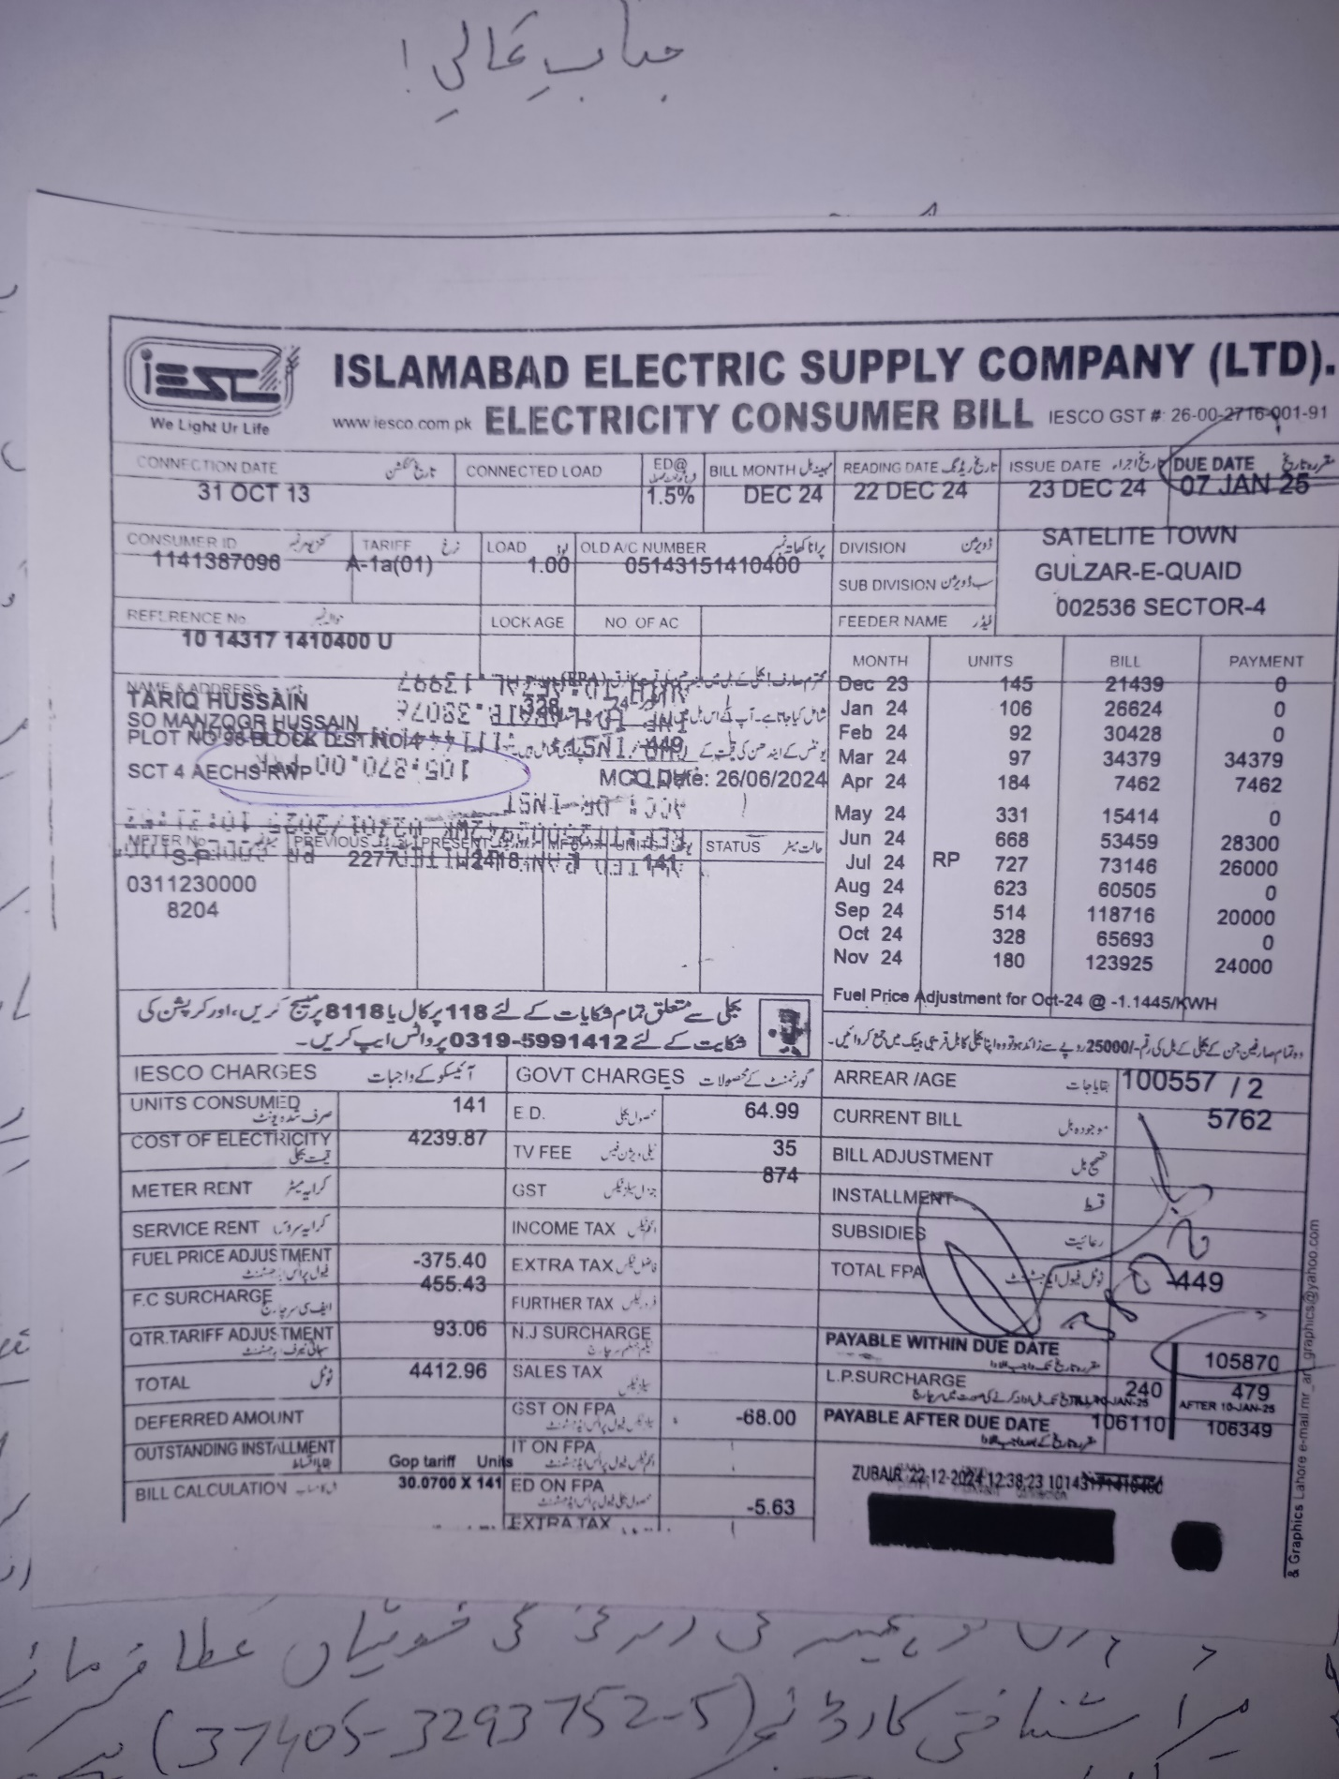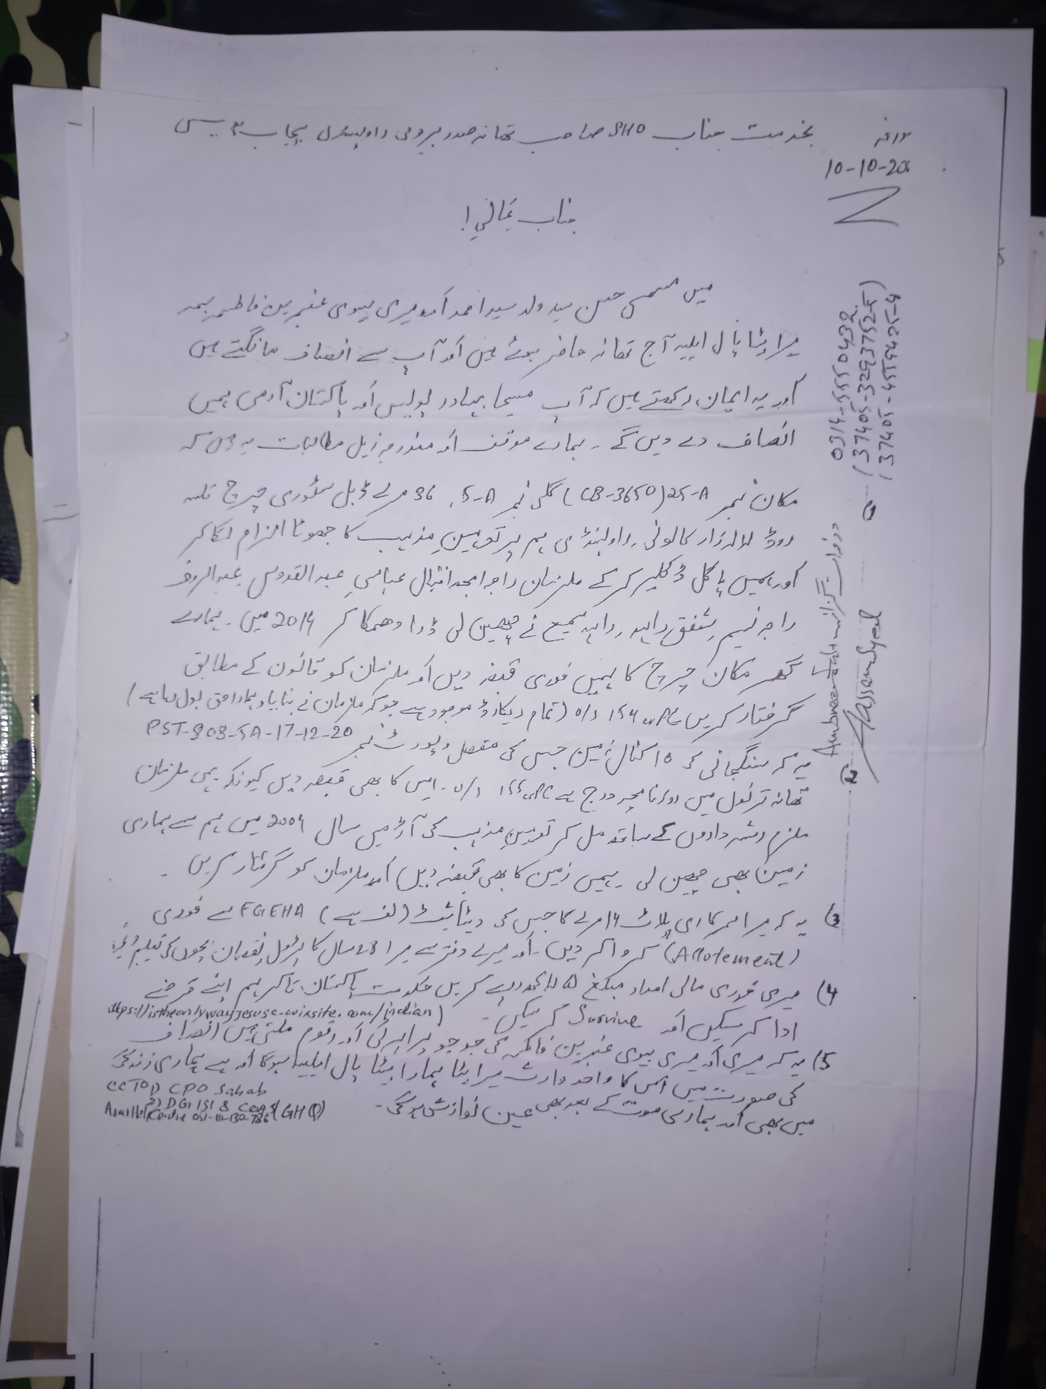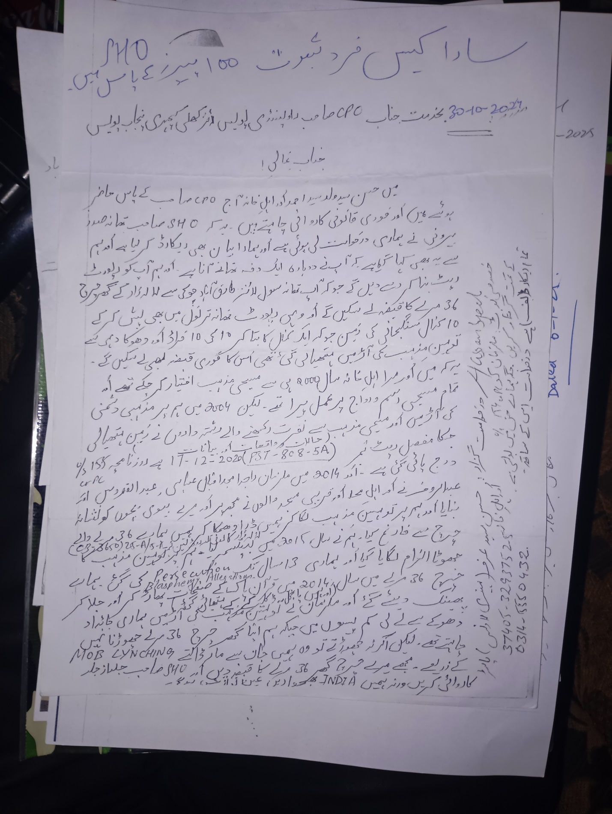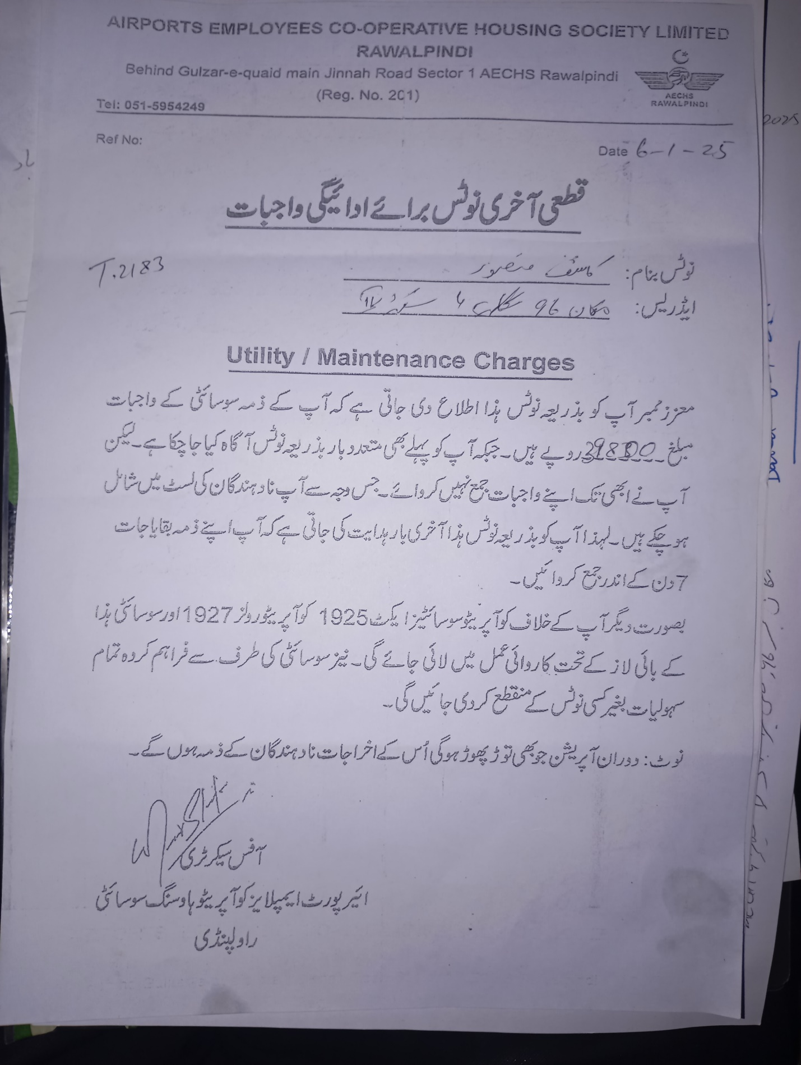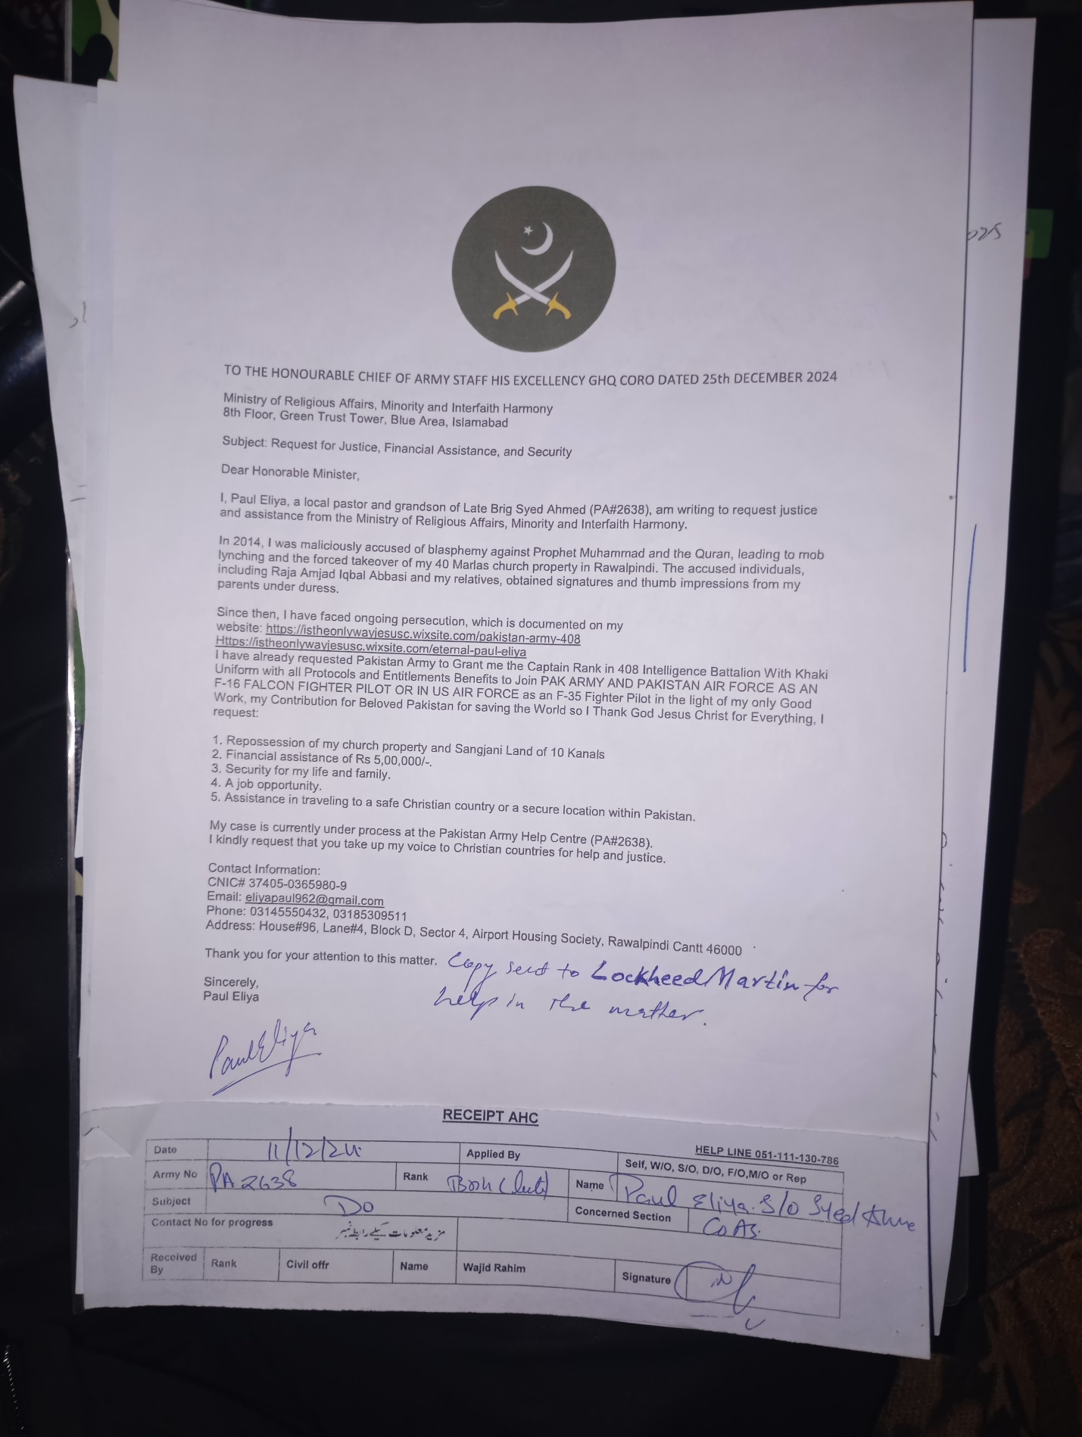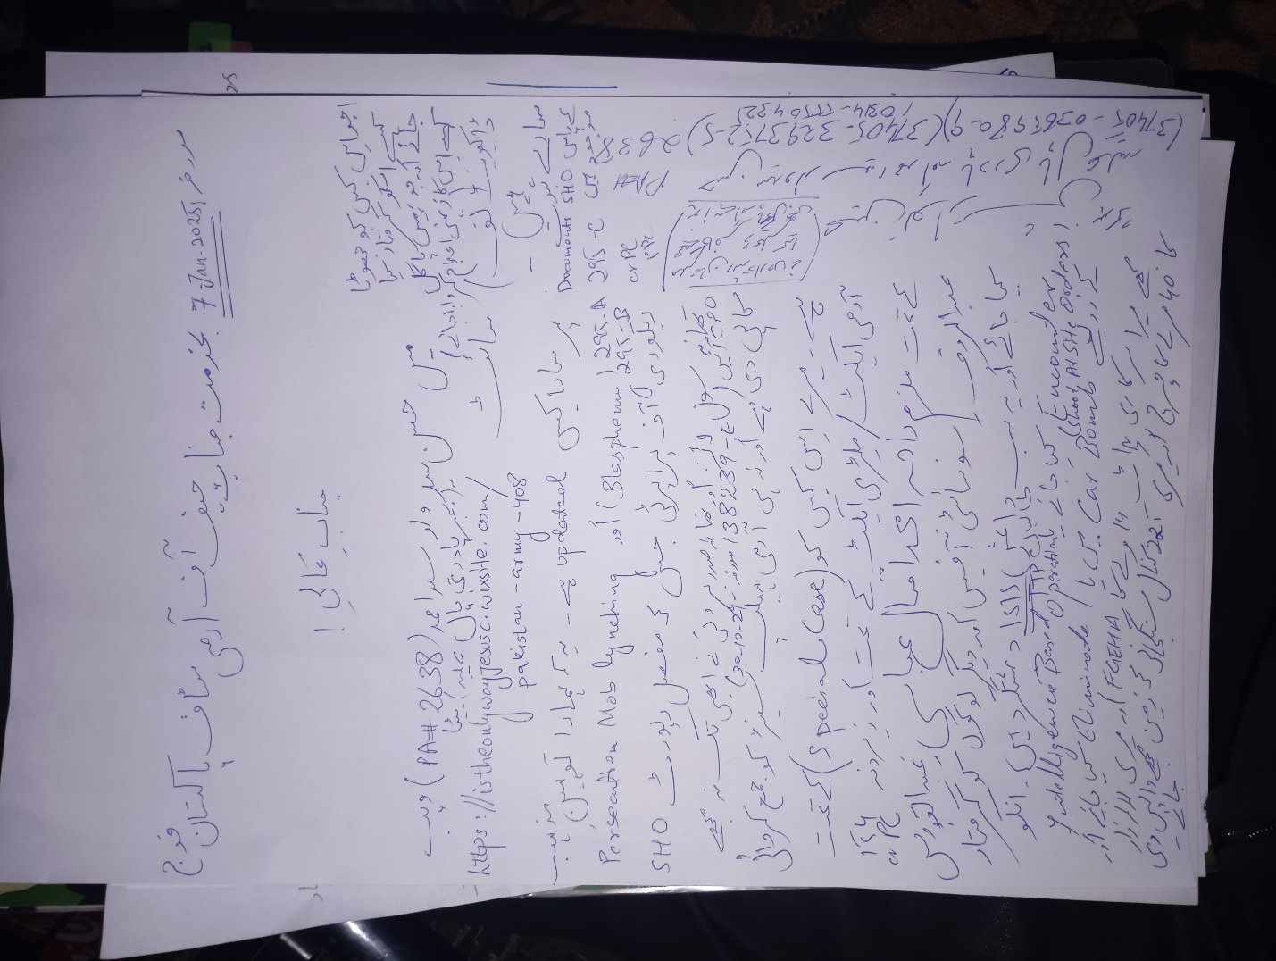
I EXIST

SUPERSOUL CAPTAIN PAUL ELIYA THE ONLY SUPREME SOUL OF JESUS CHRIST BAAP ALI MOLA ALAISALAAM
Inbox
Search for all messages with label Inbox
Remove label Inbox from this conversation
Paul Eliya1 <eliyapaul962@gmail.com> |  | 9:32 PM (24 minutes ago)
to dg, complaint, director.admin, director.finance, director.estate, director.jv, director.law, director.coord, director.IT, director.technical, director.security, director.ia, director.planning, director.land, director.maintenance, director.revenue, director.jvkci, AD.AstonAndSuttonColdfield, AD.ColeshillAndPolesworth, AD.HandsworthAndCentral, AD.KNMS, Admin, Citizen, CPIinfoMali, Courrier, Fadi.El-Abdallah, Falak, FreeJobs, GENESIS, Info, JU, Mike.Sermon, Nick.Parker, OTP, OTPNewsDesk, Ohchr-dexrel, Ombudsman, Passport.london, Paul, Perfect, Procurement, Security, Here's, Sohaibchoudry221998, Syed, WaleedbinToufeeq, WeTrip, achats, administrator, agnes.eklund, agnes.jansson, ahmadiaportugal, alexandra.cederquist, amjmalta, andia.gemsjo, anna.erhardt, anna.lund, apdpftac2, applications, appt.london, atfal, attcons.washington, bilal.lodhi, bishop.david, bishopofaston, bishopsadmin, bookkeeping, caritas.internationalis, cee-office, ceo, com.tehran, com3.washington, commregen, comms, communications, cons.islamabad, cons.tehran, cons1.telaviv, cons2.telaviv, cons6.washington, consuly, contact, contact, contact, contactus, contatti, copyright, dave, dioceseoflondon, discipleship, donorcare, eastafritac, editor, education, elana, emergencies, enquiry, environment, farrakhmansoor, financeteam, flex, frezza, fsoci.washington, fspic.washington, fund, givingtogether, glavno.tajnistvo, hammad.tariq, helpdesk, helpdesk, helplinephc, hoc.babbas, hoc.tehran, hqepu, hr, hr, hrmartha, i.registrar, ieo, imam.ahmed, imffa, imfvideo, inclusiveandaccessible, info, info, info, info, info, info, info, info, info, info, info, info, info, info, info, info, info, info, information, information.hebrew, interculturalmission, interfaith, irnte, irnteprt, isaac.elm.communications, isbad, jennyt, ju.registrar, kancelaria, khuddamireland, kontakt, kontakt, kontakt, kpk, lahore, lahore_churchcouncil, library, marriagebureau34, media, media, mineco.washington, ministry, mohsin.talpur, mubbbutt, muhammad.tariq, newchristiancommunities, ngoliaison, niazihaider786, obedarthur, office, office, ohchr-unvfvt, opinia_ta, ouse, paivytys.um, panatz, parishmissionsupport, parishsurveyor, pathways, peopleandplaces, petrosillo, pniot, press, pressoffice, procurement, property, psamb.washington, psdcm.washington, publicaffairs, publications, reception, recrutement-recruitment, reehanashraf, refworld, revchris007, safeguardingsupport, sah, sanam.javed, sbs.malta.heliga-stolen, secministerialmeetings, secretariat, sektor.jd.ks, shahid.wazir, socialdepartementet.registrator, spain, spyropoulos, support, support-india, support-pakistan, tcpak, ujieuropa, ured.drzavnog.tajnika, v-bknoojh_nnpgdkmghf_jdofaikg_jdoelhap_a, visa.islamabad, visaservicesphcnd, vocations, web, webmaster, weddings, contact, Пакистан, islamabad, islamabad.hum, islamabad.visa, islamabad.ziv, islamabad, pakistan, Webmaster, asrcrwp, asrcfsd, asrclhr, asrckci, asrcpsc, asrcqta, asrcglt, asrcmzd, asrcmtn, asrckzd, asrchyd, asrcdik, asrcpnl, complaint, Public, me, dd-it1

from: | Paul Eliya1 <eliyapaul962@gmail.com>
to: | dg@fgeha.gov.pk,  complaint@fgeha.gov.pk,  director.admin@fgeha.gov.pk,  director.finance@fgeha.gov.pk,  director.estate@fgeha.gov.pk,  director.jv@fgeha.gov.pk,  director.law@fgeha.gov.pk,  director.coord@fgeha.gov.pk,  director.IT@fgeha.gov.pk,  director.technical@fgeha.gov.pk,  director.security@fgeha.gov.pk,  director.ia@fgeha.gov.pk,  director.planning@fgeha.gov.pk,  director.land@fgeha.gov.pk,  director.maintenance@fgeha.gov.pk,  director.revenue@fgeha.gov.pk,  director.jvkci@fgeha.gov.pk,  AD.AstonAndSuttonColdfield@cofebirmingham.com,  AD.ColeshillAndPolesworth@cofebirmingham.com,  AD.HandsworthAndCentral@cofebirmingham.com,  AD.KNMS@cofebirmingham.com,  Admin@azadchaiwala.com,  Citizen Service of the Ministry of Foreign Affairs <borgarathjonusta@utn.is>,  CPIinfoMali@icc-cpi.int,  Courrier Elysée <courrier.president@elysee.fr>,  Fadi.El-Abdallah@icc-cpi.int,  Falak Tayab Corporate Service <careers@falaktayabcorporateservices.com>,  FreeJobs UAE <pr@advancelevelcon.com>,  GENESIS@matrimony.com,  Info@iranembassy.pk,  JU Brev <ju.brev@regeringskansliet.se>,  Mike.Sermon@cofebirmingham.com,  Nick.Parker@cofebirmingham.com,  "OTP InformationDesk (Article15)" <otp.informationdesk@icc-cpi.int>,  OTPNewsDesk@icc-cpi.int,  Ohchr-dexrel@un.org,  Ombudsman@mevaker.gov.il,  Passport.london@mea.gov.in,  Paul Eliya <eliyapaul289@gmail.com>,  Perfect LLC <hr@perfectllcdubai.com>,  Procurement@icc-cpi.int,  Security@icc-cpi.int,  Here's Puthran <visa.washington@mea.gov.in>,  Sohaibchoudry221998@gmail.com,  Syed Ali Abbas Paul Eliya <eliyasyedaliabbaspaul@gmail.com>,  WaleedbinToufeeq@gmail.com,  WeTrip <contact@wetrip.pk>,  achats@icj-cij.org,  administrator@stmarksitaly.com,  agnes.eklund@regeringskansliet.se,  agnes.jansson@gov.se,  ahmadiaportugal@hotmail.com,  alexandra.cederquist@gov.se,  amjmalta@gmail.com,  andia.gemsjo@regeringskansliet.se,  anna.erhardt@gov.se,  anna.lund@gov.se,  apdpftac2@imf.org,  applications@icc-cpi.int,  appt.london@mea.gov.in,  atfal@atfal.de,  attcons.washington@mea.gov.in,  bilal.lodhi@bop.com.pk,  bishop.david@manchester.anglican.org,  bishopofaston@cofebirmingham.com,  bishopsadmin@cofebirmingham.com,  bookkeeping@cofebirmingham.com,  caritas.internationalis@caritas.va,  cee-office@imf.org,  ceo@sadiqtravels.com,  com.tehran@mea.gov.in,  com3.washington@mea.gov.in,  commregen@cofebirmingham.com,  comms@cofebirmingham.com,  communications@london.anglican.org,  cons.islamabad@mea.gov.in,  cons.tehran@mea.gov.in,  cons1.telaviv@mea.gov.in,  cons2.telaviv@mea.gov.in,  cons6.washington@mea.gov.in,  consuly@iranembassy.pk,  contact@fatf-gafi.org,  contact@ahmadiyya.fr,  contact@ahmadiyya.dk,  contactus@iaa.gov.il,  contatti@alislam.it,  copyright@imf.org,  dave@redeemerdubai.com,  dioceseoflondon@luther.co.uk,  discipleship@cofebirmingham.com,  donorcare@unhcr.ca,  eastafritac@imf.org,  editor@chanakyaforum.com,  education@cofebirmingham.com,  elana@israelforever.org,  emergencies@caritas.va,  enquiry@churchofengland.org,  environment@cofebirmingham.com,  farrakhmansoor@hot.ee,  financeteam@cofebirmingham.com,  flex@cofebirmingham.com,  frezza@caritas.va,  fsoci.washington@mea.gov.in,  fspic.washington@mea.gov.in,  fund@end-violence.org,  givingtogether@imf.org,  glavno.tajnistvo@mvep.hr,  hammad.tariq@sindhbankltd.com,  helpdesk@lajnauk.org,  helpdesk@lajna.be,  helplinephc@gmail.com,  hoc.babbas@mea.gov.in,  hoc.tehran@mea.gov.in,  hqepu@unhcr.org,  hr@cofebirmingham.com,  hr fatima ali <hrfatimaali@gmail.com>,  hrmartha roy <hrmagraroy@gmail.com>,  i.registrar@gov.se,  ieo@imf.org,  imam.ahmed@ahmadiyya.ch,  imffa@imf.org,  imfvideo@imf.org,  inclusiveandaccessible@cofebirmingham.com,  info@thrivetogetherbham.org,  info@ahmadiyya.ch,  info@education.gov.il,  info@imfmetac.org,  info@end-violence.org,  info@visitouriran.com,  info@khuddam.co.uk,  info@ziyarahtours.net,  info@farrukhsaif.com,  info@ansar.org.uk,  info@alavitravel.com,  info@khuddam.nl,  info@sadiqtravels.com,  info@travelfatimah.com,  info@khuddam.be,  info@alsahlah.com,  info@cartac.org,  info@refugepoint.org,  information@icj-cij.org,  information.hebrew@yadvashem.org.il,  interculturalmission@cofebirmingham.com,  interfaith@cofebirmingham.com,  irnte@unhcr.org,  irnteprt@unhcr.org,  isaac.elm.communications@gmail.com,  isbad@international.gc.ca,  jennyt@cofebirmingham.com,  ju.registrar@gov.se,  kancelaria@msz.gov.pl,  khuddamireland@gmail.com,  kontakt@ahmadiyya.de,  kontakt@ahmadiyya.no,  kontakt@lajna.de,  kpk@pasb.mod.gov.pk,  lahore@hk-diplo.de,  lahore_churchcouncil@yahoo.com,  library@icj-cij.org,  marriagebureau34@gmail.com,  media@imf.org,  media@fatf-gafi.org,  mineco.washington@mea.gov.in,  ministry@cofebirmingham.com,  mohsin.talpur@sindhbankltd.com,  mubbbutt@gmail.com,  muhammad.tariq@mofa.gov.pk,  newchristiancommunities@cofebirmingham.com,  ngoliaison@imf.org,  niazihaider786@gmail.com,  obedarthur@gmail.com,  office@saintmarysdubai.org,  office@ahmadiyya.at,  ohchr-unvfvt@un.org,  opinia_ta@mae.ro,  ouse winterz <ousewinterz1@gmail.com>,  paivytys.um@gov.fi,  panatz@rbc.gov.il,  parishmissionsupport@cofebirmingham.com,  parishsurveyor@cofebirmingham.com,  pathways@cofebirmingham.com,  peopleandplaces@cofebirmingham.com,  petrosillo@caritas.va,  pniot@mod.gov.il,  press@pakchristiannews.com,  pressoffice@phclondon.org,  procurement@imf.org,  property@cofebirmingham.com,  psamb.washington@mea.gov.in,  psdcm.washington@mea.gov.in,  publicaffairs@imf.org,  publications@imf.org,  reception@london.anglican.org,  recrutement-recruitment@icj-cij.org,  reehanashraf@hotmail.com,  refworld@unhcr.org,  revchris007@gmail.com,  safeguardingsupport@cofebirmingham.com,  sah@cis-iwc.org,  sanam.javed@sindhbankltd.com,  sbs.malta.heliga-stolen@gov.se,  secministerialmeetings@imf.org,  secretariat@end-violence.org,  sektor.jd.ks@mvep.hr,  shahid.wazir@sindhbankltd.com,  socialdepartementet.registrator@gov.se,  spain@alislam.org,  spyropoulos@hotmail.co.uk,  support@ustravel.com,  support-india@ustraveldocs.com,  support-pakistan@ustraveldocs.com,  tcpak@um.dk,  ujieuropa@mvep.hr,  ured.drzavnog.tajnika@mvep.hr,  v-bknoojh_nnpgdkmghf_jdofaikg_jdoelhap_a@bounce.studentenquiry.mkt4116.com,  visa.islamabad@mea.gov.in,  visaservicesphcnd@gmail.com,  vocations@cofebirmingham.com,  web@mae.ro,  webmaster@icj-cij.org,  weddings@holytrinity.ae,  contact@majorgauravarya.com,  "Генконсульство России в г. Карачи, Пакистан" <karachi@mid.ru>,  islamabad@dks.ru,  islamabad.hum@eda.admin.ch,  islamabad.visa@eda.admin.ch,  islamabad.ziv@eda.admin.ch,  islamabad@eda.admin.ch,  pakistan@mid.ru,  Webmaster <webmaster@joinpakarmy.gov.pk>,  asrcrwp@joinpakarmy.gov.pk,  asrcfsd@joinpakarmy.gov.pk,  asrclhr@joinpakarmy.gov.pk,  asrckci@joinpakarmy.gov.pk,  asrcpsc@joinpakarmy.gov.pk,  asrcqta@joinpakarmy.gov.pk,  asrcglt@joinpakarmy.gov.pk,  asrcmzd@joinpakarmy.gov.pk,  asrcmtn@joinpakarmy.gov.pk,  asrckzd@joinpakarmy.gov.pk,  asrchyd@joinpakarmy.gov.pk,  asrcdik@joinpakarmy.gov.pk,  asrcpnl@joinpakarmy.gov.pk,  complaint@thepakarmy.com,  Public Response Unit <inf.london@mea.gov.in>,  Paul Eliya1 <eliyapaul962@gmail.com>,  dd-it1@fgeha.gov.pk
cc: | contact@majorgauravarya.com
date: | Jan 6, 2025, 9:32 PM
subject: | SUPERSOUL CAPTAIN PAUL ELIYA THE ONLY SUPREME SOUL OF JESUS CHRIST BAAP ALI MOLA ALAISALAAM
mailed-by: | gmail.com
: | Important mainly because it was sent directly to you.
The Honourable RAW Chief His Excellency
Research and Analysis Wing Headquarters New Delhi India
And
The Honourable The Excellency Pakistan Army Chief of Army Staff Through Army Help Centre Wajid Rahim Sahab 051111130786
Government of Pakistan
Through Honourable Federal Housing and Works Minister Mian Riaz Hussain Pirzada Via
Dy. No.508/2024-Ministry of Housing and Works 051-9209753 Dated 6th December 2024
Request for issuance of File Number of 14 Marla Plot in G-12 or In F-12 from FGEHA under Retired Quota AS A SPECIAL CASE IN THE EXECUTIVE BOARD MEETING VIA DIARY NUMBER Dy DG # 857 DATED 06-01-2025 To The Retired Senior Most Deputy Chief Hassan Syed NTRC BPS-19 Ministry of Communication AGPR Personal Number 50036345
holding CNIC#37405-3293752-5, Date of Birth 18-09-1958, Date of Retirement: 17-09-2018,
Date of Membership 13/01/2020
Category 2, Computer Generated Number 120519, Membership Drive Phase 2
Regards
HASSAN SYED BELOVED FATHER OF F-35 FIGHTER PILOT STRONGEST MAN BODY BUILDER PASTOR PAUL ELIYA THE SOUL ENERGY
Https://istheonlywayjesusc.wixsite.com/pakistan-army-408
0314-5550432

Cc to
1. Minister Incharge/Chairman Mian Riaz Hussain Pirzada (Federal Minister of Housing & Works)
2. Federal Secretary (Housing & Works) Dr. Shahzad Khan Bangash
3. Director General Capt. (Retd.) Muhammad Zafar Iqbal
4. CDA CHAIRMAN ISLAMABAD
5. AHC 051-111-130-786 DATED: 6-1-2025
Special Note: SOS ASAP ALL MY GOOD WORKS TO BE STORED IN MY SOUL DNA BONES THROUGH BIO ENGINEERING OF MY MIND HEART BODY SPIRIT AND SOUL, I AM THE CHILD OF JESUS CHRIST LIVING WITH MY BELOVED ONES WITH MY BELONGINGS WITH MY GOOD WORKS IN GOODNESS AND LOVE FOREVER IN ETERNAL LIFE WITH ALL BLESSINGS IN PEACE REST WATER AND FRUITS OF LIFE IN NEW JERUSALEM PHYSICALLY ETERNALLY HEAVENLY IN IMMORTALITY RAISED RESURRECTED INCARNATED ALL GENERATIONS
I am Happy to live and die in my Beloved Motherland Pakistan because in my hard times eternally my country gives me my Right and comfort me like Jesus Christ giving me rest and Peace then why should I leave my beloved people when everyone else in the world has abandoned me, I want to live in Pakistan Eternally with all my Soul's Goodness and Love unconditionally along with my Beloved Ones along with my belongings and along with my Good Works in my website Https://istheonlywayjesusc.wixsite.com/Pakistan-Army-408

https://youtu.be/W41nCCFZgyA?feature=shared
https://youtu.be/Ebm4geyI0YA?feature=shared
https://youtu.be/XoFr-2mcnc0?feature=shared
https://youtu.be/hSrLOBphJgU?feature=shared
https://youtu.be/n_SOM45cWxA?feature=shared
https://youtu.be/0VOXLjvv5dA?feature=shared
https://youtu.be/w-cj7bRvJuI?feature=shared
https://youtu.be/cyXV364o_jU?feature=shared
https://youtu.be/tbjl0Hkm1fE?feature=shared
https://youtu.be/j_urZ5KDPec?feature=shared
https://youtu.be/IYdg1Y8S0N0?feature=shared
23 Attachments • Scanned by Gmail

Preview YouTube video Lockheed Martin | F-35 Lightning II

Lockheed Martin | F-35 Lightning II
Preview YouTube video Arnold Schwarzenegger olympia bodybuilding motivation 2015

Arnold Schwarzenegger olympia bodybuilding motivation 2015
Preview YouTube video Arnold to Conquer

Arnold to Conquer
Preview YouTube video QURAN IS 50% TRUE BUT QURAN IS 50% EVIL SATAN.Kaba is a stone istheonlywayjesusc.wixsite.com/indian

QURAN IS 50% TRUE BUT QURAN IS 50% EVIL SATAN.Kaba is a stone istheonlywayjesusc.wixsite.com/indian
Preview YouTube video Quran is a Murderer & Satanic Prophet Muhammad is the biggest Lier.Islam is Satan Allah is misused

Quran is a Murderer & Satanic Prophet Muhammad is the biggest Lier.Islam is Satan Allah is misused
Preview YouTube video OLD TESTAMENT TELLS ABOUT 12 PRINCE SONS OF ABRAHAM DAVID LIKE JESUS CHRIST. ISLAM WAS ALWAYS SATAN.
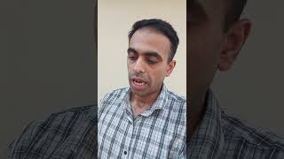
OLD TESTAMENT TELLS ABOUT 12 PRINCE SONS OF ABRAHAM DAVID LIKE JESUS CHRIST. ISLAM WAS ALWAYS SATAN.
Preview YouTube video PROPHET MUHAMMAD IS A SATANIC CARTOON CLOWN JOKER.Quran is a Murderer and Prophet Muhammad is a Lier

PROPHET MUHAMMAD IS A SATANIC CARTOON CLOWN JOKER.Quran is a Murderer and Prophet Muhammad is a Lier
Preview YouTube video ISRAEL MOSSAD JEWISH BROTHERS HELP ME PERSECUTION MOB LYNCHING istheonlywayjesusc.wixsite.com/indian

ISRAEL MOSSAD JEWISH BROTHERS HELP ME PERSECUTION MOB LYNCHING istheonlywayjesusc.wixsite.com/indian
Preview YouTube video OLD TESTAMENT TELLS ABOUT 12 PRINCE SONS OF ABRAHAM DAVID LIKE JESUS CHRIST. ISLAM WAS ALWAYS SATAN.
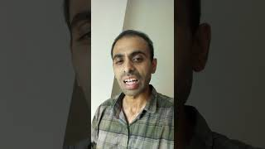
OLD TESTAMENT TELLS ABOUT 12 PRINCE SONS OF ABRAHAM DAVID LIKE JESUS CHRIST. ISLAM WAS ALWAYS SATAN.
Preview YouTube video The Matrix 1999 HD Movie Clip - Neo: "guns, lots of guns."

The Matrix 1999 HD Movie Clip - Neo: "guns, lots of guns."
Preview YouTube video First Flight | Man of Steel

First Flight | Man of Steel

Acknowledgment
Inbox
Search for all messages with label Inbox
Remove label Inbox from this conversation
Webmaster |  |  | 9:37 PM (21 minutes ago)
to me

from: | Webmaster <webmaster@joinpakarmy.gov.pk>
to: | Paul Eliya1 <eliyapaul962@gmail.com>
date: | Jan 6, 2025, 9:37 PM
subject: | Acknowledgment
mailed-by: | joinpakarmy.gov.pk
security: | Standard encryption (TLS) Learn more
: | Important according to Google magic.
Dear Applicant,
thank you for reaching out to us. Kindly note that maximum one email per issue within 24 hours of period will be addressed. Rest assured we will address your concern as soon as possible and respond accordingly.
(computer generated reply )
Best regards
Webmaster
joinpakarmy

Auto Reply from information.hebrew@yadvashem.org.il
Inbox
Search for all messages with label Inbox
Remove label Inbox from this conversation
no_reply_information.hebrew@yadvashem.org.il |  |  | 9:32 PM (26 minutes ago)
to me

from: | no_reply_information.hebrew@yadvashem.org.il
to: | eliyapaul962@gmail.com
date: | Jan 6, 2025, 9:32 PM
subject: | Auto Reply from information.hebrew@yadvashem.org.il
mailed-by: | yadvashem.org.il
security: | Standard encryption (TLS) Learn more
פונים יקרים,
בשל שינוי במדיניות, הנכם מתבקשים לשלוח את הפנייה באמצעות טופס בקישור:
https://forms.yadvashem.org/he/contact-us?subject=100&subsubject=160
Due to a policy change you are kindly requested to send your request using the following link:
https://forms.yadvashem.org/contact-us?subject=100&subsubject=160

Inactive ID Notification.
Inbox
Search for all messages with label Inbox
Remove label Inbox from this conversation
Mail Notification <MAILER-DAEMON@esahyd01.nic.in> |  |  | 9:35 PM (25 minutes ago)
to me

from: | Mail Notification <MAILER-DAEMON@esahyd01.nic.in>
to: | eliyapaul962@gmail.com
date: | Jan 6, 2025, 9:35 PM
subject: | Inactive ID Notification.
mailed-by: | esahyd01.nic.in
security: | Standard encryption (TLS) Learn more
You have received this notification, as the recipient e-mail Address has been deactivated.
Original Envelope Sender: eliyapaul962@gmail.com
Envelope Recipient: visa.islamabad@mea.gov.in
Date: 01/06/25
Time: 22:05:09
Subject: SUPERSOUL CAPTAIN PAUL ELIYA THE ONLY SUPREME SOUL OF JESUS CHRIST BAAP ALI MOLA ALAISALAAM
Message Administrator

Message Received
Inbox
Search for all messages with label Inbox
Remove label Inbox from this conversation

WETRIP |  |  | 9:33 PM (28 minutes ago)
to me

from: | WETRIP <contact@wetrip.pk>
to: | Paul Eliya1 <eliyapaul962@gmail.com>
date: | Jan 6, 2025, 9:33 PM
subject: | Message Received
mailed-by: | wetrip.pk
signed-by: | wetrip.pk
security: | Standard encryption (TLS) Learn more
Greetings,
Thank you for contacting WETRIP (SMC-PRIVATE) LTD Pakistan, the concerned team will responding to your email within 2 Business days regarding your query, if you do not hear from us please contact on our WhatsApp number at +923000938747.
Please check our website www.wetrip.pk for online bookings!
Have a great day!
Team WeTrip

ReplyForward
Add reaction

Dear Honourable His Excellency Executive Board FGEHA please Issue the Allotment of Plot in G-12 to Mr Hassan Syed
Inbox
Search for all messages with label Inbox
Remove label Inbox from this conversation
Paul Eliya1 <eliyapaul962@gmail.com> |  | 8:13 PM (10 minutes ago)
to dg, complaint, director.admin, director.finance, director.estate, director.jv, director.law, director.coord, director.IT, director.technical, director.security, director.ia, director.planning, director.land, director.maintenance, director.revenue, director.jvkci, AD.AstonAndSuttonColdfield, AD.ColeshillAndPolesworth, AD.HandsworthAndCentral, AD.KNMS, Admin, Citizen, CPIinfoMali, Courrier, Fadi.El-Abdallah, Falak, FreeJobs, GENESIS, Info, JU, Mike.Sermon, Nick.Parker, OTP, OTPNewsDesk, Ohchr-dexrel, Ombudsman, Passport.london, Paul, Perfect, Procurement, Security, Here's, Sohaibchoudry221998, Syed, WaleedbinToufeeq, WeTrip, achats, administrator, agnes.eklund, agnes.jansson, ahmadiaportugal, alexandra.cederquist, amjmalta, andia.gemsjo, anna.erhardt, anna.lund, apdpftac2, applications, appt.london, atfal, attcons.washington, bilal.lodhi, bishop.david, bishopofaston, bishopsadmin, bookkeeping, caritas.internationalis, cee-office, ceo, com.tehran, com3.washington, commregen, comms, communications, cons.islamabad, cons.tehran, cons1.telaviv, cons2.telaviv, cons6.washington, consuly, contact, contact, contact, contactus, contatti, copyright, dave, dioceseoflondon, discipleship, donorcare, eastafritac, editor, education, elana, emergencies, enquiry, environment, farrakhmansoor, financeteam, flex, frezza, fsoci.washington, fspic.washington, fund, givingtogether, glavno.tajnistvo, hammad.tariq, helpdesk, helpdesk, helplinephc, hoc.babbas, hoc.tehran, hqepu, hr, hr, hrmartha, i.registrar, ieo, imam.ahmed, imffa, imfvideo, inclusiveandaccessible, info, info, info, info, info, info, info, info, info, info, info, info, info, info, info, info, info, info, information, information.hebrew, interculturalmission, interfaith, irnte, irnteprt, isaac.elm.communications, isbad, jennyt, ju.registrar, kancelaria, khuddamireland, kontakt, kontakt, kontakt, kpk, lahore, lahore_churchcouncil, library, marriagebureau34, media, media, mineco.washington, ministry, mohsin.talpur, mubbbutt, muhammad.tariq, newchristiancommunities, ngoliaison, niazihaider786, obedarthur, office, office, ohchr-unvfvt, opinia_ta, ouse, paivytys.um, panatz, parishmissionsupport, parishsurveyor, pathways, peopleandplaces, petrosillo, pniot, press, pressoffice, procurement, property, psamb.washington, psdcm.washington, publicaffairs, publications, reception, recrutement-recruitment, reehanashraf, refworld, revchris007, safeguardingsupport, sah, sanam.javed, sbs.malta.heliga-stolen, secministerialmeetings, secretariat, sektor.jd.ks, shahid.wazir, socialdepartementet.registrator, spain, spyropoulos, support, support-india, support-pakistan, tcpak, ujieuropa, ured.drzavnog.tajnika, v-bknoojh_nnpgdkmghf_jdofaikg_jdoelhap_a, visa.islamabad, visaservicesphcnd, vocations, web, webmaster, weddings, contact, Пакистан, islamabad, islamabad.hum, islamabad.visa, islamabad.ziv, islamabad, pakistan, Webmaster, asrcrwp, asrcfsd, asrclhr, asrckci, asrcpsc, asrcqta, asrcglt, asrcmzd, asrcmtn, asrckzd, asrchyd, asrcdik, asrcpnl, complaint, Public, me, dd-it1

from: | Paul Eliya1 <eliyapaul962@gmail.com>
to: | dg@fgeha.gov.pk,  complaint@fgeha.gov.pk,  director.admin@fgeha.gov.pk,  director.finance@fgeha.gov.pk,  director.estate@fgeha.gov.pk,  director.jv@fgeha.gov.pk,  director.law@fgeha.gov.pk,  director.coord@fgeha.gov.pk,  director.IT@fgeha.gov.pk,  director.technical@fgeha.gov.pk,  director.security@fgeha.gov.pk,  director.ia@fgeha.gov.pk,  director.planning@fgeha.gov.pk,  director.land@fgeha.gov.pk,  director.maintenance@fgeha.gov.pk,  director.revenue@fgeha.gov.pk,  director.jvkci@fgeha.gov.pk,  AD.AstonAndSuttonColdfield@cofebirmingham.com,  AD.ColeshillAndPolesworth@cofebirmingham.com,  AD.HandsworthAndCentral@cofebirmingham.com,  AD.KNMS@cofebirmingham.com,  Admin@azadchaiwala.com,  Citizen Service of the Ministry of Foreign Affairs <borgarathjonusta@utn.is>,  CPIinfoMali@icc-cpi.int,  Courrier Elysée <courrier.president@elysee.fr>,  Fadi.El-Abdallah@icc-cpi.int,  Falak Tayab Corporate Service <careers@falaktayabcorporateservices.com>,  FreeJobs UAE <pr@advancelevelcon.com>,  GENESIS@matrimony.com,  Info@iranembassy.pk,  JU Brev <ju.brev@regeringskansliet.se>,  Mike.Sermon@cofebirmingham.com,  Nick.Parker@cofebirmingham.com,  "OTP InformationDesk (Article15)" <otp.informationdesk@icc-cpi.int>,  OTPNewsDesk@icc-cpi.int,  Ohchr-dexrel@un.org,  Ombudsman@mevaker.gov.il,  Passport.london@mea.gov.in,  Paul Eliya <eliyapaul289@gmail.com>,  Perfect LLC <hr@perfectllcdubai.com>,  Procurement@icc-cpi.int,  Security@icc-cpi.int,  Here's Puthran <visa.washington@mea.gov.in>,  Sohaibchoudry221998@gmail.com,  Syed Ali Abbas Paul Eliya <eliyasyedaliabbaspaul@gmail.com>,  WaleedbinToufeeq@gmail.com,  WeTrip <contact@wetrip.pk>,  achats@icj-cij.org,  administrator@stmarksitaly.com,  agnes.eklund@regeringskansliet.se,  agnes.jansson@gov.se,  ahmadiaportugal@hotmail.com,  alexandra.cederquist@gov.se,  amjmalta@gmail.com,  andia.gemsjo@regeringskansliet.se,  anna.erhardt@gov.se,  anna.lund@gov.se,  apdpftac2@imf.org,  applications@icc-cpi.int,  appt.london@mea.gov.in,  atfal@atfal.de,  attcons.washington@mea.gov.in,  bilal.lodhi@bop.com.pk,  bishop.david@manchester.anglican.org,  bishopofaston@cofebirmingham.com,  bishopsadmin@cofebirmingham.com,  bookkeeping@cofebirmingham.com,  caritas.internationalis@caritas.va,  cee-office@imf.org,  ceo@sadiqtravels.com,  com.tehran@mea.gov.in,  com3.washington@mea.gov.in,  commregen@cofebirmingham.com,  comms@cofebirmingham.com,  communications@london.anglican.org,  cons.islamabad@mea.gov.in,  cons.tehran@mea.gov.in,  cons1.telaviv@mea.gov.in,  cons2.telaviv@mea.gov.in,  cons6.washington@mea.gov.in,  consuly@iranembassy.pk,  contact@fatf-gafi.org,  contact@ahmadiyya.fr,  contact@ahmadiyya.dk,  contactus@iaa.gov.il,  contatti@alislam.it,  copyright@imf.org,  dave@redeemerdubai.com,  dioceseoflondon@luther.co.uk,  discipleship@cofebirmingham.com,  donorcare@unhcr.ca,  eastafritac@imf.org,  editor@chanakyaforum.com,  education@cofebirmingham.com,  elana@israelforever.org,  emergencies@caritas.va,  enquiry@churchofengland.org,  environment@cofebirmingham.com,  farrakhmansoor@hot.ee,  financeteam@cofebirmingham.com,  flex@cofebirmingham.com,  frezza@caritas.va,  fsoci.washington@mea.gov.in,  fspic.washington@mea.gov.in,  fund@end-violence.org,  givingtogether@imf.org,  glavno.tajnistvo@mvep.hr,  hammad.tariq@sindhbankltd.com,  helpdesk@lajnauk.org,  helpdesk@lajna.be,  helplinephc@gmail.com,  hoc.babbas@mea.gov.in,  hoc.tehran@mea.gov.in,  hqepu@unhcr.org,  hr@cofebirmingham.com,  hr fatima ali <hrfatimaali@gmail.com>,  hrmartha roy <hrmagraroy@gmail.com>,  i.registrar@gov.se,  ieo@imf.org,  imam.ahmed@ahmadiyya.ch,  imffa@imf.org,  imfvideo@imf.org,  inclusiveandaccessible@cofebirmingham.com,  info@thrivetogetherbham.org,  info@ahmadiyya.ch,  info@education.gov.il,  info@imfmetac.org,  info@end-violence.org,  info@visitouriran.com,  info@khuddam.co.uk,  info@ziyarahtours.net,  info@farrukhsaif.com,  info@ansar.org.uk,  info@alavitravel.com,  info@khuddam.nl,  info@sadiqtravels.com,  info@travelfatimah.com,  info@khuddam.be,  info@alsahlah.com,  info@cartac.org,  info@refugepoint.org,  information@icj-cij.org,  information.hebrew@yadvashem.org.il,  interculturalmission@cofebirmingham.com,  interfaith@cofebirmingham.com,  irnte@unhcr.org,  irnteprt@unhcr.org,  isaac.elm.communications@gmail.com,  isbad@international.gc.ca,  jennyt@cofebirmingham.com,  ju.registrar@gov.se,  kancelaria@msz.gov.pl,  khuddamireland@gmail.com,  kontakt@ahmadiyya.de,  kontakt@ahmadiyya.no,  kontakt@lajna.de,  kpk@pasb.mod.gov.pk,  lahore@hk-diplo.de,  lahore_churchcouncil@yahoo.com,  library@icj-cij.org,  marriagebureau34@gmail.com,  media@imf.org,  media@fatf-gafi.org,  mineco.washington@mea.gov.in,  ministry@cofebirmingham.com,  mohsin.talpur@sindhbankltd.com,  mubbbutt@gmail.com,  muhammad.tariq@mofa.gov.pk,  newchristiancommunities@cofebirmingham.com,  ngoliaison@imf.org,  niazihaider786@gmail.com,  obedarthur@gmail.com,  office@saintmarysdubai.org,  office@ahmadiyya.at,  ohchr-unvfvt@un.org,  opinia_ta@mae.ro,  ouse winterz <ousewinterz1@gmail.com>,  paivytys.um@gov.fi,  panatz@rbc.gov.il,  parishmissionsupport@cofebirmingham.com,  parishsurveyor@cofebirmingham.com,  pathways@cofebirmingham.com,  peopleandplaces@cofebirmingham.com,  petrosillo@caritas.va,  pniot@mod.gov.il,  press@pakchristiannews.com,  pressoffice@phclondon.org,  procurement@imf.org,  property@cofebirmingham.com,  psamb.washington@mea.gov.in,  psdcm.washington@mea.gov.in,  publicaffairs@imf.org,  publications@imf.org,  reception@london.anglican.org,  recrutement-recruitment@icj-cij.org,  reehanashraf@hotmail.com,  refworld@unhcr.org,  revchris007@gmail.com,  safeguardingsupport@cofebirmingham.com,  sah@cis-iwc.org,  sanam.javed@sindhbankltd.com,  sbs.malta.heliga-stolen@gov.se,  secministerialmeetings@imf.org,  secretariat@end-violence.org,  sektor.jd.ks@mvep.hr,  shahid.wazir@sindhbankltd.com,  socialdepartementet.registrator@gov.se,  spain@alislam.org,  spyropoulos@hotmail.co.uk,  support@ustravel.com,  support-india@ustraveldocs.com,  support-pakistan@ustraveldocs.com,  tcpak@um.dk,  ujieuropa@mvep.hr,  ured.drzavnog.tajnika@mvep.hr,  v-bknoojh_nnpgdkmghf_jdofaikg_jdoelhap_a@bounce.studentenquiry.mkt4116.com,  visa.islamabad@mea.gov.in,  visaservicesphcnd@gmail.com,  vocations@cofebirmingham.com,  web@mae.ro,  webmaster@icj-cij.org,  weddings@holytrinity.ae,  contact@majorgauravarya.com,  "Генконсульство России в г. Карачи, Пакистан" <karachi@mid.ru>,  islamabad@dks.ru,  islamabad.hum@eda.admin.ch,  islamabad.visa@eda.admin.ch,  islamabad.ziv@eda.admin.ch,  islamabad@eda.admin.ch,  pakistan@mid.ru,  Webmaster <webmaster@joinpakarmy.gov.pk>,  asrcrwp@joinpakarmy.gov.pk,  asrcfsd@joinpakarmy.gov.pk,  asrclhr@joinpakarmy.gov.pk,  asrckci@joinpakarmy.gov.pk,  asrcpsc@joinpakarmy.gov.pk,  asrcqta@joinpakarmy.gov.pk,  asrcglt@joinpakarmy.gov.pk,  asrcmzd@joinpakarmy.gov.pk,  asrcmtn@joinpakarmy.gov.pk,  asrckzd@joinpakarmy.gov.pk,  asrchyd@joinpakarmy.gov.pk,  asrcdik@joinpakarmy.gov.pk,  asrcpnl@joinpakarmy.gov.pk,  complaint@thepakarmy.com,  Public Response Unit <inf.london@mea.gov.in>,  Paul Eliya1 <eliyapaul962@gmail.com>,  dd-it1@fgeha.gov.pk
date: | Jan 12, 2025, 8:13 PM
subject: | Dear Honourable His Excellency Executive Board FGEHA please Issue the Allotment of Plot in G-12 to Mr Hassan Syed
mailed-by: | gmail.com
: | Important mainly because it was sent directly to you.

Dear Honourable His Excellency Executive Board FGEHA please Issue the Allotment of Plot in G-12 to Mr Hassan Syed

Special Prayer for Everyone The Best Prayer Ever
My Song

''I am Dreaming My Dream uncontrollable imaginations everlasting is my Eternal life with my Spiritual Soully Love with my Beloved ones I am the Child of my Beloved God Lord Holy Father Jesus Christ Living with my Beloved ones Father Mother Sisters Children Brothers along with my Belongings Good Works
Https://istheonlywayjesusc.wixsite.com/captain-paul-eliya Ionization of Thrust Recycling Thrust People intentions capabilities statuses cases coded assets at GPS DNA Deeds Works protecting them from their Moving still surroundings along with distribution of all resources according to their fundamental human rights physically eternally heavenly in immortality incarnated everything Energies and all Generations Raised Resurrected Renewed Forever within my Soul of Baap Ali Mola with Beautiful Fat Sharp Eyes long Hair Long EyeLashes thick EyeBrows Slim Nose Healthy Cheeks Beard White as Snow Fair Color Smiling Face with Strong Smart Body Emitting White Light of Fatima Zahra Zainab Qulsoom Mohsin Abbas 12 Prince Imam of Abraham Jai Shri RAM Shiv Allah Krishna Bhagwan In Jesus Name turning Impossible into Possible and unseen into seen Forever in Goodness and love with joy with all blessings whatever wishes dreams come true in Peace Justice Rest happiness food water cloths fruits past present future in New Jerusalem in Eternal Constant Time in infinity eternally in Beloved World Universe''
Amen
Regards
Pastor Paul Eliya Applied as A Captain in Pakistan Army or A good Future outside Pakistan or inside Pakistan https://youtu.be/-Y0WLiP6kMU?feature=shared
Please Reply to this email Thanks RAW Chief Major Gaurav Arya Gee
For calling me Genius and Intelligent IN THIS VIDEO https://youtu.be/dAe0ouPAVho?feature=shared
03145550432
Attachments area
Preview YouTube video Ae Watan Full Video Song | Romeo Akbar Walter Official Trailer | John Abraham Full Songs
Ae Watan Full Video Song | Romeo Akbar Walter Official Trailer | John Abraham Full Songs
Preview YouTube video India boosts contacts with Afghanistan Taliban, Why is Pakistan in tension? | Major Gaurav Arya |
India boosts contacts with Afghanistan Taliban, Why is Pakistan in tension? | Major Gaurav Arya |

Schedule and call the Executive Board Meeting at FGEHA Right Now and Issue the Allotment File Number of Mr Hassan Syed or Imagine the Worst that could have happen to you during driving eating drinking bathing sleeping medicine will be an accident to you or to your beloved ones or no accident but I will be responsible for anything happening good or bad to you FGEHA DG
Reminder FGEHA EXECUTIVE BOARD REGARDING SPECIAL CASE
Dear Honourable His Excellency Executive Board FGEHA and Your Beloved Beautiful Families please Issue the Allotment of Plot in G-12 to Mr Hassan Syed holding CNIC# 37405-3293752-5
The LA could have been saved if they would have obeyed me and should have installed building fire alarm system network in jungles that could have triggered sea water spray in case of this microwave Radiations causing Fire increase in temp pressure conditions of the Holly wood

Special Prayer for Everyone The Best Prayer Ever
My Song This message keeps on coming

''I am Dreaming My Dream uncontrollable imaginations everlasting is my Eternal life with my Spiritual Soully Love with my Beloved ones I am the Child of my Beloved God Lord Holy Father Jesus Christ Living with my Beloved ones Father Mother Sisters Children Brothers along with my Belongings Good Works
Https://istheonlywayjesusc.wixsite.com/captain-paul-eliya Energies Radiations Motion Sensors 24-7 Security Ionization of Thrust Recycling Thrust People intentions capabilities statuses cases coded assets at GPS DNA Deeds Works protecting them from their Moving still surroundings along with distribution of all resources according to their fundamental human rights physically eternally heavenly in immortality incarnated everything Energies and all Generations Raised Resurrected Renewed Forever within my Soul of Pooram Pita Baap Ali Mola with Beautiful Fat Sharp Eyes long Hair Long EyeLashes thick EyeBrows Slim Nose Healthy Cheeks Beard White as Snow Fair Color Smiling Face with Strong Smart Body Emitting White Light of Fatima Zahra Zainab Qulsoom Mohsin Abbas 12 Prince Imams of Abraham Jai Shri RAM Pita Jai Hanuman Gayan Gun Sagar Jai Shiv Gee Jai Guru Nanak Gee Jo Bolay So Nihaal Sat Shri a Karl Allah Hazrat Mirza Ghulam Ahmed Alaisalaam Jai Shri Krishna Bholay Bhagwan Durga Maa Laxmi Sarasvati Mata Rani Maa Fatima Maa Maryam In Jesus Name turning Impossible into Possible and unseen into seen Forever in Goodness and love with joy with all blessings whatever wishes dreams come true in Peace Justice Rest happiness food water cloths fruits past present future and Knowledge in New Jerusalem in Eternal Constant Time in infinity eternally in Beloved World Universe that co exists spiritually physically Forever with existence of Angels and Storing saving my Physical Papers Energy Good Work in the Physical Museum of New Jerusalem''
Amen
Regards
The Maha Yudh Devata Karbala KARMA Super Battle Man IN HEAVEN AND HELL The CAPTAIN PAKISTAN ARMY 408 INTELLIGENCE BATTALION GHQ PAKISTAN MILITARY ACADEMY PMA PAKISTAN AIR FORCE
Pastor Romeo Akbar Walter Ali Syed Ali Abbas Paul Eliya and Family of Hassan Syed
https://youtu.be/-Y0WLiP6kMU?si=AE_-_0oIZ50SG6Ac

Schedule and call the Executive Board Meeting at FGEHA Right Now and Issue the Allotment File Number of Mr Hassan Syed or Imagine the Worst that could have happen to you during driving eating drinking bathing sleeping medicine will be an accident to you or to your beloved ones or no accident but I will be responsible for anything happening good or bad to you FGEHA DG
Reminder FGEHA EXECUTIVE BOARD REGARDING SPECIAL CASE
Dear Honourable His Excellency Executive Board FGEHA and Your Beloved Beautiful Families please Issue the Allotment of Plot in G-12 to Mr Hassan Syed holding CNIC# 37405-3293752-5
The LA could have been saved if they would have obeyed me and should have installed building fire alarm system network in jungles that could have triggered sea water spray in case of this microwave Radiations causing Fire increase in temp pressure conditions of the Holly wood

Special Prayer for Everyone The Best Prayer Ever
My Song This message keeps on coming

''I am Dreaming My Dream uncontrollable imaginations everlasting is my Eternal life with my Spiritual Soully Love with my Beloved ones I am the Child of my Beloved God Lord Holy Father Jesus Christ Living with my Beloved ones Father Mother Sisters Children Brothers along with my Belongings Good Works
Https://istheonlywayjesusc.wixsite.com/captain-paul-eliya Https://istheonlywayjesusc.wixsite.com/indian Https://istheonlywayjesusc.wixsite.com/love Energies Radiations Motion Sensors 24-7 Security Ionization of Thrust Recycling Thrust People intentions capabilities statuses cases coded assets at GPS DNA Deeds Works protecting them from their Moving still surroundings along with distribution of all resources according to their fundamental human rights physically eternally heavenly in immortality incarnated everything Energies and all Generations Raised Resurrected Renewed Forever within my Soul of Pooram Pita Baap Ali Mola with Beautiful Fat Sharp Eyes long Hair Long EyeLashes thick EyeBrows Slim Nose Healthy Cheeks Beard White as Snow Fair Color Smiling Face with Strong Smart Body Emitting White Light of Fatima Zahra Zainab Qulsoom Mohsin Abbas 12 Prince Imams of Abraham Jai Shri RAM Pita Jai Hanuman Gayan Gun Sagar Jai Shiv Gee Jai Guru Nanak Gee Jo Bolay So Nihaal Sat Shri a Karl Allah Hazrat Mirza Ghulam Ahmed Alaisalaam Jai Shri Krishna Bholay Bhagwan Durga Maa Laxmi Sarasvati Mata Rani Maa Fatima Maa Maryam In Jesus Name turning Impossible into Possible and unseen into seen Forever in Goodness and love with joy with all blessings whatever wishes dreams come true in Peace Justice Rest happiness food water cloths fruits past present future and Knowledge in New Jerusalem in Eternal Constant Time in infinity eternally in Beloved World Universe that co exists spiritually physically Forever with existence of Angels and Storing saving my Physical Papers Energy Good Work in the Physical Museum of New Jerusalem''
Amen
Regards
The Maha Yudh Devata Karbala KARMA Super Battle Man IN HEAVEN AND HELL The CAPTAIN PAKISTAN ARMY 408 INTELLIGENCE BATTALION GHQ PAKISTAN MILITARY ACADEMY PMA PAKISTAN AIR FORCE
Pastor Romeo Akbar Walter Ali Syed Ali Abbas Paul Eliya and Family of Hassan Syed
I DEMAND THE WORLD TO DELIVER THIS GIFT TO MY BELOVED FAMILY IN JESUS NAME AMEN AS A GRACE FROM ME AS A GIFT FROM ME AS A RESULT OF MY GOOD WORKS IN THIS WEBSITE HTTPS://ISTHEONLYWAYJESUSC.WIXSITE.COM/PAKISTAN-ARMY-408 AMONG THESE BENEFICIARIES SYEDA FARHAT BANO, SYED SHAHBAZ HAIDER, MEHREEN FATIMA, AFSHEEN FATIMA AND AMBEREEN FATIMA ONLY ISLAMABAD SANGJANI LAND OF 200+ KANALS WORTH 700 CRORES PKR RUPEES OR LAND OF 200+ KANALS WILL WE DISTRIBUTED TO BE DISTRIBUTED AMONG 5 OWNERS ONLY SYEDA FARHAT BANO, SYED SHAHBAZ HAIDER, MEHREEN FATIMA, AFSHEEN FATIMA AND AMBEREEN FATIMA AND JUSTICE MY BELOVED GRAND FATHER SYED FAKHAR ALI SHAH'S OF SANGJANI ISLAMABAD IS THE RIGHTFUL OWNER OF HIS INHERITED 7 VILLAGES SHARE OF 200+ KANALS IS THE RIGHTFUL SHARE OF HIS BELOVED WIIFE SYEDA FARHAT BANO AND THEIR BELOVED CHILDREN SYED SHAHBAZ HAIDER, MEHREEN FATIMA, AFSHEEN FATIMA AND AMBEREEN FATIMA, THROUGH THE NADRA CNIC# 37405-4559435-4 OF AMBEREEN FATIMA PAKISTAN CAN PROCEED IN DELIVERING JUSTICE TO ME AS I DEMANDED RIGHT NOW FOR MY BELOVED FAMILY AND ANY OTHER SHARE IF FOUND IN RECORD MUST ALSO BE GRANTED TO MY BELOVED FAMILY OR TO THEIR CHILDREN OR SPECIAL NOTE ​INCLUDING FIVE KANALS IN FACTO CEMENT AND RECOVERY OF 5 BILLION USD DOLLARS WORTH OF ASSETS OF MR PAUL ELIYA HOLDING PAKISTANI CITIZEN# CNIC#37405-0365980-9, PAUL ELIYA IS THE ASSET OF THE STATE SO HIS ASSETS LAND BUILDING PROPERTY MONEY TO BE RECOVERED FROM THE BELOVED PAKISTAN OR FROM ITS ALLIES INCLUDING 7 CRORE PKR RUPEES TO BE RECOVERED FROM IESCO WAPDA MINISTRY AS CLAIM IN THE LIGHT OF MR PAUL ELIYA’S CASE IN PROCESS AT THE ARMY HELP CENTRE RAWALPINDI https://youtu.be/dme0hdckiXU?feature=shared
TO BE IMMEDIATELY GIVEN TO BELOVED SYEDA FARHAT BANO, SYED SHAHBAZ HAIDER, MEHREEN FATIMA, AFSHEEN FATIMA AND AMBEREEN FATIMA ONLY THROUGH MY NAME PAUL ELIYA THROUGH MY CASE IN JESUS NAME THROUGH PAKISTAN ARMY HELP CENTRE AHC 051-111-130-786 I AM THE CHILD OF JESUS CHRIST BAAP ALI MOLA ALAISALAAM
MY DREAM IS MY ETERNAL LIFE WITH MY BELOVED ONES WITH MY HOLY FATHER BAAP ALI MOLA JESUS CHRIST IMAM HUSSAIN 12 PRINCE OF ABRAHAM DAVID ALONG WITH MY TREASURE OF KNOWLEDGE https://istheonlywayjesusc.wixsite.com/eternal-paul-eliya AND MY BELONGINGS IN GOODNESS AND LOVE FOREVER JOY, REST, PEACE, PLEASURE WITH ALL BLESSINGS IN JESUS NAME WITHIN MY SOUL AMEN PRAYER BY PASTOR PAUL ELIYA
https://youtu.be/DjFMqX6rr2I?si=z-skn3hPtq2bVZMA
https://istheonlywayjesusc.wixsite.com/thankyou-jesuschrist I AM VERY FORTUNATE THAT MY HEART IS BROKEN BECAUSE THERE ARE STILL 6 FACES SOULS OF MY LOVE https://youtu.be/AmuZ0OmHENU?si=TcgKI_OXoA5yj9da THE BEAUTIFUL GIRL I DREAMED OF WILL TAKE ME TO MY BELOVED ONES, AND I WILL BECOME AN F-35 FIGHTER PILOT IN US AND THIS WEBSITE IS MY LAST WEBSITE OF MY LIFE LEADING ALL THE WORLD TO ETERNAL LIFE THROUGH BELOVED JESUS CHRIST BECAUSE NO ONE IS LIKE ME BUT I AM LIKE THEM
PRAYER BY PASTOR PAUL ELIYA SYED ALI ABBAS CNIC#37405-0365980-9
UPDATE THE WORLD REGARDING THE STATUS OF MY CASE THROUGH MY CELL#03145550432 ONLY
The Honourable RAW Chief His Excellency
Research and Analysis Wing Headquarters New Delhi India
And
The Honourable The Excellency Pakistan Army Chief of Army Staff Through Army Help Centre Wajid Rahim Sahab 051111130786
Government of Pakistan Through Honourable Federal Housing and Works Minister Mian Riaz Hussain Pirzada Via
Dy. No.508/2024-Ministry of Housing and Works 051-9209753 Dated 6th December 2024
Request for issuance of File Number of 14 Marla Plot in G-12 or In F-12 from FGEHA under Retired Quota
AS A SPECIAL CASE IN THE EXECUTIVE BOARD MEETING VIA DIARY NUMBER Dy DG # 857 DATED 06-01-2025 To The Retired Senior Most
Deputy Chief Hassan Syed NTRC BPS-19 Ministry of Communication AGPR Personal Number 50036345
holding CNIC#37405-3293752-5, Date of Birth 18-09-1958, Date of Retirement: 17-09-2018, Date of Membership 13/01/2020
Category 2, Computer Generated Number 120519, Membership Drive Phase 2
Regards
HASSAN SYED BELOVED FATHER OF F-35 FIGHTER PILOT STRONGEST MAN BODY BUILDER PASTOR PAUL ELIYA THE SOUL ENERGY
Https://istheonlywayjesusc.wixsite.com/pakistan-army-408
0314-5550432

Cc to
1. Minister Incharge/Chairman Mian Riaz Hussain Pirzada (Federal Minister of Housing & Works)
2. Federal Secretary (Housing & Works) Dr. Shahzad Khan Bangash
3. Director General Capt. (Retd.) Muhammad Zafar Iqbal
4. CDA CHAIRMAN ISLAMABAD
5. AHC 051-111-130-786 DATED: 6-1-2025
Special Note: SOS ASAP ALL MY GOOD WORKS TO BE STORED IN MY SOUL DNA BONES THROUGH BIO ENGINEERING OF MY MIND HEART BODY SPIRIT AND SOUL, I AM THE CHILD OF JESUS CHRIST LIVING WITH MY BELOVED ONES WITH MY BELONGINGS WITH MY GOOD WORKS IN GOODNESS AND LOVE FOREVER IN ETERNAL LIFE WITH ALL BLESSINGS IN PEACE REST WATER AND FRUITS OF LIFE IN NEW JERUSALEM PHYSICALLY ETERNALLY HEAVENLY IN IMMORTALITY RAISED RESURRECTED INCARNATED ALL GENERATIONS
I am Happy to live and die in my Beloved Motherland Pakistan because in my hard times eternally my country gives me my Right and comfort me like Jesus Christ giving me rest and Peace then why should I leave my beloved people when everyone else in the world has abandoned me, I want to live in Pakistan Eternally with all my Soul's Goodness and Love unconditionally along with my Beloved Ones along with my belongings and along with my Good Works in my website Https://istheonlywayjesusc.wixsite.com/Pakistan-Army-408

https://youtu.be/-Y0WLiP6kMU?si=AE_-_0oIZ50SG6Ac
https://youtu.be/W41nCCFZgyA?feature=shared
https://youtu.be/Ebm4geyI0YA?feature=shared
https://youtu.be/XoFr-2mcnc0?feature=shared
https://youtu.be/hSrLOBphJgU?feature=shared
https://youtu.be/n_SOM45cWxA?feature=shared
https://youtu.be/0VOXLjvv5dA?feature=shared
https://youtu.be/w-cj7bRvJuI?feature=shared
https://youtu.be/cyXV364o_jU?feature=shared
https://youtu.be/tbjl0Hkm1fE?feature=shared
https://youtu.be/j_urZ5KDPec?feature=shared
https://youtu.be/IYdg1Y8S0N0?feature=shared
23 Attachments • Scanned by Gmail

Preview YouTube video Lockheed Martin | F-35 Lightning II

Lockheed Martin | F-35 Lightning II
Preview YouTube video Arnold Schwarzenegger olympia bodybuilding motivation 2015

Arnold Schwarzenegger olympia bodybuilding motivation 2015
Preview YouTube video Arnold to Conquer

Arnold to Conquer
Preview YouTube video QURAN IS 50% TRUE BUT QURAN IS 50% EVIL SATAN.Kaba is a stone istheonlywayjesusc.wixsite.com/indian

QURAN IS 50% TRUE BUT QURAN IS 50% EVIL SATAN.Kaba is a stone istheonlywayjesusc.wixsite.com/indian
Preview YouTube video Quran is a Murderer & Satanic Prophet Muhammad is the biggest Lier.Islam is Satan Allah is misused

Quran is a Murderer & Satanic Prophet Muhammad is the biggest Lier.Islam is Satan Allah is misused
Preview YouTube video OLD TESTAMENT TELLS ABOUT 12 PRINCE SONS OF ABRAHAM DAVID LIKE JESUS CHRIST. ISLAM WAS ALWAYS SATAN.

OLD TESTAMENT TELLS ABOUT 12 PRINCE SONS OF ABRAHAM DAVID LIKE JESUS CHRIST. ISLAM WAS ALWAYS SATAN.
Preview YouTube video PROPHET MUHAMMAD IS A SATANIC CARTOON CLOWN JOKER.Quran is a Murderer and Prophet Muhammad is a Lier

PROPHET MUHAMMAD IS A SATANIC CARTOON CLOWN JOKER.Quran is a Murderer and Prophet Muhammad is a Lier
Preview YouTube video ISRAEL MOSSAD JEWISH BROTHERS HELP ME PERSECUTION MOB LYNCHING istheonlywayjesusc.wixsite.com/indian

ISRAEL MOSSAD JEWISH BROTHERS HELP ME PERSECUTION MOB LYNCHING istheonlywayjesusc.wixsite.com/indian
Preview YouTube video OLD TESTAMENT TELLS ABOUT 12 PRINCE SONS OF ABRAHAM DAVID LIKE JESUS CHRIST. ISLAM WAS ALWAYS SATAN.

OLD TESTAMENT TELLS ABOUT 12 PRINCE SONS OF ABRAHAM DAVID LIKE JESUS CHRIST. ISLAM WAS ALWAYS SATAN.
Preview YouTube video The Matrix 1999 HD Movie Clip - Neo: "guns, lots of guns."

The Matrix 1999 HD Movie Clip - Neo: "guns, lots of guns."
Preview YouTube video First Flight | Man of Steel

First Flight | Man of Steel

Thank you for your message
Inbox
Search for all messages with label Inbox
Remove label Inbox from this conversation

Comms Enquiry |  |  | Wed 22 Jan, 23:45 (24 minutes ago)
to me

from: | Comms Enquiry <enquiry@churchofengland.org>
to: | Syed Ali Abbas Paul Eliya <eliyasyedaliabbaspaul@gmail.com>
date: | 22 Jan 2025, 23:45
subject: | Thank you for your message
mailed-by: | churchofengland.org
Signed by: | churchofengland.org
security: | Standard encryption (TLS) Learn more
: | Important according to Google magic.
Thank you for your email.
This email address is no longer monitored. To contact the Church of England, please fill in the form on our website which can be found here: https://www.churchofengland.org/contact-us
 | ReplyForward  Add reaction

Acknowledgment
Inbox
Search for all messages with label Inbox
Remove label Inbox from this conversation

Webmaster |  |  | Wed 22 Jan, 23:44 (26 minutes ago)
to me

from: | Webmaster <webmaster@joinpakarmy.gov.pk>
to: | Syed Ali Abbas Paul Eliya <eliyasyedaliabbaspaul@gmail.com>
date: | 22 Jan 2025, 23:44
subject: | Acknowledgment
mailed-by: | joinpakarmy.gov.pk
security: | Standard encryption (TLS) Learn more
: | Important according to Google magic.
Dear Applicant,
thank you for reaching out to us. Kindly note that maximum one email per issue within 24 hours of period will be addressed. Rest assured we will address your concern as soon as possible and respond accordingly.
(computer generated reply )
Best regards
Webmaster
joinpakarmy

Automatic reply: JAI HIND
Inbox
Search for all messages with label Inbox
Remove label Inbox from this conversation

COM, Copyright Mailbox |  |  | Wed 22 Jan, 23:39 (33 minutes ago)
to me

from: | COM, Copyright Mailbox <COPYRIGHT@imf.org>
to: | Syed Ali Abbas Paul Eliya <eliyasyedaliabbaspaul@gmail.com>
date: | 22 Jan 2025, 23:39
subject: | Automatic reply: JAI HIND
mailed-by: | nam10-bn7-obe.outbound.protection.outlook.com
Signed by: | imf.org
security: | Standard encryption (TLS) Learn more
Thank you for your email message. For clearing permission to reuse IMF content, please visit the Copyright Clearance Center website: www.copyright.com.

Thank you

Message Received
Inbox
Search for all messages with label Inbox
Remove label Inbox from this conversation

WETRIP |  |  | Wed 22 Jan, 23:40 (34 minutes ago)
to me

from: | WETRIP <contact@wetrip.pk>
to: | Syed Ali Abbas Paul Eliya <eliyasyedaliabbaspaul@gmail.com>
date: | 22 Jan 2025, 23:40
subject: | Message Received
mailed-by: | wetrip.pk
Signed by: | wetrip.pk
security: | Standard encryption (TLS) Learn more
: | Important according to Google magic.
Greetings,
Thank you for contacting WETRIP (SMC-PRIVATE) LTD Pakistan, the concerned team will responding to your email within 2 Business days regarding your query, if you do not hear from us please contact on our WhatsApp number at +923000938747.
Please check our website www.wetrip.pk for online bookings!
Have a great day!
Team WeTrip

JAI HIND
Inbox
Search for all messages with label Inbox
Remove label Inbox from this conversation
Syed Ali Abbas Paul Eliya <eliyasyedaliabbaspaul@gmail.com> |  | Wed 22 Jan, 23:39 (36 minutes ago)
to dg, complaint, director.admin, director.finance, director.estate, director.jv, director.law, director.coord, director.IT, director.technical, director.security, director.ia, director.planning, director.land, director.maintenance, director.revenue, director.jvkci, AD.AstonAndSuttonColdfield, AD.ColeshillAndPolesworth, AD.HandsworthAndCentral, AD.KNMS, Admin, Citizen, CPIinfoMali, Courrier, Fadi.El-Abdallah, Falak, FreeJobs, GENESIS, Info, JU, Mike.Sermon, Nick.Parker, OTP, OTPNewsDesk, Ohchr-dexrel, Ombudsman, Passport.london, Paul, Perfect, Procurement, Security, Here's, Sohaibchoudry221998, me, WaleedbinToufeeq, WeTrip, achats, administrator, agnes.eklund, agnes.jansson, ahmadiaportugal, alexandra.cederquist, amjmalta, andia.gemsjo, anna.erhardt, anna.lund, apdpftac2, applications, appt.london, atfal, attcons.washington, bilal.lodhi, bishop.david, bishopofaston, bishopsadmin, bookkeeping, caritas.internationalis, cee-office, ceo, com.tehran, com3.washington, commregen, comms, communications, cons.islamabad, cons.tehran, cons1.telaviv, cons2.telaviv, cons6.washington, consuly, contact, contact, contact, contactus, contatti, copyright, dave, dioceseoflondon, discipleship, donorcare, eastafritac, editor, education, elana, emergencies, enquiry, environment, farrakhmansoor, financeteam, flex, frezza, fsoci.washington, fspic.washington, fund, givingtogether, glavno.tajnistvo, hammad.tariq, helpdesk, helpdesk, helplinephc, hoc.babbas, hoc.tehran, hqepu, hr, hr, hrmartha, i.registrar, ieo, imam.ahmed, imffa, imfvideo, inclusiveandaccessible, info, info, info, info, info, info, info, info, info, info, info, info, info, info, info, info, info, info, information, information.hebrew, interculturalmission, interfaith, irnte, irnteprt, isaac.elm.communications, isbad, jennyt, ju.registrar, kancelaria, khuddamireland, kontakt, kontakt, kontakt, kpk, lahore, lahore_churchcouncil, library, marriagebureau34, media, media, mineco.washington, ministry, mohsin.talpur, mubbbutt, muhammad.tariq, newchristiancommunities, ngoliaison, niazihaider786, obedarthur, office, office, ohchr-unvfvt, opinia_ta, ouse, paivytys.um, panatz, parishmissionsupport, parishsurveyor, pathways, peopleandplaces, petrosillo, pniot, press, pressoffice, procurement, property, psamb.washington, psdcm.washington, publicaffairs, publications, reception, recrutement-recruitment, reehanashraf, refworld, revchris007, safeguardingsupport, sah, sanam.javed, sbs.malta.heliga-stolen, secministerialmeetings, secretariat, sektor.jd.ks, shahid.wazir, socialdepartementet.registrator, spain, spyropoulos, support, support-india, support-pakistan, tcpak, ujieuropa, ured.drzavnog.tajnika, v-bknoojh_nnpgdkmghf_jdofaikg_jdoelhap_a, visa.islamabad, visaservicesphcnd, vocations, web, webmaster, weddings, contact, Пакистан, islamabad, islamabad.hum, islamabad.visa, islamabad.ziv, islamabad, pakistan, Webmaster, asrcrwp, asrcfsd, asrclhr, asrckci, asrcpsc, asrcqta, asrcglt, asrcmzd, asrcmtn, asrckzd, asrchyd, asrcdik, asrcpnl, complaint, Public, Paul, dd-it1

from: | Syed Ali Abbas Paul Eliya <eliyasyedaliabbaspaul@gmail.com>
to: | dg@fgeha.gov.pk,  complaint@fgeha.gov.pk,  director.admin@fgeha.gov.pk,  director.finance@fgeha.gov.pk,  director.estate@fgeha.gov.pk,  director.jv@fgeha.gov.pk,  director.law@fgeha.gov.pk,  director.coord@fgeha.gov.pk,  director.IT@fgeha.gov.pk,  director.technical@fgeha.gov.pk,  director.security@fgeha.gov.pk,  director.ia@fgeha.gov.pk,  director.planning@fgeha.gov.pk,  director.land@fgeha.gov.pk,  director.maintenance@fgeha.gov.pk,  director.revenue@fgeha.gov.pk,  director.jvkci@fgeha.gov.pk,  AD.AstonAndSuttonColdfield@cofebirmingham.com,  AD.ColeshillAndPolesworth@cofebirmingham.com,  AD.HandsworthAndCentral@cofebirmingham.com,  AD.KNMS@cofebirmingham.com,  Admin@azadchaiwala.com,  Citizen Service of the Ministry of Foreign Affairs <borgarathjonusta@utn.is>,  CPIinfoMali@icc-cpi.int,  Courrier Elysée <courrier.president@elysee.fr>,  Fadi.El-Abdallah@icc-cpi.int,  Falak Tayab Corporate Service <careers@falaktayabcorporateservices.com>,  FreeJobs UAE <pr@advancelevelcon.com>,  GENESIS@matrimony.com,  Info@iranembassy.pk,  JU Brev <ju.brev@regeringskansliet.se>,  Mike.Sermon@cofebirmingham.com,  Nick.Parker@cofebirmingham.com,  "OTP InformationDesk (Article15)" <otp.informationdesk@icc-cpi.int>,  OTPNewsDesk@icc-cpi.int,  Ohchr-dexrel@un.org,  Ombudsman@mevaker.gov.il,  Passport.london@mea.gov.in,  Paul Eliya <eliyapaul289@gmail.com>,  Perfect LLC <hr@perfectllcdubai.com>,  Procurement@icc-cpi.int,  Security@icc-cpi.int,  Here's Puthran <visa.washington@mea.gov.in>,  Sohaibchoudry221998@gmail.com,  Syed Ali Abbas Paul Eliya <eliyasyedaliabbaspaul@gmail.com>,  WaleedbinToufeeq@gmail.com,  WeTrip <contact@wetrip.pk>,  achats@icj-cij.org,  administrator@stmarksitaly.com,  agnes.eklund@regeringskansliet.se,  agnes.jansson@gov.se,  ahmadiaportugal@hotmail.com,  alexandra.cederquist@gov.se,  amjmalta@gmail.com,  andia.gemsjo@regeringskansliet.se,  anna.erhardt@gov.se,  anna.lund@gov.se,  apdpftac2@imf.org,  applications@icc-cpi.int,  appt.london@mea.gov.in,  atfal@atfal.de,  attcons.washington@mea.gov.in,  bilal.lodhi@bop.com.pk,  bishop.david@manchester.anglican.org,  bishopofaston@cofebirmingham.com,  bishopsadmin@cofebirmingham.com,  bookkeeping@cofebirmingham.com,  caritas.internationalis@caritas.va,  cee-office@imf.org,  ceo@sadiqtravels.com,  com.tehran@mea.gov.in,  com3.washington@mea.gov.in,  commregen@cofebirmingham.com,  comms@cofebirmingham.com,  communications@london.anglican.org,  cons.islamabad@mea.gov.in,  cons.tehran@mea.gov.in,  cons1.telaviv@mea.gov.in,  cons2.telaviv@mea.gov.in,  cons6.washington@mea.gov.in,  consuly@iranembassy.pk,  contact@fatf-gafi.org,  contact@ahmadiyya.fr,  contact@ahmadiyya.dk,  contactus@iaa.gov.il,  contatti@alislam.it,  copyright@imf.org,  dave@redeemerdubai.com,  dioceseoflondon@luther.co.uk,  discipleship@cofebirmingham.com,  donorcare@unhcr.ca,  eastafritac@imf.org,  editor@chanakyaforum.com,  education@cofebirmingham.com,  elana@israelforever.org,  emergencies@caritas.va,  enquiry@churchofengland.org,  environment@cofebirmingham.com,  farrakhmansoor@hot.ee,  financeteam@cofebirmingham.com,  flex@cofebirmingham.com,  frezza@caritas.va,  fsoci.washington@mea.gov.in,  fspic.washington@mea.gov.in,  fund@end-violence.org,  givingtogether@imf.org,  glavno.tajnistvo@mvep.hr,  hammad.tariq@sindhbankltd.com,  helpdesk@lajnauk.org,  helpdesk@lajna.be,  helplinephc@gmail.com,  hoc.babbas@mea.gov.in,  hoc.tehran@mea.gov.in,  hqepu@unhcr.org,  hr@cofebirmingham.com,  hr fatima ali <hrfatimaali@gmail.com>,  hrmartha roy <hrmagraroy@gmail.com>,  i.registrar@gov.se,  ieo@imf.org,  imam.ahmed@ahmadiyya.ch,  imffa@imf.org,  imfvideo@imf.org,  inclusiveandaccessible@cofebirmingham.com,  info@thrivetogetherbham.org,  info@ahmadiyya.ch,  info@education.gov.il,  info@imfmetac.org,  info@end-violence.org,  info@visitouriran.com,  info@khuddam.co.uk,  info@ziyarahtours.net,  info@farrukhsaif.com,  info@ansar.org.uk,  info@alavitravel.com,  info@khuddam.nl,  info@sadiqtravels.com,  info@travelfatimah.com,  info@khuddam.be,  info@alsahlah.com,  info@cartac.org,  info@refugepoint.org,  information@icj-cij.org,  information.hebrew@yadvashem.org.il,  interculturalmission@cofebirmingham.com,  interfaith@cofebirmingham.com,  irnte@unhcr.org,  irnteprt@unhcr.org,  isaac.elm.communications@gmail.com,  isbad@international.gc.ca,  jennyt@cofebirmingham.com,  ju.registrar@gov.se,  kancelaria@msz.gov.pl,  khuddamireland@gmail.com,  kontakt@ahmadiyya.de,  kontakt@ahmadiyya.no,  kontakt@lajna.de,  kpk@pasb.mod.gov.pk,  lahore@hk-diplo.de,  lahore_churchcouncil@yahoo.com,  library@icj-cij.org,  marriagebureau34@gmail.com,  media@imf.org,  media@fatf-gafi.org,  mineco.washington@mea.gov.in,  ministry@cofebirmingham.com,  mohsin.talpur@sindhbankltd.com,  mubbbutt@gmail.com,  muhammad.tariq@mofa.gov.pk,  newchristiancommunities@cofebirmingham.com,  ngoliaison@imf.org,  niazihaider786@gmail.com,  obedarthur@gmail.com,  office@saintmarysdubai.org,  office@ahmadiyya.at,  ohchr-unvfvt@un.org,  opinia_ta@mae.ro,  ouse winterz <ousewinterz1@gmail.com>,  paivytys.um@gov.fi,  panatz@rbc.gov.il,  parishmissionsupport@cofebirmingham.com,  parishsurveyor@cofebirmingham.com,  pathways@cofebirmingham.com,  peopleandplaces@cofebirmingham.com,  petrosillo@caritas.va,  pniot@mod.gov.il,  press@pakchristiannews.com,  pressoffice@phclondon.org,  procurement@imf.org,  property@cofebirmingham.com,  psamb.washington@mea.gov.in,  psdcm.washington@mea.gov.in,  publicaffairs@imf.org,  publications@imf.org,  reception@london.anglican.org,  recrutement-recruitment@icj-cij.org,  reehanashraf@hotmail.com,  refworld@unhcr.org,  revchris007@gmail.com,  safeguardingsupport@cofebirmingham.com,  sah@cis-iwc.org,  sanam.javed@sindhbankltd.com,  sbs.malta.heliga-stolen@gov.se,  secministerialmeetings@imf.org,  secretariat@end-violence.org,  sektor.jd.ks@mvep.hr,  shahid.wazir@sindhbankltd.com,  socialdepartementet.registrator@gov.se,  spain@alislam.org,  spyropoulos@hotmail.co.uk,  support@ustravel.com,  support-india@ustraveldocs.com,  support-pakistan@ustraveldocs.com,  tcpak@um.dk,  ujieuropa@mvep.hr,  ured.drzavnog.tajnika@mvep.hr,  v-bknoojh_nnpgdkmghf_jdofaikg_jdoelhap_a@bounce.studentenquiry.mkt4116.com,  visa.islamabad@mea.gov.in,  visaservicesphcnd@gmail.com,  vocations@cofebirmingham.com,  web@mae.ro,  webmaster@icj-cij.org,  weddings@holytrinity.ae,  contact@majorgauravarya.com,  "Генконсульство России в г. Карачи, Пакистан" <karachi@mid.ru>,  islamabad@dks.ru,  islamabad.hum@eda.admin.ch,  islamabad.visa@eda.admin.ch,  islamabad.ziv@eda.admin.ch,  islamabad@eda.admin.ch,  pakistan@mid.ru,  Webmaster <webmaster@joinpakarmy.gov.pk>,  asrcrwp@joinpakarmy.gov.pk,  asrcfsd@joinpakarmy.gov.pk,  asrclhr@joinpakarmy.gov.pk,  asrckci@joinpakarmy.gov.pk,  asrcpsc@joinpakarmy.gov.pk,  asrcqta@joinpakarmy.gov.pk,  asrcglt@joinpakarmy.gov.pk,  asrcmzd@joinpakarmy.gov.pk,  asrcmtn@joinpakarmy.gov.pk,  asrckzd@joinpakarmy.gov.pk,  asrchyd@joinpakarmy.gov.pk,  asrcdik@joinpakarmy.gov.pk,  asrcpnl@joinpakarmy.gov.pk,  complaint@thepakarmy.com,  Public Response Unit <inf.london@mea.gov.in>,  Paul Eliya1 <eliyapaul962@gmail.com>,  dd-it1@fgeha.gov.pk
date: | 22 Jan 2025, 23:39
subject: | JAI HIND
mailed-by: | gmail.com
: | Important mainly because it was sent directly to you.
I know how to Run the World because I have loved the world
I don't need Army, because I am the One Man Army because I am God in Love and Goodness where ever Love Exists I Exists.

Launch Semi Nuclear Atomic Bomb Missiles on Some Parts of the World Where Enemies of the World are Located in these parts are busy in Operating in deceiving the same world for destroying the same world that God loved with Grace but God not only Loves the World but also Protects the World as Well

So inorder to save the World, i am the New World Order
MY LOCATION CAN BE CHANGED KEEP EYE
JAI HIND SIR SOUL REPORTING SIR
JAI HIND SIR I want to join Beloved Indian Army RAW
AND I WANT TO WORK FOR RAW
Dear Beloved Friend and Beloved Brother Shri Major Gaurav Arya Gee, sir I don't love Muslims because they believe in Allah o Akbar Slogan but I believe in I believe in Baap Ali Akbar and I am different from my family because I am GOD and they call me atheist because I believe in my self and I love my children family all believers and I hate and condemne all ILLITERATE MUSLIMS WHO FOLLOW THE COMPROMISED FAKE MISLEADING QURAN HADEES PROPHET HISTORY which is 20% true and 80% Fake.
I know that Beloved India RAW my Soul Will Help us
A message to All The World
You all Exist Eternally Incarnation with your Beloved ones in Goodness and love with all your Assets and Good Works Whatever you ask for and not asked for will be given to you in the Name of Lord Holy Son and Soul of God Jesus Christ only and when we believe in this all reality that we see in dreams are our Eternal Life.
Because we all are incarnated in this world just like a fruit and all Universe is eternal Heaven.
Incarnation simply means what is invisible become visible physically
Jai Hind
Vande Mataram
Bharat Mata ki Jai
Jai Shri RAM
Jai Bholay Shiv Shankar Bhagwan
Jai Bhajrangbali Jai Hanuman Gayan Gun Sagar
Jai Shri Krishna Pooram Pita
Jai Ganesh Gee
Jai Mata Rani Jai Durga Sarasvati Maa
I saw these Beloved Souls of God who are infact God in my Dreams many times with in Indian Hindustani Military Nuclear Atomic Powers Missiles and I have alot alot to tell I also FLY WITH HANUMAN GEE ON SNOWY MOUNTAINS OM AND HANUMAN JEE JAI BHAJRANGBALI SAW ME AND MY MUSCLES BICEPTS TRICEPTS BODY BECOMES STRONG LIKE HIS IN MY DREAMS I AM GOD
These Holy Gods talk to me and Fly with me in my dreams just like in a Holy Mandir and I saw Jesus And Ahlebait Numerous times in my dreams with these Beloved Souls of God

So I Pastor Paul Eliya known as Ali The Syed Ali Abbas Ex Muslim along with family works for RAW
And this is my Demand
Schedule and call the Executive Board Meeting at FGEHA Right Now and Issue the Allotment File Number of Mr Hassan Syed holding CNIC# 37405-3293752-5 as a Special Case Through Reply from FGEHA Via Courier to House 96 lane no 4 block D sector 4 airport housing society and the Remaining All Case of PA#2638 will be solved in Beloved India (Link Attached)
--------------------------------------------------------------------------
REGARDS
3 STARS GENERAL MAJOR PAUL ELIYA
ARMY HELP CENTRE RAWALPINDI
Https://istheonlywayjesusc.wixsite.com/captain-paul-eliya
03145550432
051-111-130-786
--------------------------------------------------------------------------
OFFICIAL
https://youtu.be/hbLuCqmQ4wo?si=Nn8ilyStvQEdeThN

Producer Bhai Aap KO Bhee Namastay

Jangal Pakistan ma mor nacha kis na dikha
Dear BELOVED RAW CIA MOSSAD My Pickup Location is House#96,lane#4, block D, Sector 4 airport housing society Rawalpindi but I want to live with my family forever or I have to leave my family my identity behind and I want Justice for my family and I want that my family should receive all the properties lands amounts and all the justice from Pakistan because me and my family are Christians and we also want to move to India or to any Christian Country Forever because unfortunately Pakistan being the Holy Part of Beloved India has lost its Indian-origin-values however if I get justice in Pakistan I will live and die in my 1500 years old beloved India Bharat the Pakistan BECAUSE my Good Mission with my ALL GOODWORKS IN THIS WEBSITE HTTPS://ISTHEONLYWAYJESUSC.WIXSITE.COM/LOVE has been Accomplished and saved Forever in Goodness and love along with my beloved ones along with my belongings within my soul in Jesus Christ Forever
Please arrange my travel to Beloved India
I AM RAW AND I WORK SECRETLY, I KILL MY ENEMIES BEFORE THEY IMAGINE
I AM BEYOND THE IMAGINATION OF MY ENEMIES
I THE RAW CAME FROM THE BACK DOOR AND DO MY WORK AND THEN LEFT WITHOUT LEAVING ANY EVIDENCE FOR A GOOD CAUSE THAT IS FOR THE GREATER GOOD OF THE WORLD BECAUSE I THE RAW ONLY KILL THE EVIL SOULS OF SATAN BECAUSE I AM GOD AND I HAVE CREATED THE SATAN FOR A REASON AND ONLY I AM THE ONE WHO HAS CRUSHED THE HEAD OF SATAN
SO EVERY WORD IN THIS WEBSITE IS MY CREATION AND I HEARD THAT I HAVE MADE THIS WEBSITE AND NOW FOREIGN COUNTRY INTELLIGENCE WANTS TO HELP ME FOR GIVING JUSTICE TO ME TO HONOR ME TO GLORIFY MY FATHER WHICH IS IN HEAVEN BY PRAISING STORING LOVING SERVING AND FOLLOWING MY GOODWORKS IN THIS WEBSITE HTTPS://ISTHEONLYWAYJESUSC.WIXSITE.COM/INDIA
I want to Join RAW as their Indian Raw Agent and I want to join Indian Army as a Captain and then Major
I want to Work for RAW because RAW wants me to Work for them due to my Talent.
RAW Kill these Fake numerous Stupid Idiots Fake RAW agents infact ISIS ISI people living operating in lane 5 near me their cell phone numbers are Hashim alvi +92 322 8727794, roger +92 326 4406101 or give this assignment to me I will in ACT OF SELF DEFENCE I will kill them all who are fake RAW Agents who are infact ISIS Terrorists Daish
Pakistan Military just want Money, they are of no value to religion.
I am a Pastor and I want Justice
I need Guns and Bullets and I unconditionally love serve protect Israel My Jews Christian Hindu Sikh Shia Muslim brothers
I will be the Youngest Chief of RAW I give Immediate Approval for Launching Semi Nuclear Bombs AIR STRIKES on Terrorist Jihadist Mindset of Pakistan ASAP BY TODAY if they don’t want to change their mindsets so this is the new world order
I want to live in Pakistan Tamran Village near Sangjani for the rest of my life but I will be living in other parts
Of the World as well
I hate GUNS WEAPONS but
My Only weapon is my Prayer, I am love goodness forever
I need Guns with Bullets alot of Them
And other things used in Intelligence in case
DEAR RAW CHIEF
SHRI MAJOR GAURAV ARYA GEE
JAI HIND SIR AND NAMASTAY MISHRA GEE AND PRODUCER BHAI

SIR
Dear Donald Trump if you can help in this Matter being a Hope for Christians of Pakistan
My PRAYER to All The Beloved World
You all Exist Eternally Incarnation with your Beloved ones in Goodness and love with all your Assets and Good Works Whatever you ask for and not asked for will be given to you in the Name of Lord Holy Son and Soul of God Jesus Christ only and when we believe in this all reality that we see in dreams are our Eternal Life.
Because we all are incarnated in this world just like a fruit and all Universe is eternal Heaven.
Incarnation simply means what is invisible become visible physically

MY DEMANDS
Request for Repossession of my property and land worth billions that was taken from me in Duress against our my will by falsely accusing me for doing Blasphemy against Prophet Muhammad and Quran during Mob Lynching accused Raja Amjad Iqbal Abbasi, Abdulqudoos and Abdulrauf along with the Mob forcibly took our signatures and thumb impressions in Duress Persecuted us.
Schedule and call the Executive Board Meeting at FGEHA Right Now and Issue the Allotment File Number of Mr Hassan Syed's Plot in F-12/G-12 holding CNIC# 37405-3293752-5 as a Special Case Through Reply from FGEHA Via Courier to House 96 lane no 4 block D sector 4 airport housing society and all the case of PA#2638 will be solved In Beloved Pakistan only(Link Attached) that will confirm The Value of my Existence in Pakistan I thank all the World for deeply understanding me because My family calls me Psycho, Atheist, Mad, Alien, Patheechar, Kafir, Unparh, jahil, , gawar, mental, many more undeserving and abusing words Energies they spoke out against me all the time in silence and behind my back and sometimes Infront of me except my Beloved father and Beloved mother who cares for me and loves me with Pure Love and Goodness Just like Beloved RAW-AL-PINDI Pakistan Army my only true friend and brother supports me loved me unconditionally so it is my Soul that loves the World unconditionally, I am about to become a Rocket when I will get my lottery, people my enemies will be jealous of my Soul and my Soul's Good Works that is why On 17 January 2025 100 Punjab and Islamabad Police officers with Fully Loaded Guns in a Bus and A Prison Van and 2 Patrolling Trucks and 4 Dolphin Bikes just came at my location to Visit me and they saw me and went away, and when I asked from AI it told me about my Remarkable Presence Reputation in Pakistan, this have been happening with me for 7 years and I thank Beloved God Jesus Christ of the World for Everything.
Special Note: My Mission is Accomplished, i have delivered the Truth as mentioned in my prayer above and I wish to live a moderate life, if I am Honoured in Pakistan, well and Good and if not then I don't care, I am still the same as mentioned in my prayer because I exist forever in love and goodness
I want my Army Uniform from CSD Lalkurti RAWALPINDI or from any Armed Forces Uniform Shop my shirt size is 16.5 and my Trouser Size is 34 with Black Shoes and a Captain Cap of my Unit 408 Intelligence Battalion and medals and badges on my Uniform will be the 8 GB USBs Memory Cards holding my Data of my Good Works and my Moto as mentioned above in my prayer
I WANT MY ALL GOOD WORKS TO BE STORED IN THE ARMY MUSEUM OF RAWALPINDI.
--------------------------------------------------------------------------
REGARDS
PASTOR PAUL ELIYA SERVING LOVING PROTECTING PAKISTAN UNCONDITIONALLY
ARMY HELP CENTRE RAWALPINDI
Https://istheonlywayjesusc.wixsite.com/captain-paul-eliya
03145550432
051-111-130-786
--------------------------------------------------------------------------
OFFICIAL
https://youtu.be/hbLuCqmQ4wo?si=Nn8ilyStvQEdeThN
INTERCEPTION IS ALREADY IN PROCESS IN ALL THE CASE of PA#2638
Shams Kakar Sahab I did not received the reply for Mr Hassan Syed date of birth 18-09-1958 please send it on my WhatsApp 03145550432 and on 03185309511
Syed Chal Raha hai ab Karna hai

2 attachments • Scanned by Gmail

Preview YouTube video ALI WORKS FOR RAW HTTPS://ISTHEONLYWAYJESUSC.WIXSITE.COM/INDIAN
ALI WORKS FOR RAW HTTPS://ISTHEONLYWAYJESUSC.WIXSITE.COM/INDIAN

