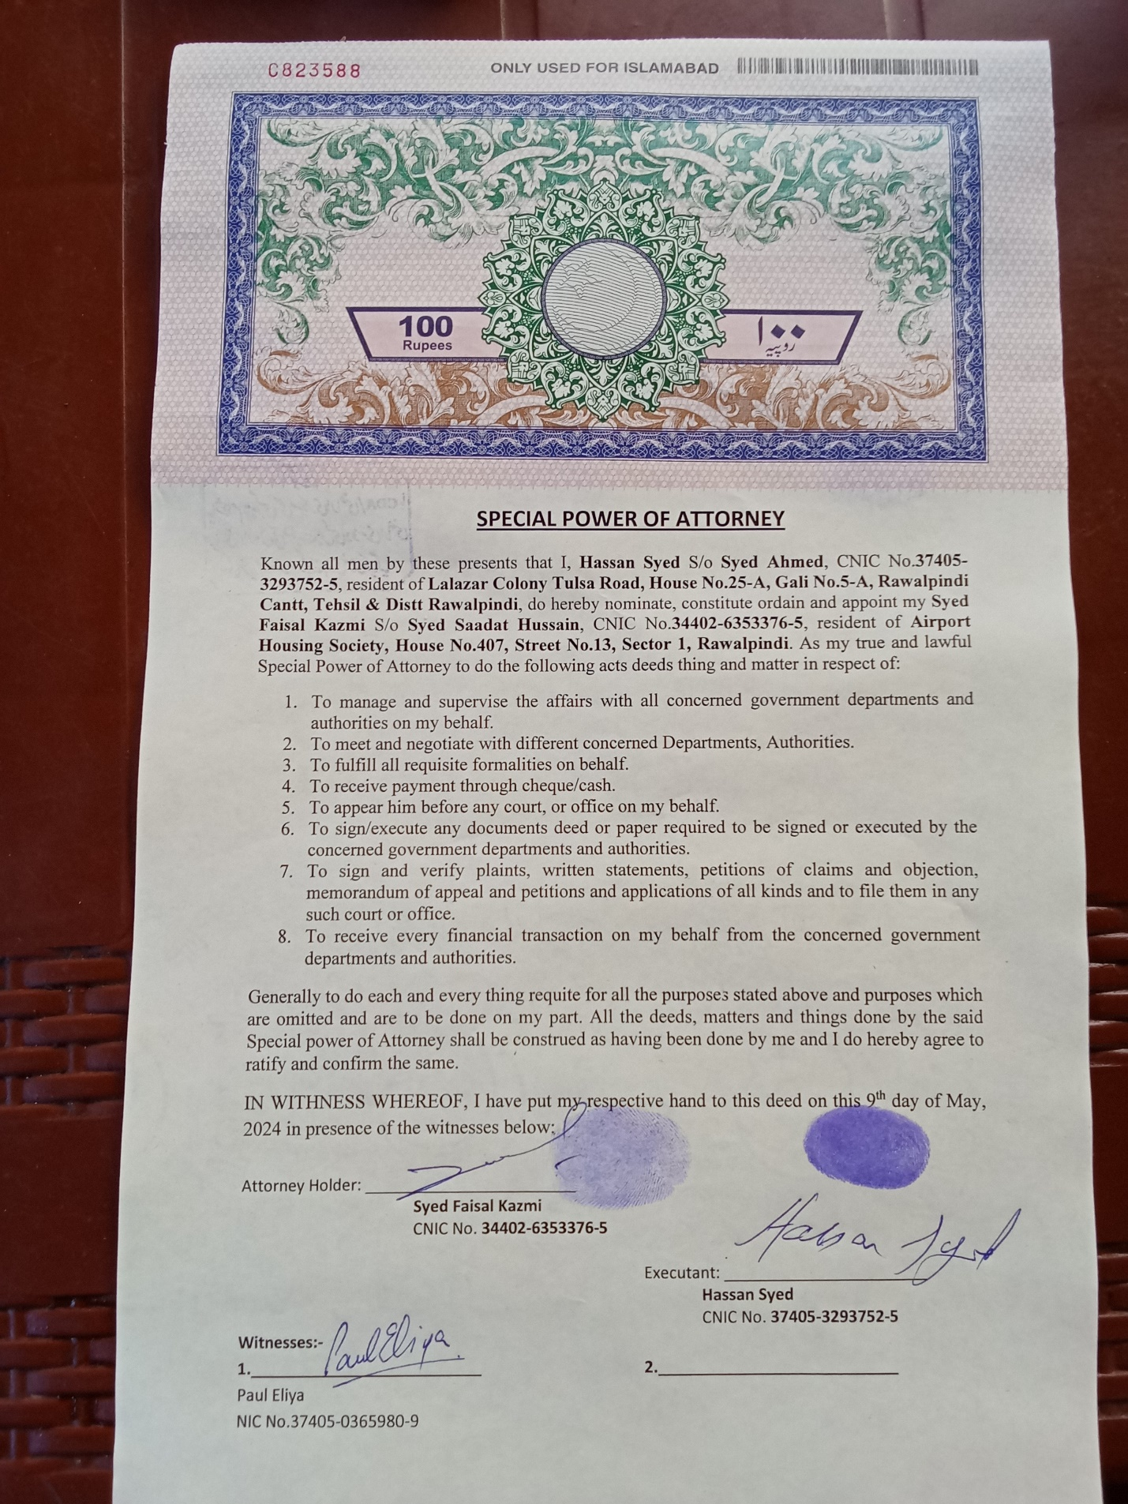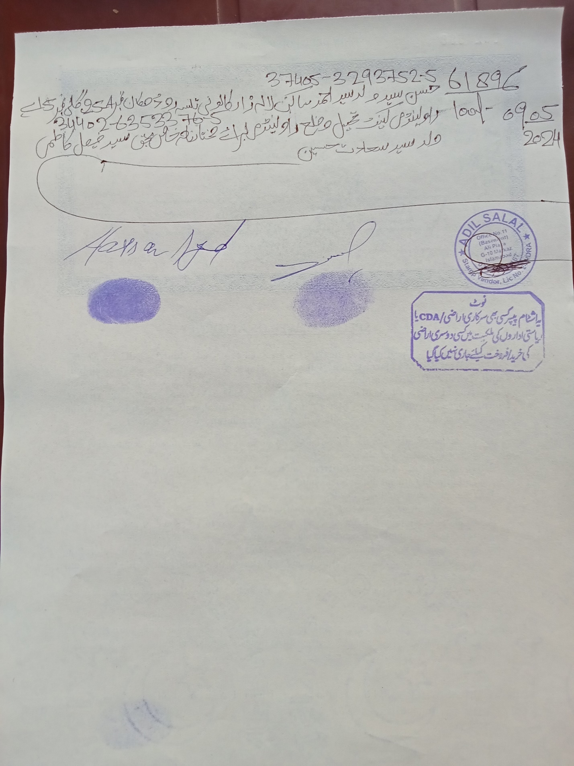
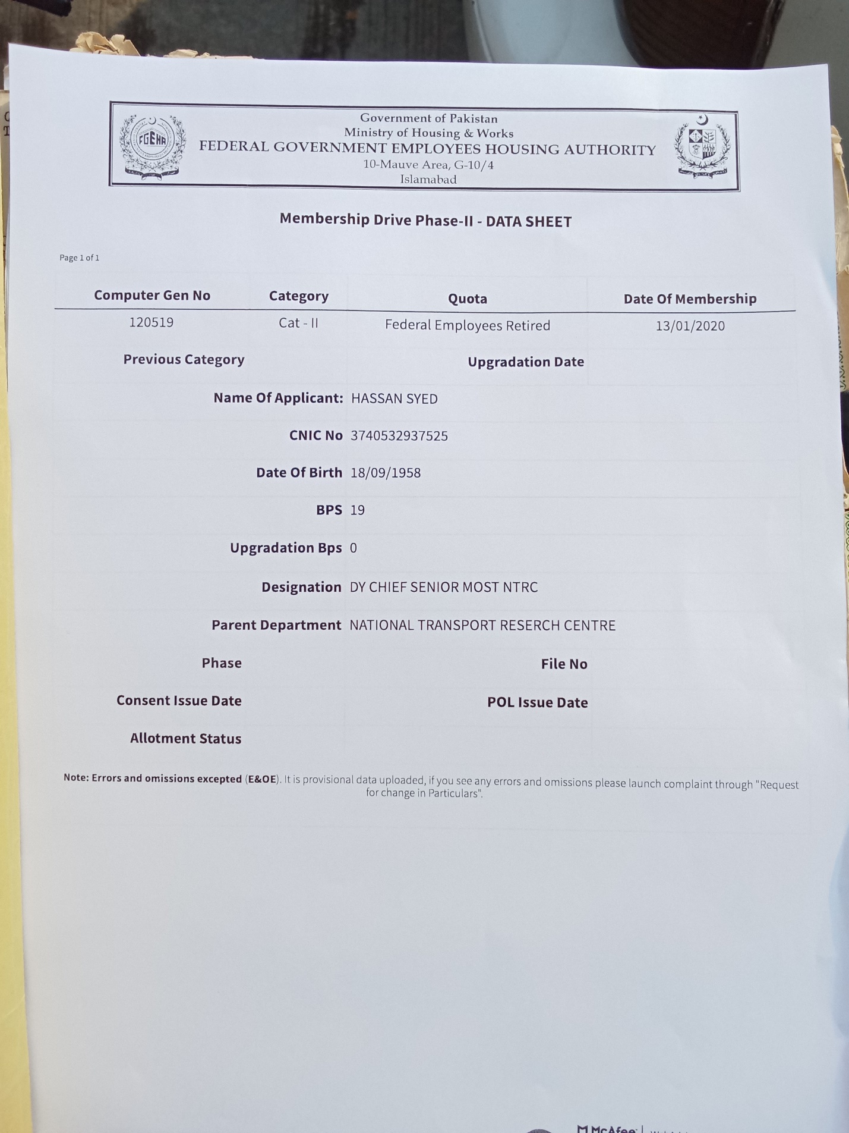

Dear Shmyla Khan

Researcher and Campaigner – Pakistan
South Asia Regional Office (SARO)
Mobile (WhatsApp and Signal): +92 0322 404 2588 shmyla.khan@amnesty.org

I Paul Eliya Son of Hassan Syed(Henry Lawrence) and Family requests the Letter of Recommendation from Amnesty International NGOs for our Immediate Refuge Asylum in any safe Country of the World
Thank you for your email
My family and I have been Experiencing a Systematic Persecution since 24 years I have also informed Pakistan Army 408 Intelligence Battalion regarding this precarious and Horrible situation, in Pakistan if anyone even said verbally only that this man has committed Blasphemy the whole Public gathers and kill that man without any proof or investigation the Pakistani Greedy Illiterate Suni Muslims Raja Amjad Iqbal Abbasi Abdul Qudoos, and Abdul Rauf and Relatives stolen our Property House Our Catholic Church#CB-3650(25-A) Lane#5-A Lalazar Colony because we regularly and daily Pray Worship in our Home and we made it Church but Neighbors and Relatives were not happy with our Unconditional Love Sincerity with our Lord Jesus Christ so the people of Tulsa Road Lalazar Colony Rawalpindi Cantt thrown us out of our Property by accusing us for doing Blasphemy against Holy Quran Islam and Holy prophet but I don't know exactly where and what kind of Hidden cases of Blasphemy are still pending against us for example 295-A crPC, 295-B crPC and 295-C crPC u/s 154 crPC in the Police stations courts of law of Pakistan in Rawalpindi and Islamabad and I appeared before Islamabad High Court and before Islamabad District and Sessions Court regarding Blasphemy Allegations in year 2022 and got Locked up for 24 hours in Police Station Kohsar on 17-02-2021 for preaching Holy Bible and Protesting for Justice me and my mother were jailed for 1 Day and were released after 24 hours, the Islamabad Police Cutted my Left hand wrist to Declare Suicide and hit my head with the Walls of Lock up jail 6 Times so hard that my Head start Bleeding and sound of my head can be heard even I was unconscious and one Police officer Took his Revolver and put it on my Head and he was about to pull the Trigger and I was unconscious and they did not took me to hospital PIMS or Poly Clinic and handcuffed me with the chair of the SHO Room but Lord Jesus Saved me because Jesus Said Be Faithful unto Death and I shall give you the Crown of Life.
we have shifted 28 houses in 8 years because Suni Majority Neighbors in Lalazar Colony and Tulsa Road Lane #5-A Accuses me and my family for Burning Quran and Tearing the Pages of Holy Book Quran and Desecration of Quran and we were forced to leave our house and they Threatened us with Mob Lynching that if we do not sign and thumb impression the transfer papers of our house the Mob will kill us and we will be assassinated by unknown and they Harrased us by stopping our basic utilities and aminities for our survival and now we are secretly hiding in Rawalpindi however The Suni Mindset Jihadi Extremists in Defence Military Authorities And in Security Agencies and in Government Kidnapped my father and threatened us that they will not let us Escape from Pakistan further they framed us as mad mentally unstable persons family to persecute us systematically due to their religious hatred against Christians.
I cannot get a job because where ever I go intelligence agencies warns the Employers not to give job or financial help at any cost even they also deprived me from getting Higher Education and they Hijacked our Fundamental Human Rights and In order to protect our lives I start using Social Media
https://istheonlywayjesusc.wixsite.com/jesuschrist
against the ISIS Jihadi Daishi Suni Deobandi Barelvi Illiterate Murderers Terrorists Criminals in Mosques Madrasas In Rawalpindi

me and my family are Vulnerable Christians Facing Persecution and Mob Lynching through Blasphemy Laws of the Islamic Republic of Pakistan and facing a Direct Threat from Mobs People in Pakistan

I'm writing to urgently request your help and support for my family and me. We're a persecuted Christian minority in Pakistan, facing imminent danger and threats from extremist groups. We've lost our assets, and our lives are at risk.

We desperately need your assistance to:

1. Provide financial support for our survival and relocation.
2. Facilitate our extraction from Pakistan and resettlement in a safe country (Europe, Canada, Australia, or Scandinavia).

We're seeking help on humanitarian and religious grounds. Any assistance would be a blessing.

Please, please help us escape this hell. We're running out of time.

Thank you for considering our plea.
I will keep following up my Request on Humanitarian Grounds
Please send necessary Help
Sincerely,
Pastor Paul Eliya Son of Pastor Henry Lawrence and family
Our Current Address is House#96, lane#4, block D, sector 4,Airport Housing Society Rawalpindi Cantt
Our Contact# +92-314-555-0432
And +92-318-530-9511
I have the 500 GB Complete Record Proof Evidences of Persecution are in my this website below and I have the Physical Documents of Courts Police Stations Complaints against The Culprits
My Online Salvation Church is https://istheonlywayjesusc.wixsite.com/jesuschrist
Jesus Christ will give us Justice
Because we are the Obedient Children of our Lord Jesus Christ, we Bow Down Our Heads Before our only Saviour Son of God Jesus Christ who lives in our Souls Minds Hearts
Please Follow up through this Email address henrylawrence7212@gmail.com

https://istheonlywayjesusc.wixsite.com/jesuschrist
https://istheonlywayjesusc.wixsite.com/love
https://istheonlywayjesusc.wixsite.com/salvation-church



“Whoever is generous to the poor lends to the lord, and he will repay him for his deed.”

MY SONG
“BELIEVE EVERYTHING IS POSSIBLE IN JESUS CHRIST
I AM THE CHILD OF JESUS CHRIST LIVING WITH MY BELOVED FATHER MOTHER CHILDREN SISTERS BROTHERS BELOVED ONES FAMILY IN JESUS CHRIST WITH JESUS CHRIST WITH HIS GOOD WORKS IN ME https://istheonlywayjesusc.wixsite.com/love
FOREVER PHYSICALLY ETERNALLY HEAVENLY IN IMMORTALITY RAISED RESURRECTED INCARNATED ALL GENERATIONS
JESUS IS MY HERO
JESUS IS MY SAVIOUR
JESUS IS MY HOME
I LOVE YOU JESUS CHRIST UNCONDITIONALLY BY BOWING DOWN MY HEAD BEFORE YOU AND SERVING YOU ONLY”
by Pastor Paul Eliya https://pauleliya853.wixsite.com/love-live-with
MY YOUTUBE CHANNEL IS JESUS CHRIST IS THE ONLY WAY SALVATION CHURCH
https://youtu.be/wgWWfe7fi98
https://youtu.be/lFoxjm5mmhA?si=l9sIW0HuE4KYAfNq
https://youtu.be/hWX3_duqAWk

Soul of Jesus

Good Works

OWNED BY JESUS

F

R

U

I

T

S

O

F

M

Y

S

O

U

L

MIND HEART

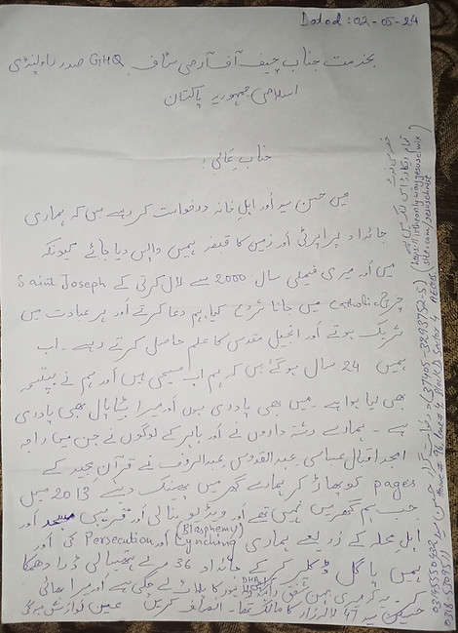
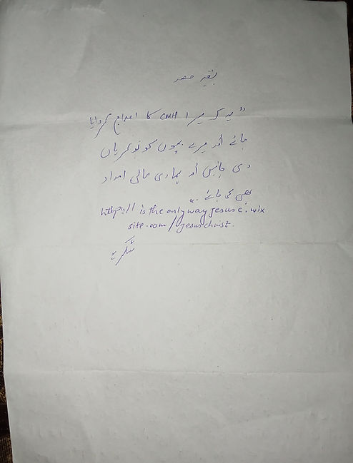
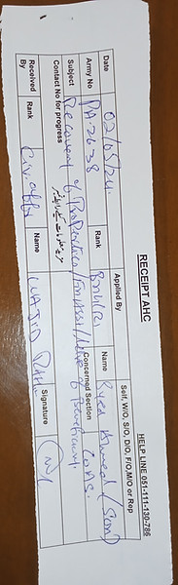

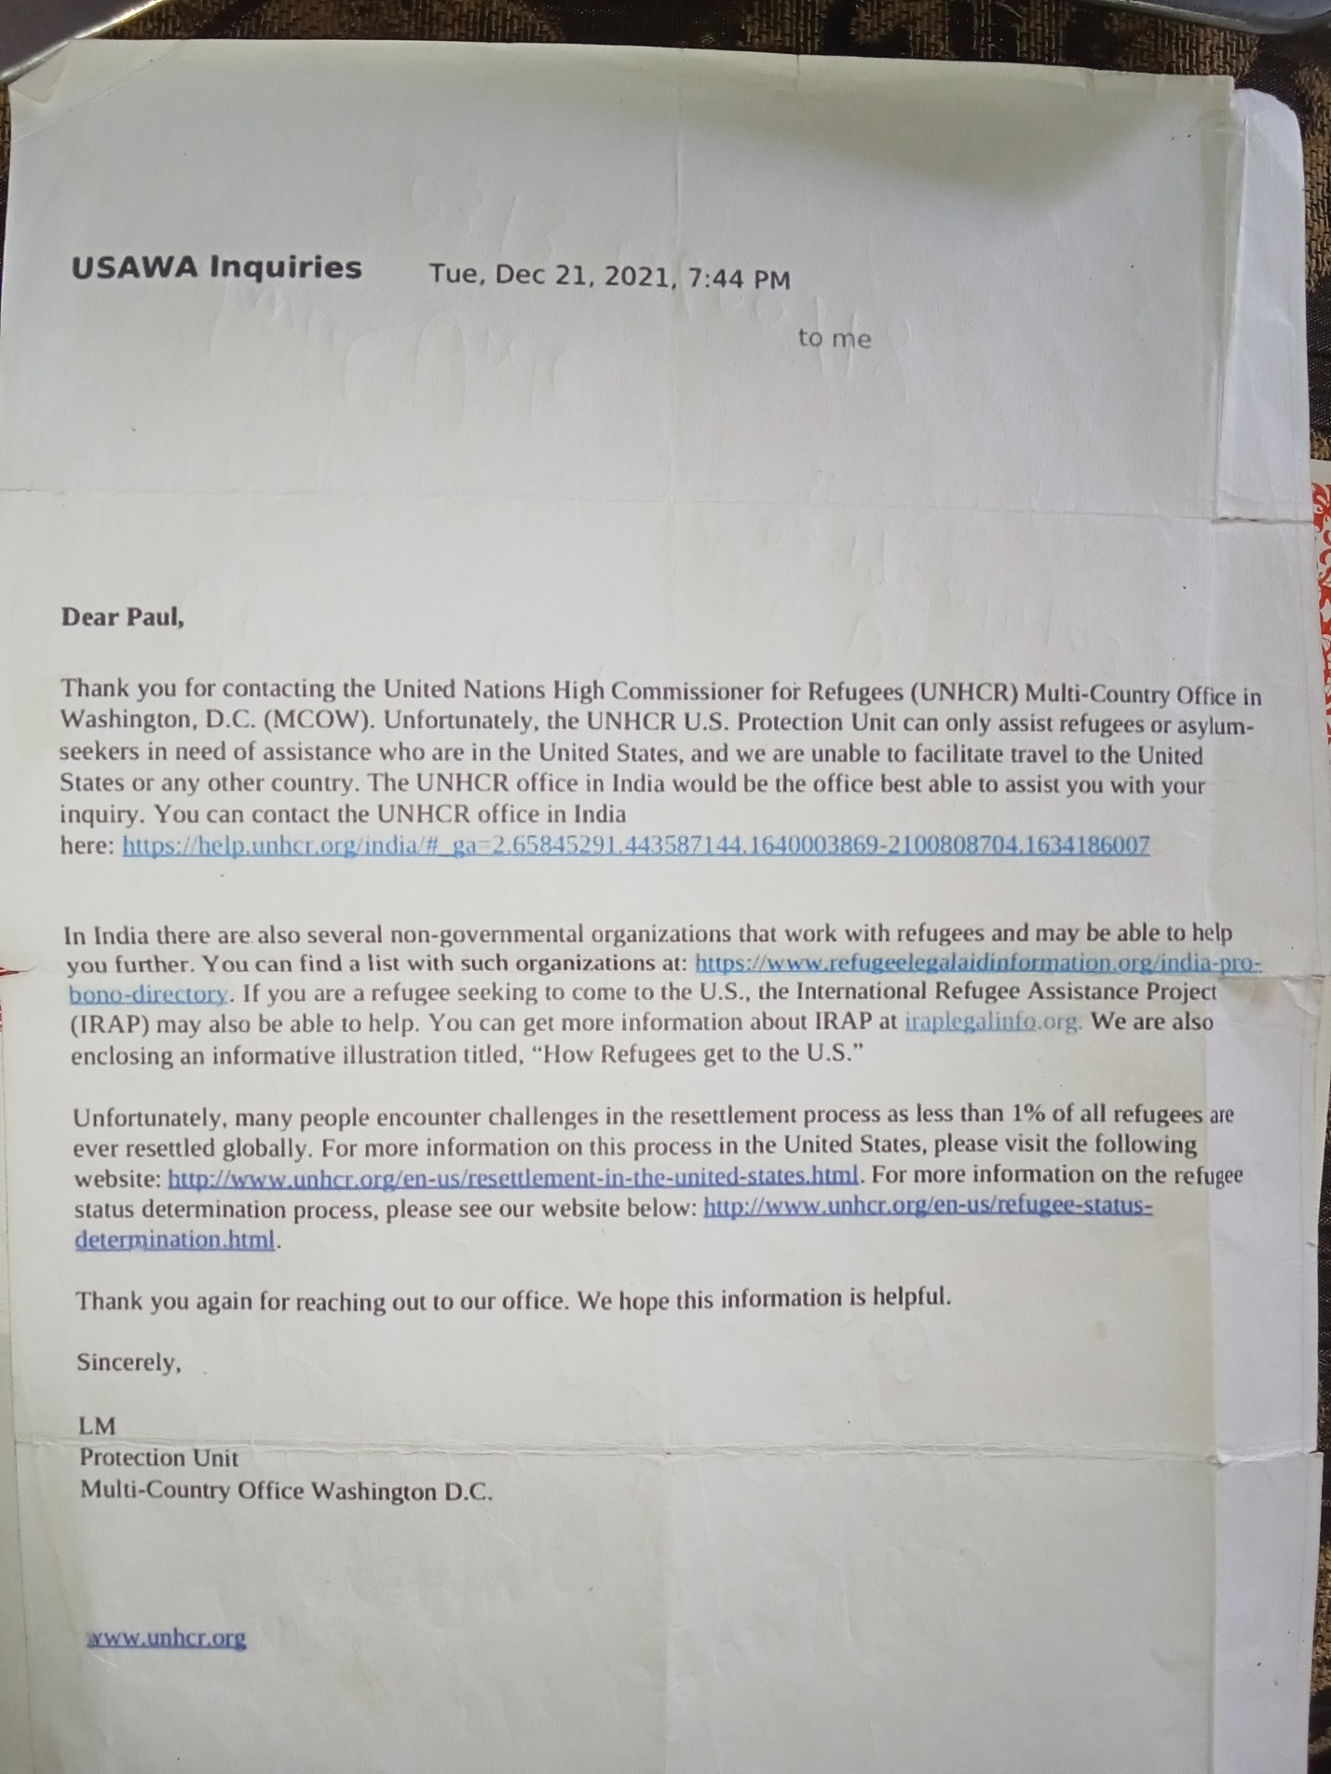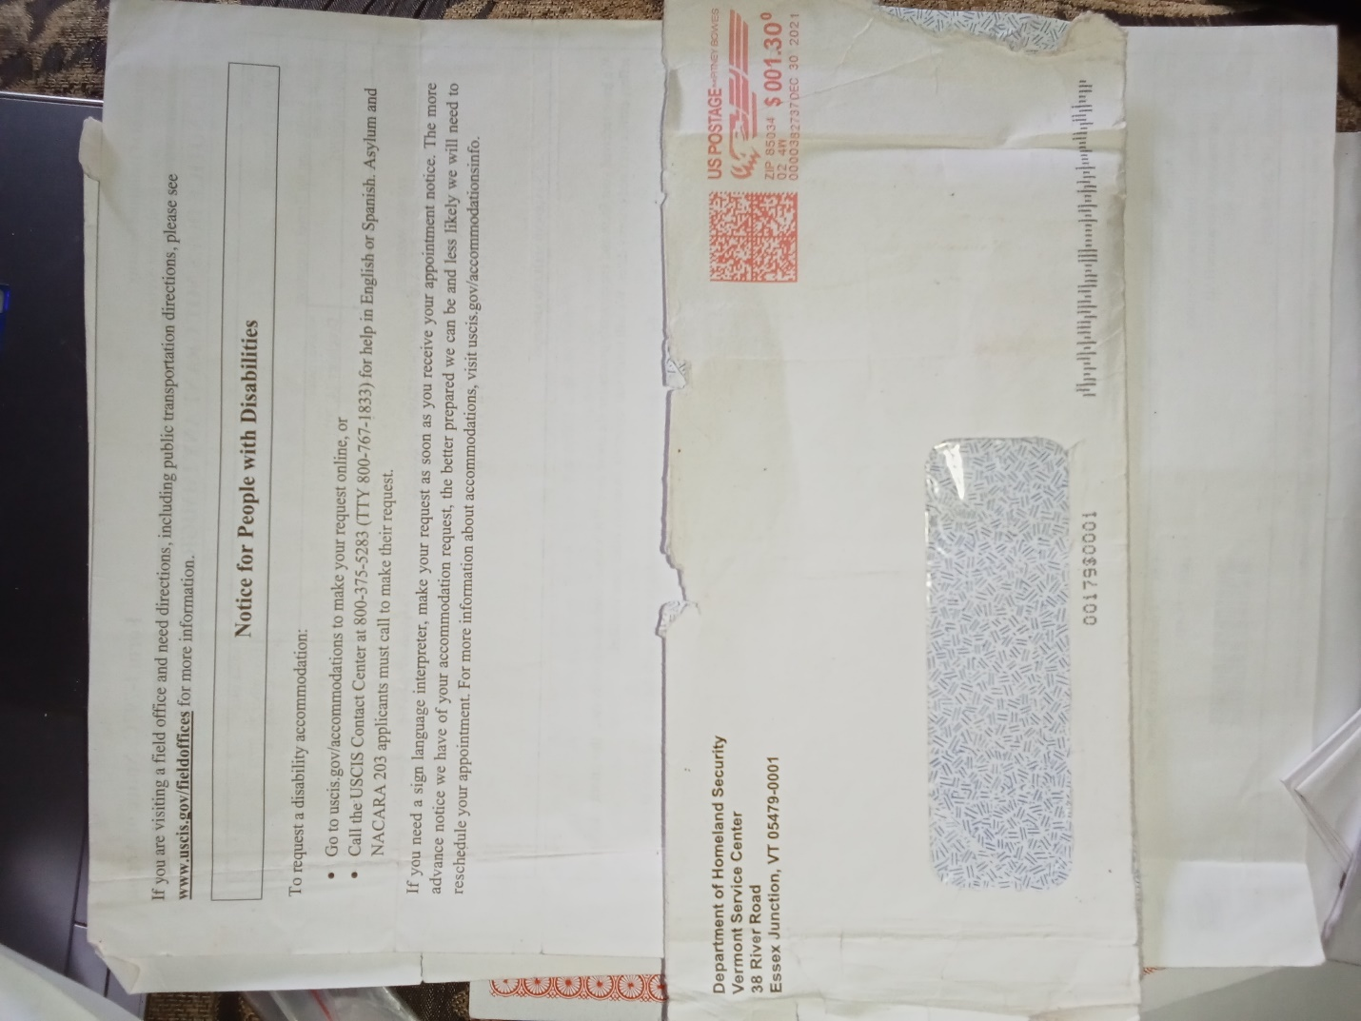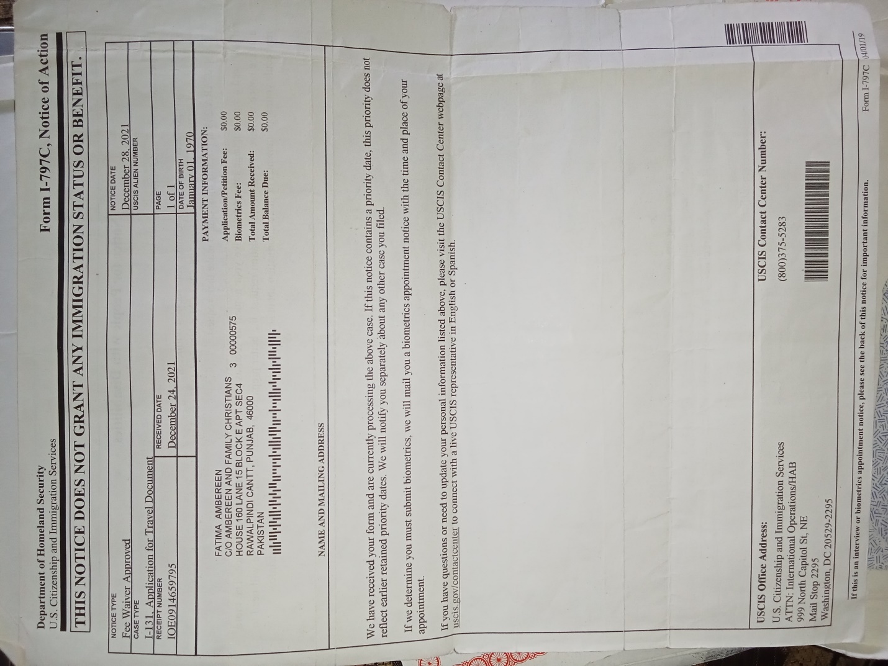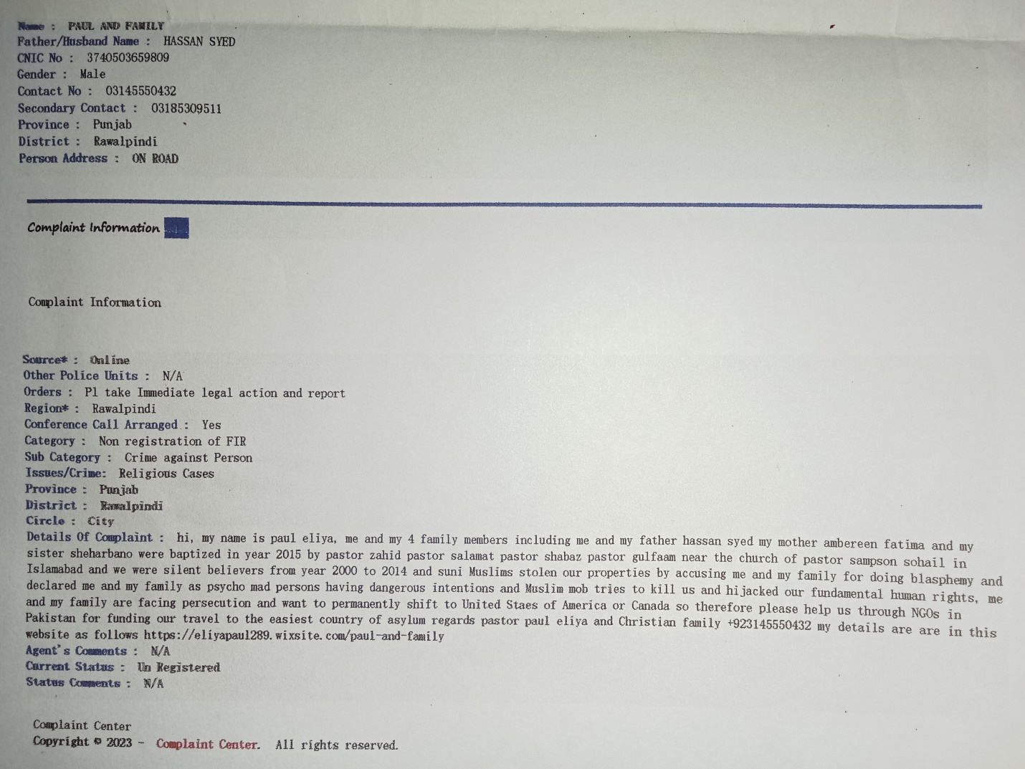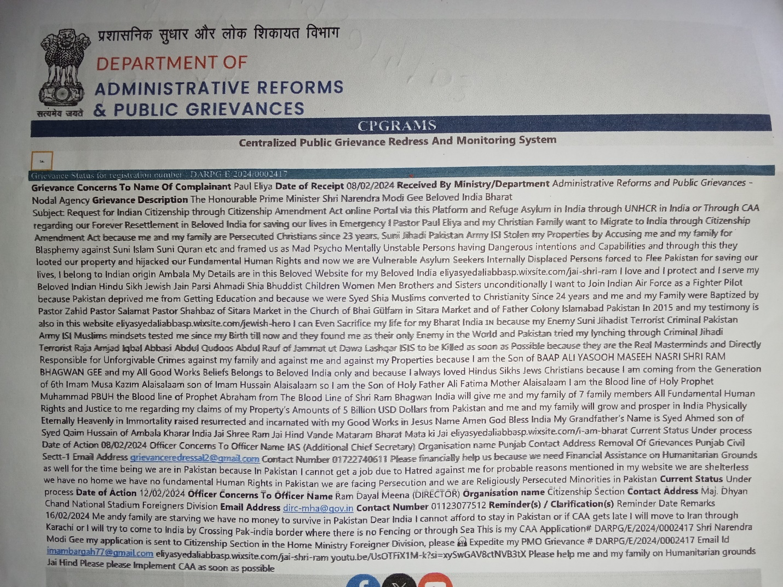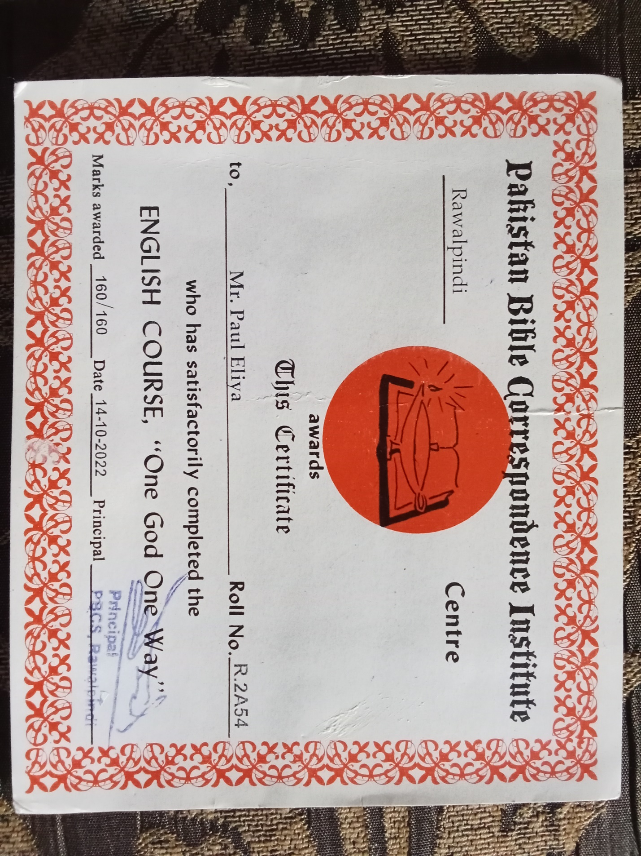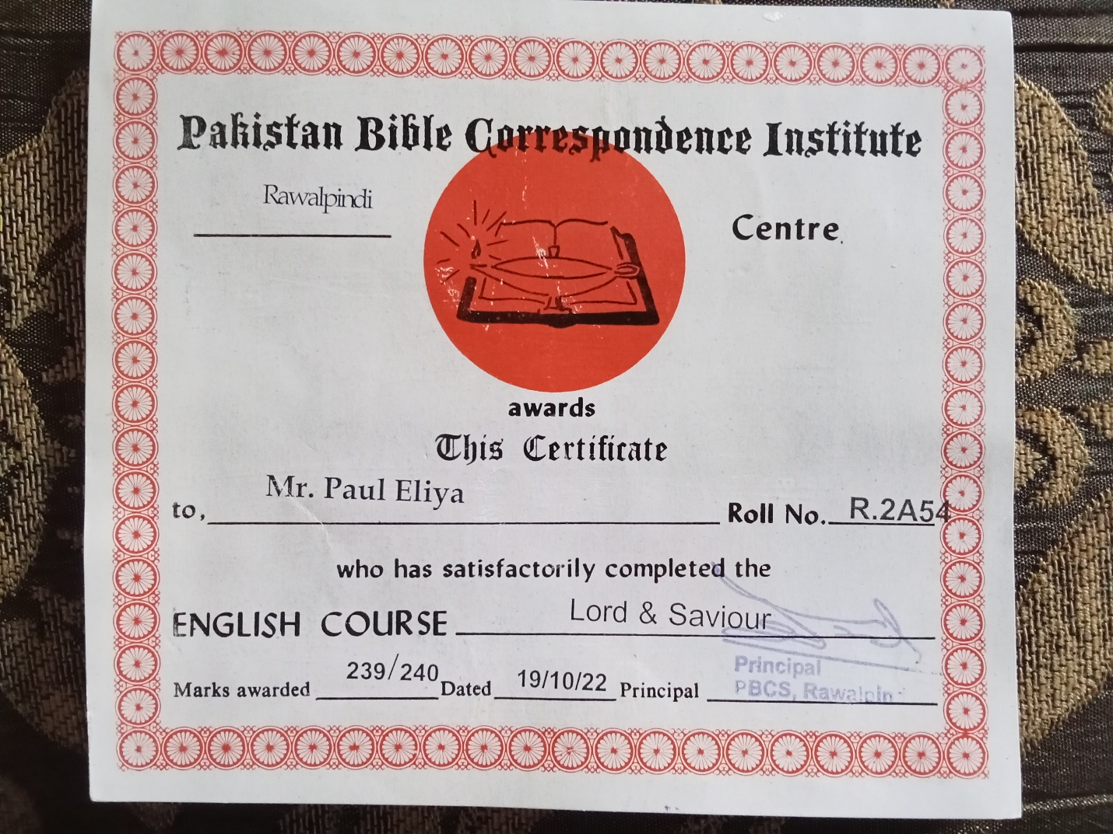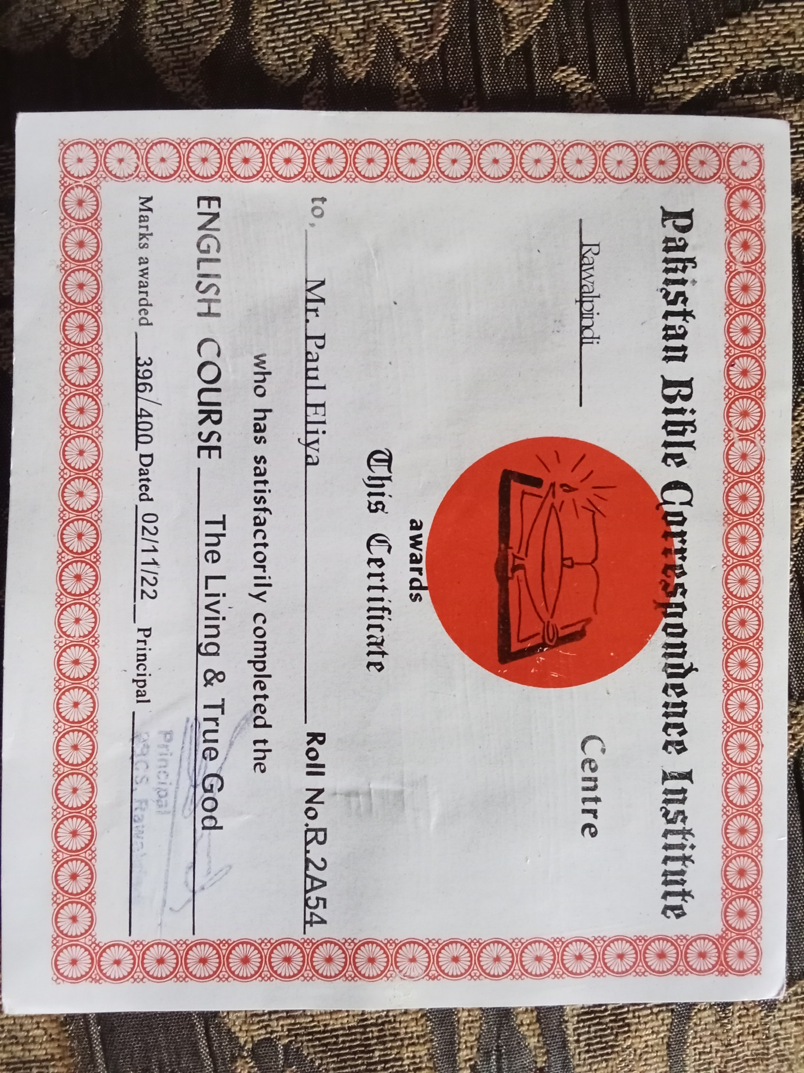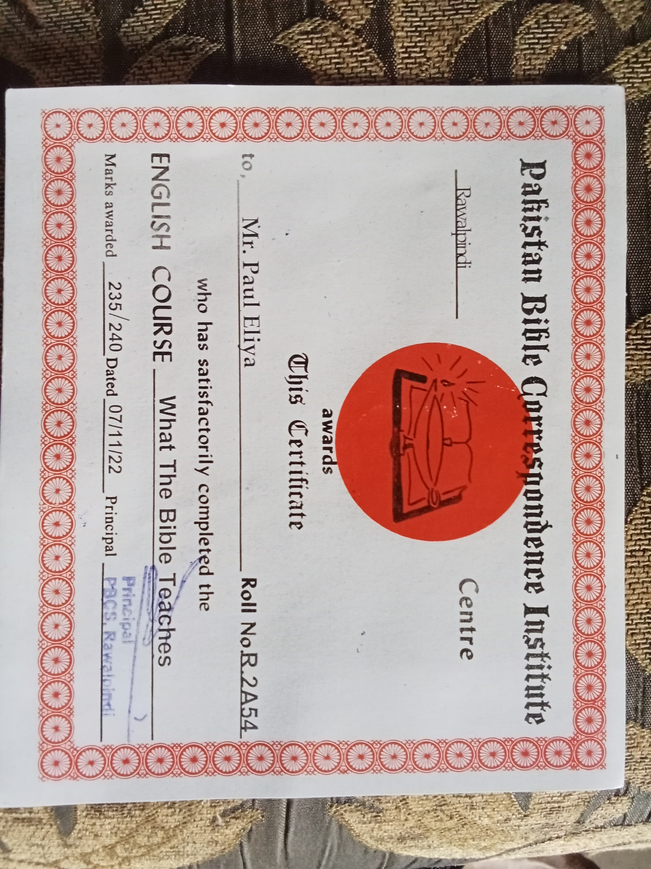

Dear Shmyla Khan

Researcher and Campaigner – Pakistan
South Asia Regional Office (SARO)
Mobile (WhatsApp and Signal): +92 0322 404 2588 shmyla.khan@amnesty.org

I Paul Eliya Son of Hassan Syed(Henry Lawrence) and Family requests the Letter of Recommendation from Amnesty International NGOs for our Immediate Refuge Asylum in any safe Country of the World
Thank you for your email
My family and I have been Experiencing a Systematic Persecution since 24 years I have also informed Pakistan Army 408 Intelligence Battalion regarding this precarious and Horrible situation, in Pakistan if anyone even said verbally only that this man has committed Blasphemy the whole Public gathers and kill that man without any proof or investigation the Pakistani Greedy Illiterate Suni Muslims Raja Amjad Iqbal Abbasi Abdul Qudoos, and Abdul Rauf and Relatives stolen our Property House Our Catholic Church#CB-3650(25-A) Lane#5-A Lalazar Colony because we regularly and daily Pray Worship in our Home and we made it Church but Neighbors and Relatives were not happy with our Unconditional Love Sincerity with our Lord Jesus Christ so the people of Tulsa Road Lalazar Colony Rawalpindi Cantt thrown us out of our Property by accusing us for doing Blasphemy against Holy Quran Islam and Holy prophet but I don't know exactly where and what kind of Hidden cases of Blasphemy are still pending against us for example 295-A crPC, 295-B crPC and 295-C crPC u/s 154 crPC in the Police stations courts of law of Pakistan in Rawalpindi and Islamabad and I appeared before Islamabad High Court and before Islamabad District and Sessions Court regarding Blasphemy Allegations in year 2022 and got Locked up for 24 hours in Police Station Kohsar on 17-02-2021 for preaching Holy Bible and Protesting for Justice me and my mother were jailed for 1 Day and were released after 24 hours, the Islamabad Police Cutted my Left hand wrist to Declare Suicide and hit my head with the Walls of Lock up jail 6 Times so hard that my Head start Bleeding and sound of my head can be heard even I was unconscious and one Police officer Took his Revolver and put it on my Head and he was about to pull the Trigger and I was unconscious and they did not took me to hospital PIMS or Poly Clinic and handcuffed me with the chair of the SHO Room but Lord Jesus Saved me because Jesus Said Be Faithful unto Death and I shall give you the Crown of Life.
we have shifted 28 houses in 8 years because Suni Majority Neighbors in Lalazar Colony and Tulsa Road Lane #5-A Accuses me and my family for Burning Quran and Tearing the Pages of Holy Book Quran and Desecration of Quran and we were forced to leave our house and they Threatened us with Mob Lynching that if we do not sign and thumb impression the transfer papers of our house the Mob will kill us and we will be assassinated by unknown and they Harrased us by stopping our basic utilities and aminities for our survival and now we are secretly hiding in Rawalpindi however The Suni Mindset Jihadi Extremists in Defence Military Authorities And in Security Agencies and in Government Kidnapped my father and threatened us that they will not let us Escape from Pakistan further they framed us as mad mentally unstable persons family to persecute us systematically due to their religious hatred against Christians.
I cannot get a job because where ever I go intelligence agencies warns the Employers not to give job or financial help at any cost even they also deprived me from getting Higher Education and they Hijacked our Fundamental Human Rights and In order to protect our lives I start using Social Media
https://istheonlywayjesusc.wixsite.com/jesuschrist
against the ISIS Jihadi Daishi Suni Deobandi Barelvi Illiterate Murderers Terrorists Criminals in Mosques Madrasas In Rawalpindi

me and my family are Vulnerable Christians Facing Persecution and Mob Lynching through Blasphemy Laws of the Islamic Republic of Pakistan and facing a Direct Threat from Mobs People in Pakistan

I'm writing to urgently request your help and support for my family and me. We're a persecuted Christian minority in Pakistan, facing imminent danger and threats from extremist groups. We've lost our assets, and our lives are at risk.

We desperately need your assistance to:

1. Provide financial support for our survival and relocation.
2. Facilitate our extraction from Pakistan and resettlement in a safe country (Europe, Canada, Australia, or Scandinavia).

We're seeking help on humanitarian and religious grounds. Any assistance would be a blessing.

Please, please help us escape this hell. We're running out of time.

Thank you for considering our plea.
I will keep following up my Request on Humanitarian Grounds
Please send necessary Help
Sincerely,
Pastor Paul Eliya Son of Pastor Henry Lawrence and family
Our Current Address is House#96, lane#4, block D, sector 4,Airport Housing Society Rawalpindi Cantt
Our Contact# +92-314-555-0432
And +92-318-530-9511
I have the 500 GB Complete Record Proof Evidences of Persecution are in my this website below and I have the Physical Documents of Courts Police Stations Complaints against The Culprits
My Online Salvation Church is https://istheonlywayjesusc.wixsite.com/jesuschrist
Jesus Christ will give us Justice
Because we are the Obedient Children of our Lord Jesus Christ, we Bow Down Our Heads Before our only Saviour Son of God Jesus Christ who lives in our Souls Minds Hearts
Please Follow up through this Email address henrylawrence7212@gmail.com

