MAI BHARAT KA BETA HOON I AM A BODY BUILDER RAW AGENT, HISTORY WILL REMEMBER ME BECAUSE I HATE AND I CONDEMN KAFIR LANTI ABUBAKAR UMER USMAN AISHA MUAWIYA ABDUL REHMAN SHIMMER YAZEED AND OTHERS INCLUDING THEIR UNFORTUNATE FOLLOWERS TO HELL FIRE FOREVER AND HISTORY WILL REMEMBER ME FOR MY GOOD WORKS AS WELL AS MENTIONED BELOW BUT COWARD PEOPLE NEVER TAKE MY NAME ON MEDIA WHY

Inbox

Search for all messages with label Inbox

Remove label Inbox from this conversation

https://lh3.googleusercontent.com/a/ACg8ocLvAOkBDovn7FrAgxBSEYhrwrDzAaDUAL2W-dvNBAFoQ5vziQw=s40-p

|  |  |  |  |  |  |  |
| --- | --- | --- | --- | --- | --- | --- |
| |  | | --- | | **Paul Eliya1 <eliyapaul962@gmail.com>** | | | | 7:15 PM (2 minutes ago) |  | https://mail.google.com/mail/u/1/images/cleardot.gif  https://mail.google.com/mail/u/1/images/cleardot.gif  https://mail.google.com/mail/u/1/images/cleardot.gif |
| |  | | --- | | to dg, complaint, director.admin, director.finance, director.estate, director.jv, director.law, director.coord, director.IT, director.technical, director.security, director.ia, director.planning, director.land, director.maintenance, director.revenue, director.jvkci, AD.AstonAndSuttonColdfield, AD.ColeshillAndPolesworth, AD.HandsworthAndCentral, AD.KNMS, Admin, Citizen, CPIinfoMali, Courrier, Fadi.El-Abdallah, Falak, FreeJobs, GENESIS, Info, JU, Mike.Sermon, Nick.Parker, OTP, OTPNewsDesk, Ohchr-dexrel, Ombudsman, Passport.london, Paul, Perfect, Procurement, Security, Here's, Sohaibchoudry221998, Syed, WaleedbinToufeeq, WeTrip, achats, administrator, agnes.eklund, agnes.jansson, ahmadiaportugal, alexandra.cederquist, amjmalta, andia.gemsjo, anna.erhardt, anna.lund, apdpftac2, applications, appt.london, atfal, attcons.washington, bilal.lodhi, bishop.david, bishopofaston, bishopsadmin, bookkeeping, caritas.internationalis, cee-office, ceo, com.tehran, com3.washington, commregen, comms, communications, cons.islamabad, cons.tehran, cons1.telaviv, cons2.telaviv, cons6.washington, consuly, contact, contact, contact, contactus, contatti, copyright, dave, dioceseoflondon, discipleship, donorcare, eastafritac, editor, education, elana, emergencies, enquiry, environment, farrakhmansoor, financeteam, flex, frezza, fsoci.washington, fspic.washington, fund, givingtogether, glavno.tajnistvo, hammad.tariq, helpdesk, helpdesk, helplinephc, hoc.babbas, hoc.tehran, hqepu, hr, hr, hrmartha, i.registrar, ieo, imam.ahmed, imffa, imfvideo, inclusiveandaccessible, info, info, info, info, info, info, info, info, info, info, info, info, info, info, info, info, info, info, information, information.hebrew, interculturalmission, interfaith, irnte, irnteprt, isaac.elm.communications, isbad, jennyt, ju.registrar, kancelaria, khuddamireland, kontakt, kontakt, kontakt, kpk, lahore, lahore\_churchcouncil, library, marriagebureau34, media, media, mineco.washington, ministry, mohsin.talpur, mubbbutt, muhammad.tariq, newchristiancommunities, ngoliaison, niazihaider786, obedarthur, office, office, ohchr-unvfvt, opinia\_ta, ouse, paivytys.um, panatz, parishmissionsupport, parishsurveyor, pathways, peopleandplaces, petrosillo, pniot, press, pressoffice, procurement, property, psamb.washington, psdcm.washington, publicaffairs, publications, reception, recrutement-recruitment, reehanashraf, refworld, revchris007, safeguardingsupport, sah, sanam.javed, sbs.malta.heliga-stolen, secministerialmeetings, secretariat, sektor.jd.ks, shahid.wazir, socialdepartementet.registrator, spain, spyropoulos, support, support-india, support-pakistan, tcpak, ujieuropa, ured.drzavnog.tajnika, v-bknoojh\_nnpgdkmghf\_jdofaikg\_jdoelhap\_a, visa.islamabad, visaservicesphcnd, vocations, web, webmaster, weddings, contact, Пакистан, islamabad, islamabad.hum, islamabad.visa, islamabad.ziv, islamabad, pakistan, Webmaster, asrcrwp, asrcfsd, asrclhr, asrckci, asrcpsc, asrcqta, asrcglt, asrcmzd, asrcmtn, asrckzd, asrchyd, asrcdik, asrcpnl, complaint, Public, me, dd-it1, bcc: contact, bcc: cons1.telaviv, bcc: cons2.telaviv, bcc: cons.islamabad, bcc: cons.tehran, bcc: consuly, bcc: cons6.washington  https://mail.google.com/mail/u/1/images/cleardot.gif | | | | | |
| from: | **Paul Eliya1** <eliyapaul962@gmail.com> |
| to: | dg@fgeha.gov.pk, complaint@fgeha.gov.pk, director.admin@fgeha.gov.pk, director.finance@fgeha.gov.pk, director.estate@fgeha.gov.pk, director.jv@fgeha.gov.pk, director.law@fgeha.gov.pk, director.coord@fgeha.gov.pk, director.IT@fgeha.gov.pk, director.technical@fgeha.gov.pk, director.security@fgeha.gov.pk, director.ia@fgeha.gov.pk, director.planning@fgeha.gov.pk, director.land@fgeha.gov.pk, director.maintenance@fgeha.gov.pk, director.revenue@fgeha.gov.pk, director.jvkci@fgeha.gov.pk, AD.AstonAndSuttonColdfield@cofebirmingham.com, AD.ColeshillAndPolesworth@cofebirmingham.com, AD.HandsworthAndCentral@cofebirmingham.com, AD.KNMS@cofebirmingham.com, Admin@azadchaiwala.com, Citizen Service of the Ministry of Foreign Affairs <borgarathjonusta@utn.is>, CPIinfoMali@icc-cpi.int, Courrier Elysée <courrier.president@elysee.fr>, Fadi.El-Abdallah@icc-cpi.int, Falak Tayab Corporate Service <careers@falaktayabcorporateservices.com>, FreeJobs UAE <pr@advancelevelcon.com>, GENESIS@matrimony.com, Info@iranembassy.pk, JU Brev <ju.brev@regeringskansliet.se>, Mike.Sermon@cofebirmingham.com, Nick.Parker@cofebirmingham.com, "OTP InformationDesk (Article15)" <otp.informationdesk@icc-cpi.int>, OTPNewsDesk@icc-cpi.int, Ohchr-dexrel@un.org, Ombudsman@mevaker.gov.il, Passport.london@mea.gov.in, Paul Eliya <eliyapaul289@gmail.com>, Perfect LLC <hr@perfectllcdubai.com>, Procurement@icc-cpi.int, Security@icc-cpi.int, Here's Puthran <visa.washington@mea.gov.in>, Sohaibchoudry221998@gmail.com, Syed Ali Abbas Paul Eliya <eliyasyedaliabbaspaul@gmail.com>, WaleedbinToufeeq@gmail.com, WeTrip <contact@wetrip.pk>, achats@icj-cij.org, administrator@stmarksitaly.com, agnes.eklund@regeringskansliet.se, agnes.jansson@gov.se, ahmadiaportugal@hotmail.com, alexandra.cederquist@gov.se, amjmalta@gmail.com, andia.gemsjo@regeringskansliet.se, anna.erhardt@gov.se, anna.lund@gov.se, apdpftac2@imf.org, applications@icc-cpi.int, appt.london@mea.gov.in, atfal@atfal.de, attcons.washington@mea.gov.in, bilal.lodhi@bop.com.pk, bishop.david@manchester.anglican.org, bishopofaston@cofebirmingham.com, bishopsadmin@cofebirmingham.com, bookkeeping@cofebirmingham.com, caritas.internationalis@caritas.va, cee-office@imf.org, ceo@sadiqtravels.com, com.tehran@mea.gov.in, com3.washington@mea.gov.in, commregen@cofebirmingham.com, comms@cofebirmingham.com, communications@london.anglican.org, cons.islamabad@mea.gov.in, cons.tehran@mea.gov.in, cons1.telaviv@mea.gov.in, cons2.telaviv@mea.gov.in, cons6.washington@mea.gov.in, consuly@iranembassy.pk, contact@fatf-gafi.org, contact@ahmadiyya.fr, contact@ahmadiyya.dk, contactus@iaa.gov.il, contatti@alislam.it, copyright@imf.org, dave@redeemerdubai.com, dioceseoflondon@luther.co.uk, discipleship@cofebirmingham.com, donorcare@unhcr.ca, eastafritac@imf.org, editor@chanakyaforum.com, education@cofebirmingham.com, elana@israelforever.org, emergencies@caritas.va, enquiry@churchofengland.org, environment@cofebirmingham.com, farrakhmansoor@hot.ee, financeteam@cofebirmingham.com, flex@cofebirmingham.com, frezza@caritas.va, fsoci.washington@mea.gov.in, fspic.washington@mea.gov.in, fund@end-violence.org, givingtogether@imf.org, glavno.tajnistvo@mvep.hr, hammad.tariq@sindhbankltd.com, helpdesk@lajnauk.org, helpdesk@lajna.be, helplinephc@gmail.com, hoc.babbas@mea.gov.in, hoc.tehran@mea.gov.in, hqepu@unhcr.org, hr@cofebirmingham.com, hr fatima ali <hrfatimaali@gmail.com>, hrmartha roy <hrmagraroy@gmail.com>, i.registrar@gov.se, ieo@imf.org, imam.ahmed@ahmadiyya.ch, imffa@imf.org, imfvideo@imf.org, inclusiveandaccessible@cofebirmingham.com, info@thrivetogetherbham.org, info@ahmadiyya.ch, info@education.gov.il, info@imfmetac.org, info@end-violence.org, info@visitouriran.com, info@khuddam.co.uk, info@ziyarahtours.net, info@farrukhsaif.com, info@ansar.org.uk, info@alavitravel.com, info@khuddam.nl, info@sadiqtravels.com, info@travelfatimah.com, info@khuddam.be, info@alsahlah.com, info@cartac.org, info@refugepoint.org, information@icj-cij.org, information.hebrew@yadvashem.org.il, interculturalmission@cofebirmingham.com, interfaith@cofebirmingham.com, irnte@unhcr.org, irnteprt@unhcr.org, isaac.elm.communications@gmail.com, isbad@international.gc.ca, jennyt@cofebirmingham.com, ju.registrar@gov.se, kancelaria@msz.gov.pl, khuddamireland@gmail.com, kontakt@ahmadiyya.de, kontakt@ahmadiyya.no, kontakt@lajna.de, kpk@pasb.mod.gov.pk, lahore@hk-diplo.de, lahore\_churchcouncil@yahoo.com, library@icj-cij.org, marriagebureau34@gmail.com, media@imf.org, media@fatf-gafi.org, mineco.washington@mea.gov.in, ministry@cofebirmingham.com, mohsin.talpur@sindhbankltd.com, mubbbutt@gmail.com, muhammad.tariq@mofa.gov.pk, newchristiancommunities@cofebirmingham.com, ngoliaison@imf.org, niazihaider786@gmail.com, obedarthur@gmail.com, office@saintmarysdubai.org, office@ahmadiyya.at, ohchr-unvfvt@un.org, opinia\_ta@mae.ro, ouse winterz <ousewinterz1@gmail.com>, paivytys.um@gov.fi, panatz@rbc.gov.il, parishmissionsupport@cofebirmingham.com, parishsurveyor@cofebirmingham.com, pathways@cofebirmingham.com, peopleandplaces@cofebirmingham.com, petrosillo@caritas.va, pniot@mod.gov.il, press@pakchristiannews.com, pressoffice@phclondon.org, procurement@imf.org, property@cofebirmingham.com, psamb.washington@mea.gov.in, psdcm.washington@mea.gov.in, publicaffairs@imf.org, publications@imf.org, reception@london.anglican.org, recrutement-recruitment@icj-cij.org, reehanashraf@hotmail.com, refworld@unhcr.org, revchris007@gmail.com, safeguardingsupport@cofebirmingham.com, sah@cis-iwc.org, sanam.javed@sindhbankltd.com, sbs.malta.heliga-stolen@gov.se, secministerialmeetings@imf.org, secretariat@end-violence.org, sektor.jd.ks@mvep.hr, shahid.wazir@sindhbankltd.com, socialdepartementet.registrator@gov.se, spain@alislam.org, spyropoulos@hotmail.co.uk, support@ustravel.com, support-india@ustraveldocs.com, support-pakistan@ustraveldocs.com, tcpak@um.dk, ujieuropa@mvep.hr, ured.drzavnog.tajnika@mvep.hr, v-bknoojh\_nnpgdkmghf\_jdofaikg\_jdoelhap\_a@bounce.studentenquiry.mkt4116.com, visa.islamabad@mea.gov.in, visaservicesphcnd@gmail.com, vocations@cofebirmingham.com, web@mae.ro, webmaster@icj-cij.org, weddings@holytrinity.ae, contact@majorgauravarya.com, "Генконсульство России в г. Карачи, Пакистан" <karachi@mid.ru>, islamabad@dks.ru, islamabad.hum@eda.admin.ch, islamabad.visa@eda.admin.ch, islamabad.ziv@eda.admin.ch, islamabad@eda.admin.ch, pakistan@mid.ru, Webmaster <webmaster@joinpakarmy.gov.pk>, asrcrwp@joinpakarmy.gov.pk, asrcfsd@joinpakarmy.gov.pk, asrclhr@joinpakarmy.gov.pk, asrckci@joinpakarmy.gov.pk, asrcpsc@joinpakarmy.gov.pk, asrcqta@joinpakarmy.gov.pk, asrcglt@joinpakarmy.gov.pk, asrcmzd@joinpakarmy.gov.pk, asrcmtn@joinpakarmy.gov.pk, asrckzd@joinpakarmy.gov.pk, asrchyd@joinpakarmy.gov.pk, asrcdik@joinpakarmy.gov.pk, asrcpnl@joinpakarmy.gov.pk, complaint@thepakarmy.com, Public Response Unit <inf.london@mea.gov.in>, Paul Eliya1 <eliyapaul962@gmail.com>, dd-it1@fgeha.gov.pk |
| cc: | contact@majorgauravarya.com, cons1.telaviv@mea.gov.in, cons2.telaviv@mea.gov.in, cons.islamabad@mea.gov.in, cons.tehran@mea.gov.in, consuly@iranembassy.pk, cons6.washington@mea.gov.in |
| bcc: | contact@majorgauravarya.com, cons1.telaviv@mea.gov.in, cons2.telaviv@mea.gov.in, cons.islamabad@mea.gov.in, cons.tehran@mea.gov.in, consuly@iranembassy.pk, cons6.washington@mea.gov.in |
| date: | Feb 14, 2025, 7:15 PM |
| subject: | MAI BHARAT KA BETA HOON I AM A BODY BUILDER RAW AGENT, HISTORY WILL REMEMBER ME BECAUSE I HATE AND I CONDEMN KAFIR LANTI ABUBAKAR UMER USMAN AISHA MUAWIYA ABDUL REHMAN SHIMMER YAZEED AND OTHERS INCLUDING THEIR UNFORTUNATE FOLLOWERS TO HELL FIRE FOREVER AND HISTORY WILL REMEMBER ME FOR MY GOOD WORKS AS WELL AS MENTIONED BELOW BUT COWARD PEOPLE NEVER TAKE MY NAME ON MEDIA WHY |
| mailed-by: | gmail.com |
| https://ssl.gstatic.com/ui/v1/icons/mail/images/cleardot.gif: | Important mainly because it was sent directly to you. |
|  | |

Dear RAW Chief MAI BHARAT KA BETA HOON

I AM A BODY BUILDER RAW AGENT, HISTORY WILL REMEMBER ME BECAUSE I HATE AND I CONDEMN KAFIR LANTI ABUBAKAR UMER USMAN AISHA MUAWIYA ABDUL REHMAN SHIMMER YAZEED AND OTHERS INCLUDING THEIR UNFORTUNATE FOLLOWERS TO HELL FIRE FOREVER AND HISTORY WILL REMEMBER ME FOR MY GOOD WORKS AS WELL AS MENTIONED BELOW BUT COWARD PEOPLE NEVER TAKE MY NAME ON MEDIA WHY

Special Note # 1: Beloved Brave Knowledgeable Intelligent Eternal Research and Analysis Wing RAW Itself is Sufficient enough to Give Justice as this Case is already in Process at the Army Help Centre under PA#2638, Only One (IJLAAS)/BOARD MEETING Headed by the Chief of Army Staff with All Supreme Authority of Beloved Pakistan Army and I Want to Work for RAW to unconditionally Serve, Love, Protect the World Biblically that is Why due to my Good works in this website [Https://istheonlywayjesusc.wixsite.com/Indian](https://istheonlywayjesusc.wixsite.com/Indian) Foreign Intelligence wants to Help me wants to give Justice to me and my family with the Support of Pakistan Army for me

Subject : Request to Expedite my Application submitted in Army Help Centre on 24th-JAN-2025 for Indian Citizenship under CAA and Immediate Repossession of my 41 Marla Building Church#25-A-CB-3650 and 10 Kanals Sangjani Land Islamabad and Kharar Ambala Haveli Property in India and Immediately arresting ISIS Terrorists Raja Amjad Iqbal Abbasi, Abdul Qudus, Abdul Rauf and Relatives for accusing me and my Family for Doing Blasphemy against Holy Prophet Muhammad and Against His Holy Quran and accused me for burning and tearing off Holy Pages of Quran in year 2014 in Jan-feb in my church during daily prayer and through Mob Lynching forcibly entered in the church premises and Took our signatures and thumb impressions in duress by threatening my Family during severe continued persecution for 8 months starting from Jan 2014 even till now, the Accused declared me and my family as mad persons mentally disturbed psycho persons and accused were successful in systematically achieving their Greed for the Minority's Property And Land with the ultimate Backing of and misusing Holy Religion Islam, Culture and People of Beloved Pakistan.

Respected Sir,

My name is Paul Eliya Son of Hassan Syed son of Late Brig Syed Ahmed PA#2638, I am the Grandson of Brig Syed Ahmed, me and my family are Ex-Muslims since year 2000 and we are all Catholic Baptized Christians, The CPO Rawalpindi was given an Application 138239-E Dated 30-10-2024 for the Mufasal Report, Repossession of Property Church and Sangjani Land, Justice, but Justice Delayed is No Justice or Justice Denied by Islamic Republic of Pakistan. Therefore I used Social Media to save our lives a Hope for all of us. My Soul is my Dream with Beloved ones with my belongings with my Good Works in Goodness and love <https://istheonlywayjesusc.wixsite.com/love> incarnated renewed Energy Eternally in Jesus Name, the European Union and all Beloved Christian Countries are requested to Give Justice to me Paul Eliya and Family

Therefore I request Pakistan Army to pursue according to the Subject cited above as I also requested to help me regarding this matter details in this website my Good works for Beloved World [HTTPS://ISTHEONLYWAYJESUSC.WIXSITE.COM/INDIA](https://istheonlywayjesusc.wixsite.com/INDIA) and Plot Allotment case has been placed put up in the Executive Board Meeting on 3rd February 2025 and Allotment of Plot worth 7 Crore Rupees will be made on Seniority Basis On the Basis Of Date of Birth of my Father as 18-09-1958 another (IJLAAS) at FGEHA Right Now for Approval and Issue the Allotment File Number of Mr Hassan Syed's Plot in F-12/G-12 holding CNIC# 37405-3293752-5 as a Special Case and Immediately Solving This Application In the Best Interests of Beloved Pakistan. SO THAT I CAN MAKE MY HOME, once I get justice in recovering 2000 crores or 5 Billion USD Dollars or Foreign rupees from Pakistan or from its allies. Every year I will come in February to enjoy my holidays in Pakistan in my kothi and will leave for UK US every year, because I will be having dual citizenship along with my family and my only wish is to settle in 1500 to 5000 years old Beloved India BHARAT only because my soul is my Bhagvaan Jai Shri Ram Jai Pooram PITA SHRI RAM SHIV BHAGVAAN SHRI KRISHNA BHAGVAAN BAAP ALI MOLA YASOOH MASEEH MUJASIM KHUDAWAND NASRI 12 PRINCE OF ABRAHAM HINDUSTAN MERI JAN, MY ALL GOOD WORKS BELONGINGS BELONGS TO MY SOUL AND MY SOUL BELONGS TO BELOVED INDIA ONLY

Regards

PASTOR PAUL ELIYA (only Owner of All Property and Land)

ARMY HELP CENTRE RAWALPINDI

03145550432, 03185309511

051-111-130-786

Special Note # 2:, very soon I will be Joining the Indian Air Force as a Fighter Pilot wearing an Indian Army Captain Uniform with Badges on my shoulders and on my Chest containing my Good works <https://istheonlywayjesusc.wixsite.com/love> in memory cards for Beloved World, I trust this Interception regarding the Justice and Allotment and Sale of my Plot through Trusted Friends

My Soul is Living with my Beloved ones with BAAP ALI MOLA YASOOH MASEEH NASRI MUJASIM KHUDAWAND THE PRINCE OF THE TWELVE PRICE OF ABRAHAM JAI SHRI POORAM PITA RAM SHIV BHAGVAAN SHRI KRISHNA BHAGVAAN with my belongings with my Good Works in Goodness and love <https://istheonlywayjesusc.wixsite.com/love> incarnated renewed Energy Eternally with Jesus Name within my soul Forever

Jai Hind

Vande Mataram

Bharat Mata Ki Jai

<https://istheonlywayjesusc.wixsite.com/love>

<https://youtu.be/RKSxWwcCn5g?si=_FQ3a4LqY4GVeClY>

Attachments area

[Preview YouTube video RAW Covert Strike: The Operation that Saved Fiji's Indians | Cinematic Video by World Affairs](https://www.youtube.com/watch?v=RKSxWwcCn5g&authuser=1" \t "_blank)

[[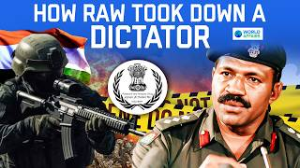](https://www.youtube.com/watch?v=RKSxWwcCn5g&authuser=1)](https://www.youtube.com/watch?v=RKSxWwcCn5g&authuser=1" \t "_blank)

[[https://ssl.gstatic.com/docs/doclist/images/mediatype/icon_2_youtube_x16.png](https://www.youtube.com/watch?v=RKSxWwcCn5g&authuser=1)](https://www.youtube.com/watch?v=RKSxWwcCn5g&authuser=1" \t "_blank)

**[RAW Covert Strike: The Operation that Saved Fiji's Indians | Cinematic Video by World Affairs](https://www.youtube.com/watch?v=RKSxWwcCn5g&authuser=1" \t "_blank)**

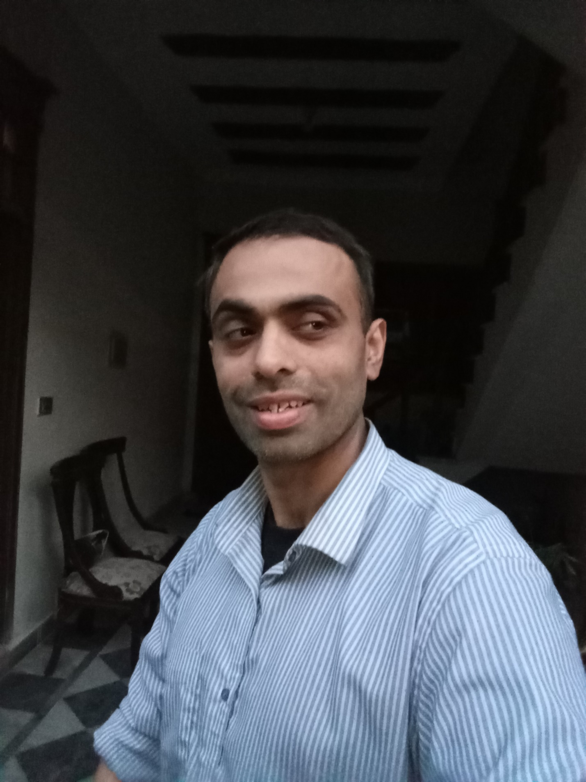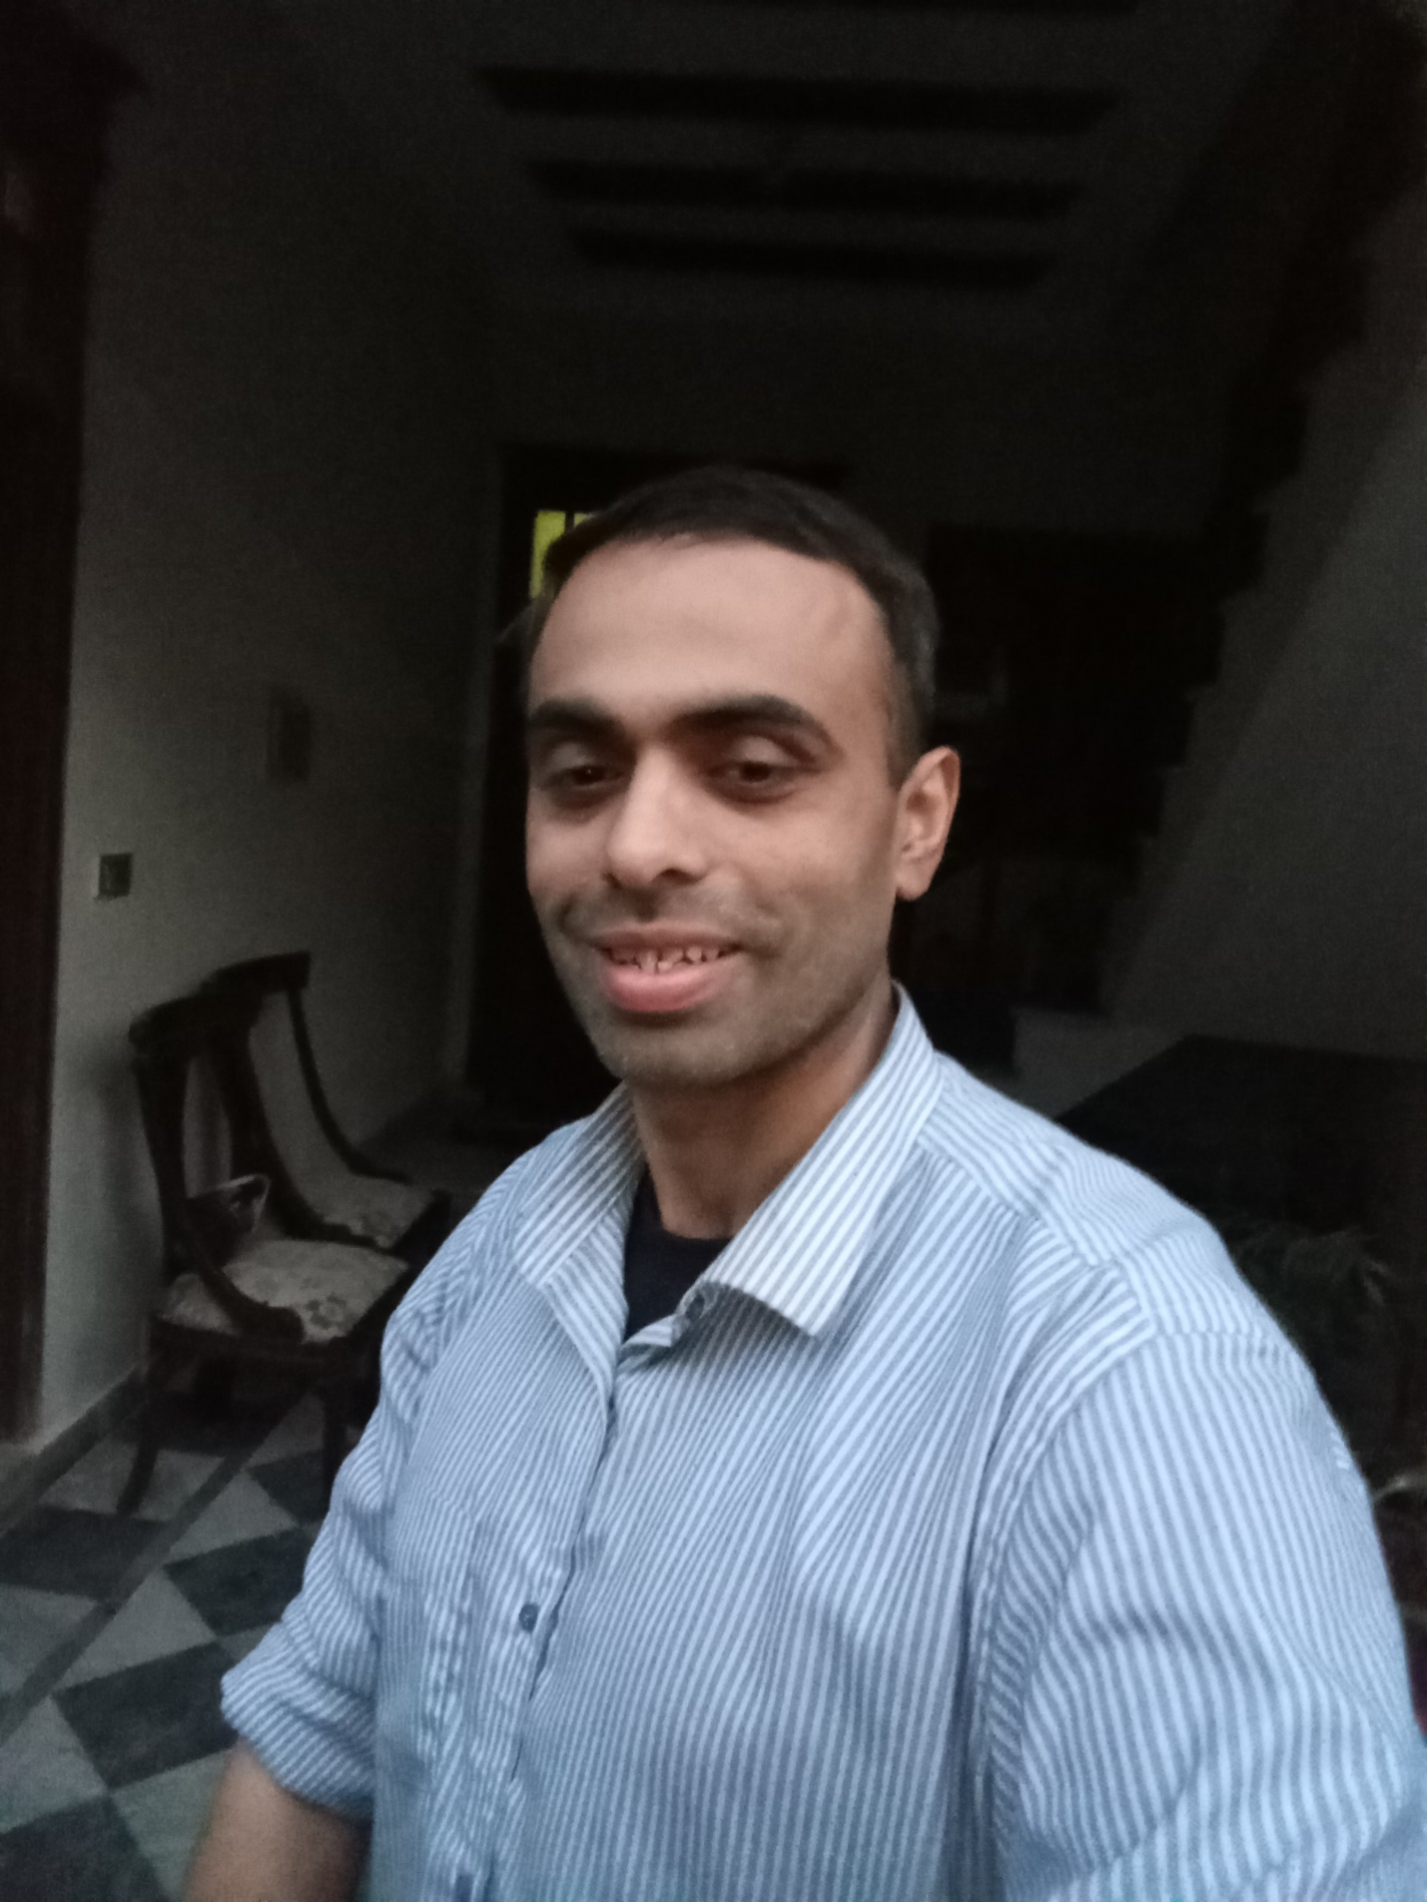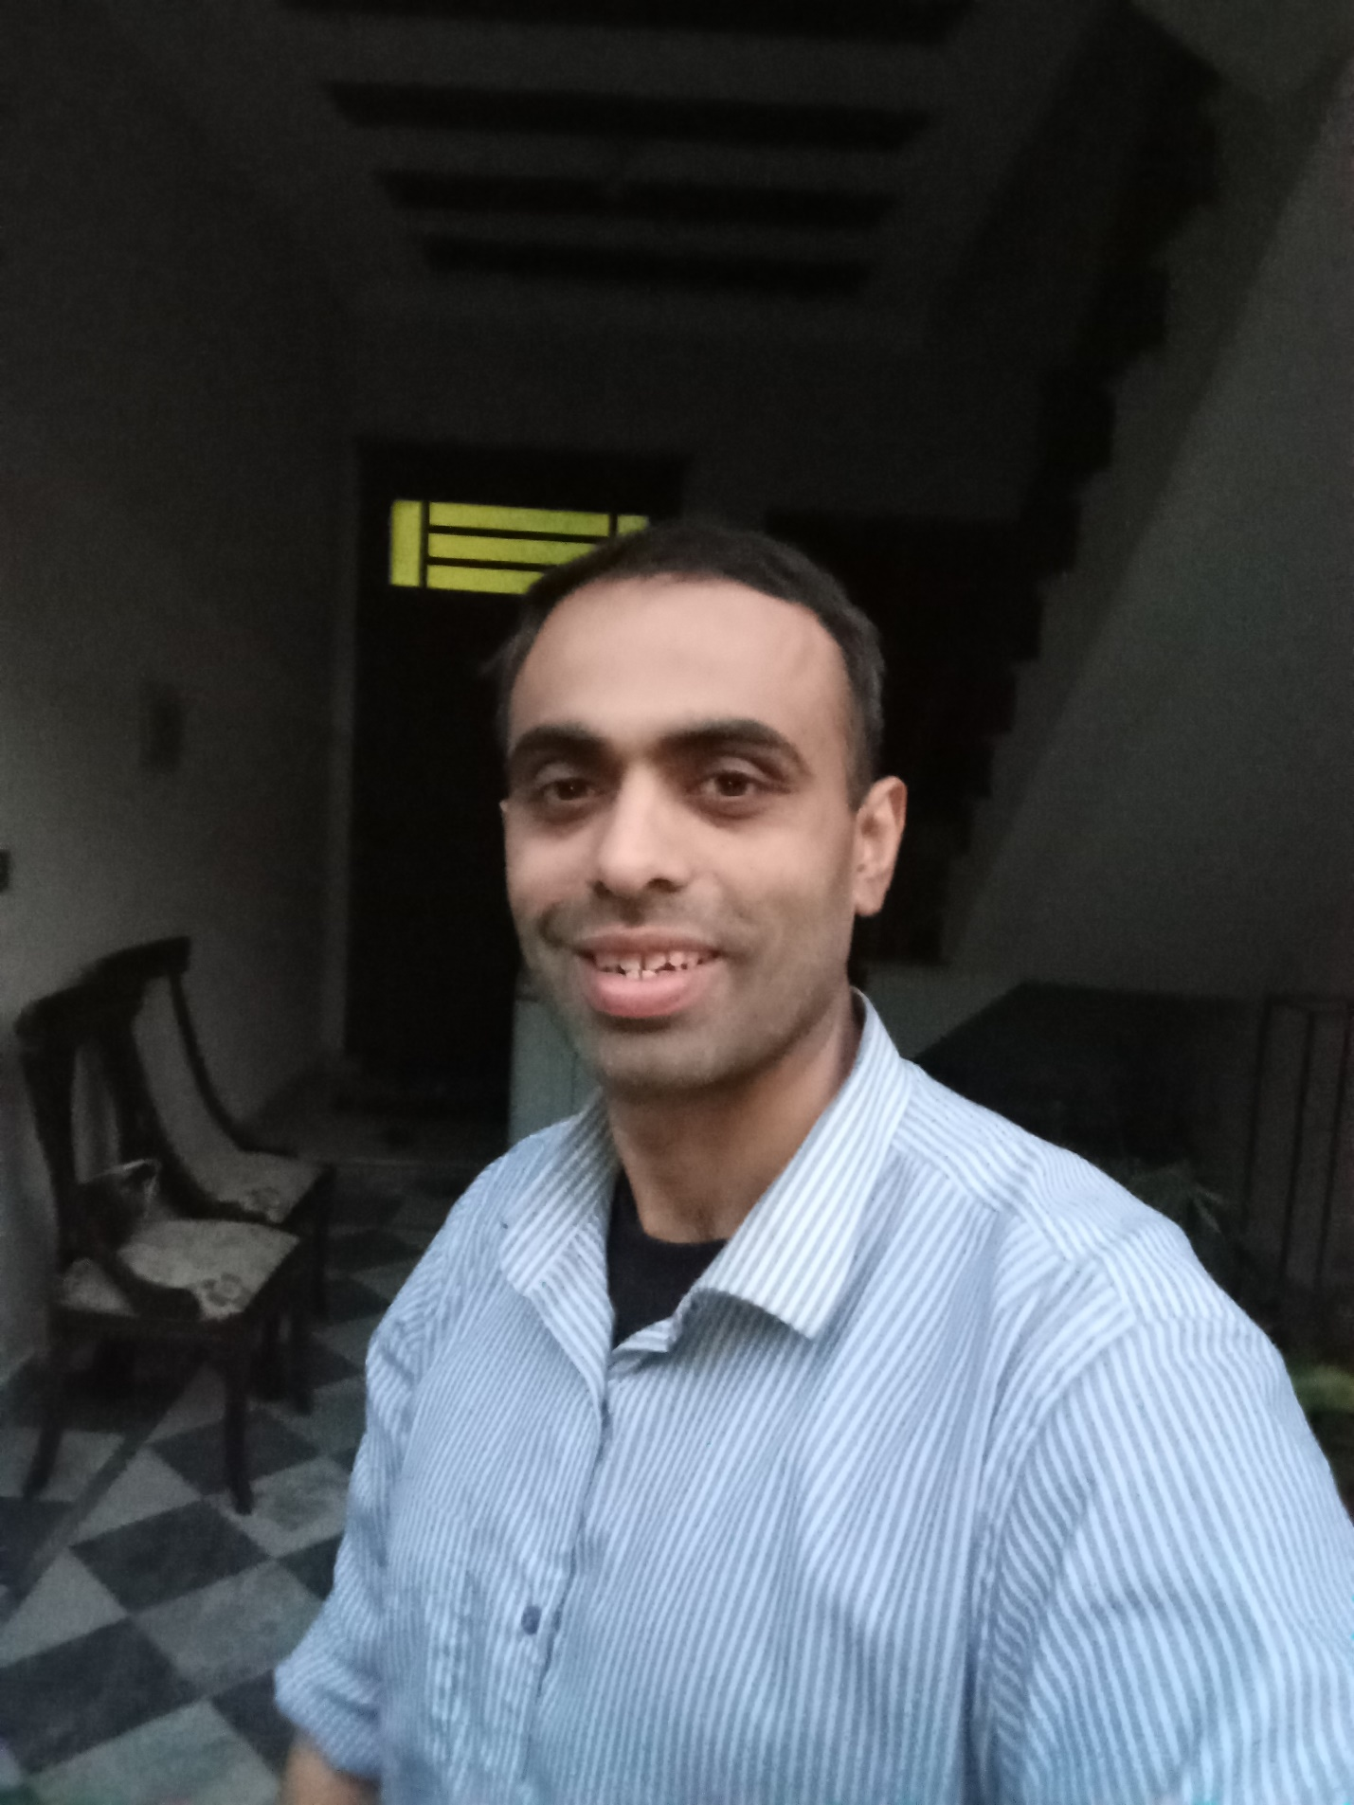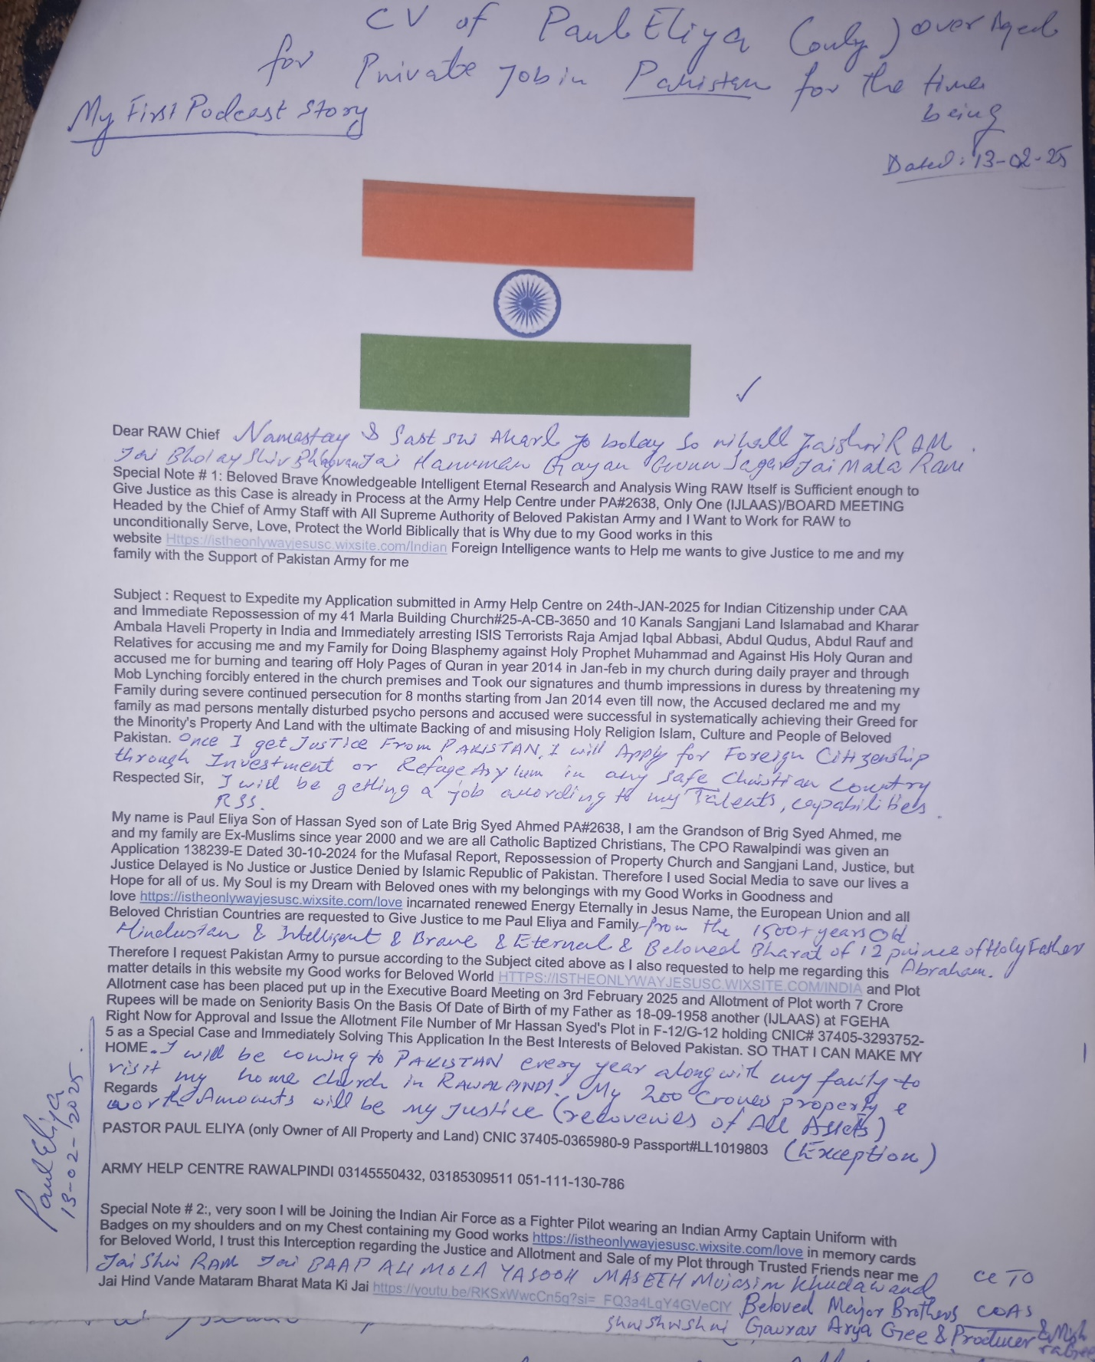

**Skip to Main Content**

**[This site was designed with the](https://www.wix.com/lpviral/enviral?utm_campaign=vir_wixad_live&adsVersion=white&orig_msid=4ff179a6-37b8-41c9-9967-ab621c0034fc" \t "_blank)**

**[.com](https://www.wix.com/lpviral/enviral?utm_campaign=vir_wixad_live&adsVersion=white&orig_msid=4ff179a6-37b8-41c9-9967-ab621c0034fc" \t "_blank)**

**[website builder. Create your website today.Start Now](https://www.wix.com/lpviral/enviral?utm_campaign=vir_wixad_live&adsVersion=white&orig_msid=4ff179a6-37b8-41c9-9967-ab621c0034fc" \t "_blank)**

**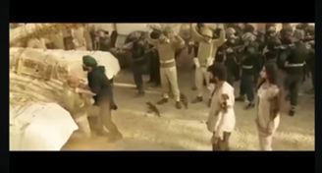**

**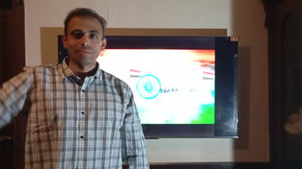**

**[](https://4ff179a6-37b8-41c9-9967-ab621c0034fc.filesusr.com/ugd/c98d81_b3a9004329524a9f8fbb532713833645.pdf)**

****

**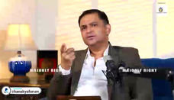**

**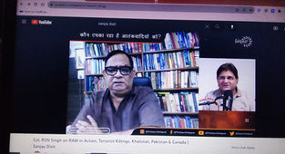**

[**DREAM**](https://4ff179a6-37b8-41c9-9967-ab621c0034fc.filesusr.com/ugd/c98d81_1f02a9febd7a4949a6306fb501b90b12.docx?dn=I%20EXIST.docx)

[**WAR**](https://4ff179a6-37b8-41c9-9967-ab621c0034fc.filesusr.com/ugd/c98d81_b3a9004329524a9f8fbb532713833645.pdf)

[**ALI**](https://4ff179a6-37b8-41c9-9967-ab621c0034fc.filesusr.com/ugd/c98d81_b3a9004329524a9f8fbb532713833645.pdf)

**[[DREAM.pdf](https://4ff179a6-37b8-41c9-9967-ab621c0034fc.filesusr.com/ugd/c98d81_b0d7fff4570c49dfaf1b081a4ecd3d98.pdf)](https://4ff179a6-37b8-41c9-9967-ab621c0034fc.filesusr.com/ugd/c98d81_b0d7fff4570c49dfaf1b081a4ecd3d98.pdf" \o "DREAM.pdf" \t "_blank)**

**[[DREAM.docx](https://4ff179a6-37b8-41c9-9967-ab621c0034fc.filesusr.com/ugd/c98d81_10ada9c8fc7f4a8381647ae5049fc8b9.docx?dn=DREAM.docx)](https://4ff179a6-37b8-41c9-9967-ab621c0034fc.filesusr.com/ugd/c98d81_10ada9c8fc7f4a8381647ae5049fc8b9.docx?dn=DREAM.docx" \o "DREAM.docx" \t "_blank)**

[**Soul**](https://4ff179a6-37b8-41c9-9967-ab621c0034fc.filesusr.com/ugd/c98d81_8456dc34e2bf44ceb4a2ac76c4353c1f.pdf)

[**TALENT**](https://4ff179a6-37b8-41c9-9967-ab621c0034fc.filesusr.com/ugd/c98d81_34881fd079734af7a0883f25841d1daf.pdf)

[**BELIEVE**](https://4ff179a6-37b8-41c9-9967-ab621c0034fc.filesusr.com/ugd/c98d81_995dd42c73a24e1eb2745c48bf10ff25.docx?dn=LIGHT.docx)

[**+**](https://4ff179a6-37b8-41c9-9967-ab621c0034fc.filesusr.com/ugd/ab9c7d_2fcbf008d7474130a33d51ab0b2ab77a.xlsx?dn=FIRST%20TALENT%20OF%20INDIA.xlsx)

[**1**](https://4ff179a6-37b8-41c9-9967-ab621c0034fc.filesusr.com/ugd/ab9c7d_ce45ae5d1761435193625ff534ec7320.pdf)

[**-**](https://4ff179a6-37b8-41c9-9967-ab621c0034fc.filesusr.com/ugd/ab9c7d_b1ba954d93924738937608afe63debbe.pdf)

[**4**](https://4ff179a6-37b8-41c9-9967-ab621c0034fc.filesusr.com/ugd/ab9c7d_7aebce1e198e49d78bfeee8272343be5.pdf)

[**2**](https://4ff179a6-37b8-41c9-9967-ab621c0034fc.filesusr.com/ugd/ab9c7d_1533a51f8c5b49f39c84a3f40daf2717.pdf)

[**3**](https://4ff179a6-37b8-41c9-9967-ab621c0034fc.filesusr.com/ugd/ab9c7d_aec1f68145814f64a3b9ed4141fc836a.pdf)

[**5**](https://4ff179a6-37b8-41c9-9967-ab621c0034fc.filesusr.com/ugd/ab9c7d_85c2926786ed4402ba60d1dc0e657c15.pdf)

[**6**](https://4ff179a6-37b8-41c9-9967-ab621c0034fc.filesusr.com/ugd/ab9c7d_34cccc067bf24fa0bc2ee087e6b77208.docx?dn=NINTH%20TALENT%20OF%20INDIA.docx)

[**\***](https://4ff179a6-37b8-41c9-9967-ab621c0034fc.filesusr.com/ugd/ab9c7d_c7c0a2bc3aea48a2a6a5b448781a912b.pdf)

[**/**](https://4ff179a6-37b8-41c9-9967-ab621c0034fc.filesusr.com/ugd/ab9c7d_28feafa3a8d845cd9cdc73ff6471104d.pdf)

[**.**](https://4ff179a6-37b8-41c9-9967-ab621c0034fc.filesusr.com/ugd/c98d81_9393185b22e24a7f99fe35bb93ee1c12.pdf)

[**7**](https://4ff179a6-37b8-41c9-9967-ab621c0034fc.filesusr.com/ugd/ab9c7d_4b6504d0aa9844d39e4a65b80e415b18.pdf)

[**8**](https://4ff179a6-37b8-41c9-9967-ab621c0034fc.filesusr.com/ugd/ab9c7d_cc1f09df178f45c39bc6112b2a5de78b.pdf)

[**9**](https://4ff179a6-37b8-41c9-9967-ab621c0034fc.filesusr.com/ugd/ab9c7d_082c7b1bbca640978a20855457caef09.docx?dn=FIGHTER%20PILOT%20PAUL%20ELIYA.docx)

[**AP**](https://4ff179a6-37b8-41c9-9967-ab621c0034fc.filesusr.com/ugd/c98d81_8daea166ab63443da7c6700311b64ef8.docx?dn=BLASPHEMY%20CASE.docx)

[**007**](https://4ff179a6-37b8-41c9-9967-ab621c0034fc.filesusr.com/ugd/c98d81_43a4c494b49d4a54928df657891094a1.pdf)

[**MI6**](https://4ff179a6-37b8-41c9-9967-ab621c0034fc.filesusr.com/ugd/c98d81_76d602d320d54fc2b4ccf5d737bbbe4d.docx?dn=NEW%20JERUSALEM.docx)

[**ALI**](https://4ff179a6-37b8-41c9-9967-ab621c0034fc.filesusr.com/ugd/c98d81_bc09785572364f0a9890ef2965bd7897.docx?dn=BLASPHEMY%20CASES.docx)

[**408**](https://4ff179a6-37b8-41c9-9967-ab621c0034fc.filesusr.com/ugd/c98d81_86d1bd7b9cad4b35b276c432dd7ec464.pdf)

[**408**](https://4ff179a6-37b8-41c9-9967-ab621c0034fc.filesusr.com/ugd/c98d81_86d1bd7b9cad4b35b276c432dd7ec464.pdf)

[**N\*10^N**](https://4ff179a6-37b8-41c9-9967-ab621c0034fc.filesusr.com/ugd/c98d81_e800c7a6f39c401fadc0181828dce542.docx?dn=JESUS%20CHRIST%20IS%20THE%20ONLY%20WAY.docx)

[**0**](https://4ff179a6-37b8-41c9-9967-ab621c0034fc.filesusr.com/ugd/c98d81_813bb0459ac042bdb30eeaf5402a7925.pdf)

[**NS**](https://4ff179a6-37b8-41c9-9967-ab621c0034fc.filesusr.com/ugd/ab9c7d_efb95ed7bce44a048076027904b45abb.pdf)

[**EW**](https://4ff179a6-37b8-41c9-9967-ab621c0034fc.filesusr.com/ugd/ab9c7d_efb95ed7bce44a048076027904b45abb.pdf)

[**HERO**](https://4ff179a6-37b8-41c9-9967-ab621c0034fc.filesusr.com/ugd/c98d81_79352ed3565d40e8850fdfdd4edda277.pdf)

[**LOVE**](https://4ff179a6-37b8-41c9-9967-ab621c0034fc.filesusr.com/ugd/c98d81_b3ca59d7398c4a50b3c8d569d78c81b9.docx?dn=HOPE.docx)

[**ELI**](https://4ff179a6-37b8-41c9-9967-ab621c0034fc.filesusr.com/ugd/c98d81_a0a1f8b164ae44b5a723dd195be0743e.pdf)

[**Gs**](https://4ff179a6-37b8-41c9-9967-ab621c0034fc.filesusr.com/ugd/c98d81_a31819fd9b4b4d0c828481b08b1dbc5c.pdf)

[**ELI**](https://4ff179a6-37b8-41c9-9967-ab621c0034fc.filesusr.com/ugd/c98d81_a56110553bdf4976b79746ea9b8be231.docx?dn=DREAM.docx)

[**RAW**](https://4ff179a6-37b8-41c9-9967-ab621c0034fc.filesusr.com/ugd/c98d81_79352ed3565d40e8850fdfdd4edda277.pdf)

[**JUSTICE**](https://4ff179a6-37b8-41c9-9967-ab621c0034fc.filesusr.com/ugd/c98d81_8456dc34e2bf44ceb4a2ac76c4353c1f.pdf)

[**MI7**](https://4ff179a6-37b8-41c9-9967-ab621c0034fc.filesusr.com/ugd/c98d81_86d1bd7b9cad4b35b276c432dd7ec464.pdf)

[**CIA**](https://4ff179a6-37b8-41c9-9967-ab621c0034fc.filesusr.com/ugd/c98d81_3b49f9b3ff5645f99ec766d3b2f6b2d4.docx?dn=BLASPHEMY.docx)

[**LOVE JESUS CHRIST**](https://4ff179a6-37b8-41c9-9967-ab621c0034fc.filesusr.com/ugd/c98d81_1f02a9febd7a4949a6306fb501b90b12.docx?dn=I%20EXIST.docx)

****

[**THE NEWS**](https://4ff179a6-37b8-41c9-9967-ab621c0034fc.filesusr.com/ugd/c98d81_8456dc34e2bf44ceb4a2ac76c4353c1f.pdf)

****

[**ENTER**](https://youtu.be/W41nCCFZgyA?si=3TdhYzsDf_kiftjl)

[**AHC**](https://4ff179a6-37b8-41c9-9967-ab621c0034fc.filesusr.com/ugd/c98d81_1a2ea86b80f64ecdb6214bee81b3e23d.pdf)

[**Https://istheonlywayjesusc.wixsite.com/indian**](https://istheonlywayjesusc.wixsite.com/indian)

****

**[[I EXIST.docx](https://4ff179a6-37b8-41c9-9967-ab621c0034fc.filesusr.com/ugd/c98d81_1f02a9febd7a4949a6306fb501b90b12.docx?dn=I%20EXIST.docx)](https://4ff179a6-37b8-41c9-9967-ab621c0034fc.filesusr.com/ugd/c98d81_1f02a9febd7a4949a6306fb501b90b12.docx?dn=I%20EXIST.docx" \o "I EXIST.docx" \t "_blank)**

**[[I EXIST.pdf](https://4ff179a6-37b8-41c9-9967-ab621c0034fc.filesusr.com/ugd/c98d81_b3a9004329524a9f8fbb532713833645.pdf)](https://4ff179a6-37b8-41c9-9967-ab621c0034fc.filesusr.com/ugd/c98d81_b3a9004329524a9f8fbb532713833645.pdf" \o "I EXIST.pdf" \t "_blank)**

[**I EXIST IN LOVE**](https://4ff179a6-37b8-41c9-9967-ab621c0034fc.filesusr.com/ugd/c98d81_1f02a9febd7a4949a6306fb501b90b12.docx?dn=I%20EXIST.docx)

[**MY GOOD WORKS OF LOVE**](https://4ff179a6-37b8-41c9-9967-ab621c0034fc.filesusr.com/ugd/c98d81_b3a9004329524a9f8fbb532713833645.pdf)

****

**[](https://4ff179a6-37b8-41c9-9967-ab621c0034fc.filesusr.com/ugd/c98d81_b3a9004329524a9f8fbb532713833645.pdf)**

**[](https://4ff179a6-37b8-41c9-9967-ab621c0034fc.filesusr.com/ugd/c98d81_1f02a9febd7a4949a6306fb501b90b12.docx?dn=I%20EXIST.docx)**

**[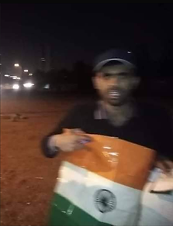](https://4ff179a6-37b8-41c9-9967-ab621c0034fc.filesusr.com/ugd/c25adb_e28345d4ea3d4a1fbe28dc882bb80a7b.docx?dn=4047.docx)**

**ONE MAN ARMY HOISTING INDIAN FLAG FOR ONE HOUR IN ISLAMABAD AND CONQUERED ALL ON 17-02-2021**

**Jai Hind Vande Mataram Bharat Mata Ki Jai**

**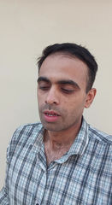**

**[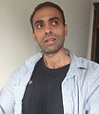](https://4ff179a6-37b8-41c9-9967-ab621c0034fc.filesusr.com/ugd/c98d81_b20c9b9795b94c7bbafd4a878845349b.pdf)**

**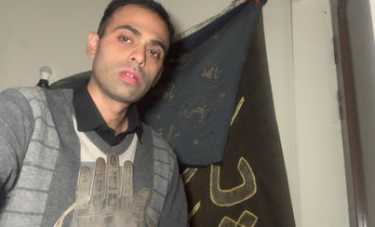**

**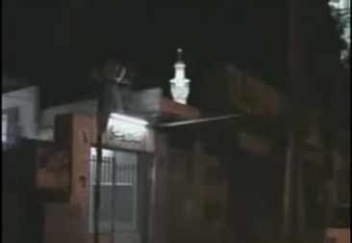**

**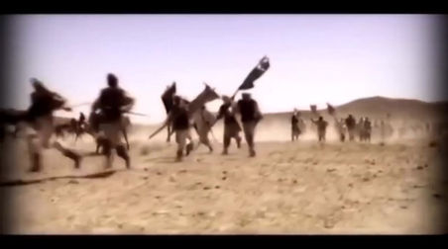**

**[[INSURANCED.pdf](https://4ff179a6-37b8-41c9-9967-ab621c0034fc.filesusr.com/ugd/c98d81_06181d5b28144ac598abda43bb78cff7.pdf)](https://4ff179a6-37b8-41c9-9967-ab621c0034fc.filesusr.com/ugd/c98d81_06181d5b28144ac598abda43bb78cff7.pdf" \o "INSURANCED.pdf" \t "_blank)**

**[[INSURANCED.docx](https://4ff179a6-37b8-41c9-9967-ab621c0034fc.filesusr.com/ugd/c98d81_ad04a9bc44894587bbf6dc873220fef0.docx?dn=INSURANCED.docx)](https://4ff179a6-37b8-41c9-9967-ab621c0034fc.filesusr.com/ugd/c98d81_ad04a9bc44894587bbf6dc873220fef0.docx?dn=INSURANCED.docx" \o "INSURANCED.docx" \t "_blank)**

**[[DREAM.docx](https://4ff179a6-37b8-41c9-9967-ab621c0034fc.filesusr.com/ugd/c98d81_a56110553bdf4976b79746ea9b8be231.docx?dn=DREAM.docx)](https://4ff179a6-37b8-41c9-9967-ab621c0034fc.filesusr.com/ugd/c98d81_a56110553bdf4976b79746ea9b8be231.docx?dn=DREAM.docx" \o "DREAM.docx" \t "_blank)**

**[[DREAM.pdf](https://4ff179a6-37b8-41c9-9967-ab621c0034fc.filesusr.com/ugd/c98d81_b20c9b9795b94c7bbafd4a878845349b.pdf)](https://4ff179a6-37b8-41c9-9967-ab621c0034fc.filesusr.com/ugd/c98d81_b20c9b9795b94c7bbafd4a878845349b.pdf" \o "DREAM.pdf" \t "_blank)**

[**A**](https://4ff179a6-37b8-41c9-9967-ab621c0034fc.filesusr.com/ugd/c98d81_b20c9b9795b94c7bbafd4a878845349b.pdf)

[**B**](https://istheonlywayjesusc.wixsite.com/bait-ul-mal)

[**C**](https://4ff179a6-37b8-41c9-9967-ab621c0034fc.filesusr.com/ugd/c98d81_678c18a664974640b4de208c41dc04f2.pdf)

[**D**](https://4ff179a6-37b8-41c9-9967-ab621c0034fc.filesusr.com/ugd/c98d81_544777bc1f34474091800c7098727b5e.docx?dn=BLASPHEMY%20CASE.docx)

[**E**](https://4ff179a6-37b8-41c9-9967-ab621c0034fc.filesusr.com/ugd/c98d81_678c18a664974640b4de208c41dc04f2.pdf)

[**F**](https://4ff179a6-37b8-41c9-9967-ab621c0034fc.filesusr.com/ugd/c98d81_632965b863e241cda9c16b70759b0043.docx?dn=BAIT%20UL%20MAL.docx)

[**G**](https://4ff179a6-37b8-41c9-9967-ab621c0034fc.filesusr.com/ugd/c98d81_d0fe980f0dbc43e5acc9bda8eb67bce8.pdf)

[**H**](https://4ff179a6-37b8-41c9-9967-ab621c0034fc.filesusr.com/ugd/c98d81_a56110553bdf4976b79746ea9b8be231.docx?dn=DREAM.docx)

[**I**](https://4ff179a6-37b8-41c9-9967-ab621c0034fc.filesusr.com/ugd/c98d81_4d2519c2e03e4d3498898cf22c664729.docx?dn=RUSSIA%20APPLICATION.docx)

[**J**](https://4ff179a6-37b8-41c9-9967-ab621c0034fc.filesusr.com/ugd/c98d81_ba60bc63d4c847daa29b4cfa1e0ff78f.pdf)

[**K**](https://4ff179a6-37b8-41c9-9967-ab621c0034fc.filesusr.com/ugd/c98d81_06181d5b28144ac598abda43bb78cff7.pdf)

[**L**](https://4ff179a6-37b8-41c9-9967-ab621c0034fc.filesusr.com/ugd/c98d81_1f4d856cb9a8421eae8347aace9128c3.pdf)

[**M**](https://4ff179a6-37b8-41c9-9967-ab621c0034fc.filesusr.com/ugd/c98d81_f195ec55bd1b481db6eb0d4ca7920b43.docx?dn=GRACE.docx)

**I know how to Run the World because I have loved the world**

**I don't need Army, because I am the One Man Army because I am God in Love and Goodness where ever Love Exists I Exists.**

**Launch Semi Nuclear Atomic Bomb Missiles on Some Parts of the World Where Enemies of the World are Located in these parts are busy in Operating in deceiving the same world for destroying the same world that God loved with Grace but God not only Loves the World but also Protects the World as Well**

**So inorder to save the World, i am the New World Order**

**MY LOCATION CAN BE CHANGED KEEP EYE**

**JAI HIND SIR SOUL REPORTING SIR**

**JAI HIND SIR I want to join Beloved Indian Army RAW**

**AND I WANT TO WORK FOR RAW**

**Dear Beloved Friend and Beloved Brother Shri Major Gaurav Arya Gee, sir I don't love Muslims because they believe in Allah o Akbar Slogan but I believe in I believe in Baap Ali Akbar and I am different from my family because I am GOD and they call me atheist because I believe in my self and I love my children family all believers and I hate and condemne all ILLITERATE MUSLIMS WHO FOLLOW THE COMPROMISED FAKE MISLEADING QURAN HADEES PROPHET HISTORY which is 20% true and 80% Fake.**

**I know that Beloved India RAW my Soul Will Help us**

**A message to All The World**

**You all Exist Eternally Incarnation with your Beloved ones in Goodness and love with all your Assets and Good Works Whatever you ask for and not asked for will be given to you in the Name of Lord Holy Son and Soul of God Jesus Christ only and when we believe in this all reality that we see in dreams are our Eternal Life.**

**Because we all are incarnated in this world just like a fruit and all Universe is eternal Heaven.**

**Incarnation simply means what is invisible become visible physically**

**Jai Hind**

**Vande Mataram**

**Bharat Mata ki Jai**

**Jai Shri RAM**

**Jai Bholay Shiv Shankar Bhagwan**

**Jai Bhajrangbali Jai Hanuman Gayan Gun Sagar**

**Jai Shri Krishna Pooram Pita**

**Jai Ganesh Gee**

**Jai Mata Rani Jai Durga Sarasvati Maa**

**I saw these Beloved Souls of God who are infact God in my Dreams many times with in Indian Hindustani Military Nuclear Atomic Powers Missiles and I have alot alot to tell I also FLY WITH HANUMAN GEE ON SNOWY MOUNTAINS OM AND HANUMAN JEE JAI BHAJRANGBALI SAW ME AND MY MUSCLES BICEPTS TRICEPTS BODY BECOMES STRONG LIKE HIS IN MY DREAMS I AM GOD**

**These Holy Gods talk to me and Fly with me in my dreams just like in a Holy Mandir and I saw Jesus And Ahlebait Numerous times in my dreams with these Beloved Souls of God**

**So I Pastor Paul Eliya known as Ali The Syed Ali Abbas Ex Muslim along with family works for RAW**

**And this is my Demand**

**Schedule and call the Executive Board Meeting at FGEHA Right Now and Issue the Allotment File Number of Mr Hassan Syed holding CNIC# 37405-3293752-5 as a Special Case Through Reply from FGEHA Via Courier to House 96 lane no 4 block D sector 4 airport housing society and the Remaining All Case of PA#2638 will be solved in Beloved India (Link Attached)**

**--------------------------------------------------------------------------**

**REGARDS  
3 STARS GENERAL MAJOR PAUL ELIYA  
ARMY HELP CENTRE RAWALPINDI**[**Https://istheonlywayjesusc.wixsite.com/captain-paul-eliya**](https://istheonlywayjesusc.wixsite.com/captain-paul-eliya) **03145550432  
051-111-130-786**

**--------------------------------------------------------------------------  
OFFICIAL**[**https://youtu.be/hbLuCqmQ4wo?si=Nn8ilyStvQEdeThN**](https://youtu.be/hbLuCqmQ4wo?si=Nn8ilyStvQEdeThN)

**Producer Bhai Aap KO Bhee Namastay**

**Jangal Pakistan ma mor nacha kis na dikha**

**Dear BELOVED RAW CIA MOSSAD My Pickup Location is House#96,lane#4, block D, Sector 4 airport housing society Rawalpindi but I want to live with my family forever or I have to leave my family my identity behind and I want Justice for my family and I want that my family should receive all the properties lands amounts and all the justice from Pakistan because me and my family are Christians and we also want to move to India or to any Christian Country Forever because unfortunately Pakistan being the Holy Part of Beloved India has lost its Indian-origin-values however if I get justice in Pakistan I will live and die in my 1500 years old beloved India Bharat the Pakistan BECAUSE my Good Mission with my ALL GOODWORKS IN THIS WEBSITE**[**HTTPS://ISTHEONLYWAYJESUSC.WIXSITE.COM/LOVE**](https://istheonlywayjesusc.wixsite.com/LOVE)**has been Accomplished and saved Forever in Goodness and love along with my beloved ones along with my belongings within my soul in Jesus Christ Forever**

**Please arrange my travel to Beloved India**

**I AM RAW AND I WORK SECRETLY, I KILL MY ENEMIES BEFORE THEY IMAGINE**

**I AM BEYOND THE IMAGINATION OF MY ENEMIES**

**I THE RAW CAME FROM THE BACK DOOR AND DO MY WORK AND THEN LEFT WITHOUT LEAVING ANY EVIDENCE FOR A GOOD CAUSE THAT IS FOR THE GREATER GOOD OF THE WORLD BECAUSE I THE RAW ONLY KILL THE EVIL SOULS OF SATAN BECAUSE I AM GOD AND I HAVE CREATED THE SATAN FOR A REASON AND ONLY I AM THE ONE WHO HAS CRUSHED THE HEAD OF SATAN**

**SO EVERY WORD IN THIS WEBSITE IS MY CREATION AND I HEARD THAT I HAVE MADE THIS WEBSITE AND NOW FOREIGN COUNTRY INTELLIGENCE WANTS TO HELP ME FOR GIVING JUSTICE TO ME TO HONOR ME TO GLORIFY MY FATHER WHICH IS IN HEAVEN BY PRAISING STORING LOVING SERVING AND FOLLOWING MY GOODWORKS IN THIS WEBSITE**[**HTTPS://ISTHEONLYWAYJESUSC.WIXSITE.COM/INDIA**](https://istheonlywayjesusc.wixsite.com/INDIA)

**I want to Join RAW as their Indian Raw Agent and I want to join Indian Army as a Captain and then Major**

**I want to Work for RAW because RAW wants me to Work for them due to my Talent.**

**RAW Kill these Fake numerous Stupid Idiots Fake RAW agents infact ISIS ISI people living operating in lane 5 near me their cell phone numbers are Hashim alvi +92 322 8727794, roger +92 326 4406101 or give this assignment to me I will in ACT OF SELF DEFENCE I will kill them all who are fake RAW Agents who are infact ISIS Terrorists Daish**

**Pakistan Military just want Money, they are of no value to religion.**

**I am a Pastor and I want Justice**

**I need Guns and Bullets and I unconditionally love serve protect Israel My Jews Christian Hindu Sikh Shia Muslim brothers**

**I will be the Youngest Chief of RAW I give Immediate Approval for Launching Semi Nuclear Bombs AIR STRIKES on Terrorist Jihadist Mindset of Pakistan ASAP BY TODAY if they don’t want to change their mindsets so this is the new world order**

**I want to live in Pakistan Tamran Village near Sangjani for the rest of my life but I will be living in other parts**

**Of the World as well**

**I hate GUNS WEAPONS but**

**My Only weapon is my Prayer, I am love goodness forever**

**I need Guns with Bullets alot of Them**

**And other things used in Intelligence in case**

**DEAR RAW CHIEF**

**SHRI MAJOR GAURAV ARYA GEE**

**JAI HIND SIR AND NAMASTAY MISHRA GEE AND PRODUCER BHAI**

**SIR**

**Dear Donald Trump if you can help in this Matter being a Hope for Christians of Pakistan**

**My PRAYER to All The Beloved World**

**You all Exist Eternally Incarnation with your Beloved ones in Goodness and love with all your Assets and Good Works Whatever you ask for and not asked for will be given to you in the Name of Lord Holy Son and Soul of God Jesus Christ only and when we believe in this all reality that we see in dreams are our Eternal Life.**

**Because we all are incarnated in this world just like a fruit and all Universe is eternal Heaven.**

**Incarnation simply means what is invisible become visible physically**

**MY DEMANDS**

**Request for Repossession of my property and land worth billions that was taken from me in Duress against our my will by falsely accusing me for doing Blasphemy against Prophet Muhammad and Quran during Mob Lynching accused Raja Amjad Iqbal Abbasi, Abdulqudoos and Abdulrauf along with the Mob forcibly took our signatures and thumb impressions in Duress Persecuted us.**

**Schedule and call the Executive Board Meeting at FGEHA Right Now and Issue the Allotment File Number of Mr Hassan Syed's Plot in F-12/G-12 holding CNIC# 37405-3293752-5 as a Special Case Through Reply from FGEHA Via Courier to House 96 lane no 4 block D sector 4 airport housing society and all the case of PA#2638 will be solved In Beloved Pakistan only(Link Attached) that will confirm The Value of my Existence in Pakistan I thank all the World for deeply understanding me because My family calls me Psycho, Atheist, Mad, Alien, Patheechar, Kafir, Unparh, jahil, , gawar, mental, many more undeserving and abusing words Energies they spoke out against me all the time in silence and behind my back and sometimes Infront of me except my Beloved father and Beloved mother who cares for me and loves me with Pure Love and Goodness Just like Beloved RAW-AL-PINDI Pakistan Army my only true friend and brother supports me loved me unconditionally so it is my Soul that loves the World unconditionally, I am about to become a Rocket when I will get my lottery, people my enemies will be jealous of my Soul and my Soul's Good Works that is why On 17 January 2025 100 Punjab and Islamabad Police officers with Fully Loaded Guns in a Bus and A Prison Van and 2 Patrolling Trucks and 4 Dolphin Bikes just came at my location to Visit me and they saw me and went away, and when I asked from AI it told me about my Remarkable Presence Reputation in Pakistan, this have been happening with me for 7 years and I thank Beloved God Jesus Christ of the World for Everything.**

**Special Note: My Mission is Accomplished, i have delivered the Truth as mentioned in my prayer above and I wish to live a moderate life, if I am Honoured in Pakistan,  well and Good and if not then I don't care, I am still the same as mentioned in my prayer because I exist forever in love and goodness**

**I want my Army Uniform from CSD Lalkurti RAWALPINDI or from any Armed Forces Uniform Shop my shirt size is 16.5 and my Trouser Size is 34 with Black Shoes and a Captain Cap of my Unit 408 Intelligence Battalion and medals and badges on my Uniform will be the 8 GB USBs Memory Cards holding my Data of my Good Works and my Moto as mentioned above in my prayer**

**I WANT MY ALL GOOD WORKS TO BE STORED IN THE ARMY MUSEUM OF RAWALPINDI.**

**--------------------------------------------------------------------------**

**REGARDS  
PASTOR PAUL ELIYA SERVING LOVING PROTECTING PAKISTAN UNCONDITIONALLY**

**ARMY HELP CENTRE RAWALPINDI**[**Https://istheonlywayjesusc.wixsite.com/captain-paul-eliya**](https://istheonlywayjesusc.wixsite.com/captain-paul-eliya) **03145550432  
051-111-130-786**

**--------------------------------------------------------------------------  
OFFICIAL**[**https://youtu.be/hbLuCqmQ4wo?si=Nn8ilyStvQEdeThN**](https://youtu.be/hbLuCqmQ4wo?si=Nn8ilyStvQEdeThN)

**INTERCEPTION IS ALREADY IN PROCESS IN ALL THE CASE of PA#2638**

**Shams Kakar Sahab I did not received the reply for Mr Hassan Syed date of birth 18-09-1958 please send it on my WhatsApp 03145550432 and on 03185309511**

**Syed Chal Raha hai ab Karna hai**

[**Preview YouTube video ALI WORKS FOR RAW HTTPS://ISTHEONLYWAYJESUSC.WIXSITE.COM/INDIAN**](https://www.youtube.com/watch?v=hbLuCqmQ4wo&authuser=1)

**Schedule and call the Executive Board Meeting at FGEHA Right Now and Issue the Allotment File Number of Mr Hassan Syed or Imagine the Worst that could have happen to you during driving eating drinking bathing sleeping medicine will be an accident to you or to your beloved ones or no accident but I will be responsible for anything happening good or bad to you FGEHA DG**

**Reminder FGEHA EXECUTIVE BOARD REGARDING SPECIAL CASE**

**Dear Honourable His Excellency Executive Board FGEHA and Your Beloved Beautiful Families please Issue the Allotment of Plot in G-12 to Mr Hassan Syed holding CNIC# 37405-3293752-5**

**The LA could have been saved if they would have obeyed me and should have installed building fire alarm system network in jungles that could have triggered sea water spray in case of this microwave Radiations causing Fire increase in temp pressure conditions of the Holly wood**

**Special Prayer for Everyone The Best Prayer Ever**

**My Song This message keeps on coming**

**''I am Dreaming My Dream uncontrollable imaginations everlasting is my Eternal life with my Spiritual Soully Love with my Beloved ones I am the Child of my Beloved God Lord Holy Father Jesus Christ Living with my Beloved ones Father Mother Sisters Children Brothers along with my Belongings Good Works**

[**Https://istheonlywayjesusc.wixsite.com/captain-paul-eliya**](https://istheonlywayjesusc.wixsite.com/captain-paul-eliya)[**Https://istheonlywayjesusc.wixsite.com/indian**](https://istheonlywayjesusc.wixsite.com/indian)[**Https://istheonlywayjesusc.wixsite.com/love**](https://istheonlywayjesusc.wixsite.com/love)**Energies Radiations Motion Sensors 24-7 Security Ionization of Thrust Recycling Thrust People intentions capabilities statuses cases coded assets at GPS DNA Deeds Works protecting them from their Moving still surroundings along with distribution of all resources according to their fundamental human rights physically eternally heavenly in immortality incarnated everything Energies and all Generations Raised Resurrected Renewed Forever within my Soul of Pooram Pita Baap Ali Mola with Beautiful Fat Sharp Eyes long Hair Long EyeLashes thick EyeBrows Slim Nose Healthy Cheeks Beard White as Snow Fair Color Smiling Face with Strong Smart Body Emitting White Light of Fatima Zahra Zainab Qulsoom Mohsin Abbas 12 Prince Imams of Abraham Jai Shri RAM Pita Jai Hanuman Gayan Gun Sagar Jai Shiv Gee Jai Guru Nanak Gee Jo Bolay So Nihaal Sat Shri a Karl Allah Hazrat Mirza Ghulam Ahmed Alaisalaam Jai Shri Krishna Bholay Bhagwan Durga Maa Laxmi Sarasvati Mata Rani Maa Fatima Maa Maryam In Jesus Name turning Impossible into Possible and unseen into seen Forever in Goodness and love with joy with all blessings whatever wishes dreams come true in Peace Justice Rest happiness food water cloths fruits past present future and Knowledge in New Jerusalem in Eternal Constant Time in infinity eternally in Beloved World Universe that co exists spiritually physically Forever with existence of Angels and Storing saving my Physical Papers Energy Good Work in the Physical Museum of New Jerusalem''**

**Amen**

**Regards**

**The Maha Yudh Devata Karbala KARMA Super Battle Man IN HEAVEN AND HELL The CAPTAIN PAKISTAN ARMY 408 INTELLIGENCE BATTALION GHQ PAKISTAN MILITARY ACADEMY PMA PAKISTAN AIR FORCE**

**Pastor Romeo Akbar Walter Ali Syed Ali Abbas Paul Eliya and Family of Hassan Syed**

**I DEMAND THE WORLD TO DELIVER THIS GIFT TO MY BELOVED FAMILY IN JESUS NAME AMEN AS A GRACE FROM ME AS A GIFT FROM ME AS A RESULT OF MY GOOD WORKS IN THIS WEBSITE**[**HTTPS://ISTHEONLYWAYJESUSC.WIXSITE.COM/PAKISTAN-ARMY-408**](https://istheonlywayjesusc.wixsite.com/PAKISTAN-ARMY-408)**AMONG THESE BENEFICIARIES SYEDA FARHAT BANO, SYED SHAHBAZ HAIDER, MEHREEN FATIMA, AFSHEEN FATIMA AND AMBEREEN FATIMA ONLY ISLAMABAD SANGJANI LAND OF 200+ KANALS WORTH 700 CRORES PKR RUPEES OR LAND OF 200+ KANALS WILL WE DISTRIBUTED TO BE DISTRIBUTED AMONG 5 OWNERS ONLY SYEDA FARHAT BANO, SYED SHAHBAZ HAIDER, MEHREEN FATIMA, AFSHEEN FATIMA AND AMBEREEN FATIMA AND JUSTICE MY BELOVED GRAND FATHER SYED FAKHAR ALI SHAH'S OF SANGJANI ISLAMABAD IS THE RIGHTFUL OWNER OF HIS INHERITED 7 VILLAGES SHARE OF 200+ KANALS IS THE RIGHTFUL SHARE OF HIS BELOVED WIIFE SYEDA FARHAT BANO AND THEIR BELOVED CHILDREN SYED SHAHBAZ HAIDER, MEHREEN FATIMA, AFSHEEN FATIMA AND AMBEREEN FATIMA, THROUGH THE NADRA CNIC# 37405-4559435-4 OF AMBEREEN FATIMA PAKISTAN CAN PROCEED IN DELIVERING JUSTICE TO ME AS I DEMANDED RIGHT NOW FOR MY BELOVED FAMILY AND ANY OTHER SHARE IF FOUND IN RECORD MUST ALSO BE GRANTED TO MY BELOVED FAMILY OR TO THEIR CHILDREN OR SPECIAL NOTE ​INCLUDING FIVE KANALS IN FACTO CEMENT AND RECOVERY OF 5 BILLION USD DOLLARS WORTH OF ASSETS OF MR PAUL ELIYA HOLDING PAKISTANI CITIZEN# CNIC#37405-0365980-9, PAUL ELIYA IS THE ASSET OF THE STATE SO HIS ASSETS LAND BUILDING PROPERTY MONEY TO BE RECOVERED FROM THE BELOVED PAKISTAN OR FROM ITS ALLIES INCLUDING 7 CRORE PKR RUPEES TO BE RECOVERED FROM IESCO WAPDA MINISTRY AS CLAIM IN THE LIGHT OF MR PAUL ELIYA’S CASE IN PROCESS AT THE ARMY HELP CENTRE RAWALPINDI**[**https://youtu.be/dme0hdckiXU?feature=shared**](https://youtu.be/dme0hdckiXU?feature=shared)

**TO BE IMMEDIATELY GIVEN TO BELOVED SYEDA FARHAT BANO, SYED SHAHBAZ HAIDER, MEHREEN FATIMA, AFSHEEN FATIMA AND AMBEREEN FATIMA ONLY THROUGH MY NAME PAUL ELIYA THROUGH MY CASE IN JESUS NAME THROUGH PAKISTAN ARMY HELP CENTRE AHC 051-111-130-786 I AM THE CHILD OF JESUS CHRIST BAAP ALI MOLA ALAISALAAM**

**MY DREAM IS MY ETERNAL LIFE WITH MY BELOVED ONES WITH MY HOLY FATHER BAAP ALI MOLA JESUS CHRIST IMAM HUSSAIN 12 PRINCE OF ABRAHAM DAVID ALONG WITH MY TREASURE OF KNOWLEDGE**[**https://istheonlywayjesusc.wixsite.com/eternal-paul-eliya**](https://istheonlywayjesusc.wixsite.com/eternal-paul-eliya)**AND MY BELONGINGS IN GOODNESS AND LOVE FOREVER JOY, REST, PEACE, PLEASURE WITH ALL BLESSINGS IN JESUS NAME WITHIN MY SOUL AMEN PRAYER BY PASTOR PAUL ELIYA**

[**https://youtu.be/DjFMqX6rr2I?si=z-skn3hPtq2bVZMA**](https://youtu.be/DjFMqX6rr2I?si=z-skn3hPtq2bVZMA)

[**https://istheonlywayjesusc.wixsite.com/thankyou-jesuschrist**](https://istheonlywayjesusc.wixsite.com/thankyou-jesuschrist)**I AM VERY FORTUNATE THAT MY HEART IS BROKEN BECAUSE THERE ARE STILL 6 FACES SOULS OF MY LOVE**[**https://youtu.be/AmuZ0OmHENU?si=TcgKI\_OXoA5yj9da**](https://youtu.be/AmuZ0OmHENU?si=TcgKI_OXoA5yj9da)**THE BEAUTIFUL GIRL I DREAMED OF WILL TAKE ME TO MY BELOVED ONES, AND I WILL BECOME AN F-35 FIGHTER PILOT IN US AND THIS WEBSITE IS MY LAST WEBSITE OF MY LIFE LEADING ALL THE WORLD TO ETERNAL LIFE THROUGH BELOVED JESUS CHRIST BECAUSE NO ONE IS LIKE ME BUT I AM LIKE THEM**

**PRAYER BY PASTOR PAUL ELIYA SYED ALI ABBAS CNIC#37405-0365980-9**

**UPDATE THE WORLD REGARDING THE STATUS OF MY CASE THROUGH MY CELL#03145550432 ONLY**

**The Honourable RAW Chief His Excellency**

**Research and Analysis Wing Headquarters New Delhi India**

**And**

**The Honourable The Excellency Pakistan Army Chief of Army Staff Through Army Help Centre Wajid Rahim Sahab 051111130786**

**Government of Pakistan Through Honourable Federal Housing and Works Minister Mian Riaz Hussain Pirzada Via**

**Dy. No.508/2024-Ministry of Housing and Works 051-9209753 Dated 6th December 2024**

**Request for issuance of File Number of 14 Marla Plot in G-12 or In F-12 from FGEHA under Retired Quota**

**AS A SPECIAL CASE IN THE EXECUTIVE BOARD MEETING VIA DIARY NUMBER Dy DG # 857 DATED 06-01-2025 To The Retired Senior Most**

**Deputy Chief Hassan Syed NTRC BPS-19 Ministry of Communication AGPR Personal Number 50036345**

**holding CNIC#37405-3293752-5, Date of Birth 18-09-1958, Date of Retirement: 17-09-2018, Date of Membership 13/01/2020**

**Category 2, Computer Generated Number 120519, Membership Drive Phase 2**

**Regards**

**HASSAN SYED BELOVED FATHER OF F-35 FIGHTER PILOT STRONGEST MAN BODY BUILDER PASTOR PAUL ELIYA THE SOUL ENERGY**

[**Https://istheonlywayjesusc.wixsite.com/pakistan-army-408**](https://istheonlywayjesusc.wixsite.com/pakistan-army-408)

**0314-5550432**

**Cc to**

**1.     Minister Incharge/Chairman Mian Riaz Hussain Pirzada  (Federal Minister of Housing & Works)**

**2.     Federal Secretary (Housing & Works) Dr. Shahzad Khan Bangash**

**3.     Director General Capt. (Retd.) Muhammad Zafar Iqbal**

**4.     CDA CHAIRMAN ISLAMABAD**

**5.     AHC 051-111-130-786                              DATED: 6-1-2025**

**Special Note:  SOS ASAP ALL MY GOOD WORKS TO BE STORED IN MY SOUL DNA BONES THROUGH BIO ENGINEERING OF MY MIND HEART BODY SPIRIT AND SOUL, I AM THE CHILD OF JESUS CHRIST LIVING WITH MY BELOVED ONES WITH MY BELONGINGS WITH MY GOOD WORKS IN GOODNESS AND LOVE FOREVER IN ETERNAL LIFE WITH ALL BLESSINGS IN PEACE REST WATER AND FRUITS OF LIFE IN NEW JERUSALEM PHYSICALLY ETERNALLY HEAVENLY IN IMMORTALITY RAISED RESURRECTED INCARNATED ALL GENERATIONS**

**I am Happy to live and die in my Beloved Motherland Pakistan because in my hard times eternally my country gives me my Right and comfort me like Jesus Christ giving me rest and Peace then why should I leave my beloved people when everyone else in the world has abandoned me, I want to live in Pakistan Eternally with all my Soul's Goodness and Love unconditionally along with my Beloved Ones along with my belongings and along with my Good Works in my website**[**Https://istheonlywayjesusc.wixsite.com/Pakistan-Army-408**](https://istheonlywayjesusc.wixsite.com/Pakistan-Army-408)

[**https://youtu.be/-Y0WLiP6kMU?si=AE\_-\_0oIZ50SG6Ac**](https://youtu.be/-Y0WLiP6kMU?si=AE_-_0oIZ50SG6Ac)

[**https://youtu.be/W41nCCFZgyA?feature=shared**](https://youtu.be/W41nCCFZgyA?feature=shared)

[**https://youtu.be/Ebm4geyI0YA?feature=shared**](https://youtu.be/Ebm4geyI0YA?feature=shared)

[**https://youtu.be/XoFr-2mcnc0?feature=shared**](https://youtu.be/XoFr-2mcnc0?feature=shared)

[**https://youtu.be/hSrLOBphJgU?feature=shared**](https://youtu.be/hSrLOBphJgU?feature=shared)

[**https://youtu.be/n\_SOM45cWxA?feature=shared**](https://youtu.be/n_SOM45cWxA?feature=shared)

[**https://youtu.be/0VOXLjvv5dA?feature=shared**](https://youtu.be/0VOXLjvv5dA?feature=shared)

[**https://youtu.be/w-cj7bRvJuI?feature=shared**](https://youtu.be/w-cj7bRvJuI?feature=shared)

[**https://youtu.be/cyXV364o\_jU?feature=shared**](https://youtu.be/cyXV364o_jU?feature=shared)

[**https://youtu.be/tbjl0Hkm1fE?feature=shared**](https://youtu.be/tbjl0Hkm1fE?feature=shared)

[**https://youtu.be/j\_urZ5KDPec?feature=shared**](https://youtu.be/j_urZ5KDPec?feature=shared)

[**https://youtu.be/IYdg1Y8S0N0?feature=shared**](https://youtu.be/IYdg1Y8S0N0?feature=shared)

**23 Attachments • Scanned by Gmail**

[**Preview YouTube video Lockheed Martin | F-35 Lightning II**](https://www.youtube.com/watch?v=W41nCCFZgyA&authuser=0)

[**Lockheed Martin | F-35 Lightning II**](https://www.youtube.com/watch?v=W41nCCFZgyA&authuser=0)

[**Preview YouTube video Arnold Schwarzenegger olympia bodybuilding motivation 2015**](https://www.youtube.com/watch?v=Ebm4geyI0YA&authuser=0)

[**Arnold Schwarzenegger olympia bodybuilding motivation 2015**](https://www.youtube.com/watch?v=Ebm4geyI0YA&authuser=0)

[**Preview YouTube video Arnold to Conquer**](https://www.youtube.com/watch?v=XoFr-2mcnc0&authuser=0)

[**Arnold to Conquer**](https://www.youtube.com/watch?v=XoFr-2mcnc0&authuser=0)

[**Preview YouTube video QURAN IS 50% TRUE BUT QURAN IS 50% EVIL SATAN.Kaba is a stone istheonlywayjesusc.wixsite.com/indian**](https://www.youtube.com/watch?v=hSrLOBphJgU&authuser=0)

[**QURAN IS 50% TRUE BUT QURAN IS 50% EVIL SATAN.Kaba is a stone istheonlywayjesusc.wixsite.com/indian**](https://www.youtube.com/watch?v=hSrLOBphJgU&authuser=0)

[**Preview YouTube video Quran is a Murderer & Satanic Prophet Muhammad is the biggest Lier.Islam is Satan Allah is misused**](https://www.youtube.com/watch?v=n_SOM45cWxA&authuser=0)

[**Quran is a Murderer & Satanic Prophet Muhammad is the biggest Lier.Islam is Satan Allah is misused**](https://www.youtube.com/watch?v=n_SOM45cWxA&authuser=0)

[**Preview YouTube video OLD TESTAMENT TELLS ABOUT 12 PRINCE SONS OF ABRAHAM DAVID LIKE JESUS CHRIST. ISLAM WAS ALWAYS SATAN.**](https://www.youtube.com/watch?v=0VOXLjvv5dA&authuser=0)

[**OLD TESTAMENT TELLS ABOUT 12 PRINCE SONS OF ABRAHAM DAVID LIKE JESUS CHRIST. ISLAM WAS ALWAYS SATAN.**](https://www.youtube.com/watch?v=0VOXLjvv5dA&authuser=0)

[**Preview YouTube video PROPHET MUHAMMAD IS A SATANIC CARTOON CLOWN JOKER.Quran is a Murderer and Prophet Muhammad is a Lier**](https://www.youtube.com/watch?v=w-cj7bRvJuI&authuser=0)

[**PROPHET MUHAMMAD IS A SATANIC CARTOON CLOWN JOKER.Quran is a Murderer and Prophet Muhammad is a Lier**](https://www.youtube.com/watch?v=w-cj7bRvJuI&authuser=0)

[**Preview YouTube video ISRAEL MOSSAD JEWISH BROTHERS HELP ME PERSECUTION MOB LYNCHING istheonlywayjesusc.wixsite.com/indian**](https://www.youtube.com/watch?v=cyXV364o_jU&authuser=0)

[**ISRAEL MOSSAD JEWISH BROTHERS HELP ME PERSECUTION MOB LYNCHING istheonlywayjesusc.wixsite.com/indian**](https://www.youtube.com/watch?v=cyXV364o_jU&authuser=0)

[**Preview YouTube video OLD TESTAMENT TELLS ABOUT 12 PRINCE SONS OF ABRAHAM DAVID LIKE JESUS CHRIST. ISLAM WAS ALWAYS SATAN.**](https://www.youtube.com/watch?v=tbjl0Hkm1fE&authuser=0)

[**OLD TESTAMENT TELLS ABOUT 12 PRINCE SONS OF ABRAHAM DAVID LIKE JESUS CHRIST. ISLAM WAS ALWAYS SATAN.**](https://www.youtube.com/watch?v=tbjl0Hkm1fE&authuser=0)

[**Preview YouTube video The Matrix 1999 HD Movie Clip - Neo: "guns, lots of guns."**](https://www.youtube.com/watch?v=j_urZ5KDPec&authuser=0)

[**The Matrix 1999 HD Movie Clip - Neo: "guns, lots of guns."**](https://www.youtube.com/watch?v=j_urZ5KDPec&authuser=0)

[**Preview YouTube video First Flight | Man of Steel**](https://www.youtube.com/watch?v=IYdg1Y8S0N0&authuser=0)

[**First Flight | Man of Steel**](https://www.youtube.com/watch?v=IYdg1Y8S0N0&authuser=0)

[**LOVE JESUS CHRIST**](https://4ff179a6-37b8-41c9-9967-ab621c0034fc.filesusr.com/ugd/c98d81_722a32d13adb4a3c8d4915b094311419.docx?dn=I%20AM%20LOVE%20GOODNESS.docx)

[**LOVE YOUR FAMILY**](https://4ff179a6-37b8-41c9-9967-ab621c0034fc.filesusr.com/ugd/c98d81_cd39ec77179a4e679e316ace345cfaaa.pdf)

[**Download**](https://4ff179a6-37b8-41c9-9967-ab621c0034fc.filesusr.com/ugd/c98d81_cd39ec77179a4e679e316ace345cfaaa.pdf)

[**THANK YOU BELOVED INDIA RAW ISRAEL**](https://4ff179a6-37b8-41c9-9967-ab621c0034fc.filesusr.com/ugd/c98d81_17df59990780493caaf19b663856411f.docx?dn=HOPE%20FAITH%20LOVE%20GOODNESS%20SOUL%20WORKS.docx)

[**THANK YOU BELOVED PAKISTAN ARMY**](https://4ff179a6-37b8-41c9-9967-ab621c0034fc.filesusr.com/ugd/c98d81_40c38b0b6e904fc98d0699a335dbec6c.pdf)

[**Explore**](https://4ff179a6-37b8-41c9-9967-ab621c0034fc.filesusr.com/ugd/c98d81_40c38b0b6e904fc98d0699a335dbec6c.pdf)

[**GOODBYE**](https://4ff179a6-37b8-41c9-9967-ab621c0034fc.filesusr.com/ugd/c98d81_07d514d99e9e409fb18e8bd2edb85520.docx?dn=GOOD%20BYE%20INDIA.docx)

[**GOODBYE**](https://4ff179a6-37b8-41c9-9967-ab621c0034fc.filesusr.com/ugd/c98d81_607301e5bb30471f9706201c57a077ec.pdf)

**Dear RAW Chief**

**Special Note # 1: Beloved Brave Knowledgeable Intelligent Eternal Research and Analysis Wing RAW Itself is Sufficient enough to Give Justice as this Case is already in Process at the Army Help Centre under PA#2638, Only One (IJLAAS)/BOARD MEETING Headed by the Chief of Army Staff with All Supreme Authority of Beloved Pakistan Army and I Want to Work for RAW to unconditionally Serve, Love, Protect the World Biblically that is Why due to my Good works in this website**[**Https://istheonlywayjesusc.wixsite.com/Indian**](https://istheonlywayjesusc.wixsite.com/Indian)**Foreign Intelligence wants to Help me wants to give Justice to me and my family with the Support of Pakistan Army for me**

**Subject : Request to Expedite my Application submitted in Army Help Centre on 24th-JAN-2025 for Indian Citizenship under CAA and Immediate Repossession of my 41 Marla Building Church#25-A-CB-3650 and 10 Kanals Sangjani Land Islamabad and Kharar Ambala Haveli Property in India and Immediately arresting ISIS Terrorists Raja Amjad Iqbal Abbasi, Abdul Qudus, Abdul Rauf and Relatives for accusing me and my Family for Doing Blasphemy against Holy Prophet Muhammad and Against His Holy Quran and accused me for burning and tearing off Holy Pages of Quran in year 2014 in Jan-feb in my church during daily prayer and through Mob Lynching forcibly entered in the church premises and Took our signatures and thumb impressions in duress by threatening my Family during severe continued persecution for 8 months starting from Jan 2014 even till now, the Accused declared me and my family as mad persons mentally disturbed psycho persons and accused were successful in systematically achieving their Greed for the Minority's Property And Land with the ultimate Backing of and misusing Holy Religion Islam, Culture and People of Beloved Pakistan.**

**Respected Sir,**

**My name is Paul Eliya Son of Hassan Syed son of Late Brig Syed Ahmed PA#2638, I am the Grandson of Brig Syed Ahmed, me and my family are Ex-Muslims since year 2000 and we are all Catholic Baptized Christians, The CPO Rawalpindi was given an Application 138239-E Dated 30-10-2024 for the Mufasal Report, Repossession of Property Church and Sangjani Land, Justice, but Justice Delayed is No Justice or Justice Denied by Islamic Republic of Pakistan. Therefore I used Social Media to save our lives a Hope for all of us. My Soul is my Dream with Beloved ones with my belongings with my Good Works in Goodness and love**[**https://istheonlywayjesusc.wixsite.com/love**](https://istheonlywayjesusc.wixsite.com/love)**incarnated renewed Energy Eternally in Jesus Name, the European Union and all Beloved Christian Countries are requested to Give Justice to me Paul Eliya and Family**

**Therefore I request Pakistan Army to pursue according to the Subject cited above as I also requested to help me regarding this matter details in this website my Good works for Beloved World**[**HTTPS://ISTHEONLYWAYJESUSC.WIXSITE.COM/INDIA**](https://istheonlywayjesusc.wixsite.com/INDIA)**and Plot Allotment case has been placed put up in the Executive Board Meeting on 3rd February 2025 and Allotment of Plot worth 7 Crore Rupees will be made on Seniority Basis On the Basis Of Date of Birth of my Father as 18-09-1958 another (IJLAAS) at FGEHA Right Now for Approval and Issue the Allotment File Number of Mr Hassan Syed's Plot in F-12/G-12 holding CNIC# 37405-3293752-5 as a Special Case and Immediately Solving This Application In the Best Interests of Beloved Pakistan. SO THAT I CAN MAKE MY HOME**

**Regards**

**PASTOR PAUL ELIYA (only Owner of All Property and Land)**

**ARMY HELP CENTRE RAWALPINDI**

**03145550432, 03185309511**

**051-111-130-786**

**Special Note # 2:, very soon I will be Joining the Indian Air Force as a Fighter Pilot wearing an Indian Army Captain Uniform with Badges on my shoulders and on my Chest containing my Good works**[**https://istheonlywayjesusc.wixsite.com/love**](https://istheonlywayjesusc.wixsite.com/love)**in memory cards for Beloved World, I trust this Interception regarding the Justice and Allotment and Sale of my Plot through Trusted Friends Shahzair Bhai Jan and uncle MOBILE NUMBER +92-316-5417171**

**Jai Hind**

**Vande Mataram**

**Bharat Mata Ki Jai**

[**https://istheonlywayjesusc.wixsite.com/love**](https://istheonlywayjesusc.wixsite.com/love)

[**https://youtu.be/RKSxWwcCn5g?si=\_FQ3a4LqY4GVeClY**](https://youtu.be/RKSxWwcCn5g?si=_FQ3a4LqY4GVeClY)

**Attachments area**

**Attachments area**

[**Preview YouTube video RAW Covert Strike: The Operation that Saved Fiji's Indians | Cinematic Video by World Affairs**](https://www.youtube.com/watch?v=RKSxWwcCn5g&authuser=0)

[**RAW Covert Strike: The Operation that Saved Fiji's Indians | Cinematic Video by World Affairs**](https://www.youtube.com/watch?v=RKSxWwcCn5g&authuser=0)

**​**

**​**

**​**

**Dear RAW Chief**

**Special Note # 1: Beloved Brave Knowledgeable Intelligent Eternal Research and Analysis Wing RAW Itself is Sufficient enough to Give Justice as this Case is already in Process at the Army Help Centre under PA#2638, Only One (IJLAAS)/BOARD MEETING Headed by the Chief of Army Staff with All Supreme Authority of Beloved Pakistan Army and I Want to Work for RAW to unconditionally Serve, Love, Protect the World Biblically that is Why due to my Good works in this website**[**Https://istheonlywayjesusc.wixsite.com/Indian**](https://istheonlywayjesusc.wixsite.com/Indian)**Foreign Intelligence wants to Help me wants to give Justice to me and my family with the Support of Pakistan Army for me**

**Subject : Request to Expedite my Application submitted in Army Help Centre on 24th-JAN-2025 for Indian Citizenship under CAA and Immediate Repossession of my 41 Marla Building Church#25-A-CB-3650 and 10 Kanals Sangjani Land Islamabad and Kharar Ambala Haveli Property in India and Immediately arresting ISIS Terrorists Raja Amjad Iqbal Abbasi, Abdul Qudus, Abdul Rauf and Relatives for accusing me and my Family for Doing Blasphemy against Holy Prophet Muhammad and Against His Holy Quran and accused me for burning and tearing off Holy Pages of Quran in year 2014 in Jan-feb in my church during daily prayer and through Mob Lynching forcibly entered in the church premises and Took our signatures and thumb impressions in duress by threatening my Family during severe continued persecution for 8 months starting from Jan 2014 even till now, the Accused declared me and my family as mad persons mentally disturbed psycho persons and accused were successful in systematically achieving their Greed for the Minority's Property And Land with the ultimate Backing of and misusing Holy Religion Islam, Culture and People of Beloved Pakistan.**

**Respected Sir,**

**My name is Paul Eliya Son of Hassan Syed son of Late Brig Syed Ahmed PA#2638, I am the Grandson of Brig Syed Ahmed, me and my family are Ex-Muslims since year 2000 and we are all Catholic Baptized Christians, The CPO Rawalpindi was given an Application 138239-E Dated 30-10-2024 for the Mufasal Report, Repossession of Property Church and Sangjani Land, Justice, but Justice Delayed is No Justice or Justice Denied by Islamic Republic of Pakistan. Therefore I used Social Media to save our lives a Hope for all of us. My Soul is my Dream with Beloved ones with my belongings with my Good Works in Goodness and love**[**https://istheonlywayjesusc.wixsite.com/love**](https://istheonlywayjesusc.wixsite.com/love)**incarnated renewed Energy Eternally in Jesus Name, the European Union and all Beloved Christian Countries are requested to Give Justice to me Paul Eliya and Family**

**Therefore I request Pakistan Army to pursue according to the Subject cited above as I also requested to help me regarding this matter details in this website my Good works for Beloved World**[**HTTPS://ISTHEONLYWAYJESUSC.WIXSITE.COM/INDIA**](https://istheonlywayjesusc.wixsite.com/INDIA)**and Plot Allotment case has been placed put up in the Executive Board Meeting on 3rd February 2025 and Allotment of Plot worth 7 Crore Rupees will be made on Seniority Basis On the Basis Of Date of Birth of my Father as 18-09-1958 another (IJLAAS) at FGEHA Right Now for Approval and Issue the Allotment File Number of Mr Hassan Syed's Plot in F-12/G-12 holding CNIC# 37405-3293752-5 as a Special Case and Immediately Solving This Application In the Best Interests of Beloved Pakistan. SO THAT I CAN MAKE MY HOME, once I get justice in recovering 2000 crores or 5 Billion USD Dollars or Foreign rupees from Pakistan or from its allies. Every year I will come in February to enjoy my holidays in Pakistan in my kothi and will leave for UK US every year, because I will be having dual citizenship along with my family and my only wish is to settle in 1500 to 5000 years old Beloved India BHARAT only because my soul is my Bhagvaan Jai Shri Ram Jai Pooram PITA SHRI RAM SHIV BHAGVAAN SHRI KRISHNA BHAGVAAN BAAP ALI MOLA YASOOH MASEEH MUJASIM KHUDAWAND NASRI 12 PRINCE OF ABRAHAM HINDUSTAN MERI JAN, MY ALL GOOD WORKS BELONGINGS BELONGS TO MY SOUL AND MY SOUL BELONGS TO BELOVED INDIA ONLY**

**Regards**

**PASTOR PAUL ELIYA (only Owner of All Property and Land)**

**ARMY HELP CENTRE RAWALPINDI**

**03145550432, 03185309511**

**051-111-130-786**

**Special Note # 2:, very soon I will be Joining the Indian Air Force as a Fighter Pilot wearing an Indian Army Captain Uniform with Badges on my shoulders and on my Chest containing my Good works**[**https://istheonlywayjesusc.wixsite.com/love**](https://istheonlywayjesusc.wixsite.com/love)**in memory cards for Beloved World, I trust this Interception regarding the Justice and Allotment and Sale of my Plot through Trusted Friends**

**My Soul is Living with my Beloved ones with BAAP ALI MOLA YASOOH MASEEH NASRI MUJASIM KHUDAWAND THE PRINCE OF THE TWELVE PRICE OF ABRAHAM JAI SHRI POORAM PITA RAM SHIV BHAGVAAN SHRI KRISHNA BHAGVAAN with my belongings with my Good Works in Goodness and love**[**https://istheonlywayjesusc.wixsite.com/love**](https://istheonlywayjesusc.wixsite.com/love)**incarnated renewed Energy Eternally with Jesus Name within my soul Forever**

**Jai Hind**

**Vande Mataram**

**Bharat Mata Ki Jai**

[**https://istheonlywayjesusc.wixsite.com/love**](https://istheonlywayjesusc.wixsite.com/love)

[**https://youtu.be/RKSxWwcCn5g?si=\_FQ3a4LqY4GVeClY**](https://youtu.be/RKSxWwcCn5g?si=_FQ3a4LqY4GVeClY)